TaskSnap Journal: A Productivity Tracker

BSDCH ZC229T: Capstone Project

by

Saipa Abhinaya

202117bh109

Design Project work carried out at

HCLTech, Nagpur



BIRLA INSTITUTE OF TECHNOLOGY & SCIENCE
PILANI (RAJASTHAN)

October 2025

TaskSnap Journal: A Productivity Tracker

BSDCH ZC229T: Capstone Project

by

Saipa Abhinaya

202117bh109

Design Project work carried out at

HCLTech, Nagpur

Submitted in partial fulfillment of B.Sc. (Design and Computing) degree programme

Under the Supervision of
Suresh Mamillapalli, Consultant
HCLTech, Bangalore

BIRLA INSTITUTE OF TECHNOLOGY & SCIENCE
PILANI (RAJASTHAN)

October 2025

CERTIFICATE

This is to certify that the Design Project entitled Productivity Tracker TaskSnap Journal: A Productivity Tracker 2.0 submitted by Saipa Abhinaya having BITS ID No. 202117bh109 for the partial fulfilment of the requirements of the B.Sc. (Design and Computing) degree programme of BITS, embodies the bonafide work done by her under my supervision.

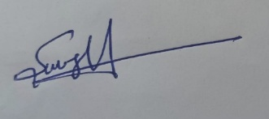
Mentor’s Signature:
Mentor’s Name: Suresh Mamillapalli
Designation: Consultant

Place: Nagpur
Date: 04/10/25

Contents

- Abstract
- Introduction
- Design & System Architecture
- Implementation Details
- Features & Functionality
- Results
- References

Abstract

TaskSnap Journal: A Productivity Tracker 2.0
TASKSNAP JOURNAL is a desktop productivity application built in Python using the CustomTkinter framework. It was developed to directly address the organizational inefficiency of manual reporting (monthly productivity and weekly screen time) and the user pain point of task procrastination. The application provides a unified, Modern & Inviting platform that automatically tracks work metrics, monitors screen time, and enforces task completion. Key features include a compulsory To-Do List launch on login, proactive Productivity Module appearance before shift end, and a Screen Time Monitor with integrated break prompts. The application successfully demonstrates a modular architecture designed for efficiency and compliance.
.

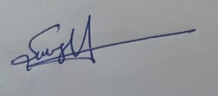
Signature of Mentor:
Name: Suresh Mamilapalli
Date: 4 Oct 2025
Place: Nagpur, India

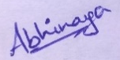
Signature of Student:
Name: Saipa Abhinaya
Date: 4 Oct 2025
Place: Nagpur, India

Introduction

1.1 Project Genesis
The TASKSNAP JOURNAL project originated from a direct organizational challenge: the constant requirement to report monthly productivity and weekly screen time. The reliance on fragmented, manual systems led to:
- Stressful end-of-month scramble and inaccurate data.
- Procrastination in task and data logging.
- Inefficient use of time that should have been spent on core work.

1.2 Our Solution
The core motivation is to create an assertive, automated desktop application that eliminates manual reporting friction. By integrating the tracking and reporting mechanism into the daily workflow, TASKSNAP JOURNAL ensures data is captured reliably and automatically. The application is built on a Modern & Inviting aesthetic designed for user comfort and consistent engagement.

Design and System Architecture

2.1 User Interface Design
The UI adheres to a "Modern & Inviting" aesthetic, defined by:
- Soft Color Palette: Muted blues, greens, and grays for a comfortable, professional feel.
- Rounded Elements: CustomTkinter is used to create smooth, rounded buttons, cards, and input fields.
- Proactive UI: The design incorporates assertive elements to enforce adherence: the To-Do List auto-launches on login, and the Productivity module appears before shift end.

2.2 Technology Stack
The technical foundation of TASKSNAP JOURNAL is built on a highly maintainable, modular stack:
- Frontend: Python with the CustomTkinter framework.
- Architecture: Modular Views Pattern (separated files like dashboard_view.py), crucial for scalability.
- Data Persistence: Local File Storage (JSON/CSV) for immediate access, complemented by organizational reporting via the Google Sheets API.
- Cross-Platform Reporting: Integration with the Google Sheets API to automatically update a single shared Excel sheet with all users' productivity and screen time data, eliminating manual consolidation.
- Automation: Python Threading & Scheduling for continuous screen monitoring and automated events.

Implementation Details: Automation and Features

3.1 Initial User Setup
The initial module collects essential data necessary to enable automation and reporting:
- Information: User Name, Email, Shift Time, Weekly Week-Offs.
- Reporting Chain: Manager's Email Address.
- Module: The Update Info section retains this form for ongoing detail modification.

3.2 Productivity Tracker
This module is the core component for compliance and reporting:
- Core Input: Users update discrete counters for QA, Incidents, Packages, and PRF Created.
- Automation Trigger: The module is configured to automatically appear on the user's screen 15 minutes before the shift ends, forcing data finalization.
- Hamburger Menu: Provides essential extensions: Send Email (sends monthly summary via API), Misc Tasks (log for uncounted tasks), Edit Data, and Summary (visual charts).
- Reporting Integration: Daily productivity data is immediately pushed to the shared Google Sheet via API.

3.3 To-Do List
This module is designed for compulsory task adherence:
- Assertive Launch: The To-Do window automatically launches upon user login.
- Enforced Completion: The module remains visible until the user has actively checked off all tasks.

3.4 Screen Time Monitoring
This module supports digital wellness and compliance reporting:
- Tracking: Shows Total Screen Time, detailed daily usage bars, an average usage bar, a pie chart by category, and a list of all apps used.
- Digital Wellness: The app automatically prompts the user to take a break after every 1 hour of continuous screen usage.
- Reporting Integration: Weekly screen time summaries are automatically uploaded to the shared Google Sheet.

Conclusion and Future Work
TASKSNAP JOURNAL successfully delivers a unified, automated, and visually appealing solution to the problem of manual corporate reporting. The implementation leveraging Python/CustomTkinter and the Google Sheets API ensures a stable, scalable, and fully integrated platform.
Future work includes integrating a persistent database and fully implementing the planned AI Mood Tracker for personalized, proactive user support

Results

Main Window Overview
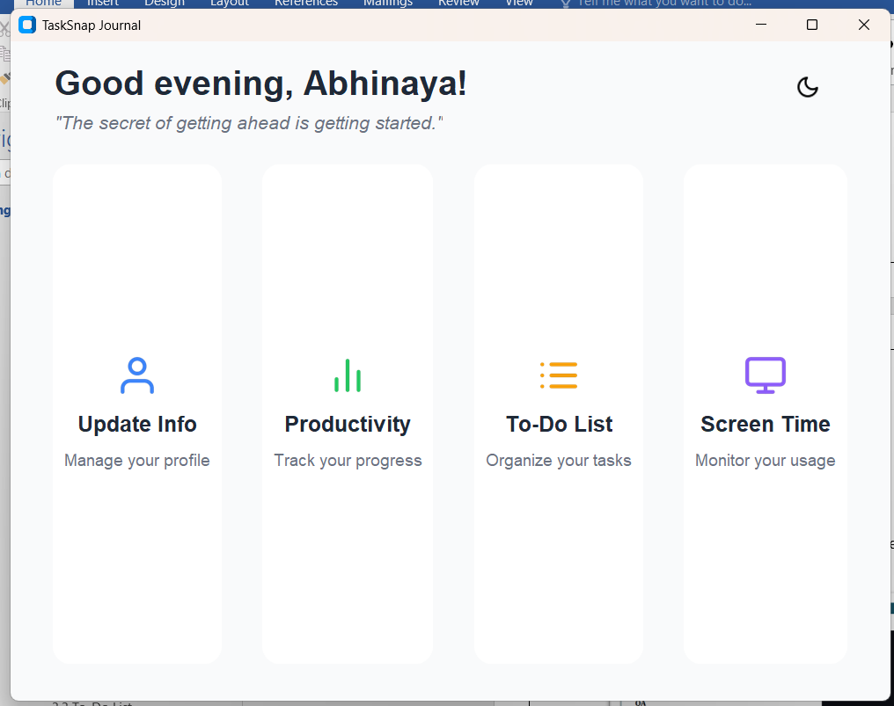

Update Info
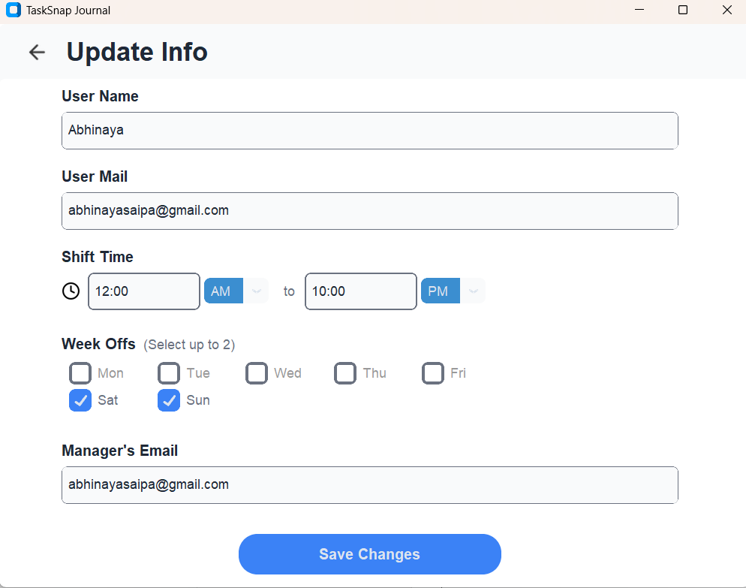

Productivity
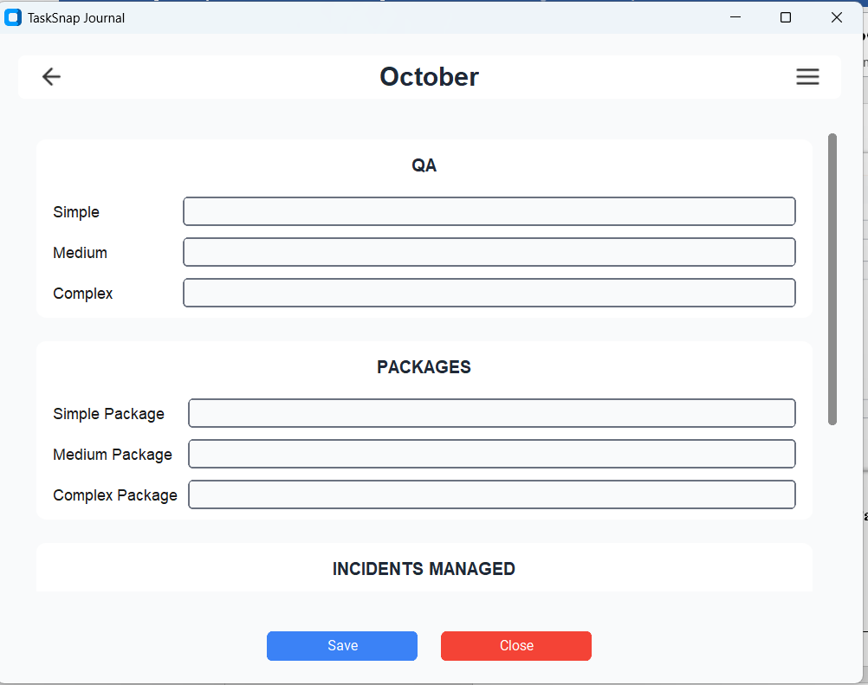

Edit Window
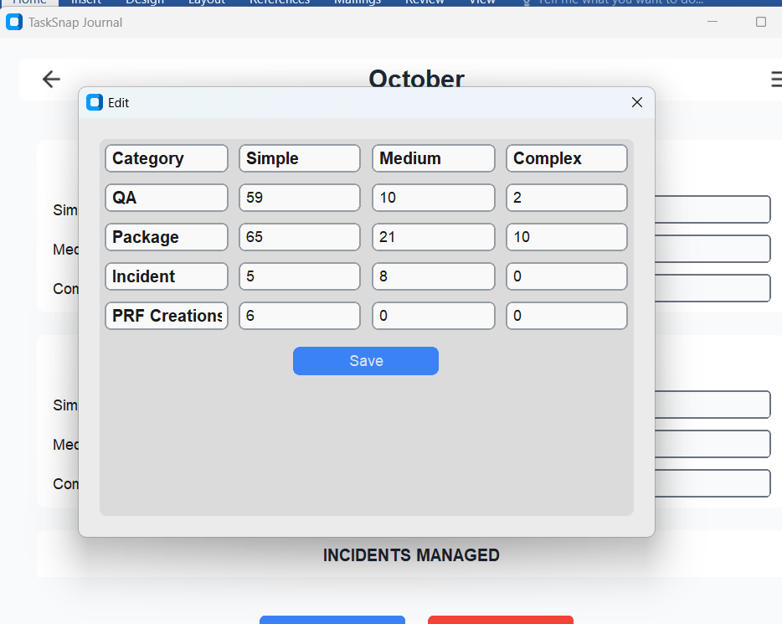

Miscellaneous Task Window
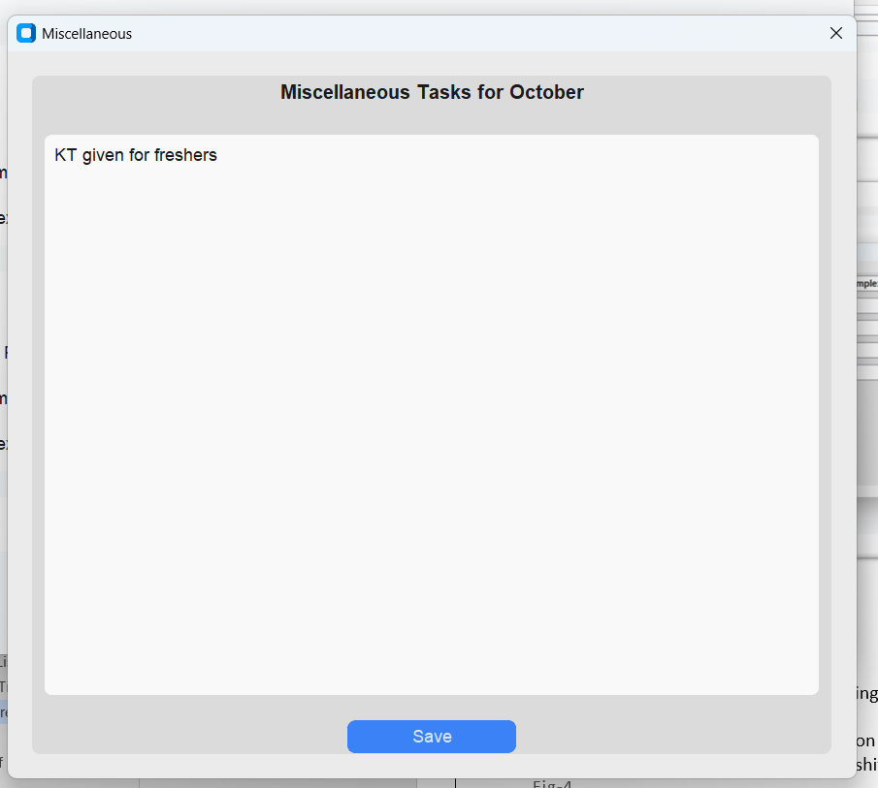

Summary
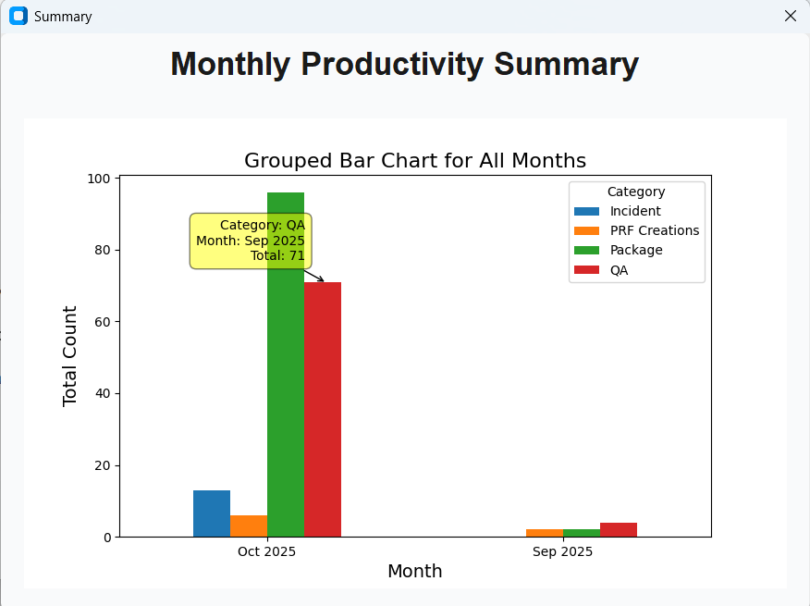

To do List
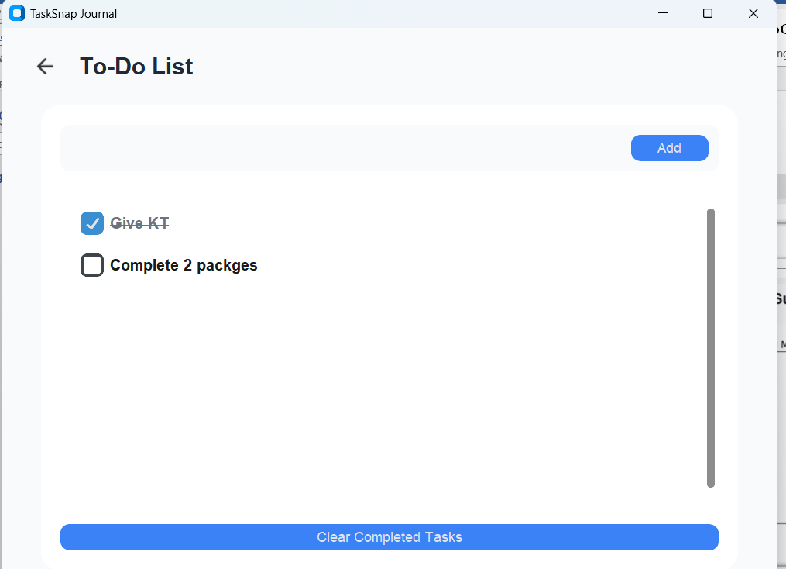

Screen Time
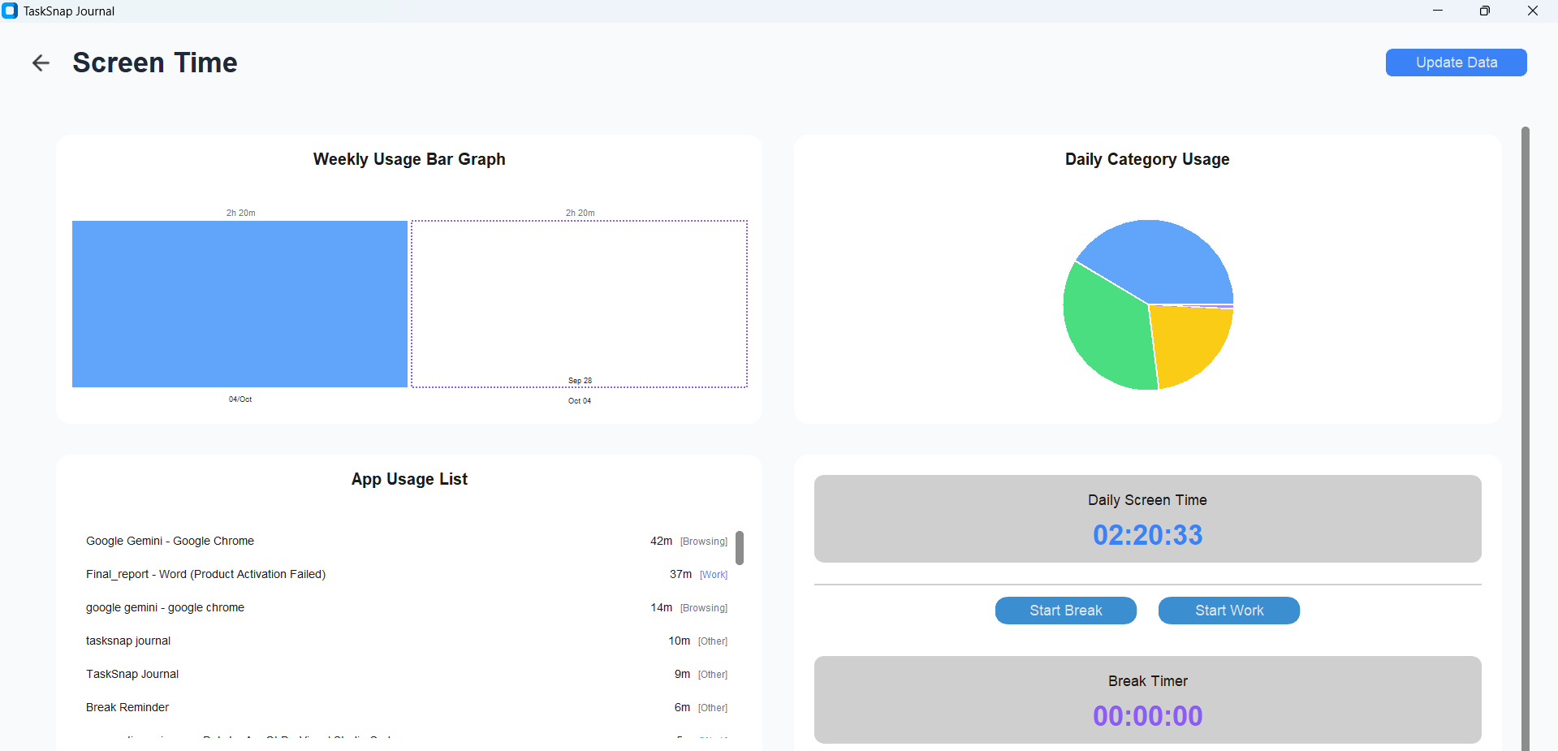

Scheduled Tasks
Successful creation of scheduled tasks using the Windows Task Scheduler ensures timely reminders for users.
- Daily Launch – triggers the launch of the productivity module 15mins before the users shift end time.
- TODOViewLaunch – triggers the todo module when the user logs in.

Email Configuration
The snapshot below showcases the email format, emphasizing the structure and content of the emailed productivity reports.
  - Fig-6
  - 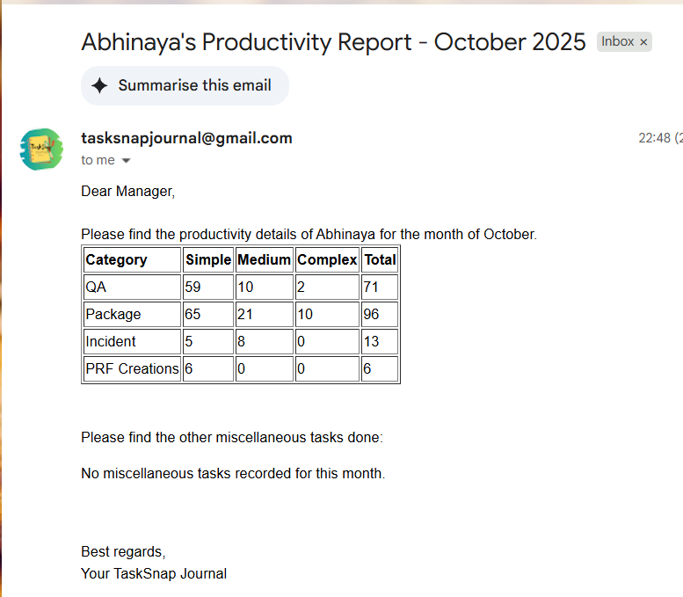

References
- Custom Tkinter Documentation https://customtkinter.tomschimansky.com/documentation/

- Python Official Documentation
https://docs.python.org/

- Matplotlib Documentation
https://matplotlib.org/stable/contents.html

- Pandas Documentation
https://pandas.pydata.org/pandas-docs/stable/index.html

- win32com.client Documentation
https://docs.microsoft.com/en-us/office/vba/api/overview/excel

- smtplib Documentation
https://docs.python.org/3/library/smtplib.html

- Task Scheduler API Documentation
https://docs.microsoft.com/en-us/windows/win32/taskschd/task-scheduler-start-page

- OpenAI GPT-3 Documentation
https://beta.openai.com/docs/

- Feather Icons
https://feathericons.com/

- Stack Overflow and other community forums for problem-solving.

Checklist of items

 | Is the final report neatly formatted with all the elements required for a technical Report? | Yes
 | Is the Cover page in proper format as given in Annexure A? | Yes
 | Is the Title page (Inner cover page) in proper format? | Yes
 | (a) Is the Certificate from the Mentor in proper format?  (b) Has it been signed by the Mentor? | Yes  Yes
 | Is the Abstract included in the report properly written within one page? Have the technical keywords been specified properly? | Yes  Yes
 | Is the title of your report appropriate? The title should be adequately descriptive, precise and must reflect scope of the actual work done. Uncommon abbreviations / Acronyms should not be used in the title | Yes
 | Have you included the List of abbreviations / Acronyms, if any? | No
 | Does the Report contain a summary of the literature survey, if any? | No
 | Does the Table of Contents include page numbers?  - Are the Pages numbered properly? (Ch. 1 should start on Page # 1)  - Are the Figures numbered properly? (Figure Numbers and Figure Titles should be at the bottom of the figures)  - Are the Tables numbered properly? (Table Numbers and Tabl e Titles should be at the top of the tables)  - Are the Captions for the Figures and Tables proper?  - Are the Appendices numbered properly? Are their titles appropriate | Yes  Yes  Yes  Yes  Yes  Yes
 | Is the conclusion of the Report based on discussion of the work? | Yes
 | Are References or Bibliography given at the end of the Report?  Have the References been cited properly inside the text of the Report?  Are all the references cited in the body of the report | Yes  Yes  Yes
 | Is the report format and content according to the guidelines? The report should not be a mere printout of a Power Point Presentation, or a user manual. Source code of software need not be included in the report. | Yes

Declaration by Student:
I certify that I have properly verified all the items in this checklist and ensure that the report is in proper format as specified in the course handout.

Place: Nagpur Signature of the Student

Date: 4/10/2025 Name: Saipa Abhinaya

ID No.: 202117bh109

