Tasksnap Journal - A Productivity Tracker 2.0

BITS ZC4999T: Capstone Project

by

Saipa Abhinaya

202117bh109

Capstone Project work carried out at

HCLTech, Nagpur



BIRLA INSTITUTE OF TECHNOLOGY & SCIENCE

PILANI (RAJASTHAN)

August 2025

Birla Institute of Technology & Science, Pilani

Work-Integrated Learning Programmes Division

BITS ZC499T: Capstone Project Mid-Semester Progress Evaluation Sheet

Bits ID: 202117bh109
Student Name: Saipa Abhinaya
Email Address: 202117bh109@wilp.bits-pilani.ac.in
Employing Organization & Location: HCLTech, Nagpur

Mentor Name:
Email Address:
Employing Organization & Location: HCLTech, Lucknow

Capstone Project Title: Tasksnap Journal - A Productivity Tracker 2.0

Content

- Details of the work done
- Details of the work yet to be done
- Evaluation
- Details of the Examiner and Mentor

Details of the Work Done

1. Application Design and Prototyping
- Initial Concept: The project started with low-fidelity sketches to establish the basic layout for the application's core screens (Dashboard, Update Info, Productivity, To-Do List).

- High-Fidelity Mockup: The initial sketches were developed into a detailed digital mockup. This process finalized the app's modern aesthetic, color scheme, and typography before development began.

- Interactive Prototype: A clickable prototype was built using Figma to test and validate the user flow and overall design, ensuring a positive user experience.

2. Core Application Architecture
- Technology Selection: The application is built with Python and the CustomTkinter library. This stack was chosen for its capability to produce modern, cross-platform user interfaces and for its flexible licensing.

- Modular Codebase: The project is organized with a clean, scalable code structure. Each screen is contained in its own module within a views package, a central theme.py file manages all styling, and main.py serves as the primary application controller.

3. User Interface Implementation
All planned UI screens have been fully constructed and are visually complete.

- Dashboard: The main hub of the application is feature complete. It includes a dynamic greeting that changes with the time of day, an inspirational quote fetched from a live API, and functional navigation cards.

- Update Info Screen: A detailed, scrollable form for managing user profile information has been built. It includes custom inputs for shift times and week-offs and is fully integrated with the theme system.

- Productivity Screen: The new screen features a clean, grid-based layout and an integrated dropdown menu for secondary actions.

- To-Do List & Screen Time Screens: The UI for the final two screens has been designed and implemented as placeholder views, ready for back-end logic.

4. Advanced UI Features
- Dynamic Theming: A fully functional light/dark mode toggle has been implemented, which instantly updates the appearance of the entire application.

- Custom Styling: The application uses the "Rubik" font and custom, dynamically color-tinted icons to create a unique and cohesive visual identity.

- Responsive Design: The application window maintains a fixed aspect ratio, and fonts scale dynamically, ensuring the UI remains well-proportioned at all sizes.

Plan of work yet to be done

With the front-end user interface now complete, the next phase of the project will focus entirely on back-end development. The primary goal is to implement the application's logic and connect it to the existing UI.

Milestone 1: Data Persistence and Configuration
- Objective: Establish a system for saving and loading all user data and application settings.

- Deliverables:
  - Data Storage Model: Implement functions to read from and write to local data files (e.g., CSV, JSON) for storing user profiles, productivity data, and to-do list items.

  - "Update Info" Backend: Connect the "Save Changes" button on the UpdateInfoView to the data storage model to enable saving and loading of user details.

Milestone 2: Core Feature Logic Implementation
- Objective: Make the primary productivity and task management features fully functional.

- Deliverables:
  - Productivity Tracker Backend: Implement the logic for the "Update" and "Clear" buttons. This includes the calculations for daily productivity based on the task complexity inputs.

  - To-Do List Backend: Develop the core functionality for the To-Do List screen, including the logic for adding, completing, and deleting tasks.

Milestone 3: Secondary Feature and External Integration
- Objective: Build out the functionality for the advanced features located in the productivity screen's menu.

- Deliverables:
  - Summary View Logic: Implement the "View Summary" feature. This will involve creating a new window that reads saved data, performs calculations, and displays a productivity summary.

  - Miscellaneous Notes Logic: Connect the "Miscellaneous" menu option to a function that opens a simple text editor for saving and loading daily notes.

  - Email Integration: Integrate the email sending logic. The "Send Email" menu option will trigger a function to format the saved productivity data into a report and send it via SMTP.

Final Milestone: Testing and Packaging
- Objective: Ensure the application is stable and bug-free

- Deliverables:
  - Full-Stack Testing: Conduct thorough testing of all features, including data saving, calculations, and email functionality, to identify and resolve any bugs.

  - Executable Build: Use a tool like PyInstaller to package the complete Python application into a single, standalone executable file for easy deployment.

EVALUATION
CAPSTONE PROJECT PROGRESS EVALUATION (Please put a tick ( ) mark in the appropriate box)
EC No. | Component | Excellent | Good | Fair | Poor
1. | Capstone Project Outline
2. | Work Progress & Achievements
3. | Initiative and Originality
4. | Documentation & Expression
5. | Research & Innovation
6. | Relevance to the work environment

DETAILS OF EXAMINER AND MENTOR
 | Mentor | Additional Examiner
Name | Suresh | Savita
Qualification | MCA | BEE(E)
Designation | Consultant | Senior Specialist
Employing Orgn and Location | HCLTech, Banglore | HCLTech, Banglore
Phone No.  (with STD Code) | +91-9916243495 | +91- 8904515927
Email Address | suresh.mamillapalli@hcltech.com | savita.khanapeth@hcltech.com
Signature | 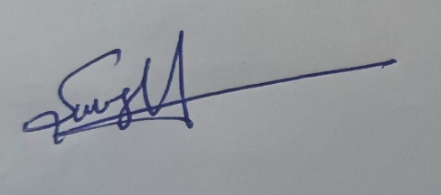 | 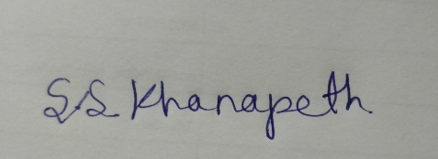
Date | 22/08/2025 | 22/08/2025

