Weekly Progress Report – Week 1

**Project Title:** Online Test Registration and Examination portal

**Submitted by:** Reddaboina Abhinaya

**Week Duration:** April 16 to April 24

**Problem Statement**:

The task is to develop a full stack Web application that allows users to register, login, take online exams and view there results.

1. Summary of work done in Week – 1

In week 1, I completed the frontend development of the Registration Page. The form is designed to collect the following user input:

* Full Name
* Email Address
* Phone Number
* College Name
* College ID Number
* Profile picture Upload
* College Id Card Upload

The registration form was built using HTML, CSS, and JavaScript. The frontend is ready to be connected to a backend services.

1. Technologies used:

* HTML
* CSS
* JavaScript

1. Screenshot:

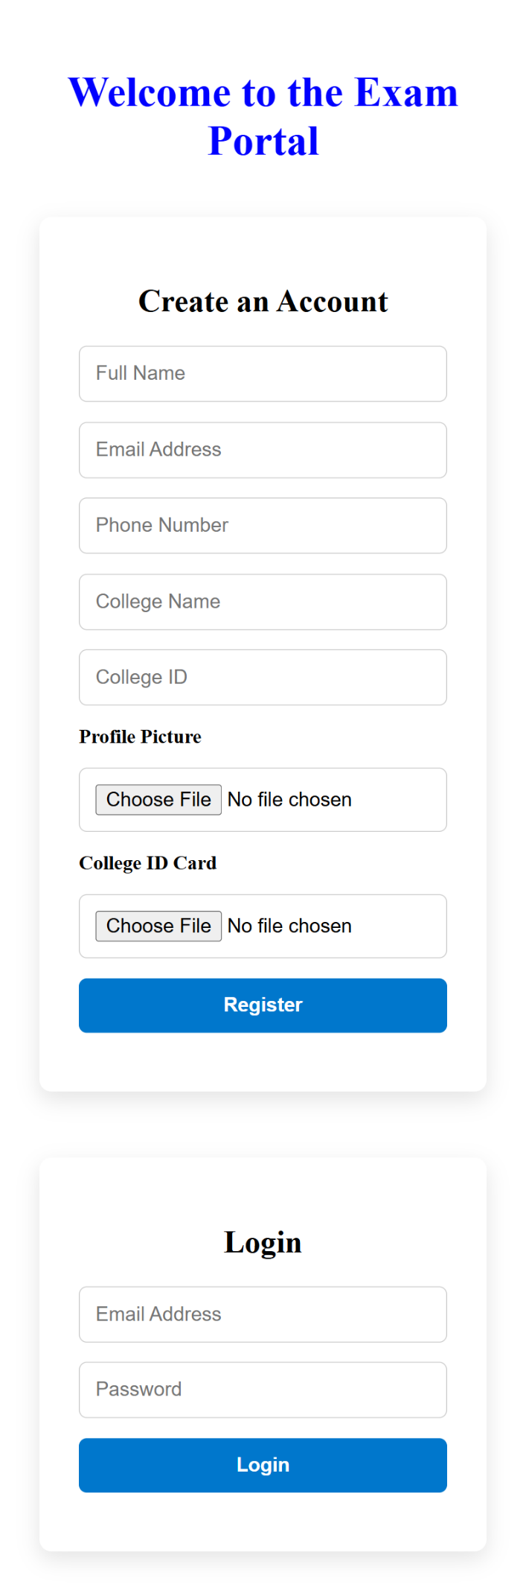

1. Files Attached:

* 
* 

1. Plan for week 2:

In week 2, the plan is to develop the backend functionality:

- Setup Node.js and MySQL database

- Generating random passwords for users

- Sending credentials to registered email

The current implementation focuses only on frontend logic. Backend functionalities will be progressively starts from week 2