Phase 8: Data Management & Deployment

**Objective:** In this phase, we focus on managing data efficiently and deploying customizations from one Salesforce environment to another. This ensures smooth migration, data consistency, and secure backups, forming the foundation for stable and scalable CRM operations.

# Data Import Wizard

Purpose: Simplifies importing data such as Accounts, Contacts, Leads, or Custom Object records directly through Salesforce UI.

1. Navigate to Setup → Data Import Wizard → Launch Wizard.
2. Choose the object (e.g., Account, Contact, or Custom Object).
3. Select the operation — Add new, Update existing, or Upsert.
4. Upload your CSV file and map fields correctly.
5. Run the import and review the success/error files.

Use Case: Ideal for smaller datasets under 50,000 records. Best used for quick imports where mapping and deduplication are simple. It is helpful when end-users or admins need to upload data without developer assistance.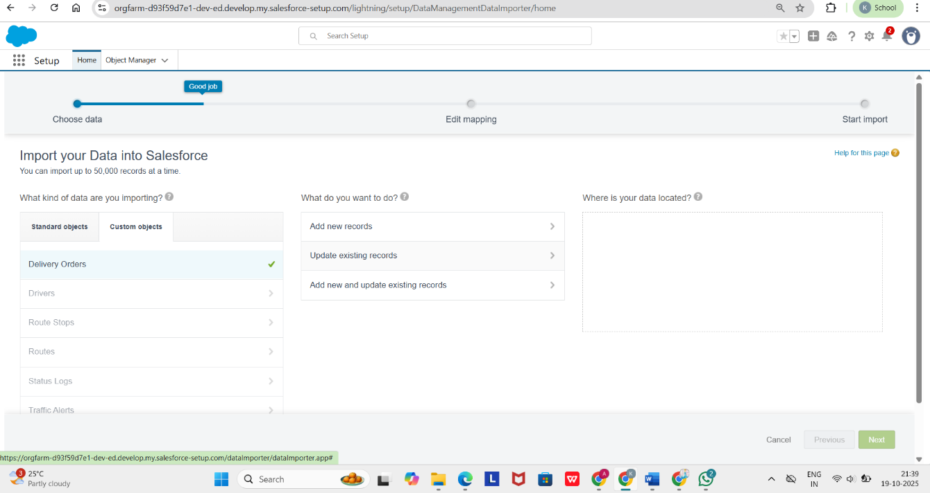

# Data Loader

Purpose: A client application for bulk import, export, update, or delete operations.

1. Download and install Salesforce Data Loader.
2. Login using Salesforce credentials or OAuth.
3. Choose the operation (Insert, Update, Upsert, Delete, Export).
4. Select the CSV file and map fields.
5. Run the operation and review success/error logs.

Use Case: Used when large volumes of data need to be migrated, such as initial data loads, mass updates, or regular data synchronization. It allows automation and provides better control over error handling and performance.A screenshot of a computer

# Duplicate & Matching Rules

Purpose: Prevent creation of duplicate records and maintain clean data.

1. Go to Setup → Matching Rules → New and define matching criteria (e.g., Email, Phone).
2. Create a Duplicate Rule using the matching rule and set behavior (Block, Alert, or Report).
3. Activate both rules.
4. Test by creating records to ensure duplicates are flagged.

Use Case: Keeps CRM data clean by automatically identifying potential duplicates during record creation or update. This improves data integrity, reporting accuracy, and customer satisfaction.A screenshot of a computer

# Data Export & Backup

Purpose: To ensure data safety and compliance by creating regular backups.

1. Navigate to Setup → Data Export.
2. Choose objects to include and decide whether to include attachments/files.
3. Click Export Now or Schedule Export for weekly/monthly backups.
4. Download the ZIP file once available.

Use Case: Ensures business continuity by maintaining secure backups of all Salesforce data. This process helps restore accidentally deleted records, recover from corruption, and meet data retention or compliance requirements.

# Change Sets

Purpose: To deploy metadata (custom objects, triggers, layouts, etc.) between connected Salesforce orgs (e.g., Sandbox → Production).

1. In Sandbox, go to Setup → Outbound Change Sets → New.
2. Add components (Apex Classes, Page Layouts, etc.).
3. Upload to target org.
4. In Production, go to Inbound Change Sets, validate, and deploy.

Use Case: Simplifies deployment between environments while maintaining control and traceability. It is ideal for admins and smaller teams who prefer a point-and-click migration method for tested configurations.

# Managed vs Unmanaged Packages

Purpose: Packaging enables distribution and reusability of Salesforce components.

Use Case: Managed packages are used by developers and ISVs to distribute upgradable solutions through AppExchange. Unmanaged packages are used when sharing source code or configurations for learning, customization, or client-specific implementations.

# ANT Migration Tool

Purpose: A Java-based command-line tool for retrieving and deploying metadata via XML manifests.

1. Install Java and Apache Ant.
2. Download the Salesforce ANT Migration Tool.
3. Configure build.properties with org credentials.
4. Edit package.xml to define components.
5. Run commands: ant retrieve / ant deploy.

Use Case: Suitable for automated deployments where consistency and repeatability are required. It enables version control integration and bulk metadata transfers across multiple Salesforce environments.

# Visual Studio Code (VS Code) & Salesforce CLI (SFDX)

Purpose: The modern development and deployment environment for Salesforce developers.

1. Install VS Code and Salesforce CLI (SFDX).
2. Create a new project using: sfdx force:project:create -n MyProject.
3. Authorize your org using: sfdx auth:web:login -a DevHubAlias.
4. Retrieve or deploy metadata using CLI commands.
5. Use Git for version control and CI/CD integrations.

Use Case: Provides a unified development platform supporting source tracking, testing, and deployment. Ideal for continuous integration (CI) and continuous delivery (CD) pipelines, improving collaboration among development teams.

**Conclusion:** Data Management & Deployment are vital for ensuring Salesforce environments remain synchronized, reliable, and secure. By leveraging tools like Data Loader, Change Sets, and SFDX, organizations can automate deployment, prevent errors, and maintain data integrity across all environments.