Salesforce Reports, Dashboards, and Security Review Document

# Reports (Tabular, Summary, Matrix, Joined)

In this stage, we review and validate the various types of reports configured in the system:

**Tabular, Summary, Matrix, and Joined**.

* + **Tabular reports** provide flat lists—useful for delivery orders lists and data exports.
  + **Summary reports** allow grouping and subtotals (e.g., grouping DeliveryOrders by city or driver).
  + **Matrix reports** enable two-dimensional grouping (e.g., number of stops by vehicle by time window).
  + **Joined reports** let you combine multiple report types into one (e.g., combining Route, Vehicle, and DeliveryOrder data).

**During this phase we:**

* + Ensure each report type aligns with business metrics (e.g., on-time vs delayed orders).
  + Confirm filters, groupings, and charts display correctly for end-users.
  + Optimize for performance and ensure correct fields/objects are included.
  + Document and classify reports by use-case (Dispatcher, Manager, Executive).
  + 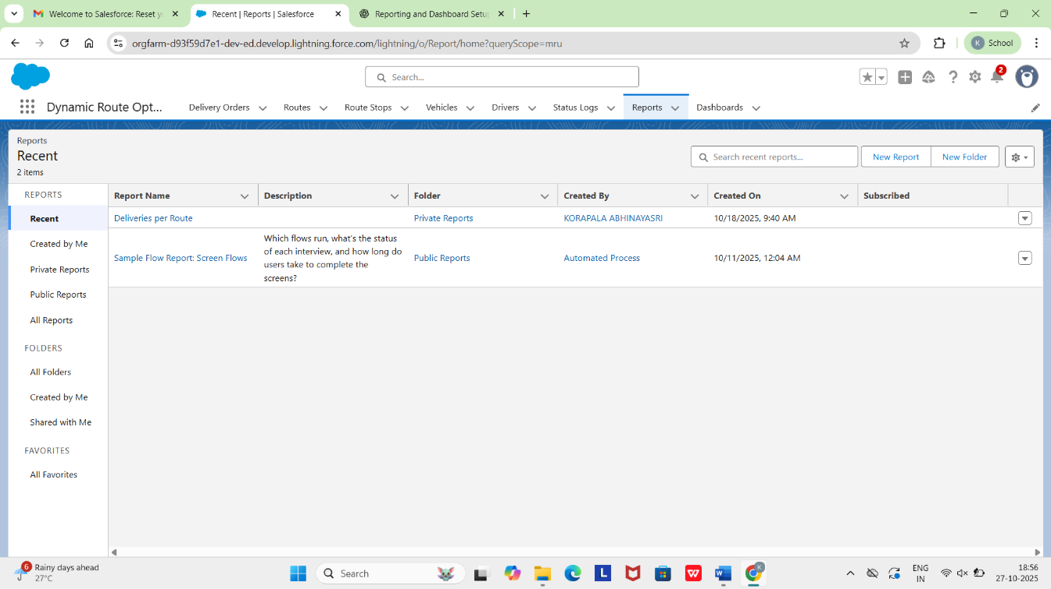
  + 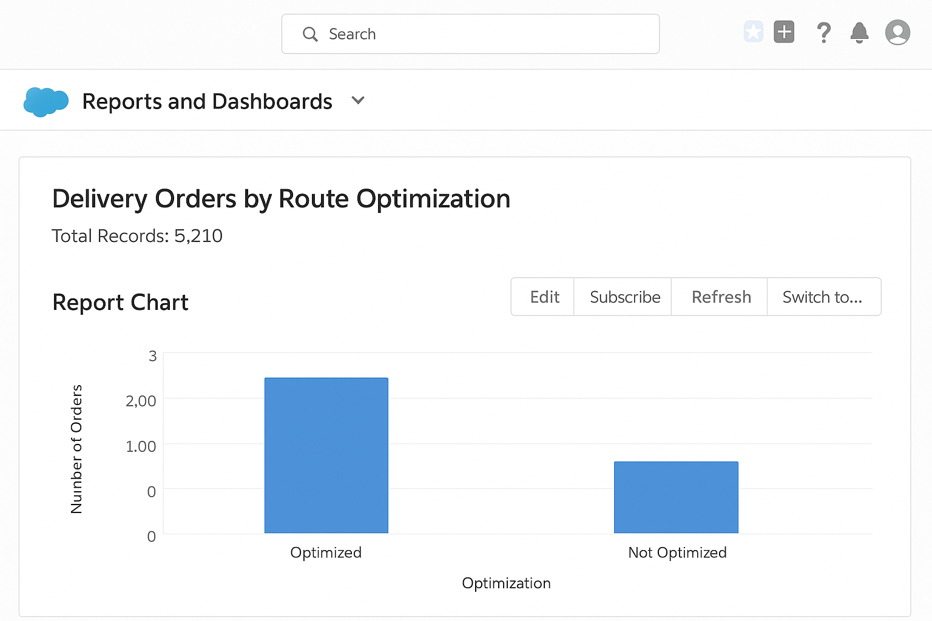

# Report Types

Report Types in Salesforce define which objects and fields are available for reporting.

**During this phase we:**

* + Review existing report types and ensure they include custom objects (DeliveryOrder, RouteStop, Vehicle, etc.).
  + Create or modify custom report types to support new use-cases (e.g., “Delivery Orders with Route Stops and Vehicle Assignment”).
  + Test each report type for correct object relationships and field availability.
  + Document naming conventions and maintain a registry of report types.

# Dashboards

Dashboards visualize key performance indicators.

**During this phase:**

* + Consolidate dashboard components (charts, gauges, tables) for routing performance metrics.
  + Validate that components reflect accurate data.
  + Check layout, color themes, and responsiveness.
  + Ensure dashboard folders and naming conventions are standardized.

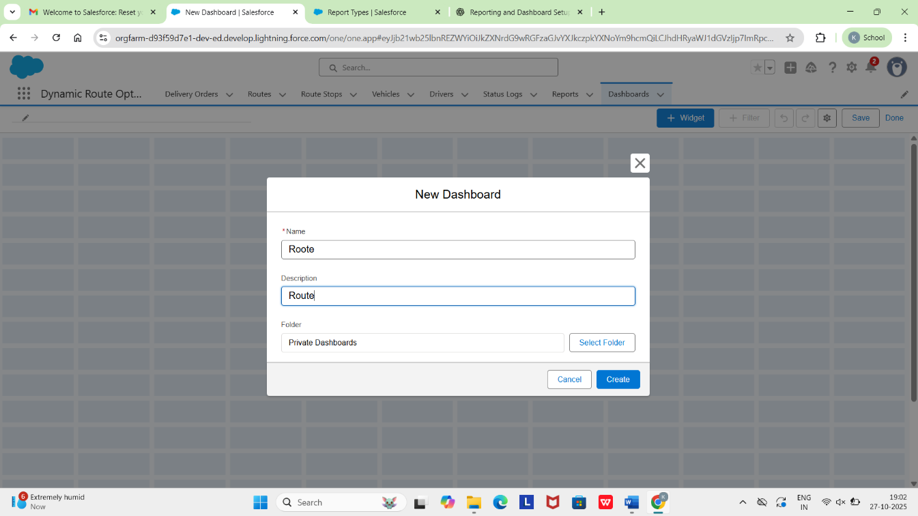

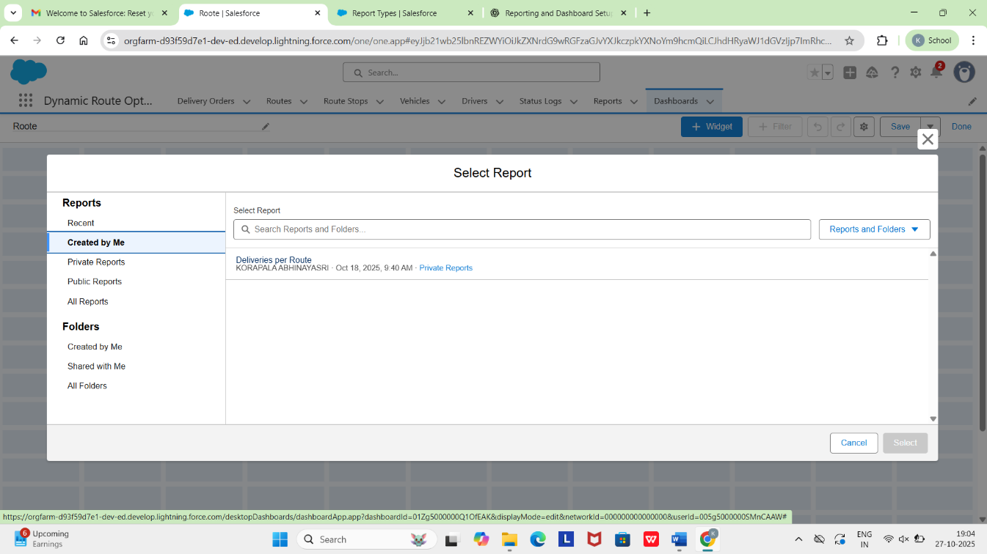

# Dynamic Dashboards

Dynamic dashboards allow personalized views for users (drivers, dispatchers, managers).

**During this phase:**

* + Identify dashboards that should be dynamic and set “Run as Logged-in User”.
  + Verify user permissions and sharing settings.
  + Review limits (e.g., Developer Edition supports 3 dynamic dashboards).
  + Test across profiles to ensure correct data filtering.

# Sharing Settings

Sharing settings control record visibility across users.

**During this phase:**

* + Review OWD for custom objects (DeliveryOrder c, Route c, etc.).
  + Validate Sharing Rules, Manual Sharing, and Apex Sharing.
  + Ensure role hierarchy aligns with business needs.
  + Test visibility for roles (driver, manager, operations head).
  + 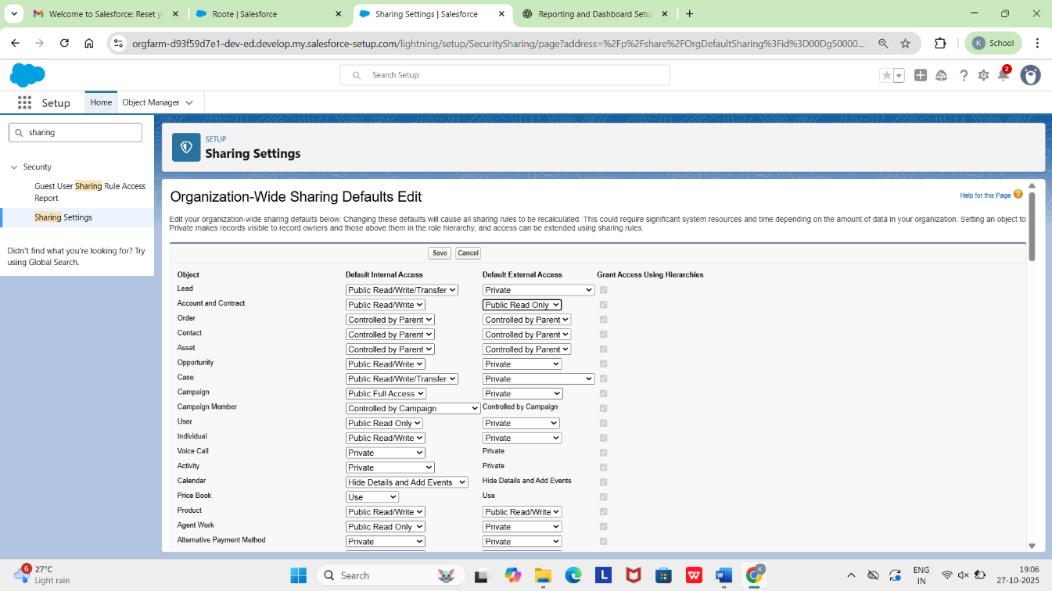

# Field-Level Security

Defines who can view/edit specific fields.

**During this phase:**

* + Hide or restrict sensitive fields (driver contact, vehicle timings).
  + Validate mandatory fields are visible and required for relevant users.
  + Review and adjust profiles/permission sets.
  + Ensure compliance with data policies.

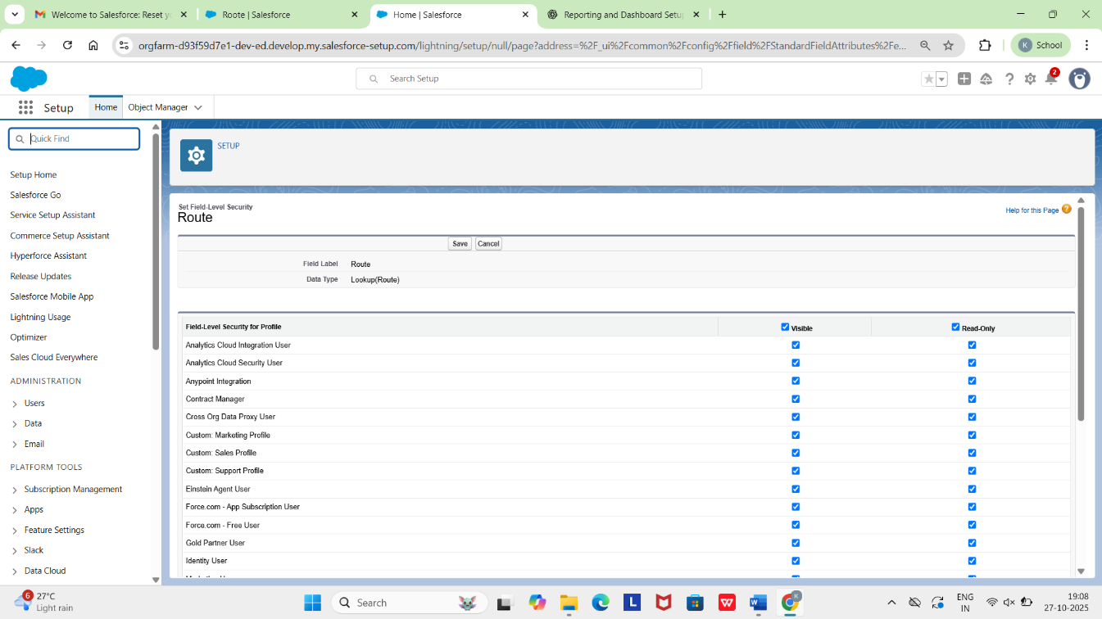

# Session Settings

Controls login session security.

**During this phase:**

* + Verify session timeout (e.g., 30 minutes for mobile users).
  + Check IP restrictions for sensitive profiles.
  + Confirm MFA and session-based permissions.
  + Document exceptions and compensating controls.

# Login IP Ranges

Defines trusted IP ranges for login.

**During this phase:**

* + Review profiles with locked IP ranges.
  + Validate restrictions for admin and operations profiles.
  + Recommend VPN/secure network access.
  + Document exceptions and monitor login anomalies.

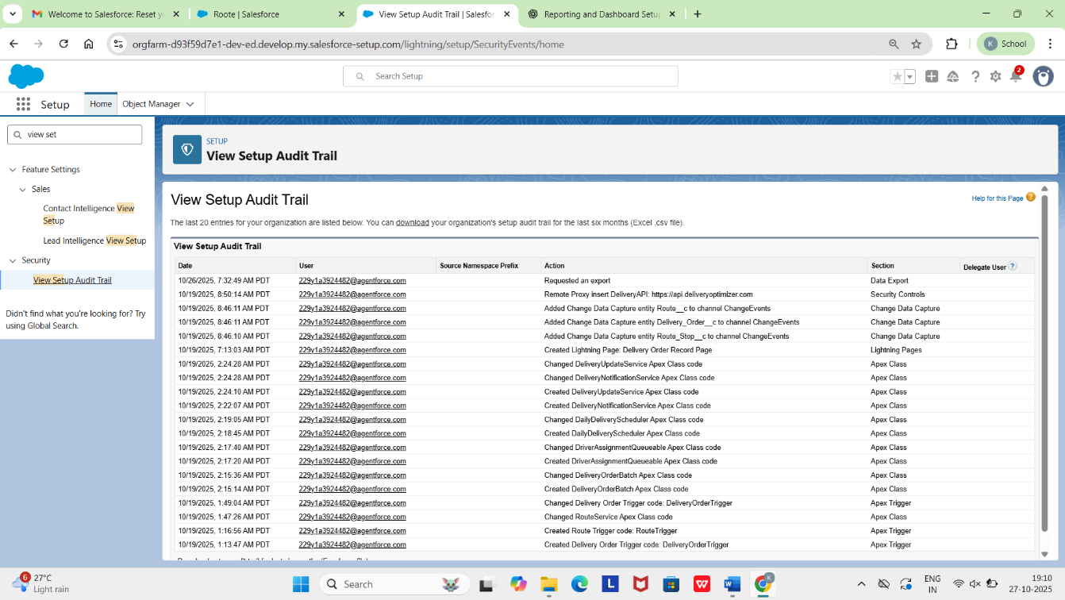

# Audit Trail

Tracks metadata and data changes.

**During this phase:**

* + Review 180-day Setup Audit Trail logs.
  + Ensure Field History Tracking is enabled on key fields.
  + Review privileged changes and validate approvals.
  + Establish audit log governance and anomaly reporting.
  + 