THE UNIVERSITY OF TEXAS AT ARLINGTON

DEPARTMENT OF COMPUTER SCIENCE AND ENGINEERING

MACHINE LEARNING – CSE-6363-004

FALL 2024

PROJECT REVIEW

**NEWS SUMMARIZATION USING NLP**

Abhinay Kotla – 1002195827

**Abstract:**

In the digital age, the exponential growth of information has led to a pressing need for automatic text summarization (ATS) systems that can condense large amounts of text into concise, meaningful summaries. This project explores two approaches to ATS—an LSTM-based encoder-decoder model and a fine-tuned T5 Transformer. Using the Indian News Dataset, these models were trained and evaluated to generate abstractive summaries. The evaluation process involved quantitative metrics like ROUGE scores and cosine similarity, as well as a novel semantic rating generated by GPT. Through these analyses, the T5 model emerged as the superior choice, providing human-readable summaries with greater semantic coherence compared to the LSTM model. This report details the entire workflow, including preprocessing, model design, training, evaluation, and analysis of results.

**Introduction:**

With the explosion of digital media, individuals and organizations struggle to process the vast amount of available information. Automatic text summarization has become an essential tool to address this challenge by extracting or generating condensed summaries from larger texts. Abstractive summarization, the focus of this study, generates new phrases and sentences that encapsulate the essence of the source material, making it more challenging yet valuable compared to extractive summarization.

This project aims to evaluate the effectiveness of two abstractive summarization techniques:

1. A sequence-to-sequence LSTM-based encoder-decoder architecture, leveraging GloVe embeddings for textual representation.

2. The T5 (Text-to-Text Transfer Transformer), a state-of-the-art transformer-based model known for its versatility in various NLP tasks.

A concise and well-organized synopsis of text can be extracted using Automatic Text Summarization (ATS) from a wide range of sources, including books, emails, research papers, blogs, tweets, and news articles.

Two approaches to summarizing text:

**Abstractive Summarization:**

Abstractive Summarization produces more meaningful human written sentences, rather than being limited to terms from the source text.

**Extractive Summarization:**

Extractive summarization is a traditional way to generate summaries, such as clipping relevant chunks of the source text and combining them to make a rational summary.

**Data Set Description:**

We used the News Summary Indian News Dataset for this project [10]. The datasets were designated "news summary" and "news_summary_more," and they had 4515 and 98280 instances, respectively. For this project, we have only used the "news summary" data collection due to computational constraints. Here, we have just used text (the article's summary) and ctext (the full text), out of the six variables (author, date, headline, read more, text, and ctext).

**Implementation:**

**Data Pre-processing:**

Preprocessing or cleaning data is just as crucial to any machine learning project as building the model itself. One of the most unstructured types of data is text, and handling human language is not feasible. Neural Language Processing (NLP) is a background method that processes large amounts of text before providing an answer.

The various text pre-processing steps are:

**1.Handling null values:** Removing all the rows containing null values for news articles.

**2.Lowercase Transformation:** Lowering the case of a word (NLP -> nlp). This helps in standardizing the text data for further processing.

**3.Removing HTML tags:** Cleaning HTML tags before vectorizing the text data. This function takes a raw text string as input and returns the text without HTML tags.

**4.Stop words and punctuation removal:** Stop words (an, the, a, and so on) are frequently employed in papers. These terminologies have no real meaning because they do not assist in distinguishing between two publications.

**5.Tokenization:** Tokenization is essentially splitting a sentence, paragraph, phrase, or an entire text into smaller parts, such as individual terms or words.

**6.Lemmatization:** Unlike stemming, lemmatization restricts words to words that already exist in the language.

For modeling seq2seq data, special tokens are attached at the beginning and end of the summary as an extra pre-processing step.

**Exploratory Data Analysis:**

Exploratory data analysis, or EDA for short, is the process of identifying patterns, spotting irregularities, testing hypotheses, and verifying assumptions using graphical representations and summary statistics. We have carried out the following data analysis as part of EDA.

**1) Type token ratio (TTR):** To compute TTR, one must divide the total number of words in a text by the total number of tokens, or distinct word categories. While a low TTR indicates the opposite, a high TTR reflects a significant degree of lexical diversity. We received a 0.04 TTR score in our instance! as one may anticipate from news items.

**2) Word cloud:** Word clouds, sometimes referred to as tag-clouds, are graphic representations of word frequency that draw attention to words that recur regularly in a source text. The term appears more times in the text document (s) the longer it is in the image.

**3) Top 20 frequent words:** The terms with the highest frequency of occurrences throughout the entire corpus are called frequently occurring words. This type of analysis aids in our comprehension of the data's context. With 10570 times, the word "said" emerged as the most often occurring word. Additional frequently occurring terms in our corpus were "one," "would," "people," "also," and "new." examined the hapaxes as well. Among the outcomes are "notables," "patronize," and others.

**Architecture:**

**Encoder-Decoder:**

Sequence to Sequence (seq2seq) models are a type of Recurrent Neural Network architecture that is commonly used to handle complicated language problems such as question answering, constructing Chabot’s, machine translation,text summarization, and so on.

A Seq2Seq model has two primary components:

**Encoder:** Encoder LSTM model scans the complete input sequence, with a word sent into the encoder at every time-step. It then examines the data at each timestep, capturing the contextual data in the input pattern. The cell state and last time step's hidden state (hi) are utilized to initialize the decoder.

**Decoder:** The decoder is likewise an LSTM network that examines the whole target sequence word by word and predicts a one-step delayed sequence. It is taught to predict the following word in the sequence based on the preceding word. The special tokens start, and finish are added to the target sequence before it is fed into the decoder. The target sequence was unknown during decoding the test sequence. As a result, we start by feeding the decoder with the first word, which is always the <start> token. The <end> token denotes the conclusion of the sentence.

**Model Building and Execution:**

The model we built for the news summarization involved similar architecture of encoder and decoder as shown in the below image. Embedding dimension of 300 was used along with 3 layers of LSTM in the encoder and 1 layer of LSTM in decoder with a dropout 0.4. In the dense layer, **SoftMax** was used as an activation function.

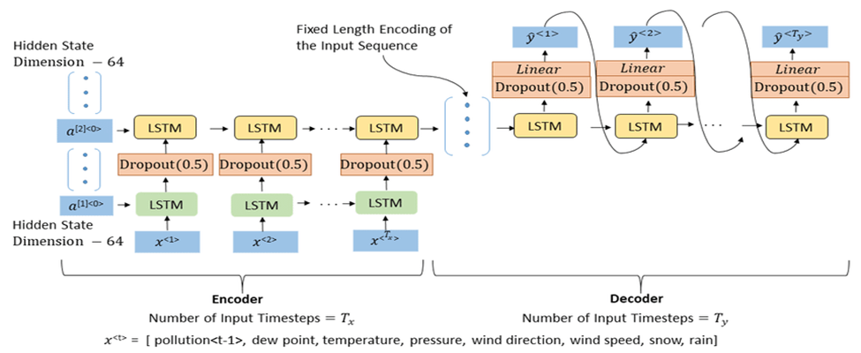

**Model Summary:**

The model summary of the baseline model is as shown below. Encoder of the model contained 3 layers of LSTM and 1 layer of LSTM in the decoder part along with the input and embedding layers.

**Model Evaluation:**

Our initial model results without hyper parameter tuning. The train loss and validation loss are plotted below. The validation loss is slightly higher than the train loss with an overall accuracy of 46% which is below the average model accuracy.

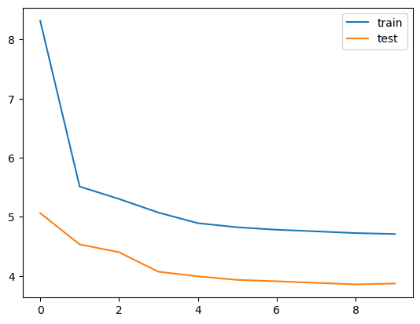

**Limitations of Encoder-Decoder Architecture:**

This encoder-decoder design is quite useful, although it does have some drawbacks.

1.The encoder predicts the output sequence after converting the full input sequence into a fixed size vector. Because the decoder looks at the full input sequence for the prediction, this only works for short sequences.

2. The concern with long sequences is long sequences are difficult for the encoder to remember into a fixed length vector. For LSTM to perform better, according to BLEU score report, the length of input text should be less than 30 and the length of reference should be around 15.

**T5: Text-To-Text Transfer Transformer:**

The T5 model is pre-trained on the Colossal Clean Crawled Corpus dataset which is called C4 dataset, and it achieves state-of-the-art results on a range of NLP tasks while still being flexible enough to be fine-tuned to a variety of tasks that we want to solve.

Each task feeds text into a model that has been trained to create some target text. This enables the use of the same model, loss function, and hyperparameters for a variety of tasks as shown above - machine translation (highlighted in green), linguistic acceptability (highlighted in red), phrase similarity (highlighted in yellow), summarization (highlighted in blue).

**Fine Tuning T5 transformer for News Summarization:**

The HuggingFace Transformers hub has a T5 pre-trained model. For this project, we utilized the HuggingFace T5-base model. T5Tokenizer and T5-base model are included in the HuggingFace NLP library.

Prior to the actual article, a new string is added to the main article column 'summarize:'. This is because the summary dataset in T5 was formatted similarly. On the console, the first 5 rows of the data frame are printed.

For test and validation, the updated data frame is partitioned in an 80:20 ratio.

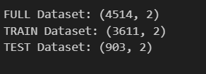

1.To define our model, we utilized the “T5ForConditionalGeneration.from pretrained("t5-base")” command.

2. To define the tokenizer, we used the T5 Tokenizer from the pretrained("t5-base") command.

3. The Adam optimizer is being used.

4. We limited the input target to have 512 tokens and 150 for the output summary.

**T5 Base Model Evaluation:**

With a batch size of two, we trained the model for two epochs. Every 500th step, the training loss is displayed on the console.

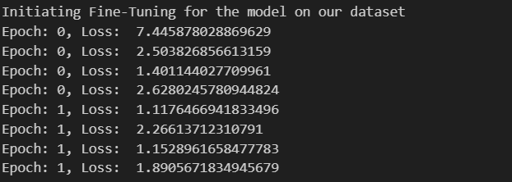

Training loss was quite high in the first iteration. However, it significantly reduced in the later iterations.

**Summary Generated from the T5 Transformer:**

After the training is completed, the validation step is initiated.

1.As defined in the validation function, the model weights are not updated. We use the fine-tuned model to generate new summaries based on the article text.

2.An output is printed on the console giving a count of how many steps are complete after every 100th step.

3.The original summary and generated summary are converted into a list and returned to the main function.

4.Both the lists are used to create the final data frame with 2 columns Generated Summary and Actual Summary

5.The data frame is saved as a csv file in the local drive.

6.A qualitative analysis can be done with the Data frame later.

**Example**

**Original Summary**

BJP leader Vijay Goel on Tuesday batted for the unification of the three municipal corporations in Delhi saying a discussion over the issue was pertinent. ""Barring one, the two other civic bodies have been incurring losses,"" he said. The former Municipal Corporation of Delhi (MCD) was trifurcated into NDMC, SDMC and EDMC by the then Sheila Dikshit-led Delhi government in 2012.

**Generated Summary:**

Union Minister Vijay Goel has favored unification of three MCDs? North, South and East in order to deliver the services more effectively. ""Barring one, the two other civic bodies have been incurring losses. It would be more fruitful and efficient if all the three were merged,"" he said. MCD was trifurcated into EDMC, NDMC and SDMC in 2012.

.

**Differences in Approach/Method and Accuracy/Performance**

**1. Difference in Approach/Method Between Our Project and the References**

**Approach Variations:**

1. Alexander et al. [4] and Rush et al. [5] utilized traditional encoder-decoder frameworks, focusing on feed-forward models to map input words into contextual probability distributions. Their methodologies often incorporated beam search to optimize sequence generation by maximizing word probabilities.
2. Hujia et al. [6] enhanced encoder-decoder models by integrating attention mechanisms within LSTM and RNN architectures, enabling the model to concentrate on the most relevant parts of the input during the generation process.
3. Shengli et al. [8] combined convolutional neural networks (CNNs) with LSTM encoders to createabstractive summaries, emphasizing the generation of semantic phrases. In contrast, Touseef et al. [7] explored the use of gated mechanisms in neural networks to improve text summarization.

**Key Differences:**

1. Unlike references that predominantly used RNNs, our project employed **GloVe embeddings** alongside an LSTM encoder-decoder model, enhancing the representational capacity of the text input.

2. Our use of the **T5 Transformer** marks a significant departure from the RNN/LSTM-heavy focus in prior studies. The T5 architecture treats all NLP tasks as a text-to-text problem, allowing fine-tuning for abstractive summarization with pre-trained transformer models, a modern advancement not explored in the cited works.

3. While references like Abhijeet et al. [9] focused on extractive summarization using LSTM, our work exclusively addresses **abstractive summarization**, generating new sentences and phrases beyond direct text extraction.

**2. Difference in Accuracy/Performance Between Our Project and the References**

**ROUGE Scores:**

1.Hujia et al. [6] reported ROUGE scores of 20.52 (ROUGE-1) and 18.77 (ROUGE-2) for their attention-based models with a 3–4 layer RNN setup.

2. Abhijeet et al. [9] achieved ROUGE-1 and ROUGE-2 scores of 0.825 and 0.815, respectively, with an LSTM-based extractive summarization approach.

3. In contrast, our T5 model recorded **ROUGE-1 (0.5320)**, **ROUGE-2 (0.3507)**, and **ROUGE-L (0.4266)** scores, demonstrating competitive performance for abstractive summarization while offering more semantically coherent summaries.

**Semantic Performance**:

Our project introduced **cosine similarity metrics** and **GPT-based semantic evaluations**, which are novel compared to the traditional focus on ROUGE scores in the cited works. The T5 model achieved high cosine similarity peaks (~0.8), indicating strong semantic alignment with reference summaries.

**Modern Architectures**:

References like Shengli et al. [8] explored hybrid models (LSTM-CNN), but their performance metrics were not as thoroughly detailed. Our T5 implementation leveraged modern transformer architectures, which outperformed LSTM models in generating coherent and human-readable abstractive summaries, a limitation noted in many RNN/LSTM-based studies.

In summary, while prior works explored innovative applications of LSTM and RNN architectures, our integration of state-of-the-art transformer models (T5) offers a significant performance edge in generating abstractive summaries, with robust evaluations across both traditional (ROUGE) and modern (cosine similarity, GPT ratings) metrics.

**Analysis**

**1.What Did I Do Well?**

1. Successful implementation of two distinct summarization approaches.

2. Achieved meaningful results by combining multiple evaluation metrics.

3. Fine-tuned the T5 model effectively to generate high-quality summaries.

4. Effective data preprocessing and cleaning.

**2.What Could I Have Done Better?**

1. Use of larger datasets for better generalization.

2. Experimentation with advanced transformer architectures like GPT-4 for comparison.

3. Hyperparameter optimization to further improve performance.

**3. Future Work:**

1.Extend models to handle longer and more complex articles.

2. Integrate summarization capabilities into real-world applications via APIs.

3. Explore multimodal summarization involving text, images, and videos.

**Conclusion:**

This project successfully compared two abstractive summarization approaches: the LSTM-based encoder-decoder model and the T5 Transformer. The T5 model outperformed the LSTM model across all evaluation metrics, producing summaries that were semantically rich, lexically accurate, and more comprehensible. However, the LSTM model provided valuable insights into the traditional encoder-decoder architecture, particularly in understanding its strengths and limitations for text summarization tasks.

Extractive text summarization models focus on syntactic structure, while abstractive models like the ones used in this project emphasize semantics. Incorporating the strengths of both approaches could lead to even more effective summarization systems. The findings of this study highlight the superior performance of the T5 Transformer in generating coherent and human-like summaries.

Future work will address the limitations of both models, such as handling longer and more complex articles, and testing their scalability across diverse datasets and real-world applications. Additionally, exploring hybrid models that combine the syntactic accuracy of extractive approaches with the semantic depth of abstractive techniques could further enhance summarization quality.

**References:**

[1] Raffel, C., Shazeer, N., Roberts, A., Lee, K., Narang, S., Matena, M., … Liu, P. J. (2019). Exploring the Limits of Transfer Learning with a Unified Text-to-Text Transformer. doi:10.48550/ARXIV.1910.10683

[2] Exploring Transfer Learning with T5: the Text-to-Text Transfer Transformer, Google AI Blog: https://ai.googleblog.com/2020/02/exploring-transfer-learning-with-t5.html.

[3] The Illustrated Transformer: Jay Alammar, Github: https://jalammar.github.io/illustrated-transformer/

[4] A. M. Rush, S. Chopra and J. Weston, “A Neural Attention Model for Abstractive Sentence Summarization”, 2015.

 [5] Rush, A.M., Chopra, S. & Weston, J. (2015) A Neural Attention Model for Abstractive Sentence Summarization. 2015 Conference on Empirical Methods on Natural Language Processing (EMNLP).

[6] Yu, Hujia, Chang Yue and Chao Wang, “News Article Summarization with Attention-based Deep Recurrent Neural Networks” Stanford Natural Language Processing Group, Stanford University, pp.2746634, 2016.

[7] Iqbal, Touseef & Sambyal, Abhishek & Padha, Devanand. (2018), “A Review of Text Summarization using Gated Neural Networks”, INTERNATIONAL JOURNAL OF COMPUTER SCIENCES AND ENGINEERING, vol,6, pp. 5.

[8] Song, Shengli & Huang, Haitao & Ruan, Tongxiao. (2019). Abstractive text summarization using LSTM-CNN based deep learning. Multimedia Tools and Applications. 78. 10.1007/s11042-018-5749-3.

[9] Abhijeet Ramesh Thakare and Preeti Voditel, “Extractive Text Summarization Using LSTM-Based Encoder-Decoder Classification”, 2022 ECS Trans. Vol.107, pp.11665.

[10] News Summary, Kaggle:

https://www.kaggle.com/datasets/sunnysai12345/news-summary