Use Case Document: GoodFoods Reservation Agent

Goal
To create a high-conversion, multi-agent conversational system that allows GoodFoods customers to search, receive personalized recommendations, and manage their restaurant reservations seamlessly through natural language interaction.
Long Term Goal
Establish the GoodFoods Agent as the Interoperable Demand Management System (IDMS) for the chain, enabling automated data exchange with external services (e.g., transportation, loyalty programs) using the A2A protocol to maximize table occupancy and increase average transaction value per customer.
Success Criteria (Measurable Metrics & ROI)
Metric | Target | Potential ROI Impact
Reservation Conversion Rate (RCR) | Increase by 25% | Direct Revenue Increase: Converts passive interest into confirmed sales via superior conversational flow.
No-Show Rate | Decrease by 15% | Cost Savings/Revenue Protection: Minimizes wasted seating inventory via automated confirmations/reminders.
Upsell Attachment Rate | Achieve 10% | Increased Average Transaction Value (ATV): Maximizes profit per customer by suggesting high-margin items pre-arrival.
Agent Efficiency Rate | Maintain 95% | Operational Savings: Reduces staff time spent on phone reservations and management.

📝 Use Case Summary
The GoodFoods Agent uses a Google A2A architecture for robust transaction management. The Client Agent (Orchestrator) identifies intent and delegates complex tasks (Search, Booking, or Modification) to specialized Remote Agents via structured Task Objects. This design ensures high conversational accuracy, rapid execution, and eliminates the "data dump" look by converting structured results (Artifacts) back into conversational, personalized responses. This approach maximizes demand capture and enhances the customer experience.

Key Steps (Customer Flow)
The flow is designed for maximal customer clarity and minimal friction.
- Initiation & Search: Customer asks for a venue with complex criteria (e.g., romantic Italian near downtown).
- Agent Presentation: The Agent returns a conversational list of 2-3 tailored options, using descriptive sentences instead of bullet points.
- Selection & Check: Customer selects an option and provides party size/time.
- Confirmation & Upsell: Agent confirms availability and proactively offers a high-margin upsell (e.g., Chef's Special).
- Booking: Agent collects final details (name, email), executes the transaction via the Booking Agent, and generates a dummy confirmation email artifact.
- Management: Customer can return later to modify or cancel the reservation via natural language commands (e.g., "Change my 7 PM booking to 8 PM.").

Architectural & Protocol Specifications
1. Client Agent State Transition Diagram
The Client Agent manages conversation flow, context retention, and slot filling, ensuring all required data is collected before executing a task. 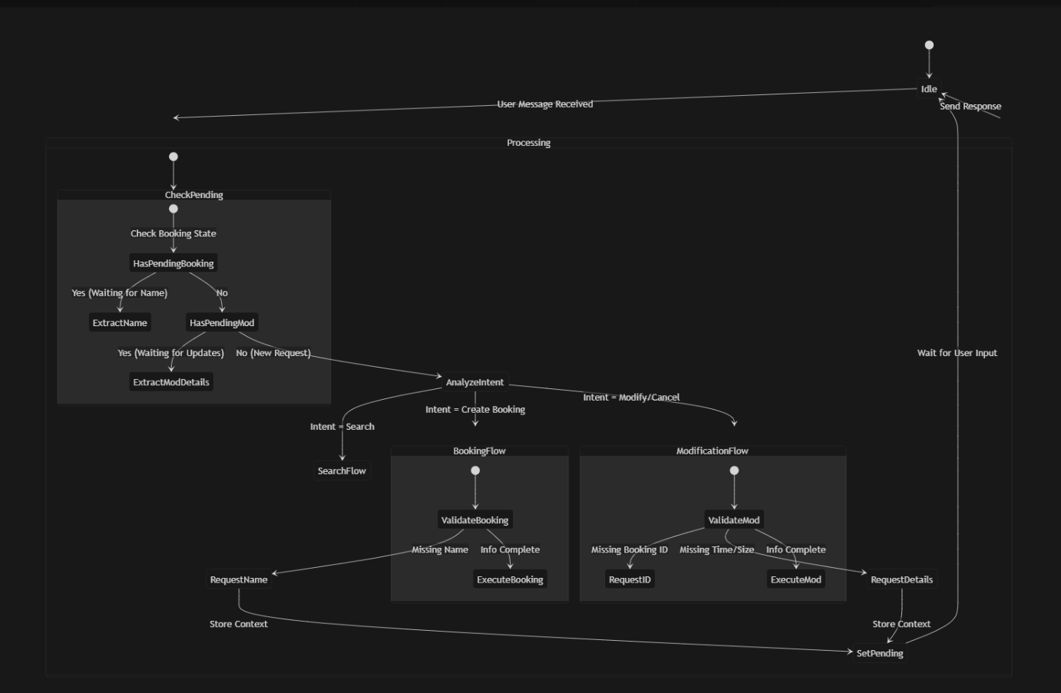
Fig. 1 Client Agent State Transition Diagram

2. System Workflow Diagram (End-to-End A2A)
The full system uses the A2A pattern: the Client Agent delegates Tasks to Specialist Agents (Search, Booking, Modification) and receives Artifacts in return, which are then used to generate the Final Response. 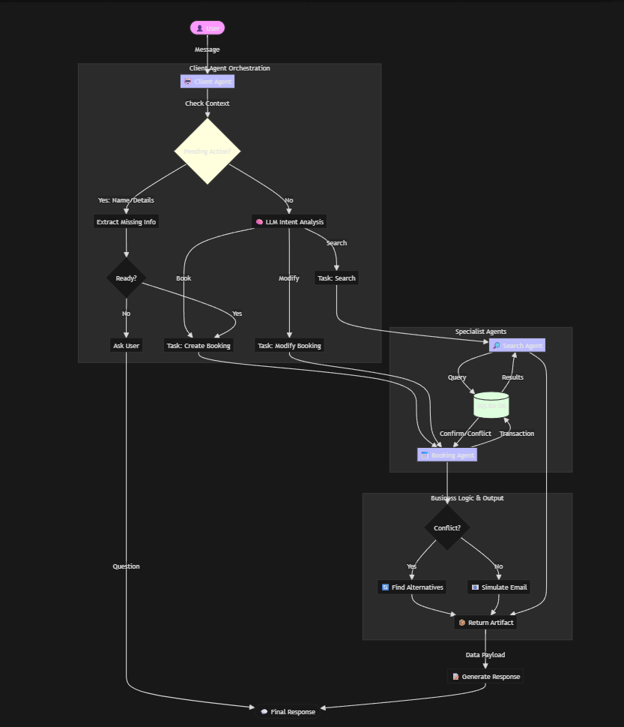
Fig.2 System Workflow Diagram (End-to-End)

3. Communication Flow Breakdown
Step | Action | Data Artifact Exchanged | Agent Responsibility
1. User → Client Agent | Provides input (Plain Text). | Text | Client Agent determines intent.
2. Client Agent → Remote Agent | [Creates Task] Parses text into a structured JSON payload. | Task Object (JSON) | Client Agent acts as Orchestrator and translator.
3. Remote Agent | [Executes Task] Performs DB queries/transactions. | Internal Database/API Calls | Specialist Agents execute business logic (e.g., availability check).
4. Remote Agent → Client Agent | [Returns Artifact] Packages results into structured output. | Artifact Object (JSON) | Specialist Agent returns standardized data ("status": "CONFIRMED").
5. Client Agent → User | [Generates Response] Converts Artifact into conversational text. | Text | Client Agent ensures User Experience and final reply quality.

Bot Features and Specifications
This section covers the Key Specifications, Tools, Languages, New Features, and Integrations based on the architecture.
Feature | Key Specification (What Customer Cares About) | Integrations Needed
A2A Orchestration | Seamless, multi-turn conversation flow without losing context. | Internal A2A Agents (Search, Booking, Modify)
Booking Tool | Instant confirmation and email/log artifact generation. | SQLite DB (Mock Data)
Search Tool | Highly personalized filtering (cuisine, price, ambiance) with conversational results. | SQLite DB
LLM Backend | Intent detection, response generation, and reliable JSON tool/task parsing. | GPT-4o mini (OpenAI)
New Feature Ask | Proactive Upselling during the booking process (e.g., suggesting a high-margin appetizer). | Menu/Pricing Data
Knowledge Bases (KBs) | None explicitly needed; core knowledge is in the Structured DB and the LLM's training data. | N/A

Specialist Agent Specifications
Booking Agent: create_reservation
Role: Transaction Handler.
- Inputs: customer_name, restaurant_name, time, date, party_size.
- Process: DB Insert → Get booking_id → Dummy Email Generation.
- Dummy Email: Print full confirmation details (with booking_id) to the log file.
- Output (Success): Artifact with "status": "CONFIRMED" and confirmation_id.
Modification Agent: update_reservation
Role: Data Mutator.
- Inputs: booking_id, action_type ("UPDATE" or "CANCEL"), optional new_time/new_party_size.
- Process: Retrieve Record → Validate change (capacity check) → DB Update (or Status change) → Dummy Notification.
- Output (Success): Artifact with "status": "MODIFIED" or "status": "CANCELLED".

Strategic Advantages & Vertical Expansion
Unique Competitive Advantages
- A2A Interoperability Engine: Enables future seamless integration with external services (e.g., Uber/Lyft, loyalty platforms) using a robust, standardized protocol.
- Proactive Slot Negotiation: The system actively suggests the next best available slot or alternative location when a primary request fails, maximizing conversion by avoiding simple "Unavailable" responses.
- High-Confidence Recommendation Engine: Filters based on complex, non-quantifiable attributes like ambiance ("romantic," "lively") to deliver highly personalized matches.

Vertical Expansion
The A2A architecture allows adaptation to any industry with scheduling and inventory management needs:
- Medical/Dental: Scheduling, automatic waitlist management, and filling cancellations (using Modification Agent logic).
- Hospitality/Salons: Booking complex services and matching specific staff skills to client preferences.
- Fitness/Classes: Booking specific resources (e.g., particular equipment, classes at specific times).

Future Work & Roadmap
1. Integration with AP2 (Automated Payment)
The current system handles reservations but lacks a payment component. Integrating with the AP2 (Automated Payment) protocol is the next logical step to enable high-value transactions.
- Implementation: Introduce a new Remote Agent: Payment Agent that adheres to the A2A protocol.
- Use Case: Allow the customer to pre-authorize payment for the deposit or the full upsell amount (e.g., wine, fixed menu special) during the initial create_reservation task.
- Benefit: Enables immediate revenue capture for high-margin items and significantly reduces operational friction on arrival, further minimizing no-shows for high-demand bookings.
- Workflow Integration: The Booking Agent would send an internal A2A Task to the Payment Agent after receiving customer confirmation but before sending the final confirmation artifact.
2. Dynamic Pricing & Yield Management Agent
To maximize revenue and seat inventory, a dedicated intelligent agent is required to manage pricing in real-time.
- Implementation: Introduce a Remote Agent: Yield Agent. This agent uses predictive models (based on historical no-show rates and time-of-day demand) to set seating prices.
- Use Case: The Search Agent would query the Yield Agent to retrieve the current dynamic price for a slot. The Orchestrator can then offer incentives (e.g., a "10% off for 5:30 PM booking" message) to fill traditionally slow periods.
- Benefit: Direct impact on profitability by implementing dynamic surge/discount pricing and maximizing revenue per available seat-hour.

Key Challenges
- A2A Implementation Complexity: Building the custom A2A protocol layer (Task/Artifact JSON serialization) from scratch within the tight time constraint without using orchestration frameworks (e.g., LangChain).
- LLM Reliability (Tool/Task Calling with GPT-4o mini): Prompt engineering the smaller GPT-4o mini model to reliably generate correct, complex JSON payloads for the A2A Task objects (e.g., accurately parsing names, dates, and restaurant IDs simultaneously).
- State Management in Multi-Agent System: Ensuring the Client Agent accurately maintains the conversation context and transfers the correct data points when handing off between the non-transactional Search Agent and the transactional Booking Agent

