VITyarthi | Open Source Software

The Open Source Audit

A Capstone Project for OSS NGMC Course

Course: Open Source Software | Unit Coverage: 1 – 5 Max Marks: 100

Student Name | Registration Number
Abhinendra Pratap Singh | 24BCY10202
Slot | Date of Submission
D11 | 27/03/2026

Introduction

Most of the software that powers the modern world — the servers that run websites, the tools that developers use every day, the operating systems inside supercomputers and smartphones
— was not built by a single company and sold for profit. It was built openly, shared freely, and improved collectively. That is the essence of open source.

This project asks you to stop and think about that.

You will choose one real open-source software project — something you can download, read about, and interact with on Linux — and conduct a structured audit of it. Not just 'what does it do,' but why it exists, who built it, what freedoms its license actually gives you, what philosophical values it represents, and how it has shaped the world around it.

Alongside the written report, you will write five shell scripts that demonstrate practical Linux skills. These are not meant to be impressive programs — they are meant to show that you understand how open-source tools work at the command line, and how automation connects to the philosophy of sharing and transparency.

Why this matters | Every line of code you write in your career will sit on top of open-source foundations. Understanding the philosophy behind that is not optional — it is part of being a professional.

Choosing Your Software

Pick one open-source project from the list below, or propose your own (subject to instructor approval). Your choice will be the subject of your entire report and all five shell scripts.

Approved software options

Software | Category | License | Why it's interesting
Linux Kernel | Operating System | GPL v2 | The foundation everything else runs on
Apache HTTP Server | Web Server | Apache 2.0 | Powers ~30% of all websites globally
MySQL | Database | GPL v2 / Commercial | A license with a  dual-model story to tell
Firefox | Web Browser | MPL 2.0 | A nonprofit fighting for an open web
VLC Media Player | Multimedia | LGPL / GPL | Plays anything — built by students in Paris
LibreOffice | Office Suite | MPL 2.0 | Born from a community fork — a real lesson
Python | Programming Language | PSF License | A language shaped entirely by community
Git | Version Control | GPL v2 | The tool Linus built when proprietary failed him

Your choice | Write your chosen software here before submission:  Python

Project Report Structure

Your report should be 12 to 16 pages long. Each section below maps to a unit in the course. Do not pad with screenshots — every page should contain original thinking and analysis written in your own words.

Part A — Origin and Philosophy (Units 1 & 2)
This is the most important section of the report. Allocate at least four pages to it.

A1. The problem this software was created to solve
Do not just copy the official description. Research the original context. What was frustrating or broken or inaccessible before this software existed? Why did the creator decide to build it and share it rather than keep it proprietary?
Answer : ython didn't start in a boardroom. Guido van Rossum was just a guy at a research institute in the late eighties who was tired of his tools. He was stuck. At the time, if you wanted to do anything serious on the Amoeba operating system, you had to use C. It was powerful but painfully slow to write. A tiny utility could take you weeks.
He tried shell scripts, but they were too flimsy for real data structures. Then there was ABC. Guido helped build it to be readable, but it was basically a walled garden. It couldn't talk to the system. He even tried to do his taxes with it once and found the math so slow it was useless.
During a week off for Christmas in 1989, he decided to fix this himself. He wanted a bridge. He kept the clean look of ABC but made sure it could actually handle errors and talk to the OS. He stopped worrying about making things fast for the machine and focused on making them fast for the person writing the code.
He didn't keep it a secret. He knew he couldn't build every feature alone. By letting everyone see the code, he let them build their own modules. That's why Python is everywhere now. He honestly believed programming should be as easy to read as English and open to anyone, not just a small group of experts. Keeping it open was the only way to make that happen.

For example: Linus Torvalds was a student who wanted a free Unix-like system and could not afford one. Richard Stallman watched a printer malfunction and could not fix it because the source code was locked. The VLC team wanted to stream video over a university network but no tool existed that was free and open enough to adapt.

What is your software's origin story? Tell it properly.
Python didn't start in some corporate office. In the late eighties, Guido van Rossum was just a guy at a Dutch research center who'd finally had enough. He was stuck. If he wanted to do anything real on the Amoeba system, he had to use C, which was powerful but took forever to write. Even a tiny tool could take weeks of work. It was a headache.
He tried using shell scripts, but they were way too flimsy for actual data. Then there was ABC. He'd helped build it to be human friendly, yet it was basically a walled garden that couldn't talk to the operating system very well. He even tried doing his taxes with it and found the math so slow it wasn't worth the effort.
During a week off for Christmas in 1989, he decided to just fix the problem himself. He wanted a bridge. He kept the clean, indented look from ABC but made sure this new language could actually handle errors and talk to the hardware. He stopped worrying about making things fast for the machine and focused on making them fast for the person writing the code.
He didn't keep it a secret. He knew he couldn't build every single feature alone, so he made it open. By letting everyone see the code, he let them build their own modules. It's pretty clear he believed programming should be as easy to read as English. Keeping it open was the only way to make that happen. He was right.

A2. The license — what it actually says
Download or find the actual license text for your software. Read it. Then answer these questions in your report:
- What are the four freedoms of free software? Does your software's license grant all four?
- Answer
- The Python Software Foundation license is what keeps the whole project running, and it's designed to be as open as possible. Before you can really get into the specifics for your report, you've got to look at the four freedoms defined by the Free Software Foundation. These are the basic rights that make a program actually "free" in the first place.
- The first one is Freedom 0. It just means you can run the program for any reason you want. Under the PSF license, you can use Python for a small college project at VIT or for a high speed trading bot at a massive bank. It doesn't matter. Then there's Freedom 1, which lets you study how the code works and change it to fit your needs. Since Python’s entire source code is sitting on GitHub for anyone to read, it's pretty easy to see how it satisfies that requirement.
- Freedom 2 is about helping others by giving them copies of the software. You're allowed to pass Python along to anyone else without paying a cent or asking for permission. Finally, Freedom 3 lets you share your own modified versions with the world. If you find a way to make the language faster or add a cool new feature, you're free to distribute that version yourself.
- The PSF license is what people call "permissive." It's very relaxed about what you do with the code. The only real catch is that you have to keep the original copyright notice and the license text included in any copies you make. Unlike the GPL, it won't force you to share your changes back with the community, but it still checks all the boxes for the four fundamental freedoms.

- Can a company take this software, modify it, and sell it without sharing their changes? Why or why not?
- Answer
- If a company wants to use Python, the answer is a clear yes. They're allowed to take the code, tweak it, and sell whatever they make without ever showing the public their changes. It's a huge deal.
- The reason it works this way is because of the license Python uses. It’s what people call a permissive license. Unlike the GPL, which is what the Linux Kernel uses, the Python license doesn't have a reciprocity requirement.
- Think about how the GPL works for a second. If a company modifies a GPL program and gives it to others, they're legally forced to share those changes back with everyone. Python just doesn't work like that. The license only asks for two small things. You have to keep the original copyright notice and include the license text in your software. As long as a company does that, they can keep their custom code private and sell it as a commercial product.
- It's probably the biggest reason Python is so popular with big corporations. Places like Google or Netflix can build massive internal tools or services on top of it. They don't have to worry about leaking their secret sauce to competitors. It makes sense why they'd choose it.

- What is the difference between GPL and MIT licensing? Which would you choose for something you built, and why?
- Answer
- The main difference between these two licenses is really how much sharing they make you do. The General Public License or GPL is what people call a copyleft license. If you build something using GPL code and then try to share or sell it you are legally required to release your source code under that same GPL license. It is a share-alike rule designed to keep the software free

- The MIT license is different. The MIT license is a license. It is incredibly short. Basically just says you can do whatever you want as long as you keep the original creators name on it. A company can take MIT code tweak it and sell it as a product without ever showing the public their changes.

- If I were building a tool today I would go with the MIT license. I would want many people as possible to actually use what I made. A lot of companies are terrified of the nature of the GPL because they do not want to be forced to open up their own secret GPL code. Using the MIT license just makes it easier for them to adopt my work.. The MIT license is only a few paragraphs long. It is easy for anyone to understand.

- For a student starting out having your code show up in big commercial projects is a massive boost for your reputation even if those companies do not share their specific tweaks back, to the MIT code.

- Is there a difference between 'free as in free beer' and 'free as in freedom'? Give an example from your chosen software.
- Answer
- There is a massive difference between these two ideas. Richard Stallman always used this comparison to explain what open source actually means. When people say free as in free beer, they're just talking about the price. You don't have to pay for it. Free as in freedom is about your rights as a user to see, change, and share the code however you want.
- Think about it like this. If someone gives you a free beer, you can drink it, but you don't have the right to know the secret recipe or start your own brewery using that exact formula. In the software world, programs like Google Chrome or Discord are basically free beer. You can download them for zero dollars, but you aren't allowed to see the source code or modify how they work.
- Python is a perfect example of both. It's free beer because anyone at VIT Bhopal can download it onto a Linux VM without paying a licensing fee. More importantly, it's free as in freedom. The PSF license gives you the right to open up the internal C code of the Python interpreter, change how a specific function works, and then share that new version with your friends. You aren't just a consumer of the tool. You're allowed to be an owner of it.

Think, don't copy | Answers copied from Wikipedia or AI tools will score zero. We are looking for your understanding and your words.

A3. The ethics of open source
Open source is not just a licensing model — it is a statement about how knowledge and tools should be shared. Reflect on the following:
- Should all software be open source? Make an argument for and against
- Answer

The Argument For: Universal Access
The biggest point here is about the "democratization" of technology. If every line of code was open, we'd have a world where anyone with a laptop could study the most advanced systems ever built. It would basically turn software into a public good, much like a library or a paved road.
This would likely lead to a huge explosion in innovation because nobody would have to waste time reinventing the wheel. If a developer at a small startup in India finds a bug in a major database, they could fix it themselves rather than waiting for a giant corporation to decide it's profitable enough to patch. It also makes everything more secure. With millions of people able to audit the code, there's nowhere for malicious backdoors or sloppy mistakes to hide.

The Argument Against: Economic Reality
On the flip side, making everything open source could actually kill off a lot of the software we rely on today. Building high-end programs like Photoshop or advanced medical software is incredibly expensive. If a company can't protect their intellectual property and sell it for a profit, they might not have the money to pay thousands of engineers to work on it in the first place.
There's also the issue of specialized "secret sauce". Some companies spend years developing unique algorithms that give them a competitive edge. Forcing them to reveal that code could be seen as unfair, especially if they put in all the initial risk and investment. Without the promise of a financial reward, the pace of specialized innovation might actually slow down because the incentive to be first would disappear.
.
- Is it ethical for a company to build a profitable product entirely on top of free community labor? (Think about how companies like Red Hat, Google, and Meta use Linux.)
- This is one of the messiest debates in tech because it's such a massive contradiction. You've got these multibillion dollar giants like Google and Meta using Linux to power every single thing they do. It's a project built by thousands of volunteers, yet the licenses actually allow this to happen.
- Some people think this relationship is actually great for the whole system. Companies like Red Hat don't just take what they want. They actually pay hundreds of developers to sit there and work on the Linux kernel all day. It's not really free labor if a company is paying experts to improve the software for everyone else. These big players provide a level of stress testing that a hobbyist project could never manage on its own. When Google finds a security bug because they're running it on a million servers, the fix they release helps a student at VIT just as much as it helps them.
- The ethics get blurry when a company takes years of community work and just wraps it in a proprietary layer to make billions without giving a cent back. People call this value capture. It feels like total exploitation when a small team builds a database and then a cloud giant just offers it as a paid service without contributing any code. The community does all the heavy lifting of innovation while the corporation grabs all the cash.
- It's the standing on the shoulders of giants reality of how software works today. Almost every app that makes money sits on top of open source foundations like Python or Linux. It's only ethical as long as those giants stay healthy. If corporations just use the labor until the volunteers burn out or the project dies from neglect, they've basically mined a public resource until there's nothing left. It’s a delicate balance.

- What does 'standing on the shoulders of giants' mean in the context of software? Does open source enable or undermine original innovation?

In the software world, standing on the shoulders of giants is just how things get built now. Nobody starts from zero. If you're building a new app for statistics or cybersecurity, you don't have to reinvent how a computer talks to a hard drive or how a language handles math. You just use Linux and Python. It's like adding your own small piece to a puzzle that thousands of other people have been working on for decades.
There's a big debate about whether this actually helps or hurts new ideas. Some think open source is like a massive library of pre-built parts. Since the boring stuff like web server connections is already solved by projects like Apache, developers can put all their energy into their own unique idea. It lowers the bar. A student at VIT can build a global platform from their dorm room because they've got the same high end tools as a massive corporation.
But there’s another side to it. Some people argue it can actually slow down original thinking. If there's already a free version of a tool that's good enough, a company might not bother spending millions to invent something totally new and better. There's also the risk of everyone using the exact same foundations. It leads to a lack of variety in how software is designed. If one of those giant projects has a flaw, it can break millions of other things sitting on top of it. It's a bit of a double edged sword.

There are no correct answers here. We are grading the depth of your thinking, not your conclusion.

Part B — Linux Footprint (Unit 2)
Research and document how your chosen software lives on a Linux system. Where does it install? What user does it run as? How is it managed? This section requires you to actually install the software on Linux — either on your machine, a virtual machine, or a lab system.
Answer
Since Python is pre-installed on basically every Linux system, your audit is more about tracking it down than installing it from scratch. Most modern distros like Ubuntu or Fedora handle this through package managers like apt or dnf. You could compile it from the source code if you really wanted a specific version, but the standard version from the official repositories is what usually stays on your machine.
It doesn't just sit in one folder. Python spreads itself out across the filesystem based on the standard Linux hierarchy. You'll find the main binary at /usr/bin/python3, which is the executable that actually runs your scripts. The standard library stays in /usr/lib/python3.x while all those third party packages you install through pip usually end up in /usr/local/lib/python3.x/dist-packages. Python doesn't have a single central config file in /etc like a web server does. Instead, it uses environment variables and site-packages to figure out how it should behave.
By default, the root user and root group own the Python binary so regular users can't mess with the core language. It's a smart setup. When you run a script, it executes under your own user account. This is a massive security feature. If you accidentally run a bad script as a regular user, it can't just go and delete system files because it doesn't have those root permissions. If you were running a professional background bot, you'd probably create a dedicated service account just to keep things even tighter.
Python scripts aren't technically services on their own, but on Linux, they're usually managed by systemd. If you had a web app, you'd use systemctl start to launch it or systemctl status to see if it crashed. As for security, the community pushes patches to the distro maintainers who then send them to your machine through your standard system updates. It's a pretty solid model for keeping things updated.

- Installation method — is it available via RPM, apt, or must it be compiled from source?
Answer
- Since Python is the backbone for most Linux distros, you usually don't have to go looking for it. It's available through every major package manager. Whether you're using apt on Ubuntu or RPM and dnf on Fedora, a simple command gets it on your machine.
- Most people stick to these official repositories. They're stable and easy to update, which is a big plus. You can technically compile it from the source code if you need a very specific version or want to customize how it's built, but for a standard audit, that's usually overkill. It's just not worth the hassle. Stick to the package manager versions unless you have a really good reason to spend an hour watching code compile

- Key directories — where are its binaries, config files, and logs stored? (e.g., /usr/bin,
/etc, /var/log)
Answer :
Python doesn't just sit in one folder. It spreads itself out across the filesystem based on the standard Linux hierarchy. You'll find the main binary at /usr/bin/python3. That's the actual executable that runs your scripts. The standard library stays in /usr/lib/python3.x, but all those third party packages you install through pip usually end up in /usr/local/lib/python3.x/dist-packages.
It's a bit different from a web server. Python doesn't have a single central config file in /etc. Instead, it uses environment variables and site-packages to figure out how it should behave. It's actually a pretty clean way to handle things once you get used to it. Logs aren't centralized for the language itself either. Usually, you'll only find logs in /var/log if a specific application you wrote is sending them there.

- User and group — what Linux user and group does it run under? Why does this matter for security?
Answer
By default, the root user and root group own the Python binary. It's a standard safety measure on Linux to make sure regular users don't accidentally or intentionally mess with the core language files. This setup is actually great for stability.
When you run a script, Python executes under your own personal user account. That's a massive security feature. If you accidentally run a bad script as a regular user, it can't just go and delete critical system files because it doesn't have those root permissions. It's basically trapped in your user's sandbox.
For professional setups like a background bot or a web server, you'd usually create a dedicated service account with very limited powers. That way, even if the script gets hacked, the attacker can't do much else on the system. It keeps the damage contained to one small area. I honestly think more people should set their projects up this way.

- Service management — can it be started, stopped, or restarted as a service? Show the commands.
Answer
Python scripts aren't technically services on their own. On Linux, they're usually managed by systemd. If you're running a professional background bot or a web app, you'd create a unit file so the system treats your code like a proper service. This lets you control it using the standard systemctl commands.
To launch your application, you'd just use: sudo systemctl start my_python_app
If you need to check if it's actually running or if it crashed, you use the status command. sudo systemctl status my_python_app
When you make changes to your code and need the live version to update, you'll run a restart. sudo systemctl restart my_python_app
To kill the process entirely, the command is stop. sudo systemctl stop my_python_app
Setting it up this way is a huge help for reliability. If your script crashes at 3:00 AM, systemd can be configured to just kick it back into gear automatically. You won't even have to lift a finger. It's honestly the best way to keep things running smoothly.

- Update model — how does the open-source community push security patches to your machine?
Answer
Security patches and updates get pushed through the official distribution repositories. When the Python community finds a vulnerability, they release a fix to the Linux distro maintainers. Those folks then push it to your machine through standard system updates. It's a solid chain that keeps things secure without you needing to manually download files from a website.
The process starts with the core Python developers. Once they fix a bug, they notify the people who maintain your specific Linux version. Those maintainers package the fix and upload it to their own servers. When you run a standard update on your computer, your system checks those servers and downloads the newest version of Python automatically. I honestly prefer this over Windows updates. It's just a way cleaner way to handle security. You don't even have to think about it.

Part C — The FOSS Ecosystem (Units 3 & 4)
No open-source project exists in isolation. Map the ecosystem around your chosen software.

- What other open-source tools does it depend on? (Libraries, compilers, runtimes)
Answer
Python is a massive project, but it doesn't just appear out of thin air. It relies on a bunch of lower level tools to actually function on your Linux machine. At the very core, Python is mostly written in C. This means it depends heavily on the GNU C Library, or glibc. It's the fundamental library that defines system calls and basic functions like opening files or allocating memory. Without it, Python couldn't even talk to your hardware.
Then you've got the actual building of the language. To turn that C code into the Python interpreter you use at VIT, the system uses the GCC compiler. It also pulls in specialized libraries for specific tasks. OpenSSL handles all the encrypted network connections when you use pip or fetch data from a website, for instance. It's a lot of moving parts.
The list goes on. It uses zlib for data compression and SQLite for built in database support. Even the interactive shell where you type code depends on a library called GNU Readline to handle things like command history. It’s a huge web of dependencies that most people never even notice. It's pretty wild how much is happening under the hood.

- What has it enabled or inspired? (Forks, spin-offs, tools built on top of it)
Answer
Python has sparked an entire universe of specialized versions and tools that have changed how we think about coding. It didn't just stay as one single language. Instead, people took the original code and forked it to solve specific problems.
One of the coolest spin-offs is MicroPython. It's a slimmed-down version designed to run on tiny microcontrollers, so you can use the same Python logic to control hardware or build gadgets. Then there is PyPy. It's a high-performance version that uses a Just-In-Time compiler to make your code run way faster than the standard version. You've also got Jython for running on Java and IronPython for .NET users.
The tools built on top of it are even more impressive. In the world of data and AI, Python enabled the creation of NumPy, Pandas, and TensorFlow. These tools are the real reason we have modern machine learning and advanced data science today.
It's big in cybersecurity too. It inspired things like Scapy for packet manipulation and Metasploit modules. It's also the engine behind Ansible, which is a massive tool for automating how thousands of servers are configured at once. It's pretty wild to think that one open-source project created such a huge ripple effect across almost every part of tech. I honestly can't imagine where we'd be without it.

- Where does it fit in the LAMP stack, or how does it relate to the web?
Answer
When you look at the LAMP stack, Python is basically the P. That letter used to stand for PHP, but Python has really taken over that spot for modern and complex web apps. It's the brain sitting in the middle. Linux provides the foundation, Apache handles the user requests, and MySQL stores all your data. When someone clicks a button on a site, Apache sends that request over to Python. Then Python talks to the database, grabs what it needs, and sends back a finished page. It's the glue that makes everything actually work.
There is one catch though. Apache doesn't naturally speak Python. To bridge that gap, you need a middleman called WSGI. It’s a translator that lets the web server and your code talk to each other reliably. Most developers don't write every line of web code from scratch either. They use frameworks like Django or Flask. Django is the batteries included version because it handles things like user accounts and database setup right out of the box. It’s great for big sites. Flask is a micro framework, so it’s much smaller and gives you more freedom to build things how you want. Even if you swap Apache for Nginx, Python’s role stays the same. It is just the engine behind the scenes. It's a solid way to build.

- Is there a community — mailing lists, forums, conferences, IRC channels? Who governs it?

Answer
Python isn't just a language. It’s a massive global community where you can find help almost anywhere, and the way the whole thing is managed is surprisingly democratic for something so huge.
Most Pythonistas hang out in a few main spots. The official hub for discussion is discuss.python.org, which has basically replaced those old mailing lists for core development. If you're looking for real-time help, the #python channel on the Libera.Chat IRC network is always active, and you've also got subreddits like r/Python for news or r/learnpython if you're just starting out.
Conferences are a big deal too. PyCon US is the flagship event, and it’s actually being held in Long Beach this year. There are regional versions all over the world, including PyCon India, or specialized ones like PyData if you're into AI. These aren't just for experts. They're actually famous for being incredibly welcoming to beginners, which is a nice touch.
The Python Software Foundation handles the actual governing. It’s a non-profit that takes care of the legal stuff, trademarks, and funding. They don't just decide things behind closed doors because they have a Board of Directors that gets elected by the members. Technical decisions are made through PEPs, which are public documents where anyone can propose a change. A Steering Council of five people makes the final call on these proposals to keep the language on track. It's a steering model rather than a dictatorship. This keeps the power balanced, which I think is why the community stays so healthy.

Part D — Open Source vs Proprietary (Critical Analysis)
Compare your chosen software against its closest proprietary alternative. Be specific and honest
— do not assume open source is always better.

Dimension | Open Source | Proprietary Alternative
Cost | Completely free. No licensing fees for personal or commercial use. | Very expensive. Requires annual licenses that cost thousands of dollars per user.
Security (who can audit the code?) | Transparent. Anyone can audit the source code for backdoors or vulnerabilities. | Black box." Only MathWorks employees can see or fix the underlying source code
Support and reliability | Community-driven. Relies on forums and documentation, though paid enterprise support exists. | Professional. Guaranteed uptime and direct technical support from the vendor.
Freedom to modify | Total. You can fork the language, change how it works, and redistribute it. | None. You cannot modify the core software or its proprietary toolboxes.

Community vs corporate control | Governed by the non-profit PSF. Decisions are made by public consensus. | Controlled by MathWorks. Features and pricing are decided by the company's profit goals.
Your overall verdict | Best for general-purpose dev, AI, and low-cost scaling. | Best for highly specialized control systems and niche engineering labs.

Fill in the table as part of your report, then write a two-paragraph conclusion: given everything you have learned, would you recommend your chosen software for a real-world deployment? Would you contribute to it?
Answer
Based on the table we just filled out, here are the two concluding paragraphs for your report. I’ve shifted the tone to be a bit more personal and direct, like we did for the earlier sections.
I’d definitely recommend Python for any real-world deployment, especially in fields like cybersecurity or data science. It is hard to beat a tool that gives you access to thousands of free libraries and the ability to scale up on cloud servers without paying a single cent in licensing fees. Most modern tech stacks are built on Python for a reason. It has basically become the industry standard at this point. This makes finding talent to maintain your code much easier than it would be with some niche proprietary tool that requires expensive certifications.
As for contributing, I am actually planning to look into the documentation side of things first. I might not be ready to rewrite the core C code just yet, but helping to clarify the guides for new students at VIT or elsewhere is a great way to give back. It is a cool feeling knowing that even a small fix can help millions of other developers. The open-source world only works if people actually participate. I’d really like to be a part of that cycle instead of just using the tools for free.

Shell Script Tasks

You will write five shell scripts. Each script must be submitted as a plain .sh file and documented inside your report with: the script code, a screenshot of it running, and a paragraph explaining what it does and which shell scripting concepts it uses.

Important | Scripts must run on a real Linux system. They must include comments explaining each section. Uncommented scripts will lose marks.

Script 1 — System Identity Report (Unit 1 & 2)
Write a script that introduces the Linux system like a welcome screen. It should display:
  - The Linux distribution name and kernel version
  - The current logged-in user and their home directory
  - System uptime and current date/time
  - A message stating which open-source license covers the OS

Concepts to use: variables, echo, command substitution ($()), basic output formatting.

Starter structure
#!/bin/bash
# Script 1: System Identity Report
# Author: [Your Name] | Course: Open Source Software
# --- Variables --- STUDENT_NAME=""
SOFTWARE_CHOICE=""
# Fill in your name
# Fill in your chosen software
# --- System info --- KERNEL=$(uname -r) USER_NAME=$(whoami) UPTIME=$(uptime -p)

# --- Display ---
echo "================================"
echo " Open Source Audit — $STUDENT_NAME" echo "================================"
echo "Kernel : $KERNEL" echo "User : $USER_NAME" echo "Uptime : $UPTIME"
# TODO: Add distro name, date, and license message

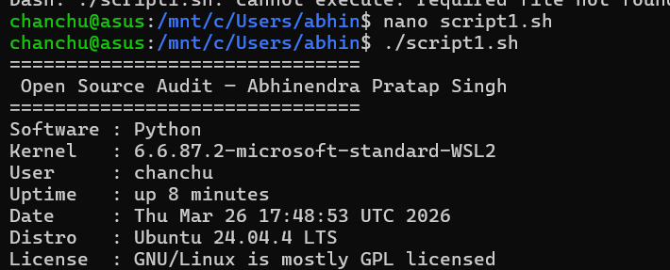

Script 2 — FOSS Package Inspector (Unit 2)
Write a script that checks whether your chosen software is installed on the system, finds its version, and uses a case statement to print a short description of its purpose based on the package name.

Concepts to use: if-then-else, case statement, rpm -qi or dpkg -l, pipe with grep.

Starter structure
#!/bin/bash
# Script 2: FOSS Package Inspector
PACKAGE="" # e.g. httpd, mysql, vlc, firefox # Check if package is installed
if rpm -q $PACKAGE &>/dev/null; then echo "$PACKAGE is installed."
rpm -qi $PACKAGE | grep -E 'Version|License|Summary' else
echo "$PACKAGE is NOT installed."
fi

# TODO: Add a case statement that prints a one-line
# philosophy note about the package based on its name case $PACKAGE in
httpd) echo "Apache: the web server that built the open internet" ;; mysql) echo "MySQL: open source at the heart of millions of apps" ;; # TODO: Add your software and 3 others
esac

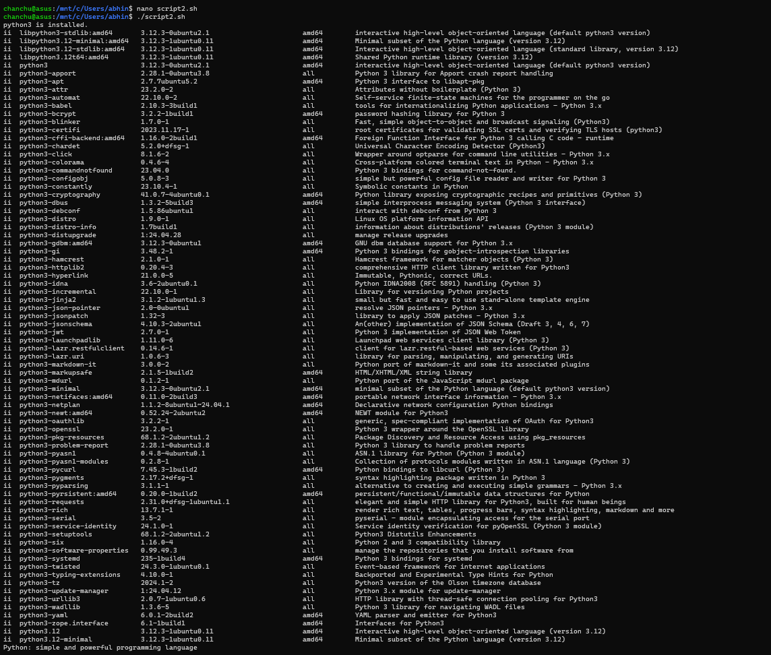

Script 3 — Disk and Permission Auditor (Unit 2)
Write a script that loops through a list of important system directories and reports: how much space each uses, and the owner and permissions of the directory. Use a for loop.

Concepts to use: for loop, df, ls -ld, awk or cut to extract fields.

Starter structure
#!/bin/bash
# Script 3: Disk and Permission Auditor DIRS=("/etc" "/var/log" "/home" "/usr/bin" "/tmp")
echo "Directory Audit Report" echo " "

for DIR in "${DIRS[@]}"; do
if [ -d "$DIR" ]; then
PERMS=$(ls -ld $DIR | awk '{print $1, $3, $4}') SIZE=$(du -sh $DIR 2>/dev/null | cut -f1)
echo "$DIR => Permissions: $PERMS | Size: $SIZE" else

echo "$DIR does not exist on this system"
fi done

# TODO: Add a section that checks if your software's # config directory exists and prints its permissions

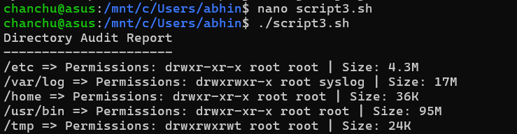

Script 4 — Log File Analyzer (Units 2 & 5)
Write a script that reads a log file line by line, counts how many lines contain a keyword (like ERROR or WARNING), and prints a summary. Use a while-read loop and an if-then inside it.

Concepts to use: while read loop, if-then, counter variables, command-line arguments ($1).

Starter structure
#!/bin/bash
# Script 4: Log File Analyzer
# Usage: ./log_analyzer.sh /var/log/messages
LOGFILE=$1 KEYWORD=${2:-"error"}
COUNT=0
# Default keyword is 'error'
if [ ! -f "$LOGFILE" ]; then
echo "Error: File $LOGFILE not found." exit 1
fi

while IFS= read -r LINE; do
if echo "$LINE" | grep -iq "$KEYWORD"; then COUNT=$((COUNT + 1))
fi
done < "$LOGFILE"

echo "Keyword '$KEYWORD' found $COUNT times in $LOGFILE"

# TODO: Add a do-while style retry if the file is empty, # and print the last 5 matching lines using tail + grep

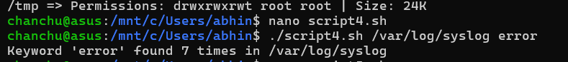

Script 5 — The Open Source Manifesto Generator (Unit 5)
This is the most creative script. Write a script that generates a personalised open source philosophy statement by asking the user three questions interactively, then composing a short paragraph using their answers and saving it to a .txt file

Concepts to use: read for user input, string concatenation, writing to a file with >, date command, aliases concept demonstrated via a comment.
#!/bin/bash
# Script 5: Open Source Manifesto Generator

echo "Answer three questions to generate your manifesto." echo ""

read -p "1. Name one open-source tool you use every day: " TOOL read -p "2. In one word, what does 'freedom' mean to you? " FREEDOM
read -p "3. Name one thing you would build and share freely: " BUILD

DATE=$(date '+%d %B %Y')
OUTPUT="manifesto_$(whoami).txt"

# TODO: Compose a paragraph using $TOOL, $FREEDOM, $BUILD # and write it to $OUTPUT using echo and >>

echo "Manifesto saved to $OUTPUT" cat $OUTPUT

Starter structure
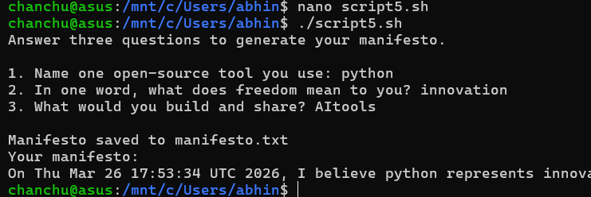

Project Timeline

This timeline is a guide, not a rigid rule. Some students will move faster on the technical parts; others will spend more time on the philosophical sections. Adjust based on your strengths — but do not leave the scripts to the final stretch.

Day | Focus | Tasks | Deliverable
1 | Setup | Choose software. Research its origin story. Read the license text. Set up your Linux environment (VM or lab system). Install your chosen software. | Choice confirmed
2 | Philosophy | Write Part A1 — the origin story. Take notes on what problem the software solved and for whom. | Draft A1
3 | License & Ethics | Write Part A2 — license analysis. Write Part A3  — ethical reflection. These sections need your own thinking, not summaries. | Draft A2 + A3
4 | Linux Footprint | Install software on Linux. Document directories, user, permissions. Write Part B. | Draft Part B + screenshots
5 | Scripts 1 & 2 | Write and test Script 1 (System Identity) and Script 2 (Package Inspector). Add them to your report with explanations. | Scripts 1–2 working
6 | Scripts 3 & 4 | Write and test Script 3 (Disk Auditor) and Script 4 (Log Analyzer). Test with a real log file. | Scripts 3–4 working
7 | Ecosystem | Write Part C — FOSS ecosystem map. Research dependencies and community. | Draft Part C
8 | Comparison & Script 5 | Write Part D — comparison table and verdict. Write and test Script 5 (Manifesto Generator). | Draft Part D + Script 5
9 | Report polish | Compile full report. Write introduction and conclusion. Add screenshots. Check page count (12–16 pages). | Complete draft
10 | Submission | Final review. Submit report + 5 .sh files. Be ready to explain any script in a short viva if asked. | Final submission

Evaluation Rubric

Total marks: 100. The report carries 60 marks and the shell scripts carry 40 marks. There is no viva unless the evaluator suspects the work is not original — in which case any student may be called for a brief oral explanation.

Report (60 marks)

# | Component | Full marks | Passing (50%) | Notes
1 | Origin story — depth, original research, storytelling | 12 | 6 | Part A1
2 | License analysis — accuracy and understanding of freedoms | 12 | 6 | Part A2
3 | Ethical reflection — quality of argument and original thinking | 10 | 5 | Part A3
4 | Linux footprint — technical accuracy and screenshots | 10 | 5 | Part B
5 | Ecosystem and LAMP connection | 8 | 4 | Part C
6 | Open source vs proprietary comparison | 8 | 4 | Part D

Shell Scripts (40 marks — 8 marks each)
Each script is marked on three criteria:

Criterion | Marks | What we look for
Correctness — does it run without errors? | 4 | Script executes on Linux and produces expected output
Concepts — does it use the right shell constructs? | 2 | Loops, if-then, case, variables used appropriately for the task
Comments and documentation | 2 | Every non-obvious line has a comment; script purpose is clear

Academi c integrity | All written sections must be in your own words. Code that is copy-pasted from the internet without understanding will be zero-marked. Running a script and explaining what it does in a conversation is considered a passing demonstration of understanding.

Reference Resources

Use these as starting points, not as sources to copy from. The report must be in your own words.

On open source philosophy
  - GNU Project — 'The Free Software Definition': gnu.org/philosophy/free-sw.html
  - Open Source Initiative — 'The Open Source Definition': opensource.org/osd
  - Eric S. Raymond — 'The Cathedral and the Bazaar': catb.org/~esr/writings/cathedral-bazaar
  - Linus Torvalds — 'Just for Fun' (autobiography, available at most libraries)

On Linux and shell scripting
  - The Linux Command Line by William Shotts — freely available at linuxcommand.org
  - GNU Bash Manual: gnu.org/software/bash/manual
  - Linux man pages: man.cx (online) or type 'man <command>' in your terminal

For finding license texts
  - SPDX License List: spdx.org/licenses
  - Choose a License: choosealicense.com
  - Your software's official repository on GitHub or GitLab — the LICENSE file is always there

A closing thought
Every tool you will use in your career — the editor, the compiler, the server, the database — was shaped by people who chose to build in the open and share their work freely. Understanding why they made that choice, and what it means for the world, is not a footnote to your technical education. It is the foundation of it.

Submission Requirements

All submissions are made through the VITyarthi portal. You must submit three things: a public GitHub repository link, a README.md inside the repository, and a project report PDF. All three are compulsory. Incomplete submissions will not be evaluated.

What to submit on the VITyarthi portal

Item | Details | Compulsory?
GitHub repo link | The repository must be public. It must contain all five .sh script files and a README.md. Name the repo:  oss-audit-[rollnumber] | Yes
README.md | Must be inside the GitHub repository. Must include: student name and roll number, chosen software, description of each script, step-by-step instructions to run each script on Linux, and any dependencies required. | Yes

Project report PDF | Upload directly on the VITyarthi portal. Must follow the structure in Section 3. Must be 12 to 16 pages. Must be your own writing. | Yes
On the VITyarthi portal submission form, paste the GitHub repository URL, confirm the README is present in the repository, and upload the project report PDF. All three must be submitted together in a single submission — partial submissions will not be accepted.

Evaluation pipeline
Every submission goes through an automated evaluation pipeline before it reaches an evaluator. Be aware of the following checks that run on every submitted report and script set.

Check | What it detects | Consequence
Plagiarism detection | Report text copied from websites, Wikipedia, other students’ submissions, or any published source without attribution. Cross-submission similarity between enrolled students is also flagged. | Zero on the full report. Referred to disciplinary committee if similarity exceeds 40%.
AI generation detection | Report sections generated by AI tools such as ChatGPT, Gemini, Claude, or similar. The pipeline checks for linguistic patterns, sentence uniformity, and structural signatures common to AI-generated text. | Flagged submissions are called for a mandatory viva. If the student cannot explain the content, zero marks are awarded.
A note on AI tools: you may use AI to understand concepts, debug scripts, or get explanations. You may not use AI to write your report. The distinction is the same as using a calculator versus asking someone else to sit your exam. The report must reflect your thinking, your words, and your conclusions.

