**TABLE OF CONTENTS**

|  |  |  |
| --- | --- | --- |
| **SI. No.** | **CHAPTERS** | **PAGE No.** |
| **1.** | **Introduction**   * 1. Architecture of DBMS   2. Overview of the mini project      1. Problem statement      2. Overview      3. Objective of Proposed System | 3  4  5  5  5 |
| **2.** | **System Design and methodology**  2.1 System Architecture  2.2 ER Diagram  2.3 Schema Diagram | **6**  6  7  7 |
| **3.** | **Module Implementation** | **8** |
| **4.**  **5.** | **Code Snippets**  **Results and Screenshots**  **Conclusion** | **9**  **13**  **16** |

**LIST OF FIGURES AND TABLES**

|  |  |  |  |
| --- | --- | --- | --- |
| **SI. No.** | **Title of Figure** | | **Page No.** |
| 1 | Three Schema Architecture | | 4 |
| 2 | System Architecture of Bank Management System. | | 6 |
| 3  4 | ER Diagram  Schema Diagram | | 7  7 |
| 5 | Open Account Page | | 13 |
| 6 | Deposit amount Page | | 13 |
| 7 | Withdraw Money and Balance enquiry Page | | 14 |
| 8 | Manager Login Page | | 14 |
| 9 | Closing Account Page | | 15 |
| 10 | Checking account Number and Name Page | | 15 |
|  |  |
|  |  |
|  |  |
|  |  |
|  |  |
|  |  |

**CHAPTER 1**

**INTRODUCTION**

* 1. **Introduction to DBMS**

Database is a collection of related data. DBMS came into existence in 1960 by Charles. Again in 1960 IBM brought IMS-Information management system. In 1970 EdgorCodd at IBM came with new database called RDBMS. In 1980 then came SQL Architecture- Structure Query Language. In 1980 to 1990 there were advances in DBMS e.g. DB2, ORACLE. A database has the following implicit properties:

* A database represents some aspect of the real world, sometimes called the miniworld or the universe of discourse (UoD). Changes to the miniworld are reflected in the database.
* A database is a logically coherent collection of data with some inherent meaning. A random assortment of data cannot correctly be referred to as a database.
* A database is designed, built, and populated with data for a specific purpose. It has an intended group of users and some preconceived applications in which these users are interested.

In other words, a database has some source from which data is derived, some degree of interaction with events in the real world, and an audience that is actively interested in its contents.

Metadata (meta data, or sometimes meta information) is "data about data", of any sort in any media. An item of metadata may describe a collection of data including multiple content items and hierarchical levels, for example a database schema. In data processing, metadata is definitional data that provides information about or documentation of other data managed within an application or environment. The term should be used with caution as all data is about something and is therefore metadata.

A database management system (DBMS) is a collection of programs that enables users to create and maintain database. The DBMS is a general-purpose software system that facilitates the process of defining, constructing, manipulating and sharing databases among various users and applications.

Defining a database specifying the database involves specifying the data types, constraints and structures of the data to be stored in the database. The descriptive information is also stored in the database in the form database catalogue or dictionary; it is called meta-data. Manipulating the data includes the querying the database to retrieve the specific data. An application program accesses the database by sending the queries or requests for data to DBMS. The important function provided by the DBMS includes protecting the database and maintain the database.

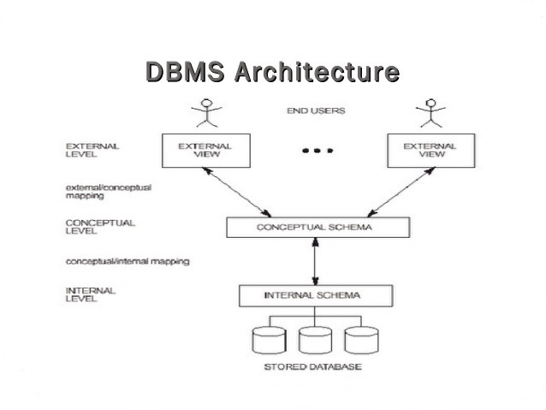

**Figure 1.1: Three schema architecture**

* 1. **Overview of the project**

The “Bank Management System” has been developed to override the problems prevailing in the practicing manual system. This software is supported to eliminate and, in some cases, reduce the hardships faced by the existing system. Moreover, this system is designed for a need of the institution to carry out operations in a smooth and effective manner.

The application is reduced as much as possible to avoid errors while entering the data. It also provides error messages while entering invalid data. No formal knowledge is needed for the user to use this system. Thus, by this all it provides it is user-friendly. This approach is usually adopted with a view to decrease the percentage of the parking problems. Thus, it will help Institution in better utilization of resources.

* + 1. **Problem statement:**

To open an account in a bank and to maintain the account and providing all transaction options.

* + 1. **Objectives of the project:**
* The purpose of this is to build an application to reduce the manual work for managing accounts in a bank.
* It tracks all the details about an individual’s account.
* The project is totally built at administrative end, but all the users have access to their account after certain level of verification.
* It manages all the information about the transactions, current balance and other account details.

**CHAPTER 2**

**SYSTEM DESIGN AND METHODOLOGY**

**2.1. System Architecture**

**Login**

**Withdraw**

**Deposit**

**Database**

**USER**

**Figure 2.1: System Architecture of Bank Management System**

The Figure 2.1 describes the System Architecture of a Bank Management System. The architecture consists of a centralized database, which will be accessed by only one type of users namely: user. user access is required for the security, which is implemented through login module with which the security can login with their registered username and password.

Once login is successful, they can view account details, they can deposit the money, withdraw the money and they can view the transaction details.

**2.2. Entity Relationship Diagram**

managesss

**MAN**

**ACCOUNT**

Figure 1: ER Diagram of Bank Database

**2.3. SCHEMA DIAGRAM**

**ACCOUNT**

accno name type deposit password

**MAN**

manid manpin

Figure 2: Schema Diagram of Bank Database

**CHAPTER 3**

**MODULE IMPLEMENTATION**

**Platform Description**

**XAMPP as a Back-End**

XAMPP is a [free and open source](https://en.wikipedia.org/wiki/Free_software) [cross-platform](https://en.wikipedia.org/wiki/Cross-platform) [web server](https://en.wikipedia.org/wiki/Web_server) [solution stack](https://en.wikipedia.org/wiki/Solution_stack) package developed by Apache Friends, consisting mainly of the [Apache HTTP Server](https://en.wikipedia.org/wiki/Apache_HTTP_Server), [MariaDB](https://en.wikipedia.org/wiki/MariaDB) [database](https://en.wikipedia.org/wiki/Database), and [interpreters](https://en.wikipedia.org/wiki/Interpreter_(computing)) for scripts written in the [PHP](https://en.wikipedia.org/wiki/PHP) and [Perl](https://en.wikipedia.org/wiki/Perl) [programming languages](https://en.wikipedia.org/wiki/Programming_language).  XAMPP stands for Cross-Platform (X), Apache (A), MariaDB (M), PHP (P) and Perl (P). It is a simple, lightweight Apache distribution that makes it extremely easy for developers to create a local web server for testing and deployment purposes. Everything needed to set up a web server – server application (Apache), database (MariaDB), and scripting language (PHP) – is included in an extractable file. XAMPP is also cross-platform, which means it works equally well on Linux, Mac and Windows. Since most actual web server deployments use the same components as XAMPP, it makes transitioning from a local test server to a live server extremely easy as well. XAMPP also provides support for creating and manipulating databases in [MariaDB](https://en.wikipedia.org/wiki/MariaDB) and [SQLite](https://en.wikipedia.org/wiki/SQLite) among others.

**CHAPTER 4**

**CODE SNIPPETS**

**CODING**

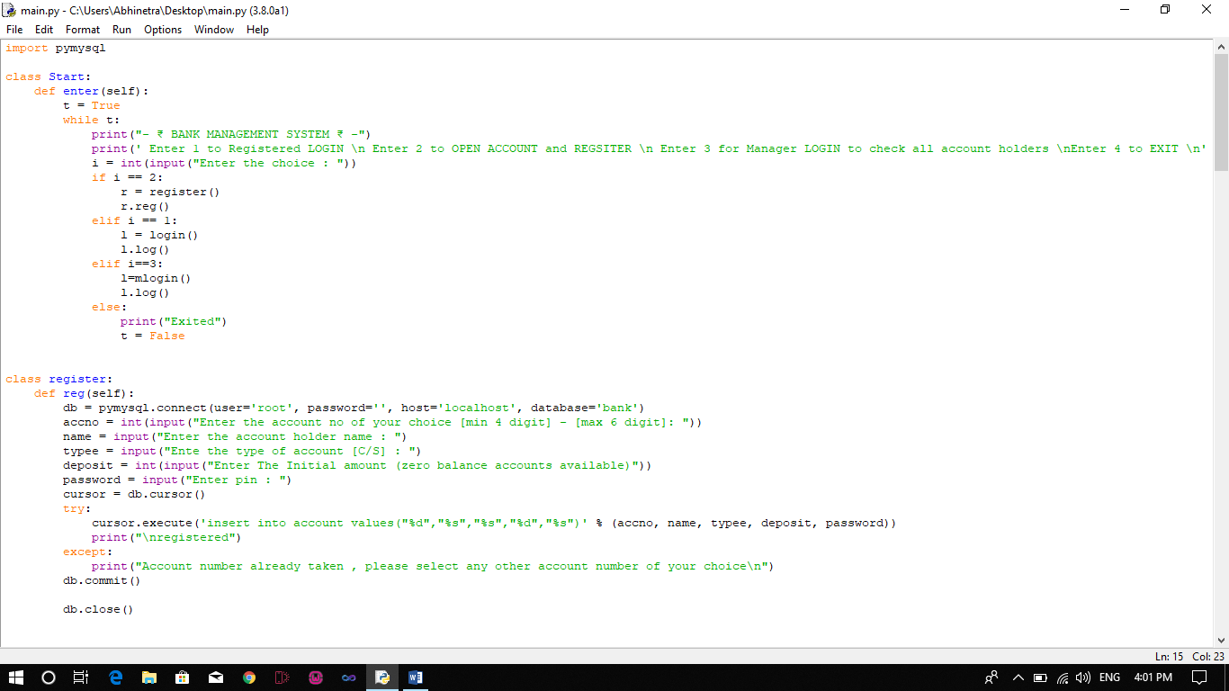

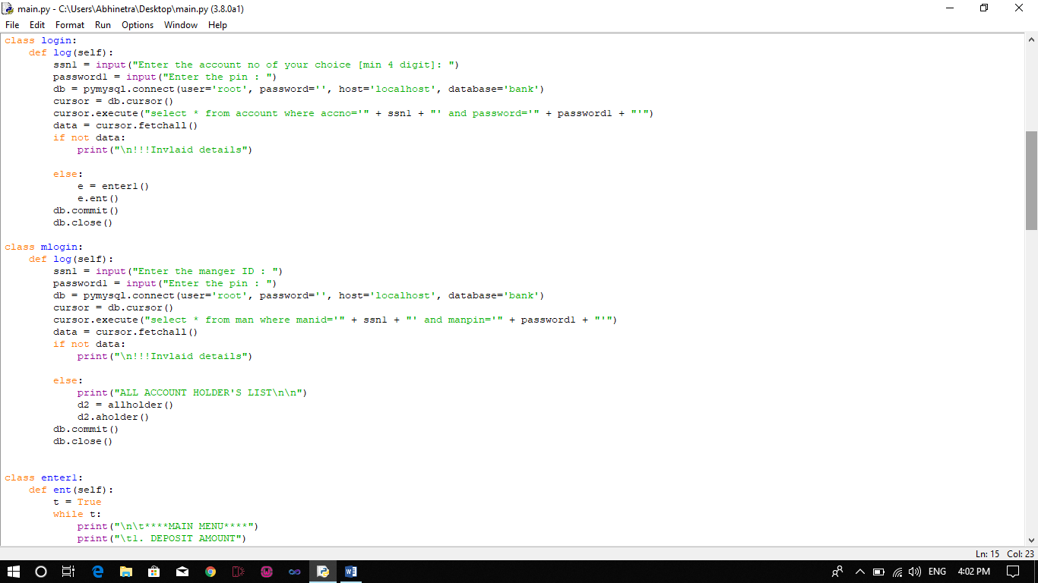

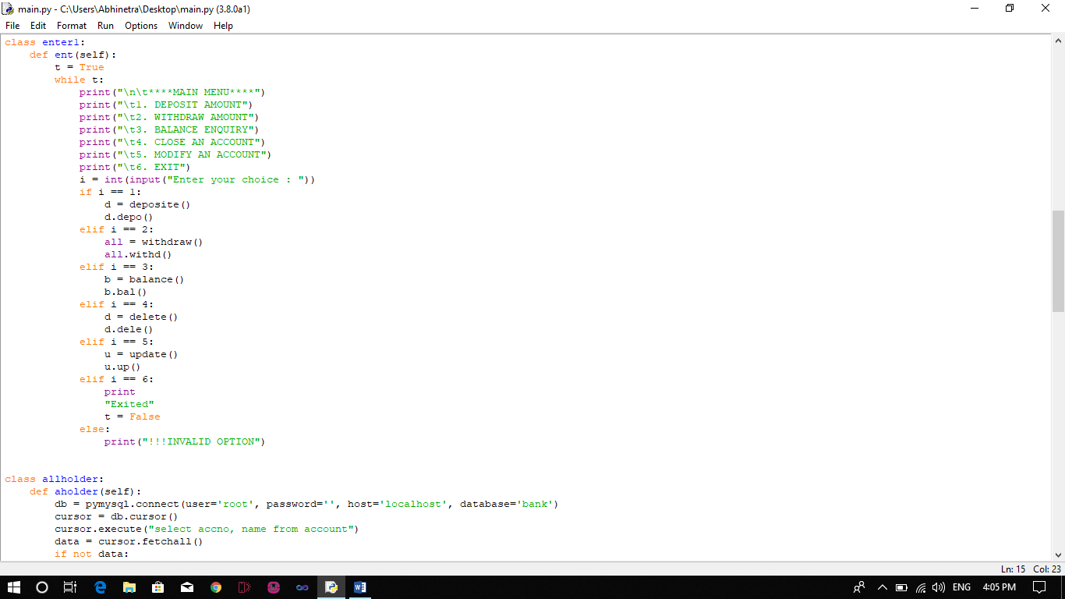

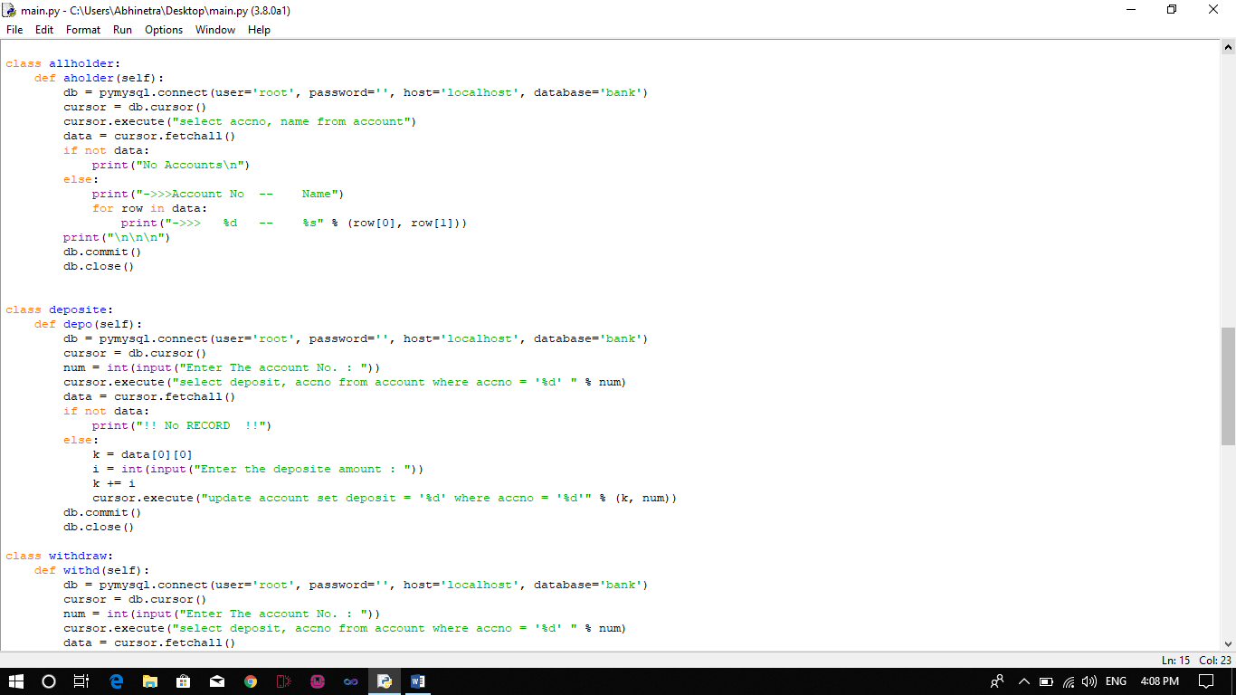

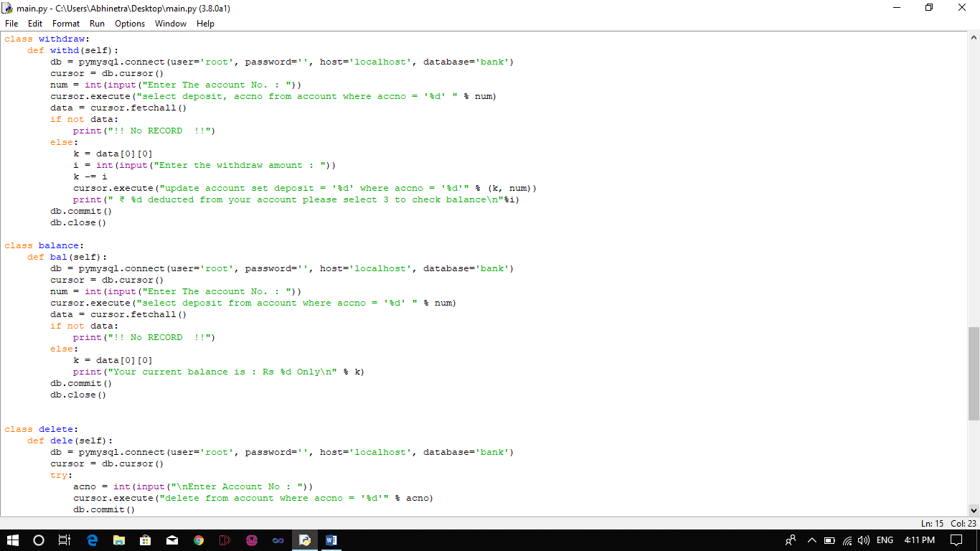

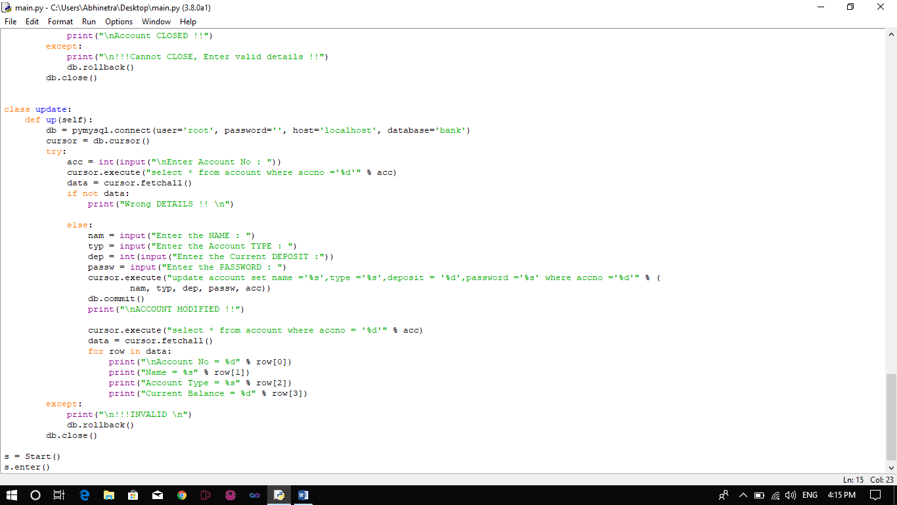

**CHAPTER 5**

**SCREENSHOTS**

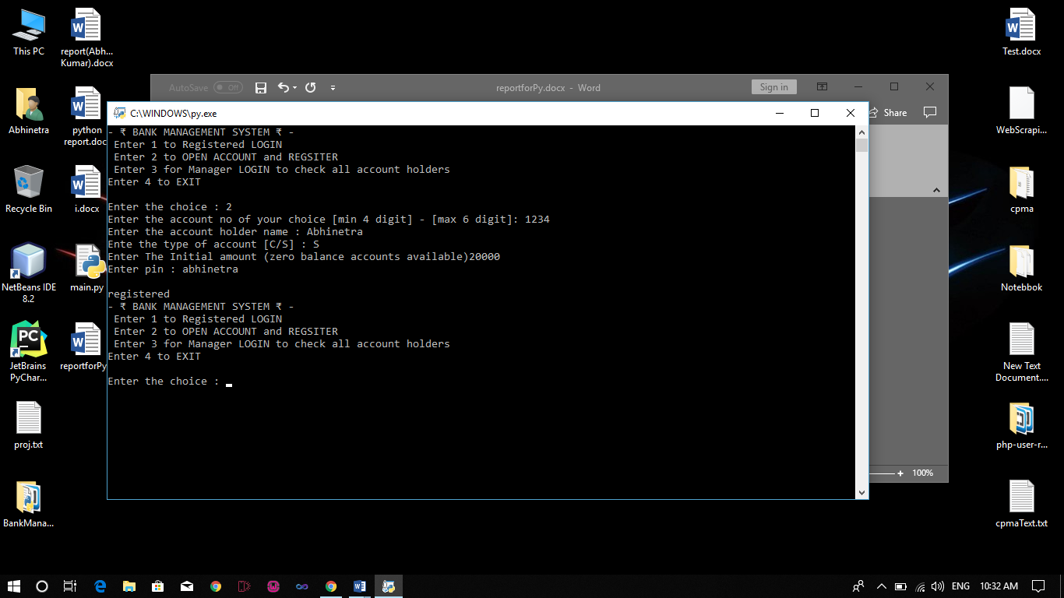

Figure 1: OPEN ACCOUNT

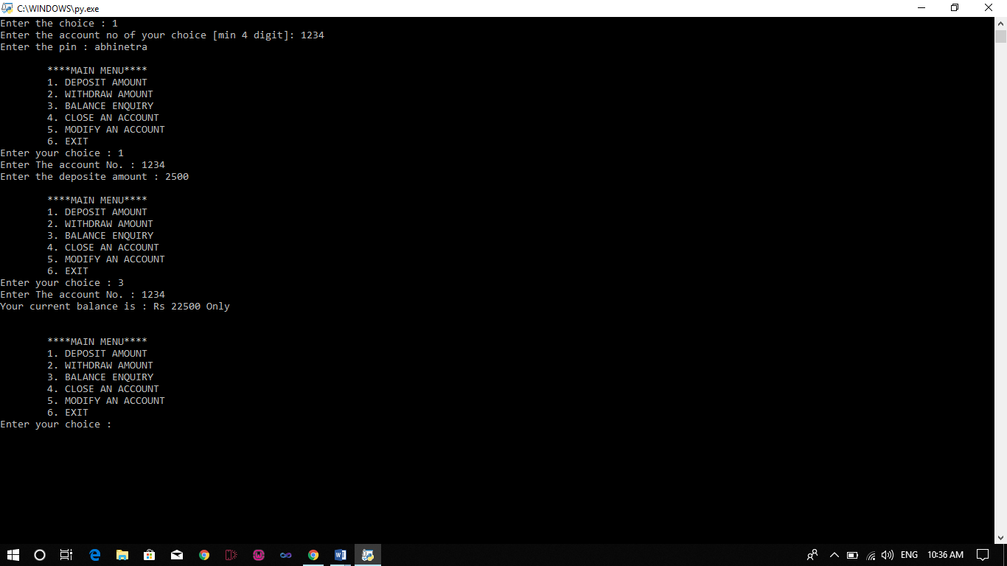

Figure 2: DEPOSIT AMOUNT

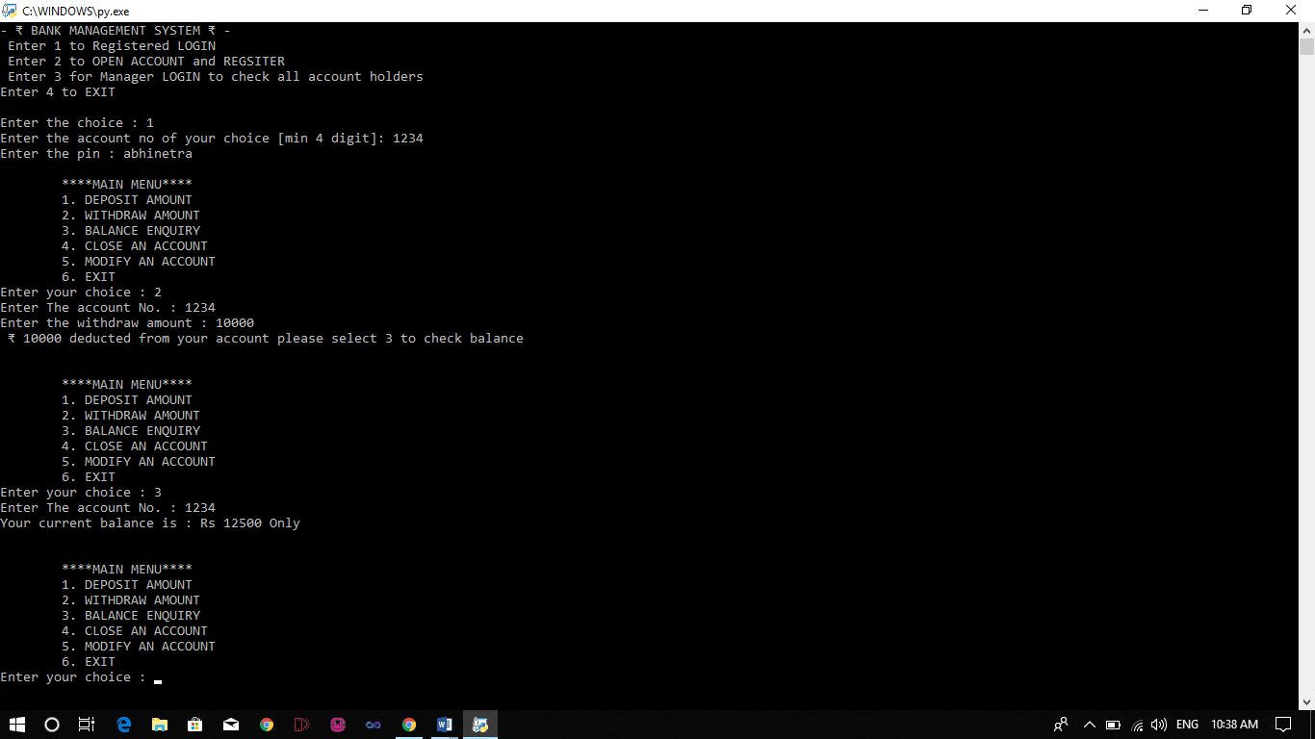

Figure 3: WITHDRAW AMOUNT & BALANCE ENQUIRY

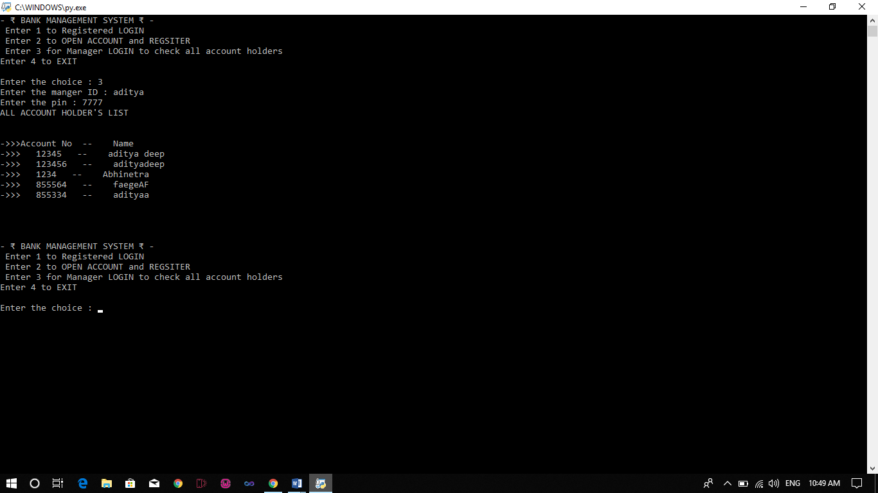

Figure 4: Manager Login & All Holder’s List

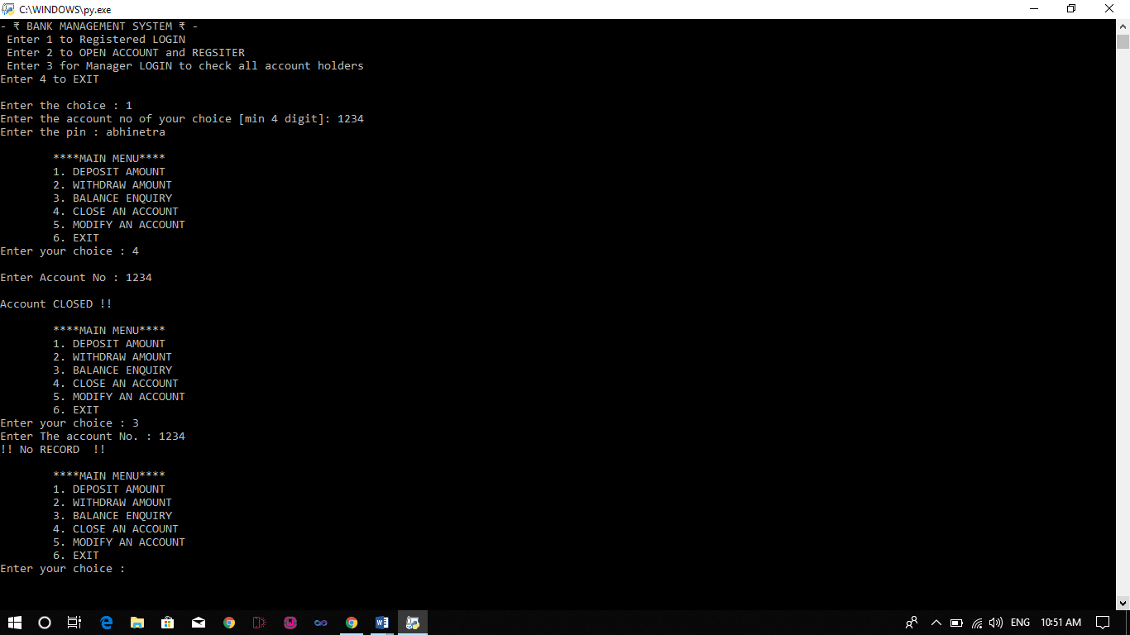

Figure 5: CLOSE AN ACCOUNT

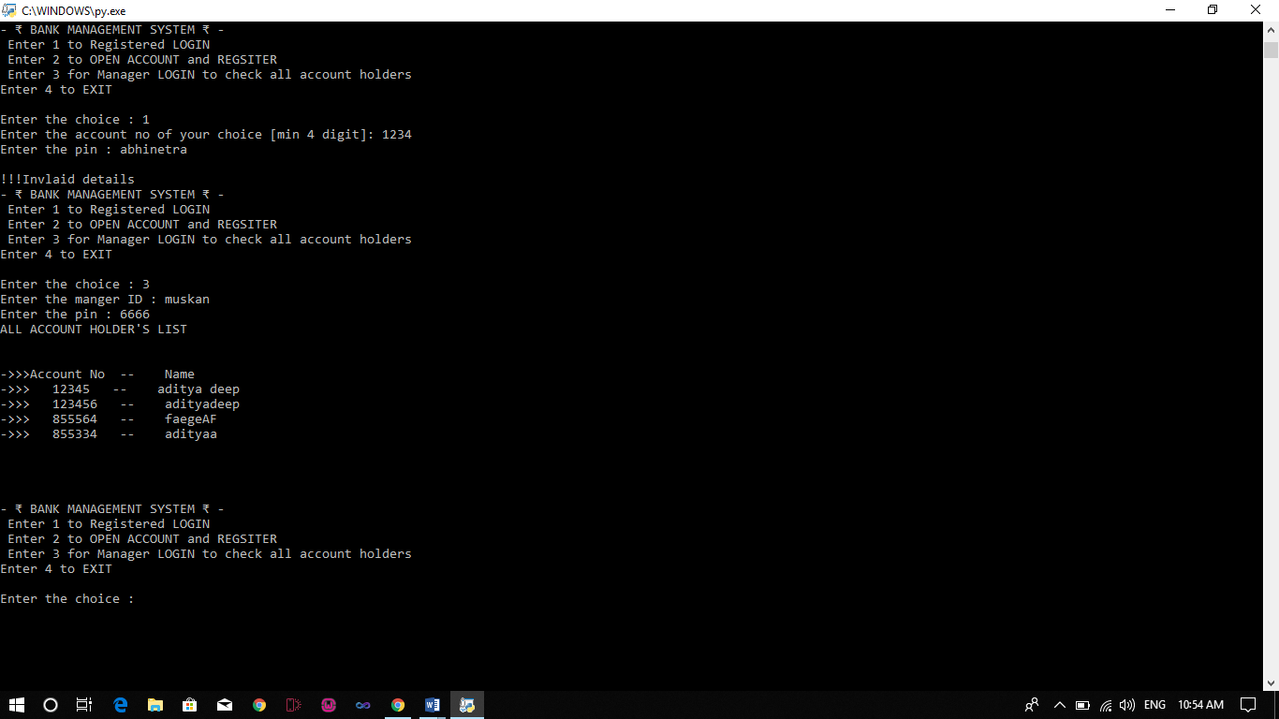

Figure 6: Checking account No and Name

**CONCLUSION**

Banks are quite important to the economy and are involved in such economic activities as issuing money, settling payments, credit intermediation, maturity transformation and money creation in the form of fractional reserve banking.

To make money, banks use deposits and whole sale deposits, share equity and fees and interest from debt, loans and consumer lending, such as credit cards and bank fees.

History has proven banks to be vulnerable to many risks, however, including credit, liquidity, market, operating, interesting rate and legal risks. Many global crises have been the result of such vulnerabilities and this has led to the strict regulation of state and national banks.

This mini project provides user with different options and it is a console based one end project.