HEALTHCARE PREDICTIVE ANALYTICS
Disease (heart disease) prediction using Logistic Regression | Tool: Microsoft Excel | Task 5
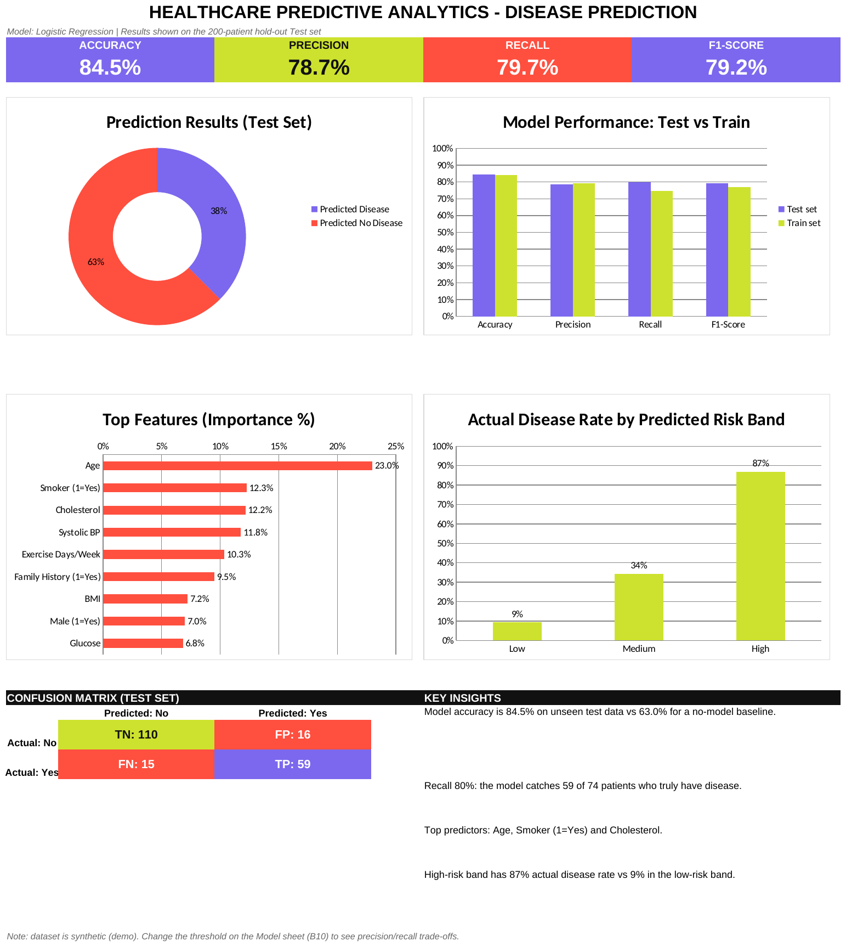  Excel dashboard (hold-out test set, 200 patients) | 1. Problem  Predict the likelihood that a patient has heart disease from routine clinical data, so high-risk patients can be flagged early.  2. Method (4 steps)  - Data collection: 1,000 patient records (age, gender, BMI, BP, cholesterol, glucose, smoking, family history, exercise).  - Preprocessing: cleaned data; 800 records for training, 200 held out for testing.  - Model building: Logistic Regression; probability computed with Excel formulas, threshold 0.50.  - Evaluation: confusion matrix, accuracy, precision, recall, F1.  3. Results (test set)  - Accuracy 84.5% vs 63.0% for a no-model baseline.  - Precision 78.7%, Recall 79.7%, F1 79.2%.  - Model catches 59 of 74 patients who truly have disease (FN = 15, FP = 16).  - Top predictors: age, smoking, cholesterol, systolic BP.  - High-risk band: 87% actual disease rate vs 9% in the low-risk band.  4. Conclusion  A simple model gives useful, explainable risk scores and generalises well (train and test scores are close). Lowering the threshold raises recall at the cost of precision, which suits screening.  5. Limitations  Data is synthetic and for demonstration only; not for clinical use. A real project needs real, larger data and validation.

