1. Introduction

1.1 Purpose

1.2 Scope

1.3 Tools Used

1.4 References

1.5 Technologies to be used

1.6 Software Interface

1.7 Hardware Requirements

2. Specific Requirements

2.1 Use-Case Reports

2.2 Activity Diagrams

2.3 Sequence Diagrams

3. Wireframe

3.1 Screen 1

3.2 Screen 2 and so on

INTRODUCTION

**PURPOSE :::**

Document Search Engine is a web application, a simple CRUD app. That interacts with a RESTful API.

**SCOPE :**

There are two basic users →

1. Administrator

2. End- User

Administrator → manages the information that is available on the web page.

End- User → one who accesses the resources/information/content available on the web page.

- A user can be able to download any document from the list.

- A user will have an advanced search option. i.e. user can filter out the type of document, author, subject, creation date, etc.

- A user will be given one web page where a user can do a CRUD operation of a document and its metadata.

- A document can be in the form of an image, doc, docx, ppt, pdf, etc. - UI must be very clean and simple and it must be responsive.

- A List must be in the form of card-ui and there must be a pagination at server and client side.

**TOOLS USED :**

**REFERENCES :**

**TECHNOLOGIES TO BE USED :**

*Front-End Software →* HTML5, CSS3, JavaScript

*Back-End Software →* PHP

*Data-Interchange* → JSON

**SOFTWARE INTERFACE :**

*Client-Side* → Google-Chrome, Mozilla-Firefox, Internet-Explorer/Microsoft-Edge, Safari, …

Server-Side → WAMP/XAMPP, Any Operating System; MySQL/NoSQL/MongoDB(Database)

**HARDWARE-REQUIREMENTS** :

Minimum requirements :

|  |  |  |  |
| --- | --- | --- | --- |
| CLIENT-SIDE | | | |
| Internet-Explorer, Google-Chrome, Mozilla-Firefox, Safari-Browser | Processor | Ram | Disk Space |
| Intel Pentium | 1 GB | 30 GB |

|  |  |  |  |
| --- | --- | --- | --- |
| SERVER-SIDE | | | |
|  | Processor | Ram | Disk Space |
| Apache, MySql2 | Intel Core i3 3217U | 2 GB | 300 GB |

Recommended requirements :

|  |  |  |  |
| --- | --- | --- | --- |
| CLIENT-SIDE | | | |
| Microsoft-Edge/ Google-Chrome/ Mozilla-Firefox/ Safari-Browser | Processor | Ram | Disk Space |
| All Intel or AMD -  1 GHZ | 2 GB | 50 GB |

|  |  |  |  |
| --- | --- | --- | --- |
| SERVER-SIDE | | | |
|  | Processor | Ram | Disk Space |
| Apache, MySql2 | All Intel or AMD -  2 GHZ | 4 GB | 500 GB |

SPECIFIC REQUIREMENTS :::

**USE-CASE REPORTS** **:**

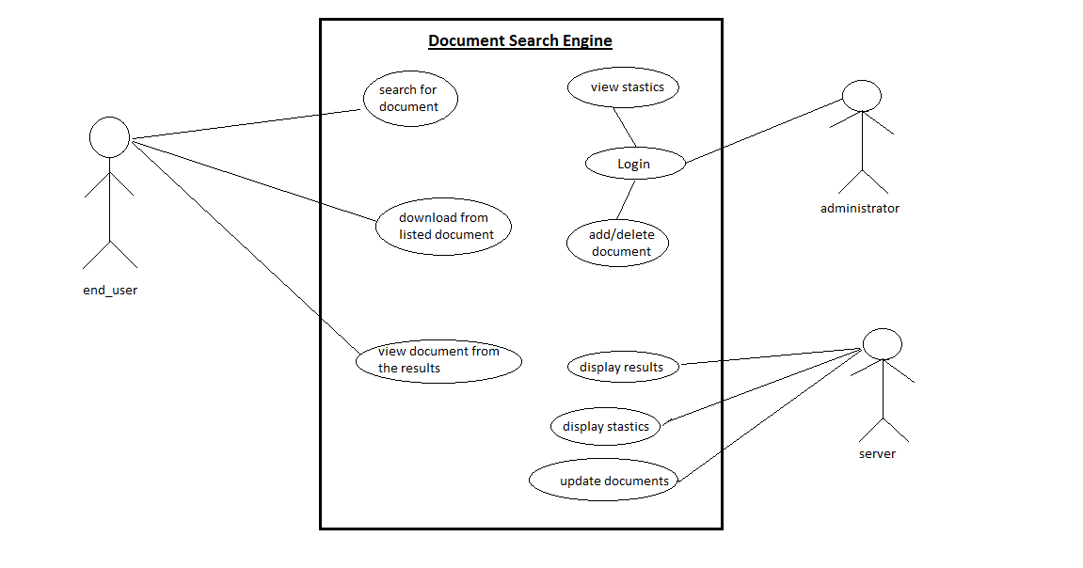

**ACTIVITY-DIAGRAM :**

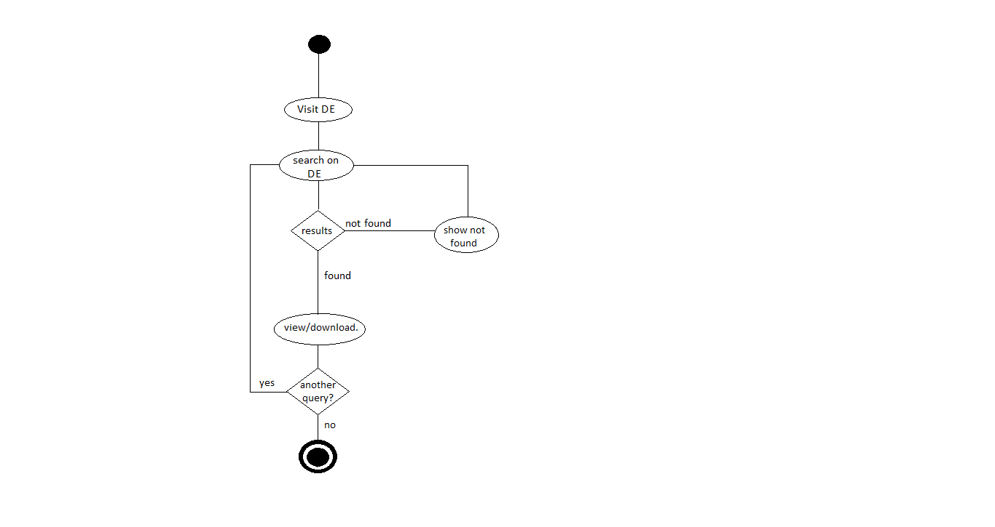

**DATABASE-DESIGN :**

|  |
| --- |
| *document* |
| doc _id  doc_name  doc_type  keywords_in_doc  doc_download_count  doc_visit_count |

|  |
| --- |
| *keyword_in_document* |
| keyword_id  keyword_name  keyword_count |