DSA/ISE 5103 Intelligent Data Analytics
Homework 8
Name: Sai Abhinov Chowdary Katragadda | Sooner Id: 113636339
Date: 23rd November 2024
TASK 1:
The dataset Energy Efficiency is designed for energy analysis of buildings simulated in Ecotect. It includes simulated data for 12 different building shapes. The features capture various structural and design parameters, while the targets represent energy-related metrics.
Overall Description:
The data contains 768 observations with 8 features describing the building parameters and 2 continuous targets representing energy loads (heating and cooling). The dataset could be used for regression analysis (predicting heating and cooling loads) or multi-class classification (if the targets are rounded to integers).

Features Breakdown:
- Continuous Features (6):
- X1: Relative Compactness
- X2: Surface Area
- X3: Wall Area
- X4: Roof Area
- X5: Overall Height
- X7: Glazing Area
- Integer Features (2):
- X6: Orientation (Categorical represented as integers)
- X8: Glazing Area Distribution (Categorical represented as integers)
(ii)Where it comes from
The data originates from simulations run in Ecotect, a building energy performance analysis software. The simulations capture how building characteristics such as glazing area, orientation, and structural dimensions impact energy demands.The data is extracted from website: “ https://archive.ics.uci.edu/dataset/242/energy+efficiency”.

Summary of Features and Target Variables:
Variable Name | Role | Type | Description | Units | Missing Values
X1 | Feature | Continuous | Relative Compactness | - | No
X2 | Feature | Continuous | Surface Area | - | No
X3 | Feature | Continuous | Wall Area | - | No
X4 | Feature | Continuous | Roof Area | - | No
X5 | Feature | Continuous | Overall Height | - | No
X6 | Feature | Integer | Orientation | - | No
X7 | Feature | Continuous | Glazing Area | - | No
X8 | Feature | Integer | Glazing Area Distribution | - | No
Y1 | Target | Continuous | Heating Load | - | No
Y2 | Target | Continuous | Cooling Load | - | No

TASK 2:
Before performing cluster visualization of the data, it is essential to do the visualizations which are interpretable while reducing it’s dimensionality. Thus Principal Component Analysis is performed on the data. The variance explained by each Principal Component can be obtained from following visual :
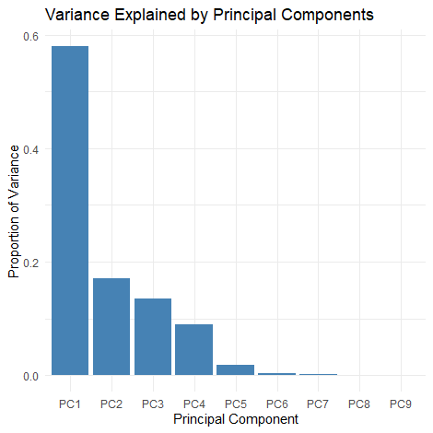
Thus there are three principal components with significant insight into data.
The means to decide the k value for the data is visualized below:
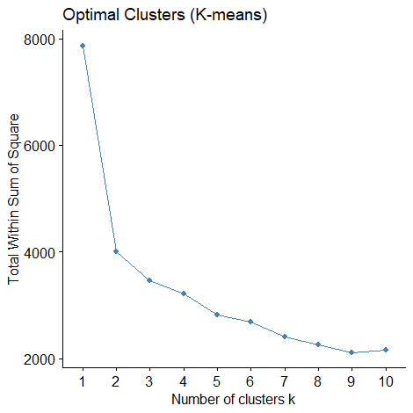

Thus k-means is performed with k= 3, as there is sudden decrease in rate of decrement of within sum of square after k = 3. Thus k = 3 is chosen as elbow point.

The K- means Clustering :
The PCA with K- means Cluster Visualization for k=3 :
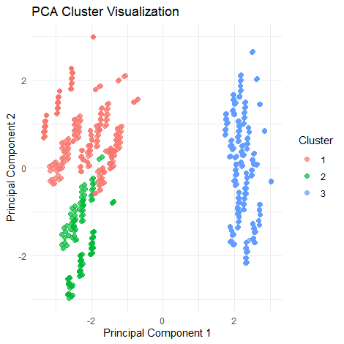

The K- medoids Clustering :
The PCA with K- medoids Cluster Visualization for k=3 :
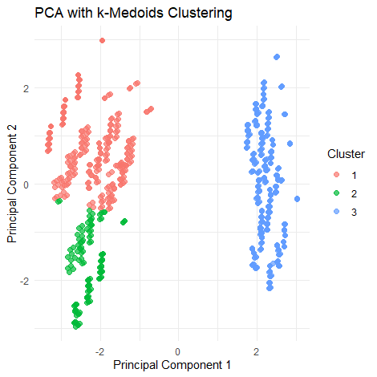

The DBSCAN Clustering :
The PCA with Density Based Cluster Visualization : (eps = 1, minPts = 5)
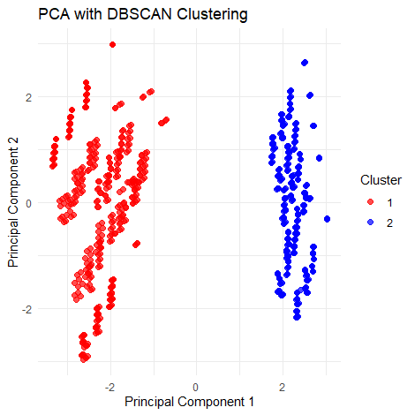
The K-means and K-medoids methods were effective with three clusters but the Density based clustering reduced the number of clusters to two, when compared to clusters of K-means, it is evident that two clusters which were apparently closer were combined into one cluster in the Density Based clustering thus resulting only in two clusters.

Analysis of clusters and drawing insights:
The provided PCA cluster visualization for K- means reveals how the data points are distributed across the first two principal components (PC1 and PC2), colored by cluster labels.

1. Well-Separated Clusters
- Cluster 1 (red) is located on the far left, with negative values for PC1 and mostly higher values for PC2.
- Cluster 2 (green) is on the far left, with negative PC1 values and negative values of PC2.
- Cluster 3 (blue) is on the far right of the other clusters, with positive PC1 values and spread widely across PC2 .
This clear separation indicates that the first two principal components capture most of the variance and provide meaningful distinctions between the clusters.

2. Principal Component Contributions
- PC1 (horizontal axis): The spread of the clusters along PC1 suggests that this component captures a significant amount of variance in the data. Features with high loadings on PC1 are likely critical for differentiating Cluster 3 from Cluster 1 and 2.
- PC2 (vertical axis): The vertical spread (along PC2) primarily separates Cluster 2 from the Cluster 1. This indicates that PC2 highlights a variance dimension specific to Cluster 2.

3. Cluster Characteristics
- Cluster 1 (red): Intermediate PC1 values and distinct PC2 values. This cluster may correspond to buildings with balanced energy characteristics (e.g., moderate heating and cooling loads).
- Cluster 2 (green): Likely characterized by low scores for features contributing to PC1. These points may represent buildings with lower compactness, smaller surface areas, or specific glazing/energy patterns.
- Cluster 3 (blue): High PC1 values. These buildings might have larger surface areas, higher compactness, or unique energy demands.

4. Outliers
There are no significant outliers visible in this plot, as all points are clustered around their respective groups with no distant points.

To further understand the clusters , there is a need to understand the relationship between features and principal components, which can be visualized below:
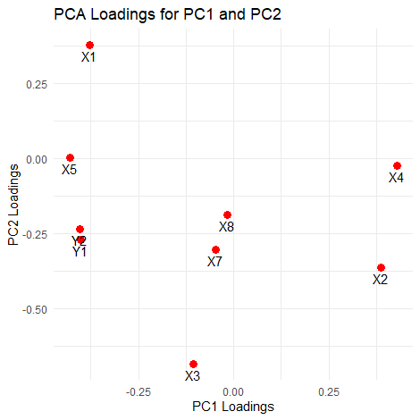
The PCA Loadings Plot displays how each feature contributes to the first two principal components (PC1 and PC2).

1. PC1 Contributions
- X1 (Relative Compactness), X3 (Wall Area), X5 (Overall height): Strong negative contribution to PC1.
- X2 (Surface Area) and X4 (Roof Area): Strong positive contributions to PC1.
This suggests that PC1 captures a trade-off between wall area (negatively correlated) and surface/roof area (positively correlated).

2. PC2 Contributions
- X1 (Relative Compactness): Dominates PC2 with a strong positive loading.
- X3 (Wall Area), X2(Surface Area), X7(Glazing Area): Moderate negative contribution to PC2.
This indicates that PC2 reflects a contrast between relative compactness and heating load. Buildings with higher compactness likely have lower heating loads.

3. Combined Insights
- Features like X3 (Wall Area) and X2 (Surface Area) dominate PC1, which explains much of the horizontal spread in the PCA cluster visualization.
- X1 (Relative Compactness) drives PC2, contributing to the vertical separation, particularly distinguishing Cluster 2 from the others.
4. Targets (Y1, Y2)
- Y1 (Heating Load) has a notable negative loading on PC2, suggesting it is inversely related to relative compactness (X1). Buildings with higher compactness tend to require less heating energy.
- Y2 (Cooling Load) does not appear prominently in PC1 or PC2, meaning it likely contributes to later components.
The distribution of clusters across Heating Load can be visualized as follows:
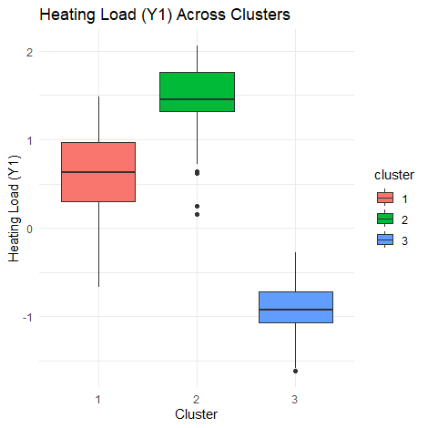
The distribution of clusters across Cooling Load can be visualized as follows:
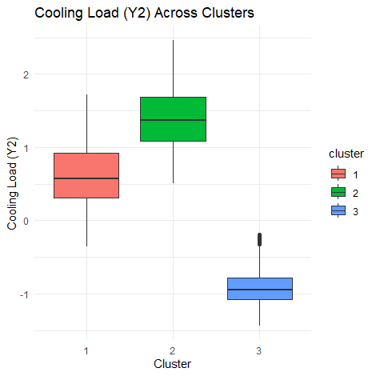
Conclusions & Recommendations:
From above visualizations the green cluster has the most inefficient energy consumption while the blue cluster has most effective energy consumption. The red cluster has moderate energy consumption observations which is due to high Relative Compactness scores compared to that of green cluster.

The close proximity of red and green clusters in the box plots for distribution of clusters across Heating and Cooling Load indicates the decision of Density Based Cluster plot to have only two clusters.
Design Strategies:
- Focus on optimizing compactness (X1) and wall/roof areas (X3, X4) to balance energy loads.
- Analyze the trade-off between surface area (X2) and energy efficiency.
Energy Insights:
- Cluster differences in PCA space can be tied to energy loads. Buildings in clusters with high X1 (compactness) likely require less heating energy.
Targeted Optimization:
- Features like X3 (Wall Area) have a significant negative effect on PC1, indicating that reducing wall area might improve energy efficiency.

