Assignment 1 : Simple SQL Query with a single table with where clause

Create table Products(

ProductID int primary key,

ProductName nvarchar(50) not null,

SupplierID int not null,

CategoryID int not null,

QuantityPerUnit nvarchar(50) not null,

UnitPrice float not null,

UnitsInStock int not null,

UnitsOnOrder int not null,

ReorderLevel int not null,

Discontinued bit

);

insert into products values (1,'chai',1,1,'10box',18,39,0,10,0),

(2,'chang',1,1,'24bottle',19,17,40,25,0),

(3,'syrup',1,2,'12bottle',10,13,70,25,0),

(4,'cajun',2,2,'48 jars',22,53,0,0,0),

(5,'ghumbomix',2,2,'36box',21,0,0,0,1),

(6,'spread',3,2,'12jars',25,120,0,25,0),

(7,'peracit',2,2,'10box',36.0,50,0,10,0),

(8,'pencil',1,1,'900box',25.0,17,40,25,0),

(9,'pen',1,2,'200box',10.0,13,70,25,0),

(10,'rubber',2,2,'240box',50.00,53,0,0,0),

(11,'sharpener',2,2,'360box',26.00,0,0,0,1),

(12,'milk bag',3,2,'500pic',20,120,0,25,0);

Output: 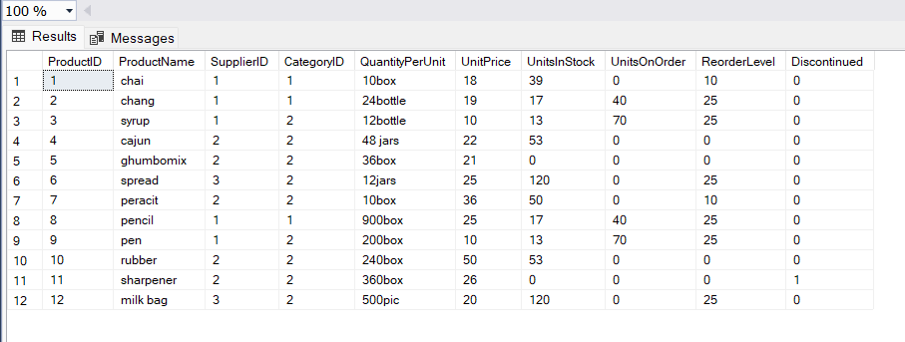

Query 1): Write a query to get a Product list (id, name, unit price) where current products costless than $20.

Sol: select ProductID,ProductName,UnitPrice from products where UnitPrice<20

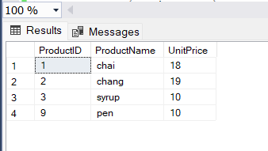

Query:2) Write a query to get Product list (id, name, unit price) where products cost between$15 and $25

Sol: select ProductID,ProductName,UnitPrice from products where UnitPrice between 15 and 25

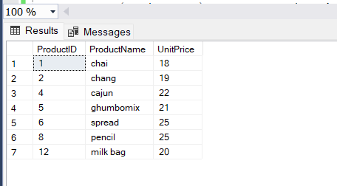

Query: 3)Write a query to get Product list (name, unit price) of above average price.

Sol:SELECT DISTINCT ProductName, UnitPrice

FROM Products

WHERE UnitPrice > (SELECT avg(UnitPrice) FROM Products)

ORDER BY UnitPrice;

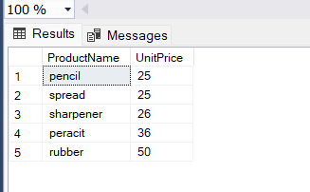

Query:5) Write a query to get Product list (name, unit price) of ten most expensive products

Sol:select top 10\* from products order by UnitPrice DESC

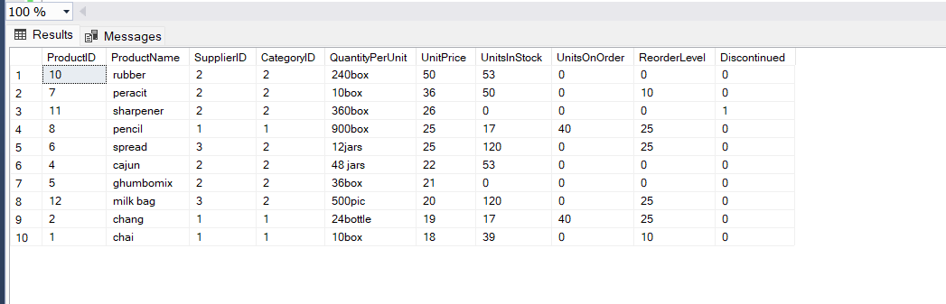

Query:6) Write a query to count current and discontinued products

Sol:SELECT Count(ProductName) as currentorder,Discontinued

FROM Products

GROUP BY Discontinued;

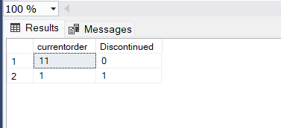

Query:7) Write a query to get Product list (name, units on order , units in stock) of stock is lessthan the quantity on order

Sol:select ProductID,ProductName,UnitPrice from Products where UnitsInStock<UnitsOnOrder

