|  |  |
| --- | --- |
| **NAME** | **ID NO** |
| **Abhipal Sharma** | **2019A7PS0161H** |
| **Iype Eldho** | **2018AAPS0339H** |
| **CH V S S Chaitanya** | **2018AAPS0393H** |

**Assignment-2A: Logistic Regression**

1) Logistic Regression is a model using a sigmoid function to classify data points into different categories. The code contains a class called “Logreg”, which contains a constructor for learning rate, number of iterations, batch size, weights and bias.

There are two classes for gradient descent “gradient_descent” and “stochastic_gradient_descent”. The weights and bias get updated by minimizing the loss by reducing its derivative till the updating ceases to happen (or till the number of iterations = 1000). The batch size = 10 for stochastic gradient descent.

The other metrics calculated are accuracy, precision, recall. f1-score. The data is randomly divided into 70:30 split for testing and training 10 times. The plots are specifically for the 5th time: training and testing loss vs iteration and training and testing accuracy vs iteration.

Finally, the means of training loss, testing loss, training accuracy, testing accuracy, precision, recall, f1-score and weights are calculated and displayed.

2) The most important feature in the dataset is the 1st attribute since its mean weight is the largest.

3) Gradient Descent 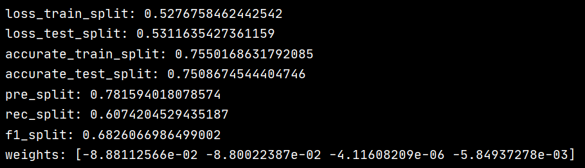(mean)

Stochastic Gradient Descent (mean)

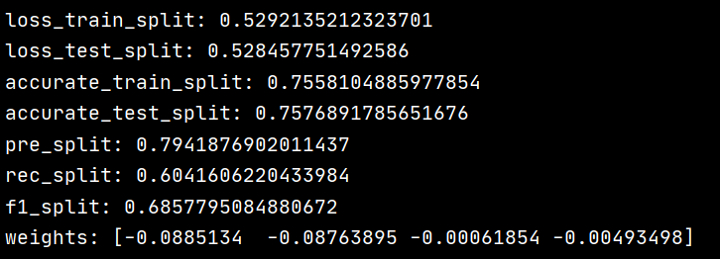

4) Gradient Descent (η1 = 0.001)

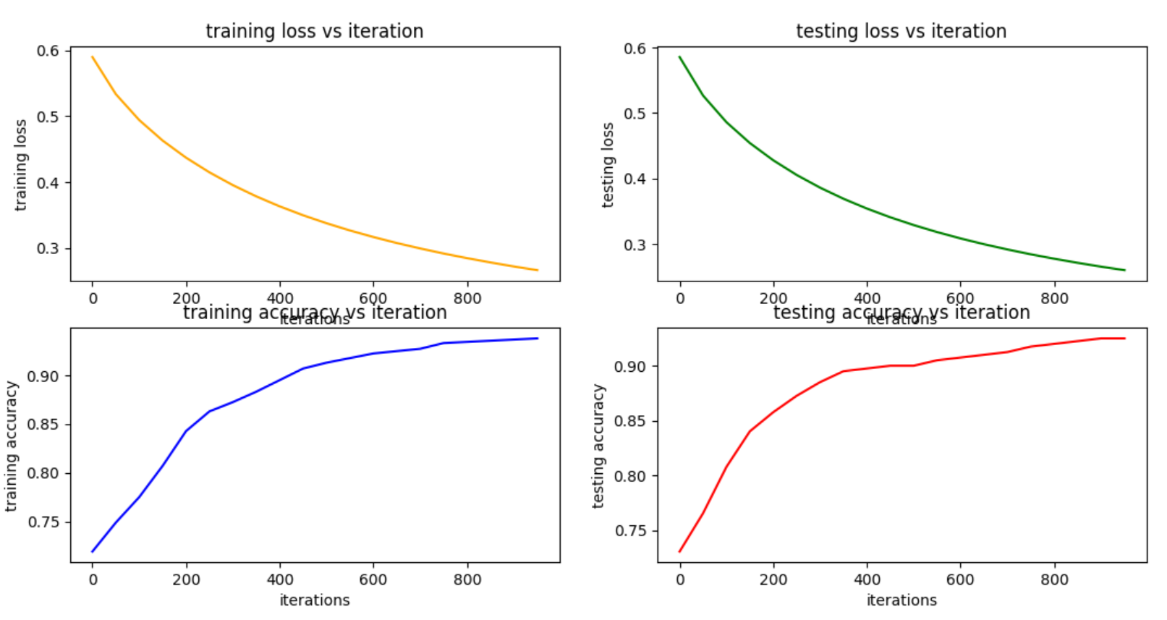

Gradient Descent (η2 = 0.0001)

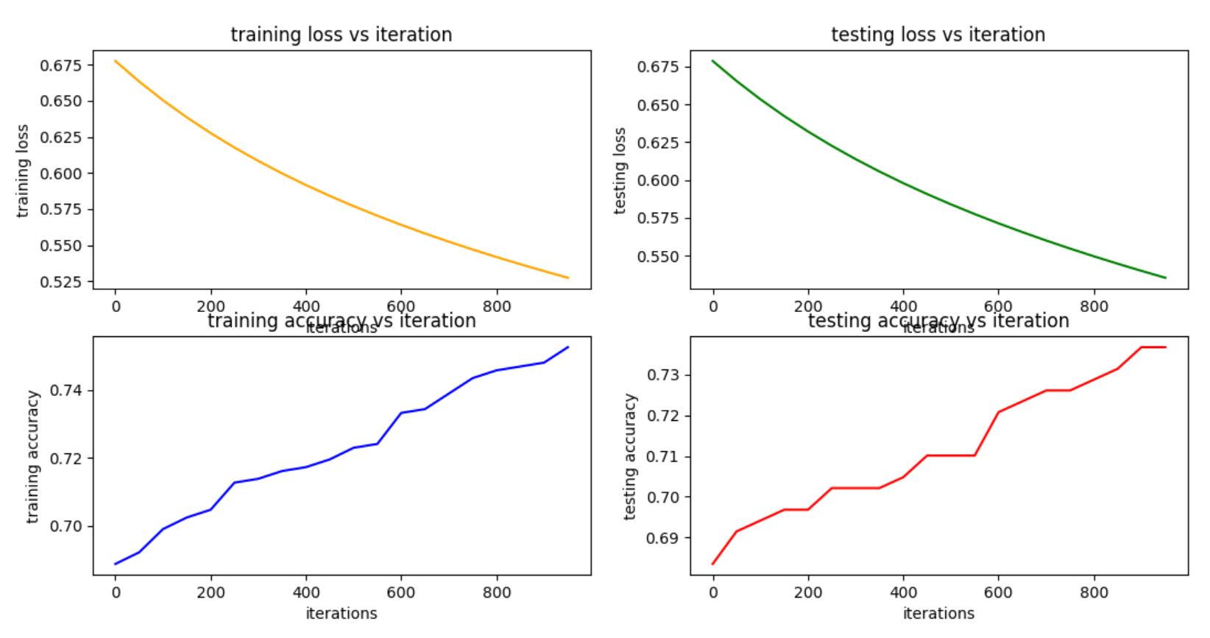

Gradient Descent (η3 = 0.0001)

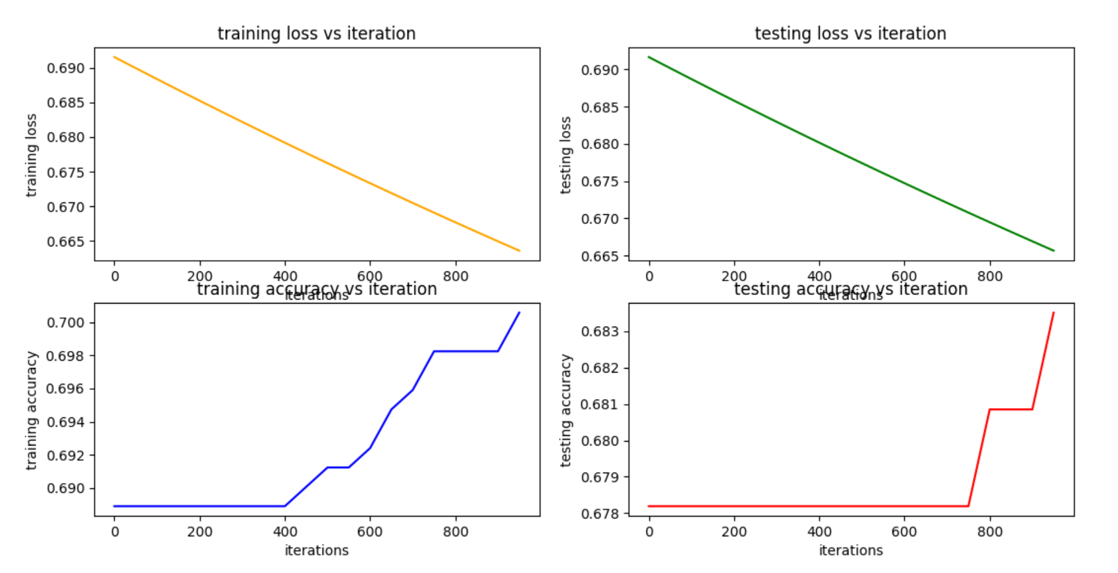

Stochastic Gradient Descent (η1 = 0.001)

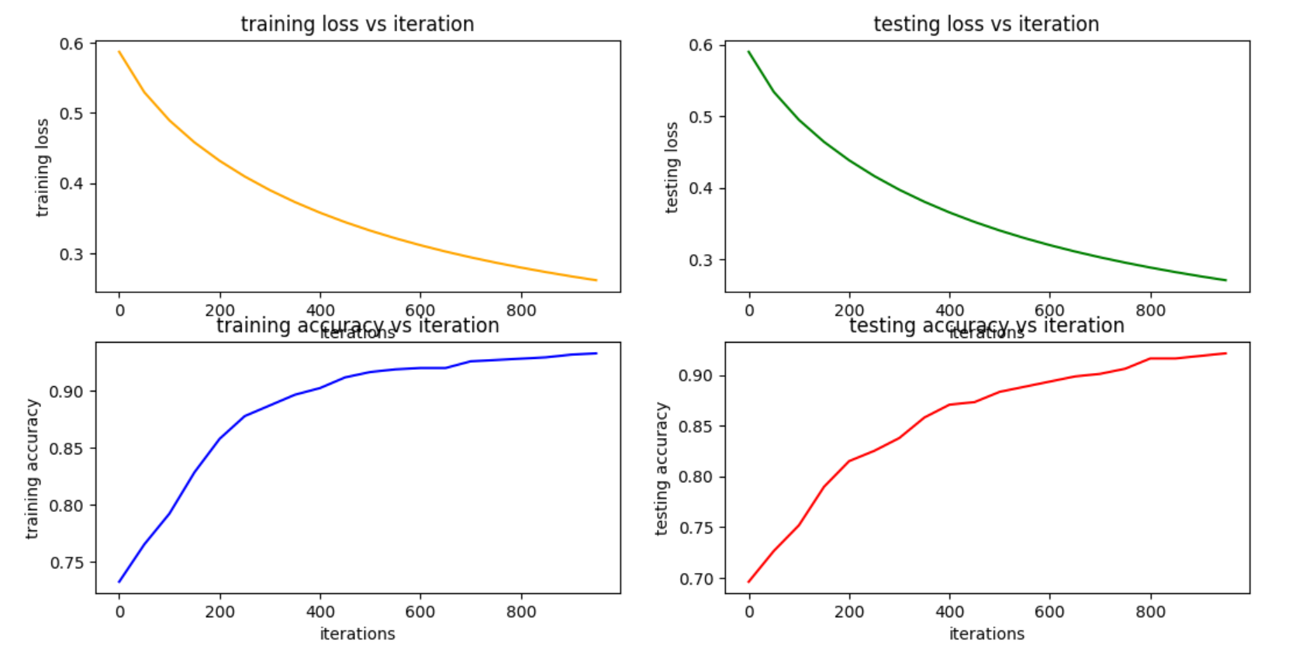

Stochastic Gradient Descent (η2 = 0.0001)

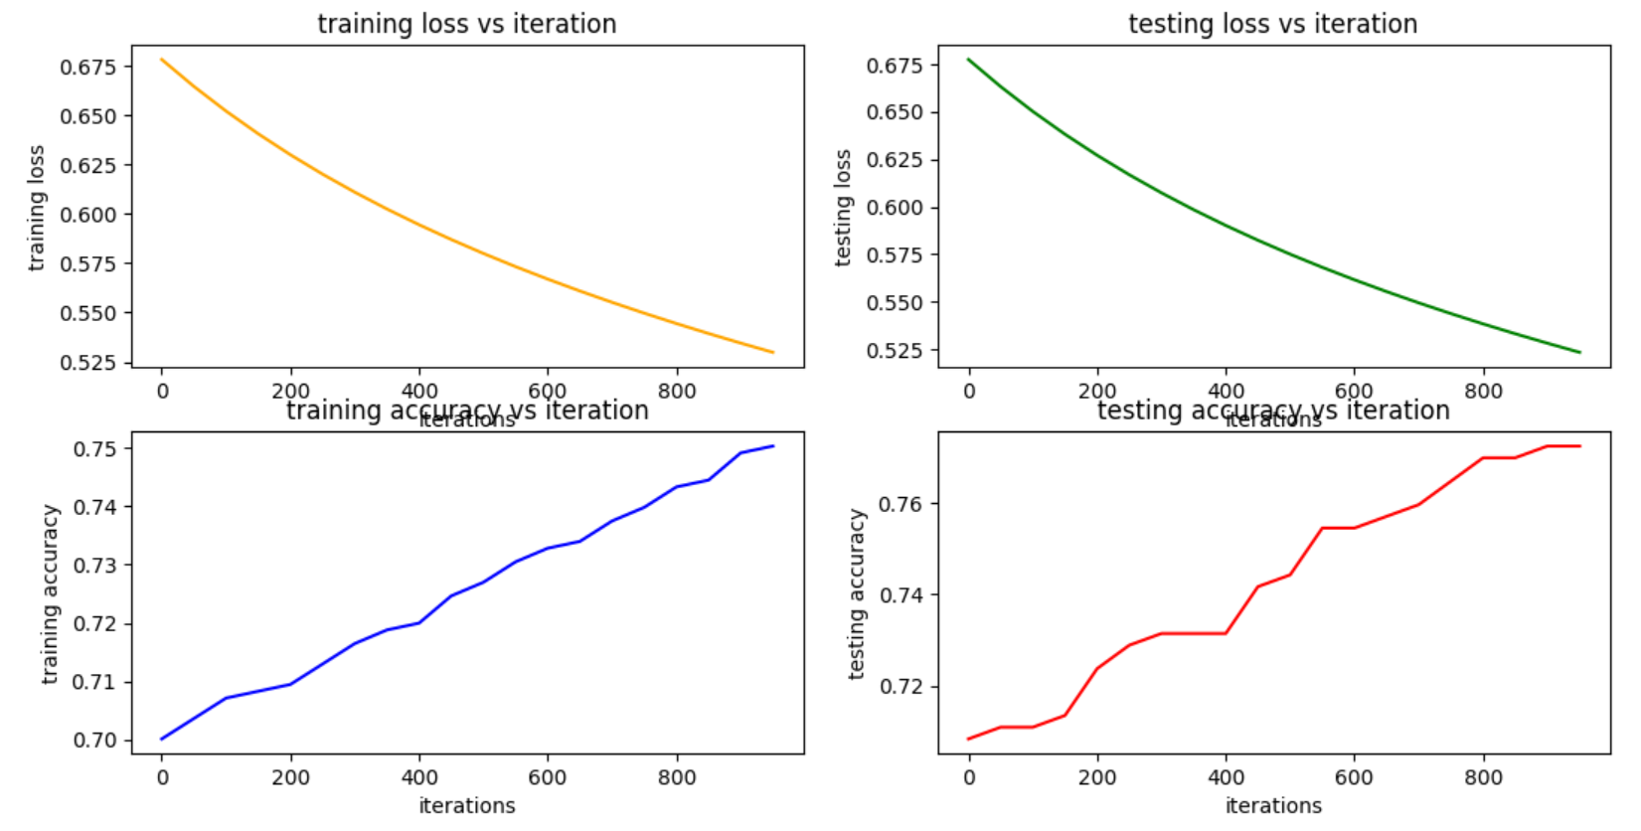

Stochastic Gradient Descent (η3 = 0.00001)

