Assignment-1

* Process For Create Repository in GitHub and Add Folder:
* **Step - 1:** Goto GitHub site and login. And then Select New Repositories.

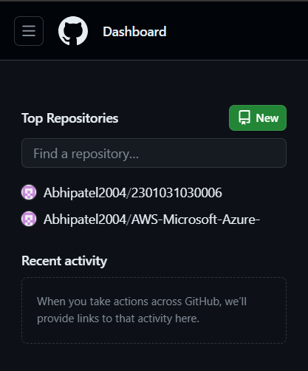

* **Step - 2:** Then Give Your Repo Name whatever you want and select public. Then you can add README File if you want to add.

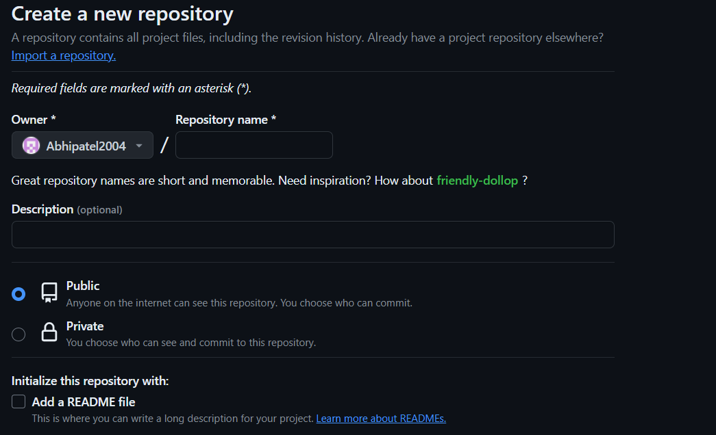

* **Step - 3:** End last select Create repository.

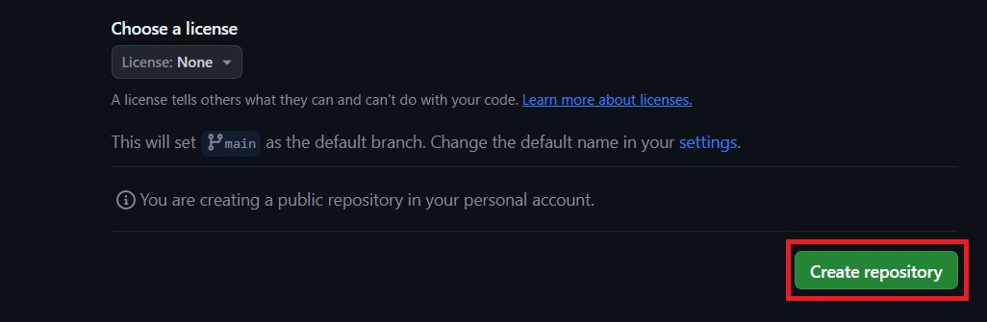

* **Step - 4:** Your Repository Will be look like this.



* **Step - 5:** Here, You can upload File From your Desktop.

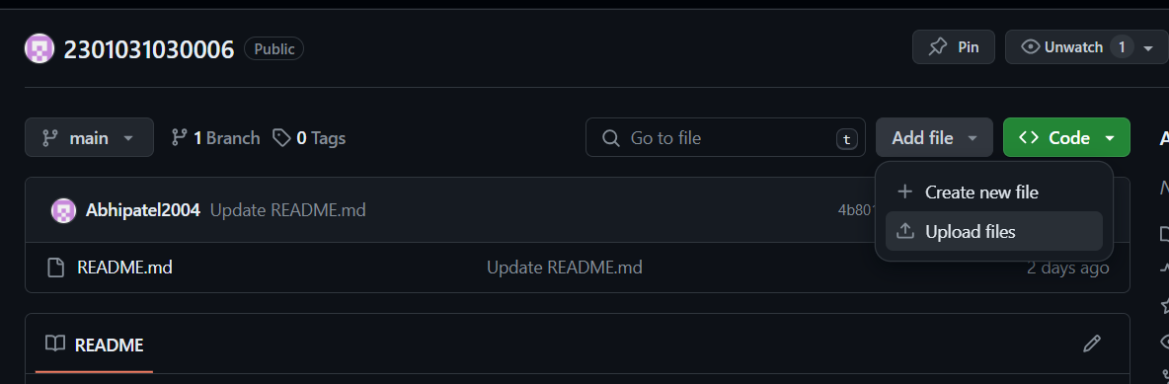

* **Step – 6:** And also you can clone this repository to your pc. For Clone, you need to select HTTPS url display below in picture.

