- Write a Python Program to Check if a Number is Positive, Negative or Zero?
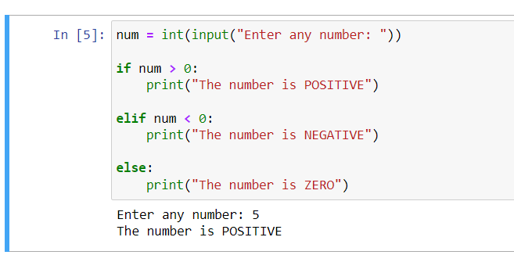

- Write a Python Program to Check if a Number is Odd or Even?.

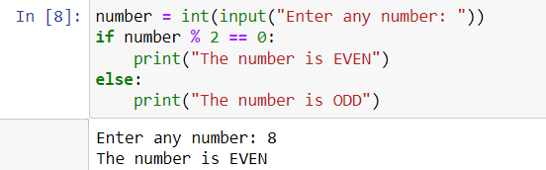

- Write a Python Program to Check Leap Year?
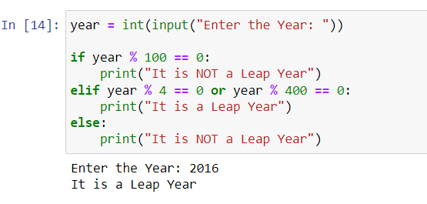

- Write a Python Program to Check Prime Number?
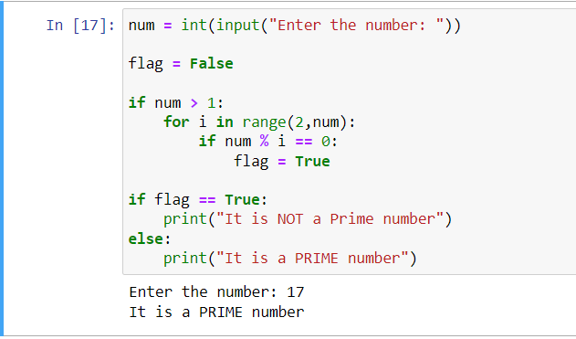

- Write a Python Program to Print all Prime Numbers in an Interval of 1-10000?

