- Write a Python program to convert kilometres to miles?
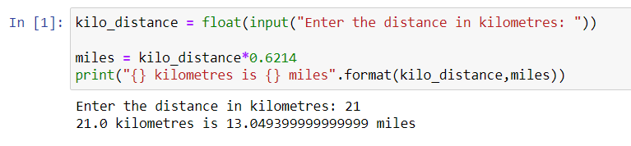

- Write a Python program to convert Celsius to Fahrenheit?
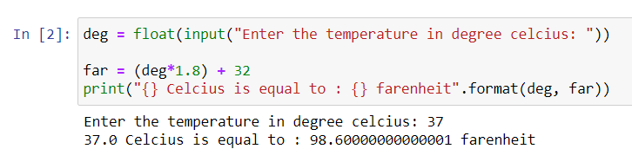

- Write a Python program to display calendar?
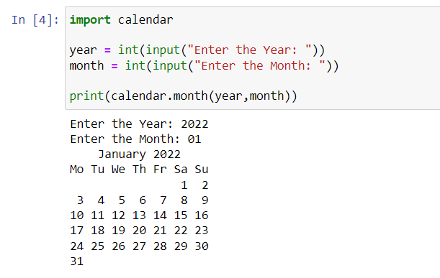

- Write a Python program to solve quadratic equation?
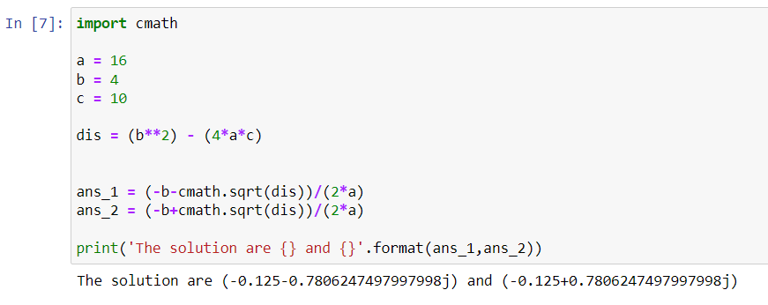

- Write a Python program to swap two variables without temp variable?
