- Write a Python Program to Find the Factorial of a Number?
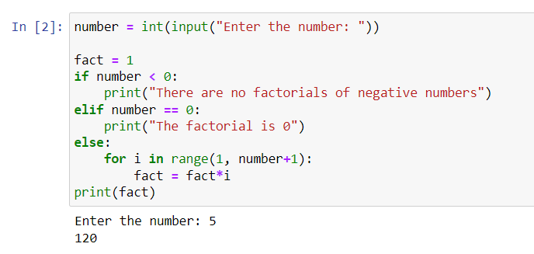

- Write a Python Program to Display the multiplication Table?
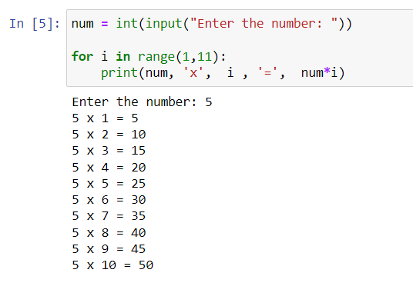

- Write a Python Program to Print the Fibonacci sequence?
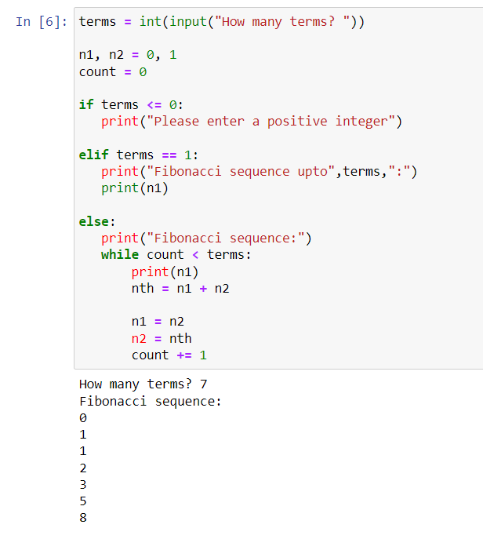

- Write a Python Program to Check Armstrong Number?
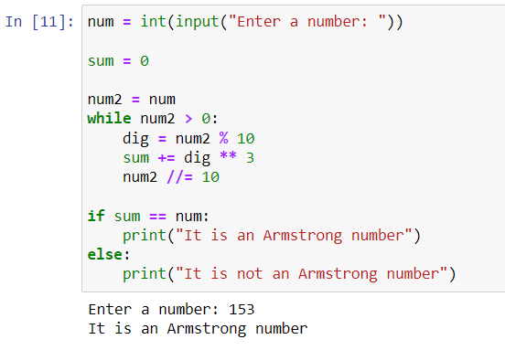

- Write a Python Program to Find Armstrong Number in an Interval?
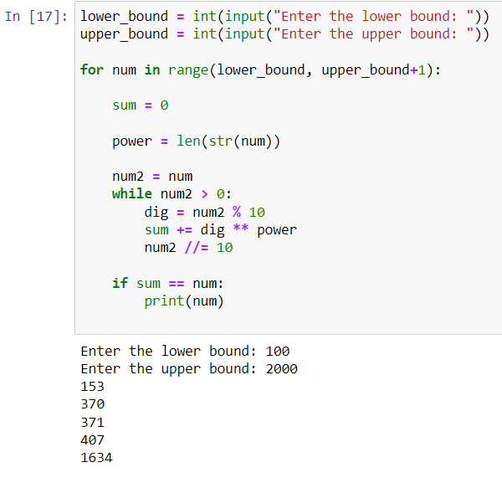

- Write a Python Program to Find the Sum of Natural Numbers?
