- Write a Python program to print "Hello Python"?
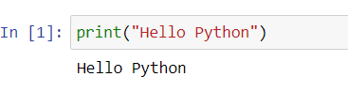

- Write a Python program to do arithmetical operations addition and division.?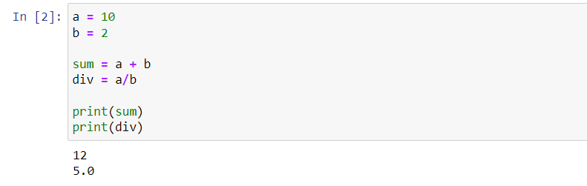

- Write a Python program to find the area of a triangle?
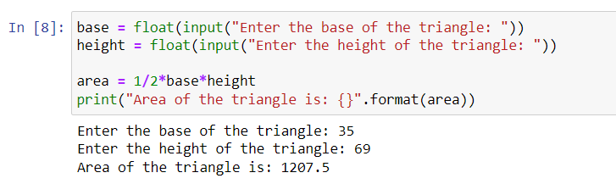

- Write a Python program to swap two variables?
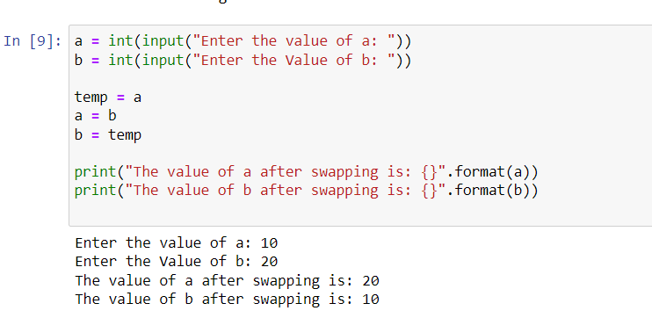

- Write a Python program to generate a random number?
