Student Name – Abhijeet Rajguru
CSE-AIML-A
PRN – 12310781
Roll No. 01
Subject – CN Lab

Experiment Number: 01
TITLE: Setting up small wired and wireless computer networks and hands on networking commands
OBJECTIVES:
1. To learn how to setup a wired and wireless network and understand working of various
internetworking devices
2. To learn the network commands
PROBLEM STATEMENT
1a) Setting up small wired computer network:
Set up a small wired network of 2 to 4 computers using Hub/Switch/. It includes Preparation of Cables and setting up wired network.
THEORY:
Network Setup and Cable Types
In this experiment, we set up a network using two methods:
- Wired Connection – Devices (laptops/desktops) were connected using Ethernet cables via a hub or switch. Network settings were configured through the Control Panel.
- Wireless Connection – Devices connected over Wi-Fi (not the focus of this cable-based explanation).

Cable Preparation and Types
Networking cables play a crucial role in establishing proper connections. There are three main types of Ethernet cables used for different purposes:
1. Straight-Through Cable
- Structure: All 8 wires connect to the same pins on both ends.
- Standard: Typically follows the 568A or 568B wiring standard.
- Use Cases: Used to connect unlike devices.
  - Computer → Switch
  - Router → Hub
  - LAN Port → Switch/Hub/Computer
2. Crossover Cable
- Structure: Pairs of wires (like orange-white and green-white) are crossed.
- Use Cases: Used to connect like devices.
  - Computer → Computer
  - Router → Router
  - Switch → Switch
  - Hub → Hub
3. Rollover Cable (Yost Cable)
- Structure: Wires on one end are the mirror image (reversed) of the other end.
- Use Cases:
  - Used to connect a PC to the console port of a router or switch for configuration purposes.
  - Typically not used for data transfer.
  - Often color-coded differently.
Note:
Modern network devices may support Auto-MDI/MDIX, which allows the use of either straight-through or crossover cables. However, using the correct cable type ensures broader compatibility, especially in manual setups.
DIAGRAM :
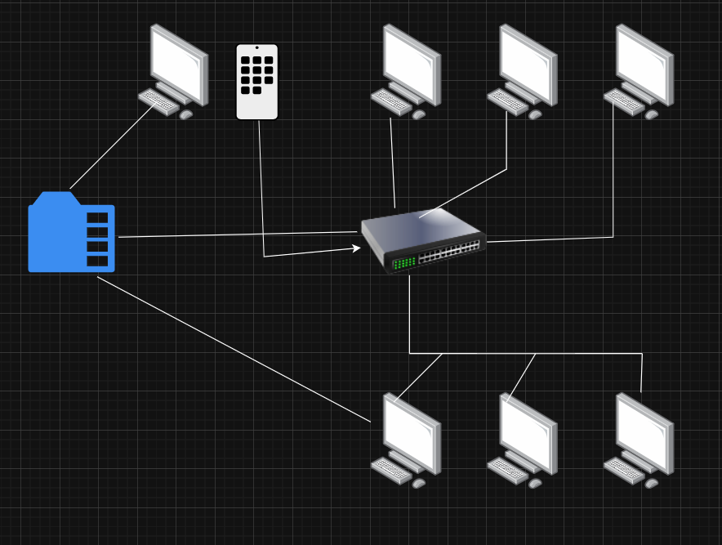

CONCLUSION :
In this experiment, we successfully demonstrated the process of setting up a basic computer network using both wired and wireless methods. The primary focus was on the wired setup, where we explored the use of different Ethernet cables — straight-through, crossover, and rollover — based on the type of devices being connected.
We understood that:
- Straight-through cables are ideal for connecting unlike devices (e.g., PC to switch).
- Crossover cables are used for like devices (e.g., PC to PC or switch to switch).
- Rollover cables are specifically used for configuring network hardware via the console port.
By properly identifying the correct cable type and configuring network settings, we established successful communication between devices, laying the groundwork for larger and more complex networks. This practical knowledge is essential for understanding the physical layer of computer networking.
1b) Setting up small wireless computer network and hands-on networking command:
Set up a small wired network of 2 to 4 computers using access point and ask students to access it on
their wireless gadgets.

THEORY :
Wireless networking enables devices to connect to a local area network (LAN) and the internet without physical cables, using radio frequency (Wi-Fi). In this experiment, we focus on creating a basic wireless network using a wireless router or access point and connect devices such as laptops, desktops, or mobile phones.
A wireless network uses Wi-Fi protocols (IEEE 802.11) for communication. A router typically serves as both an access point and a DHCP server, assigning IP addresses dynamically to connected devices.
Key Concepts:
- Access Point (AP): A device that allows wireless devices to connect to a wired network using Wi-Fi.
- DHCP (Dynamic Host Configuration Protocol): Automatically assigns IP addresses to devices on the network.
- Router Configuration: Routers can be configured via a web interface using a default IP address or URL (e.g., www.routerlogin.net).
- Access Control: In institutional networks like VIT, internet access is monitored and authenticated through gateway IPs (e.g., 172.16.x.x).

Wi-Fi Setup Procedure:
- Connect Router to Internet:
  - Use the yellow-colored port (WAN) to connect the router to the internet/modem.
- Connect System to Router:
  - Use a non-yellow port (LAN) to connect a laptop/desktop for initial configuration.
- Enable DHCP on System:
  - Set the system’s network settings to obtain IP address automatically.
- Access Router Admin Panel:
  - Open a browser and visit www.routerlogin.net or router’s IP (commonly 192.168.0.1 or 192.168.1.1).
- Configure Router Settings:
  - On the Basic Setup screen, enter the internet credentials, enable DHCP, and set up the SSID (Wi-Fi name) and password.
- Connect Wireless Devices:
  - Use phones or laptops to search and connect to the configured Wi-Fi network.
  - Access the internet through browser using VIT’s access control IP (e.g., 172.16.x.x) which might require login credentials.

Networking Commands (Optional Hands-On):
Students can explore networking commands such as:
- ipconfig / ifconfig – View IP configuration.
- ping – Test connectivity to other devices.
- tracert / traceroute – Track route to a server.
- netstat – View network connections.
- nslookup – Query DNS.

DIAGRAM :

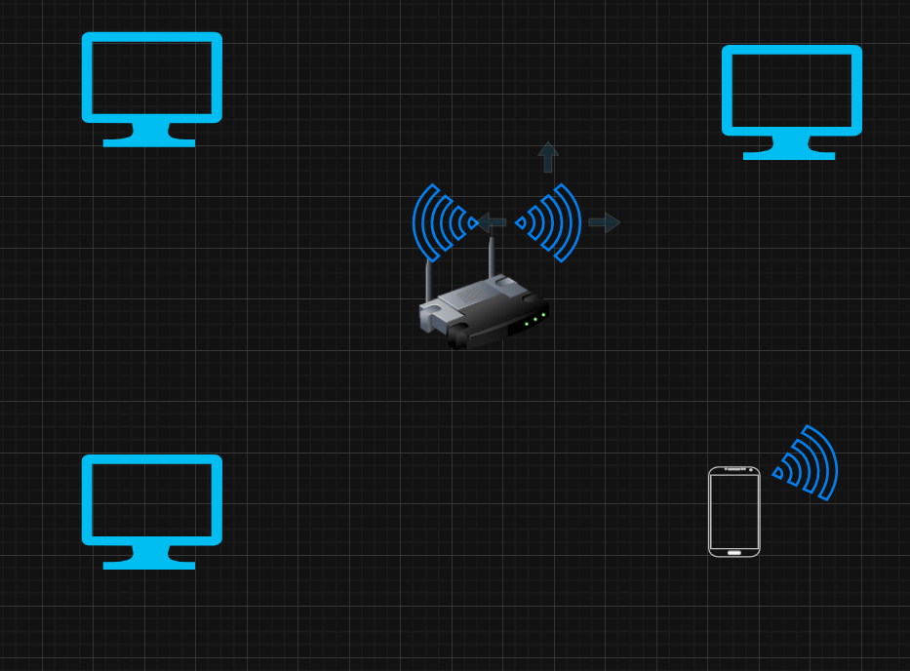
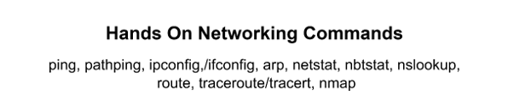CONCLUSION :
In this experiment, we successfully set up a small wireless network using a router as an access point. We configured the router, enabled DHCP on the system, and connected wireless devices to the network. Students learned how to access and configure router settings, observe DHCP in action, and verify internet access via IP-based access control.
This exercise provided a hands-on understanding of wireless networking, router configuration, and network troubleshooting commands, which are fundamental in real-world networking environments.

