Name: Abhijeet Rajguru
Class: TY-AIML-A
Roll No: 01
PRN:12310781
Batch: 3

Experiment No 2: Routing in the Internet
Problem statement: Write a program to find the shortest path using Dijkstra Equation for Link State Routing Protocol which is used by Open Shortest Path First Protocol (OSPF) in the Internet for the network flow provided by instructor.

Theory: The Link State Routing Protocol is a type of routing protocol used in computer networks to determine the shortest path from one node to another. It is based on the concept of each router or node in the network maintaining a database of its neighbors and the cost or distance to reach them. Dijkstra's algorithm is commonly employed to compute the shortest path in Link State Routing Protocol.
Dijkstra’s Working:
- Start Point: Set the distance to the starting router as 0, and all others as infinity.
- Pick Closest Router: From the unvisited routers, pick the one with the smallest known distance.
- Update Neighbors: For each neighbor of that router, check if going through it offers a shorter path. If yes, update the distance.
- Mark as Visited: Once done, mark the router as visited.
- Repeat: Keep repeating steps 2–4 until all routers are visited.
- Build Path Tree: The result is a shortest path tree showing the best routes from the starting router to all others.
Each router shares info about its direct connections with others. Then, using Dijkstra’s algorithm, every router builds its own shortest path table to all other routers in the network.

Program:
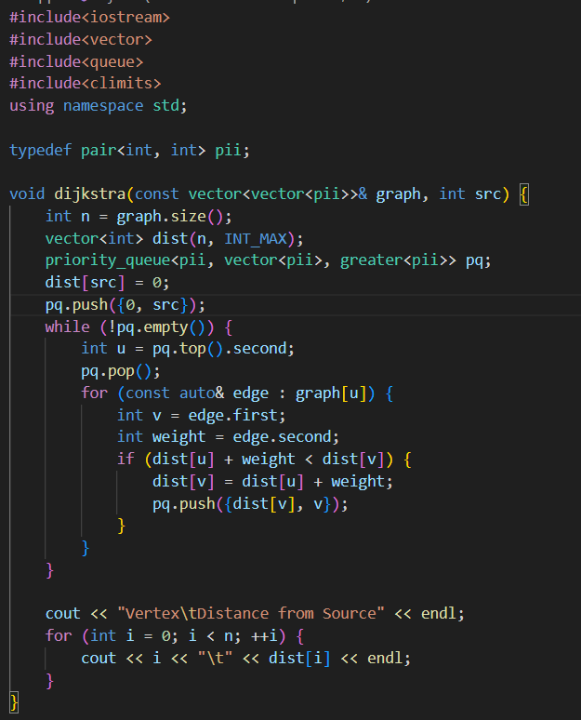
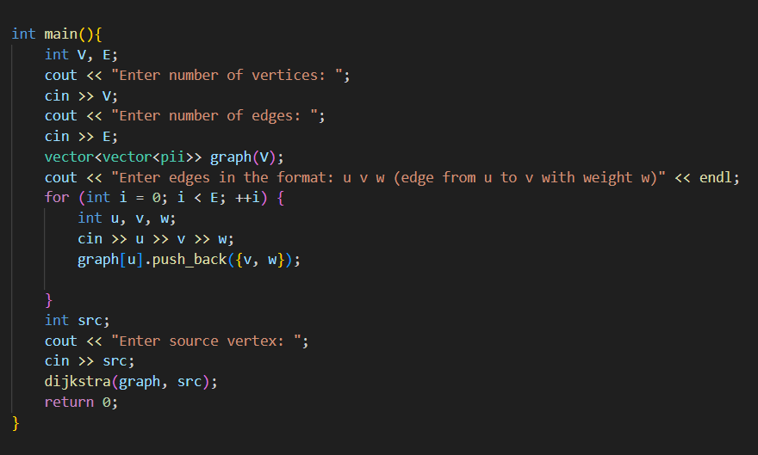

Output :
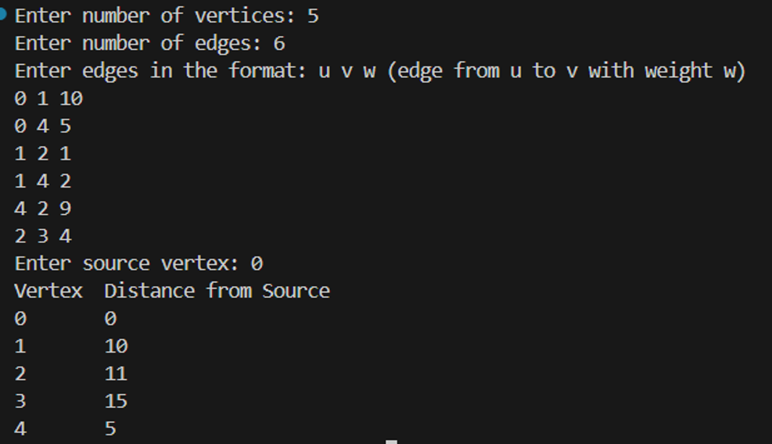

Flow chart:

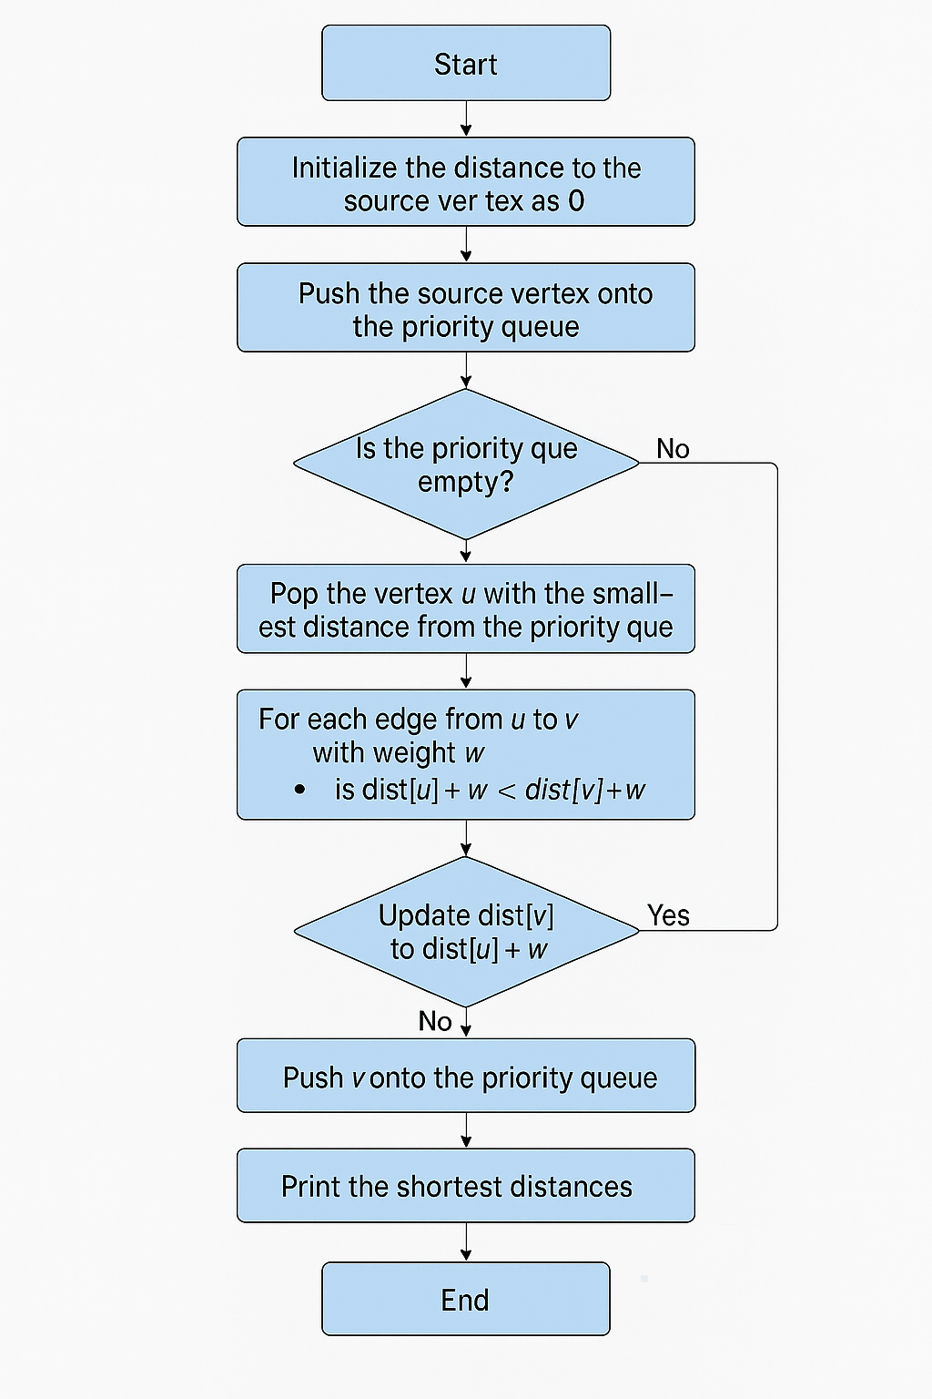

Conclusion: Dijkstra’s algorithm helps routers find the best path in a network. It uses link information to calculate the shortest routes, so data can travel faster and more reliably. This makes the Link State Routing Protocol work smoothly and efficiently.

