Bansilal Ramnath Agarwal Charitable Trust’s
VISHWAKARMA INSTITUTE OF TECHNOLOGY – PUNE

COMPUTER NETWORKS

Branch | CS - AIML
Division | A
Batch | 3
GR-no | 12310781
Roll no | 01
Name | Abhijeet Rajguru

Experiment No. 3a:

TITLE: Socket programming

PROBLEM STATEMENT:
Write the client server programs using TCP Berkeley socket primitives for wired /wireless
network for following
a. to say Hello to Each other
b. File transfer

LINUX SOCKET PROGRAMMING
The Berkeley socket interface, an API, allows communications between hosts or between processes on one computer, using the concept of a socket. It can work with many different I/O devices and drivers, although support for these depends on the operating- system implementation. This interface implementation is implicit for TCP/IP, and it is therefore one of the fundamental technologies
underlying the Internet. It was first developed at the University of California, Berkeley for use on
UNIX systems. All modern operating systems now have some implementation of the Berkeley socket interface, as it has become the standard interface for connecting to the Internet.
Programmers can make the socket interfaces accessible at three different levels, most powerfully and fundamentally at the RAW socket level. Very few applications need the degree of control over
outgoing communications that this provides, so RAW sockets support was intended to be available
only on computers used for developing Internet- related technologies. In recent years, most operating systems have implemented support for it anyway, including Windows XP.

The header files
The Berkeley socket development library has many associated header files. They include:
<sys/socket.h>
Definitions for the most basic of socket structures with the BSD socket API
<sys/types.h>
Basic data types associated with structures within the BSD socket API
<netinet/in.h>
Definitions for the socketaddr_in{} and other base data structures.
<sys/un.h>
Definitions and data type declarations for SOCK_UNIX streams

TCP provides the concept of a connection. A process creates a TCP socket by calling the socket() function with the parameters PF_INET or PF_INET6 and SOCK_STREAM.

Server
Setting up a simple TCP server involves the following steps:
- Creating a TCP socket
Call socket() to create the socket.
- Binding the socket to a listening port
  - Declare a sockaddr_in structure.
  - Clear it using bzero() or memset().
  - Set the sin_family to AF_INET or AF_INET6.
  - Set the sin_port to the listening port (in network byte order).
    - Use htons() to convert a short int from host to network byte order.
- Preparing the socket to listen
Call listen() to make the socket a listening socket.
- Accepting incoming connections
Call accept().
  - This blocks until an incoming connection is received.
  - Returns a socket descriptor for the accepted connection.
  - The original socket descriptor remains as the listening descriptor and can be used for further accept() calls until closed.
- Communicating with the remote host
Use send() and recv() for data transmission.
- Closing sockets
Call close() on each socket once it is no longer needed.
  - If fork() is used, each process must close the sockets it knows about.
  - Two processes should not use the same socket simultaneously

Client
Setting up a TCP client involves the following steps:
- Creating a TCP socket
Call socket() to create the socket.
- Connecting to the server
Call connect(), passing a sockaddr_in structure with:
  - sin_family set to AF_INET or AF_INET6
  - sin_port set to the server’s listening port (in network byte order)
  - sin_addr set to the server’s IPv4 or IPv6 address (in network byte order)
- Communicating with the server
Use send() and recv() for data transmission.
- Terminating the connection
Call close() to clean up.
  - If fork() is used, each process must close the socket it knows about.

Berkeley Socket Programming (TCP)
The Berkeley socket interface is an API that allows communication between hosts across a network or between processes on the same machine. It was first developed at the University of California, Berkeley, for UNIX systems and has since become the standard interface for Internet communication.
It supports multiple communication protocols (e.g., TCP, UDP, RAW sockets) and is available in all modern operating systems.

Important Functions
- socket(domain, type, protocol) → creates a socket.
- bind(sockfd, addr, addrlen) → assigns IP and port to a socket.
- listen(sockfd, backlog) → prepares socket to accept connections.
- accept(sockfd, cliaddr, addrlen) → accepts a client connection.
- connect(sockfd, serv_addr, addrlen) → client connects to server.
- send(sockfd, buffer, length, flags) → sends data.
- recv(sockfd, buffer, length, flags) → receives data.
- close(sockfd) → closes the socket.

Blocking vs Non-Blocking
- Blocking: Functions like accept(), recv() block until data/connection is available.
- Non-blocking: Socket functions return immediately, even if no data is available.
(Configured via fcntl() or ioctl().)

Cleaning Up
Every socket created with socket() must be closed using close().
This releases system resources and avoids memory leaks.

Applications in Assignment

a) Hello Client-Server
- Server waits for connection.
- Client connects and sends "Hello Server".
- Server replies "Hello Client".

b) File Transfer
Server:
- Create, bind, listen, and accept.
- Open a file, read data, and send() it to the client.
- Close file and socket.
Client:
- Create and connect to server.
- Receive file data using recv().
- Save received data into a file.
- Close socket.

Code:
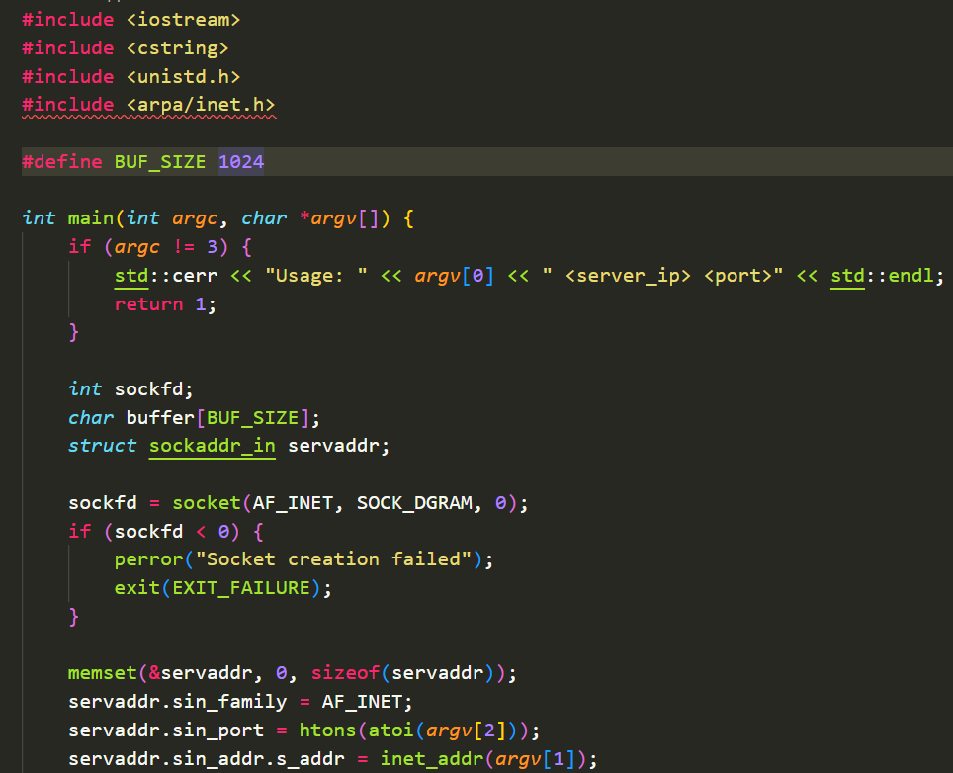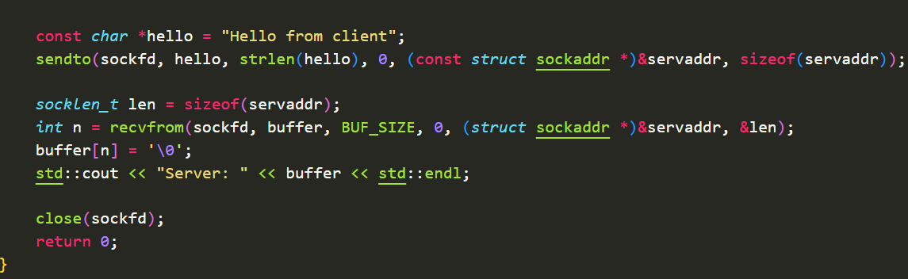

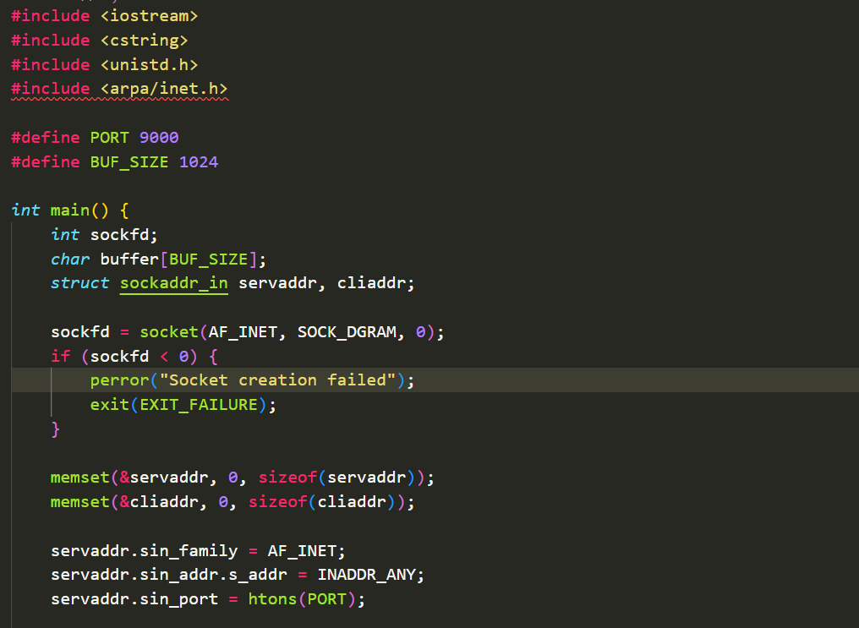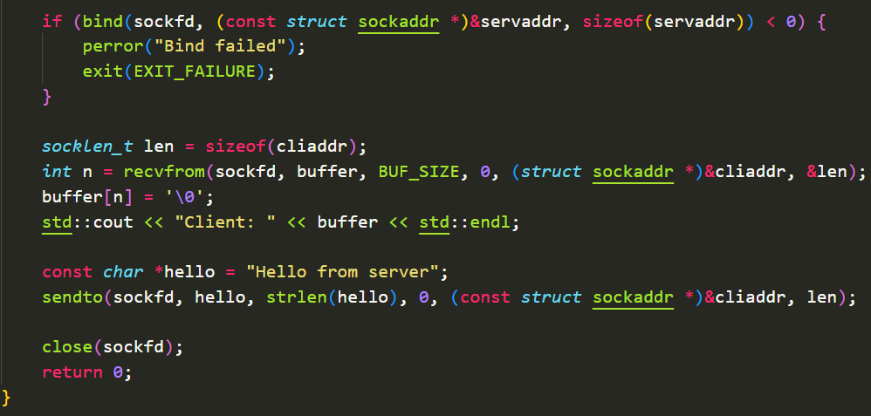

Output:

For files:

Code:-
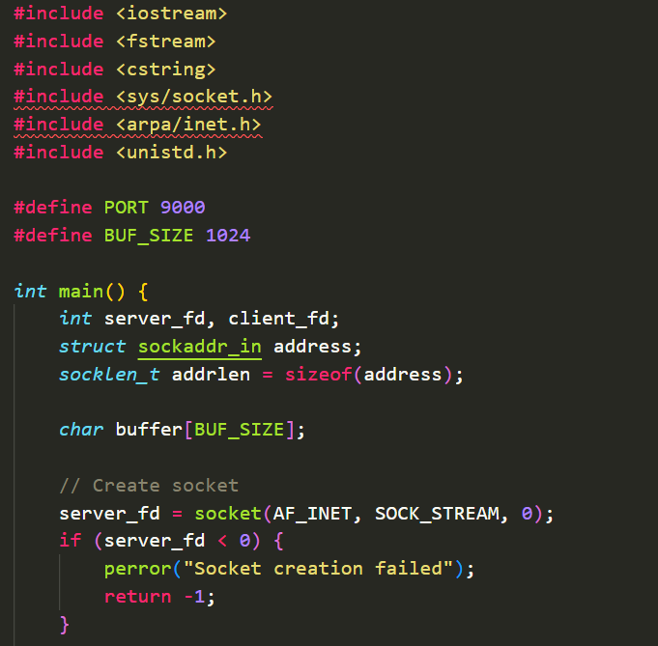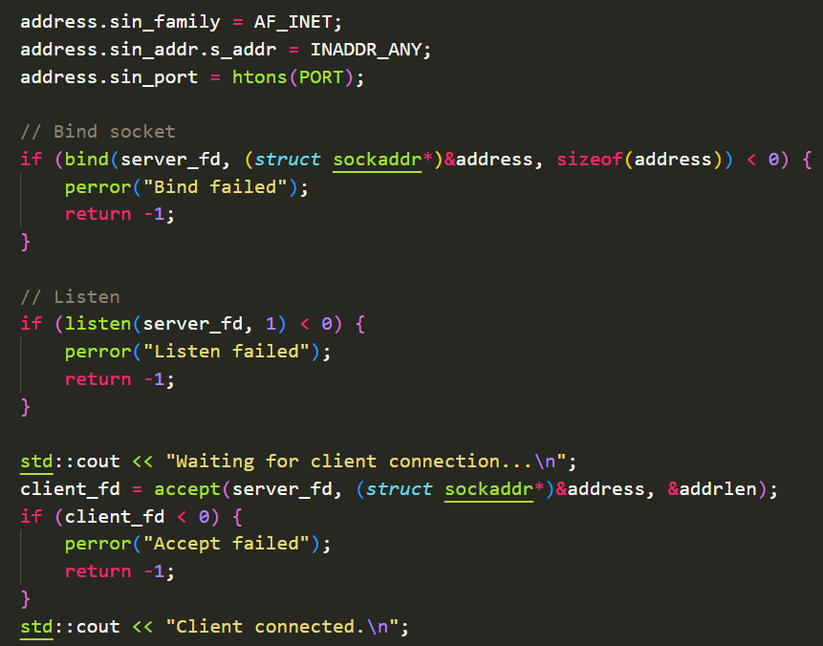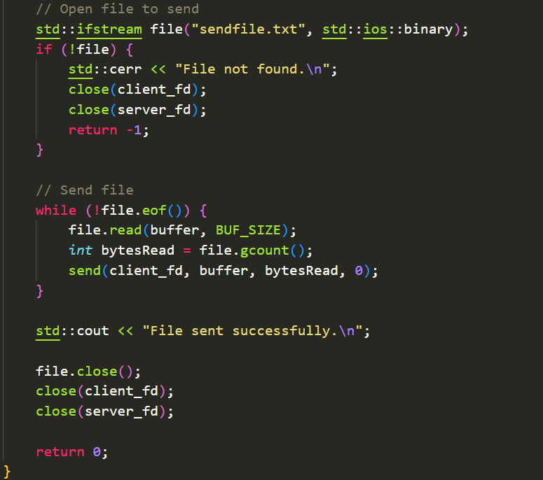

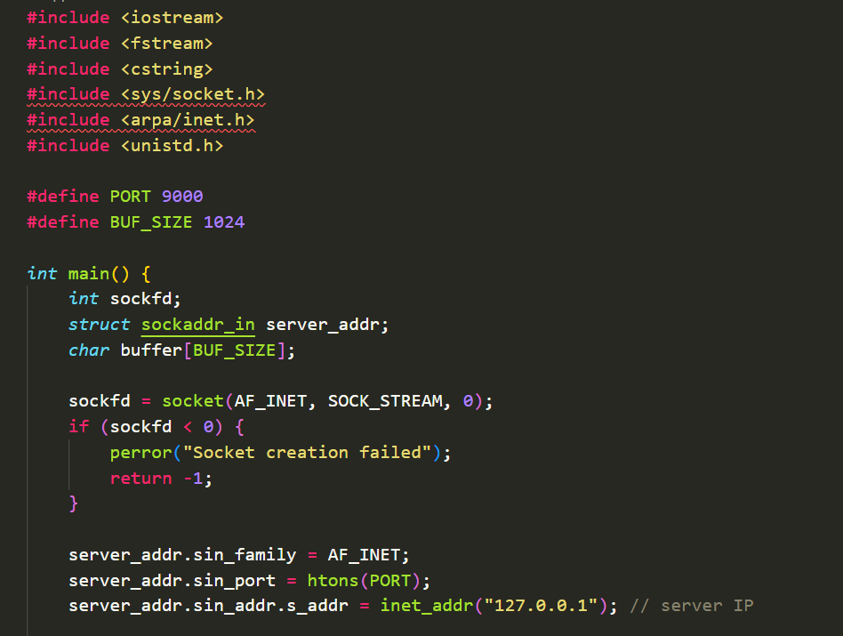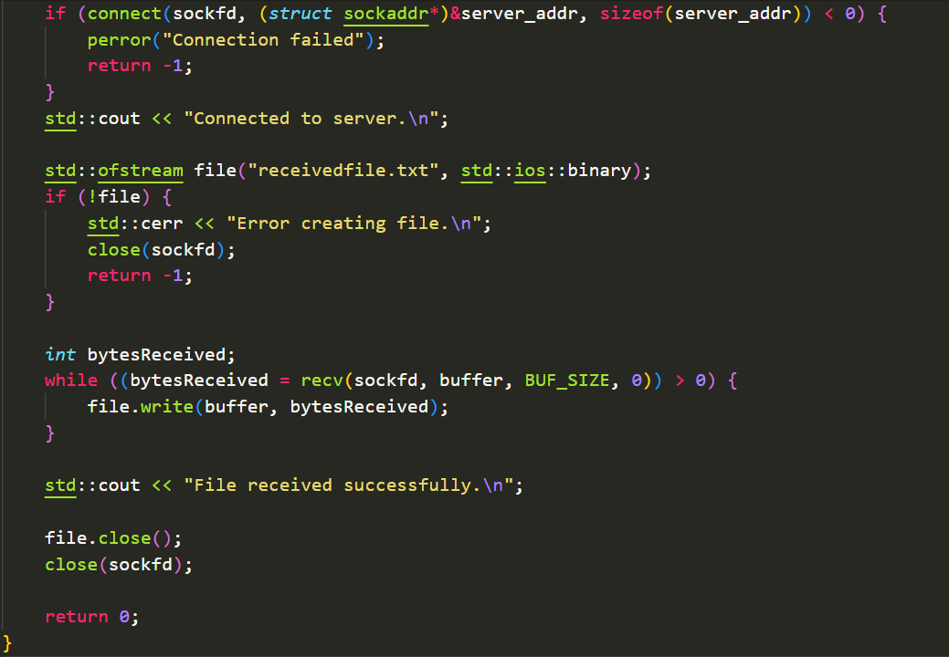

Output)

