**Defect Report**

Defect ID: DF_01

Defect Description: On ‘your spaces’ page we have public and private space created. In the private space we cannot see the symbol for ‘workflows’ which is supposed to be there as appearing in the public space.

Expected Result: User should be able to see ‘workflows’ symbol in private space.

Actual Result: User is not able to see ‘workflows’ symbol in private space.

Date and Time: 12/02/2023, 12:46pm

Steps to reproduce:

1. Open <https://hub.knime.com> in browser.
2. Sign in with your credentials.
3. Click on profile and go to ‘your spaces’.
4. Scroll down and check private work space.

Tester: Abhiraj Taral

Screenshots:

1. Open <https://hub.knime.com> in browser.

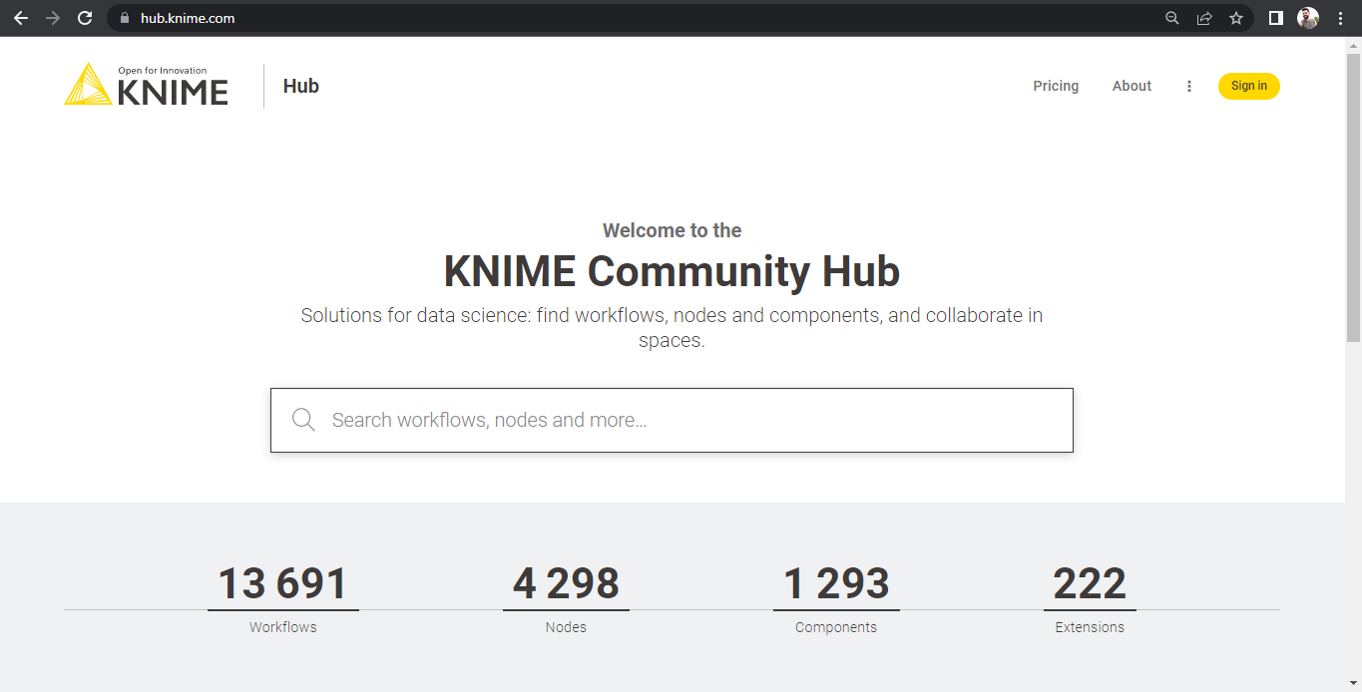

1. Sign in with your credentials.

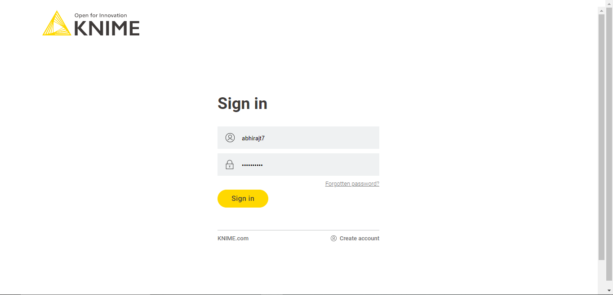

1. Once able to see hotel results, add check-in/checkout date

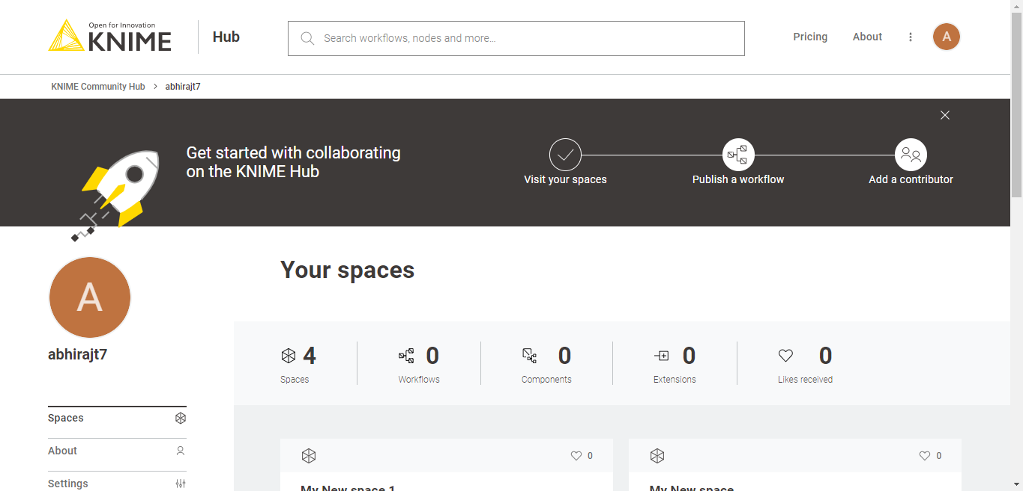

1. Scroll down and check private work space.

