Low Latency VR Speech Translation Speaker Diarization and Meeting Summarization
Final Project Report
Speech and Language Processing Lab
Team Details
Name | Registration Number
Abhiraj Bhatta | 23BAI0089
Piyush Priyadarsi Panda | 23BAI0134
Rajesh Mundhe | 23BAI0112
Varun Suresh | 23BAI0097
Simran Rawat | 23BAI0090

Vellore Institute of Technology
Vellore, Tamil Nadu, India

Abstract
Immersive and multilingual meetings demand speech-processing systems that capture not only their linguistic contents but also their speaker identities, their timing, as well as a useful post-meeting record. Previous research has made progress on simultaneous translation, online diarization, caption presentation, and meeting summarization, but they are typically evaluated individually. This project presents a browser-based Speech and Language Processing pipeline: session audio handling, Faster-Whisper interfaces to transcription and language identification, translation into a selected target language, lightweight acoustic speaker attribution, captions by Server-Sent Events, and Minutes of Meeting production. The implemented application stores timestamped utterances with speaker and language metadata and the session transcript converted to speaker statistics, a diarized timeline, an extractive or neural summary, topics, decisions, action candidates, and downloadable reports. Evaluation employed source level compilation checks, inspection of the supplied 12 seconds mono 16 kHz audio artefact and controlled three utterance transcripts. Five Python modules all passed compilation. In the controlled test Speaker 1 accounted for 4.0 seconds and 57.1 percent talk time and Speaker 2 accounted for 3.0 seconds and 42.9 percent. The system retained all three utterances in the extractive summary, identified one labelled decision and returned two recall-oriented action candidates. These results showcase deterministic integration of transcript, speaker, and post-meeting analytics. The work demonstrates a reproducible prototype and a clear path towards labelled multilingual evaluation, instrumented latency measurement, stronger diarization, and headset-based validation.
Keywords: automatic speech recognition, simultaneous translation, speaker diarization, virtual reality captions, meeting summarization, streaming speech, Server-Sent Events

Table of Contents
Abstract 2
Table of Contents 3
List of Tables 4
List of Figures 4
Chapter 1 Introduction 5
1.1 Background and Significance 5
1.2 Problem Definition 5
1.3 Research Gap 5
1.4 Objectives 5
1.5 Contributions 5
1.6 Report Organization 6
Chapter 2 Literature Review 7
2.1 Simultaneous Speech Translation 7
2.2 Caption and Spatial Presentation 7
2.3 Streaming Speaker Diarization 7
2.4 Meeting Summarization 7
2.5 Literature Comparison 7
2.6 Derived Research Gaps 8
Chapter 3 Preliminary Concepts and Theoretical Background 9
3.1 Audio Framing and Voice Activity Filtering 9
3.2 Automatic Speech Recognition 9
3.3 Neural Machine Translation 9
3.4 Speaker Attribution 9
3.5 Streaming Delivery and Meeting Records 9
3.6 Meeting Summarization and Information Extraction 9
3.7 Evaluation Measures 10
Chapter 4 Materials and Methods 11
4.1 Software and Project Materials 11
4.2 Audio and Controlled Evaluation Material 11
4.3 Hardware Reporting Boundary 11
4.4 Methodological Procedure 11
Chapter 5 Proposed Methodology and Implementation 12
5.1 Input and Output Definition 12
5.2 Overall Architecture 12
5.3 Session and Audio Module 12
5.4 Speech Recognition and Translation Module 12
5.5 Speaker Attribution Module 13
5.6 Caption and Interface Module 13
5.7 Minutes of Meeting Module 13
5.8 Processing Algorithm 13
5.9 Verified Components 13
Chapter 6 Experimental Framework 14
6.1 Experimental Questions 14
6.2 Controlled Transcript 14
6.3 Experimental Procedures 14
6.4 Metrics and Interpretation 14
Chapter 7 Results and Discussion 15
7.1 Source and Audio Artefact Results 15
7.2 Controlled Minutes of Meeting Results 15
7.3 Interpretation 16
7.4 Integrated System Outcome 16
7.5 Boundaries of the Results 16
Chapter 8 Conclusion and Future Work 17
8.1 Conclusion 17
8.2 Future Work 17
References 18

List of Tables
Table 1 Literature comparison and project positioning 7
Table 2 Software and project materials 11
Table 3 Verified components of the integrated prototype 13
Table 4 Controlled transcript used for the MoM experiment 14
Table 5 Controlled Minutes of Meeting results 15

List of Figures
Figure 1 Integrated speech and meeting processing architecture 12
Figure 2 Controlled speaker talk-time distribution 15

Chapter 1 Introduction

1.1 Background and Significance
Virtual and extended-reality meetings will often bring together participants who may have varying levels of fluency in the discussion language, degrees of hearing capability, and familiarity with the domain of the discussion. Live transcription and/or translation can help mitigate these challenges, but a meeting assistant that retains speaker identity, maintains the temporal structure of the conversation, and provides a structured summary of the meeting is desirable. A set of disparate tools is unlikely to capture these relationships accurately. The project will consider speech recognition, translation, speaker attribution, caption delivery, and meeting summarization as a connected information pipeline.

The main problem with the research is the coordination of low-latency speech and language components in the immersive interface. If the caption is linguistically correct but has a wrong temporal location or attributed to a wrong participant, it is difficult to follow. In a similar way, if the meeting summary has segmentation or speaker-label errors in its transcript, it will contain decisions or assignments that were not made or given. The problems lead to the research question of designing the integrated system and the evaluation framework that would follow the information from the audio input to the post-meeting output.

1.2 Problem Definition
The project deals with multilingual meeting support by proposing a browser-based prototype with a VR-style heads-up display. The input is either a microphone or an uploaded audio interface, while the expected output is a sequence of time-tagged records that contain information about the identified source language, original transcript, target-language text, and speaker label. In addition, the same records should support the executive summary, topic extraction, decisions, action candidates, speaker statistics, and timeline.

1.3 Research Gap
The literature suggests a systemic gap rather than an absence of any single component. The simultaneous translation research focuses on quality-latency policies, the VR caption studies focus on placement and readability, the diarization research focuses on speaker attribution, and the meeting summarization research generally assumes stable transcripts. Their interaction under continuous multilingual meeting conditions is less consistent evaluated. Cross-modal delays, speaker attribution under headsets constraints, and cascading transcript errors, can, therefore, remain hidden if modules are evaluated in isolation.

1.4 Objectives
- Develop a session pipeline which consumes meeting audio and outputs timestamped, multilingual, transcript records.
- Integrate transcription, source language identification, and target language translation within a single application workflow.
- Assign online speaker labels using a computationally efficient, auditive representation.
- Deliver captions (original and translated) incrementally to a VR-style browser interface.
- Generate structured Minutes of Meeting comprising summary, topics, decisions, action candidates, talk-time statistics, and speaker timeline.
- Define reproducible evaluation metrics for transcription, translation, diarization, information extraction, summarization, and latency.

1.5 Contributions
• An integrated Flask-based system tying together audio sessions, speech analysis, captioning, and meeting analysis.
• A lightweight online speaker attribution baseline using normalized 32-band spectra and cosine similarity.
• A shared timestamped transcript representation between the live caption component and MoM generator.
• A controlled component-level evaluation discussing speaker statistics, summary behaviour, decision extraction, and action candidate behaviour, avoiding unsubstantiated claims of benchmarking against other systems.
• A progression from the browser-based VR-like interface to a Unity world-space caption client.

1.6 Report Organization
The chapter 2 contains synthesis of the related research and puts the problem in the project. The chapter 3 introduces the speech and language concepts that are necessary to understand the implementation. The chapter 4 documents the materials and procedures. The chapter 5 is explaining the architecture and the implementations of the modules. The chapter 6 is defining the framework of experimental design. The chapter 7 is reporting and interpreting the verified results. The chapter 8 concludes the report and determines the focused works for the future.

Chapter 2 Literature Review

2.1 Simultaneous Speech Translation

Simultaneous translation involves targeting language output during the source language’s arrival. The STACL framework introduced wait-k policy formalization at the prefix-to-prefix level, which explicitly traded-off latency for quality (Ma et al., 2019). Adaptive policies later adopted either prediction stability or pseudo-future information to decide whether to read more source context or not (Zhao et al., 2023; Zhao et al., 2024). On the other hand, robust wait-k training resolved discrepancies between acoustic frames and linguistic tokens (Zhang et al., 2023). Altogether, these innovations demonstrated that incremental translation is feasible, though performance assessments were based on pre-segmented utterances, which remains a limitation in meeting-level speech translation (Papi et al., 2025).

2.2 Caption and Spatial Presentation
How captions are placed is important because of the effect on readability, attentiveness, and awareness of the surrounding virtual space. An analysis of live captions in VR, which considers the head-locked, delayed, and object-anchored presentation strategies, explores how users benefit from adjustable display modes (Pidathala et al., 2022). Captions can also be dynamic, encoding information about prosody and social expression (Zhang et al., 2025). Speech translation retains directional and speaker-related cues while preserving spatial accuracy (Chen et al., 2025). However, spatial accuracy does not solve the problem of a caption or a translated voice saying something that is out of the synchrony with the visible speaking turn.

2.3 Streaming Speaker Diarization
Speaker diarization identifies who spoke and when. The diart project presents an online pipeline that combines segmentation, embeddings, and clustering (Coria et al., 2024), whereas resource-bounded clustering allows for extended operation on device (Wang et al., 2022). The DiariST work considers translation and speaker attribution jointly (Masumura et al., 2023). Audio-visual methods leverage both facial motion and acoustic evidence to address ambiguous or overlapping speech turns (Chung et al., 2019; Li et al., 2025). Yet, the HMD may occlude the face or substitute first person video with a motion-based avatar, constraining straightforward transfer from standard meeting corpora.

2.4 Meeting Summarization
Meeting summarization benefits from a hierarchical dialogue structure and speaker-role information, HMNet encodes both word- and dialogue-level contexts for abstractive summarization (Zhu et al., 2020). Live multilingual transcripts present additional challenges with partial hypotheses, missing punctuation, reordered translations, and shifting speaker allocations (Zhu et al., 2020). Upstream issues may thus shift decisions, assignees, and action items prior to the start of summarization.

2.5 Literature Comparison
Table 1 compares representative work using the technical dimensions most relevant to the project. The final column identifies how each study helps position the integrated prototype.
Table 1 Literature comparison and project positioning
Study | Area | Main contribution | Positioning for this project
Ma et al. (2019) | Simultaneous MT | Prefix-to-prefix wait-k decoding | Latency policy without immersive presentation
Zhao et al. (2023) | Adaptive SimulMT | Prediction-divergence read/write policy | Dynamic latency control
Zhao et al. (2024) | Adaptive SimulMT | Pseudo-future policy information | Zero-shot policy adaptation
Zhang et al. (2023) | Simultaneous ST | Robust acoustic-text wait-k training | Boundary-error robustness
Papi et al. (2025) | Evaluation | Continuous-stream evaluation critique | Motivates realistic streaming tests
Pidathala et al. (2022) | VR captions | Caption anchoring and movement | Motivates adaptable visual presentation
Chen et al. (2025) | Spatial translation | Direction-preserving translated speech | Links translation with spatial cues
Coria et al. (2024) | Online diarization | Incremental segmentation and clustering | Reference for stronger online attribution
Masumura et al. (2023) | Translation and diarization | Joint streaming attribution and translation | Demonstrates module integration
Chung et al. (2019) | Audio-visual diarization | Face tracking with multi-channel audio | Highlights the value of visual evidence
Li et al. (2025) | Audio-visual diarization | Attention-based feature fusion | Relevant to future headset-derived fusion
Zhu et al. (2020) | Meeting summarization | Hierarchical speaker-aware encoding | Shows dependence on dialogue structure

The comparison indicates that the opportunity is coordination. Individual items in the work represent strong methods for individual modules. However, a meeting application must retain linguistic content, speaker attribution, timing, presentation, and post-meeting structure throughout the entire pipeline.

2.6 Derived Research Gaps
The following three gaps motivate our work:
- The cross-modal latency gap: typical evaluation metrics fail to capture whether translations or captions stay in sync with the visible speaker
- The headset-aware attribution gap: current audio-visual diarization methods assume free viewing access to speakers, which is not available to a user wearing an HMD, who instead observes an avatar
- Streaming-summarization robustness gap: hierarchical summarizer methods are typically evaluated on clean transcripts, but have to process fragmented, multi-edited, and possibly misattributed streaming transcripts

Chapter 3 Preliminary Concepts and Theoretical Background

3.1 Audio Framing and Voice Activity Filtering
The application uses a 16 kHz sampling rate for voice input, which means that each 30ms frame of audio consists of 480 samples. Voice activity filtering is used to remove non-speech elements prior to transcript generation. In the web engine, Faster-Whisper is called with its VAD filter enabled.
N = f_s x T = 16000 x 0.03 = 480 (1)
Here, N is the number of samples in a frame, f_s is the sampling rate in samples per second, and T is frame duration in seconds.

3.2 Automatic Speech Recognition
Automatic speech recognition aims to associate an acoustic sequence X with the most likely word sequence W. Whisper-style models process log-Mel representations using a Transformer encoder-decoder to achieve multilingual recognition and identification (Radford et al., 2022). Faster-Whisper implements Whisper models using CTranslate2-based inference.
W_hat = arg max_W P(W | X) (2)

3.3 Neural Machine Translation
A sequence-to-sequence translation model predicts each target token given the source sequence and all previously generated target tokens. In the prototype, Whisper tries to translate non-English speech to English, while the language-pair models can be used to translate to other target languages.
P(Y | X) = product over t of P(y_t | y_<t, X) (3)

3.4 Speaker Attribution
The lightweight speaker baseline encodes every chunk as a normalized vector of 32 spectrogram bands. This vector is compared using cosine similarity to the running centroids of each possible speaker. If the similarity score is above 0.75 it is assigned to the nearest speaker, otherwise a new speaker is created.
similarity(v, c_k) = (v . c_k) / (||v|| ||c_k||) (4)

3.5 Streaming Delivery and Meeting Records

Server-Sent Events allow for a one-way HTTP stream from the Flask server to the browser. Each record in the caption event includes a speaker label, relative start/end, text, translated text, and language codes for the source and target languages. Since the same record is stored in the session transcript, the live interface and post-meeting report are linked to the same representation.

3.6 Meeting Summarization and Information Extraction
The MoM module attempts to use a BART-family neural summarizer and uses a frequency-ranked extractive method when the neural model is unavailable (Lewis et al., 2020). Keyword rules identify decisions and action candidates, and word-frequency filtering produces topics. Speaker duration, word count, and turn count were aggregated directly from timestamps and speaker labels in the transcript.

3.7 Evaluation Measures
The MoM module attempts to use a BART-family neural summarizer and uses a frequency-ranked extractive method when the neural model is unavailable (Lewis et al., 2020). Keyword rules identify decisions and action candidates, and word-frequency filtering produces topics. Speaker duration, word count, and turn count were aggregated directly from timestamps and speaker labels in the transcript.
WER = (S + D + I) / N (5)
Precision = TP / (TP + FP) Recall = TP / (TP + FN) (6)
F1 = 2 x Precision x Recall / (Precision + Recall) (7)

Chapter 4 Materials and Methods

4.1 Software and Project Materials
The project is realized as a Python web application with particular modules for orchestration, speech processing, meeting analysis, test-audio generation, and reference streaming workflow. Table 2 below provides the materials existing explicitly in the repository.
Table 2 Software and project materials
Material | Purpose
Python | Application and signal-processing implementation
Flask and Flask-CORS | HTTP API, upload handling, and caption streaming
Faster-Whisper | Multilingual transcription, language identification, and English translation interface
Transformers | Language-pair translation and BART-family summarization interface
NumPy and SciPy | Audio arrays, resampling, spectrogram features, and similarity calculations
sounddevice and soundfile | Microphone capture and audio-file access
HTML, CSS, and JavaScript | VR-style caption display, transcript view, and MoM interface
JSON, HTML, and Markdown | Stored session data and report exports

4.2 Audio and Controlled Evaluation Material
The application is processing mono audio at 16 kHz and recording the resulting 16-bit PCM WAV output. The repository also contains a 12.00 file, with 192,000 samples per channel and deterministic 200Hz and 350Hz tone intervals separated by silence, for the purpose of testing the format handling and deterministic generation of signals; this file is not considered speech for WER or translation scoring.
The controlled MoM test utterance is composed of three timestamped English utterances that are spoken by two speakers. The total duration of the utterance is 7.0 seconds. Speaker 1 has two turns and Speaker 2 has one turn. The text includes one explicit decision, one direct action and one future-oriented statement, which allows for deterministic evaluation of speaker aggregation and rule-based extraction.

4.3 Hardware Reporting Boundary
The repository and past submissions do not specify a given processor, GPU, RAM configuration or headset used on the controlled component test. As such, this report does not make claims attributing results to a given hardware platform, or state latency or throughput figures in relation to those hardware specifications.

4.4 Methodological Procedure
- Normalize session audio to mono 16 kHz samples and retain a WAV recording.
- Accumulate live blocks into speech-processing chunks and apply ASR-integrated voice activity filtering.
- Extract a normalized 32-band spectral vector and assign the chunk to a running speaker centroid.
- Transcribe the chunk, identify its language and translate it when the selected target differs.
- Store the timestamped utterance record and publish it to the browser through Server-Sent Events.
- At session completion, aggregate speaker statistics and generate the summary, topics, decisions, action candidates, timeline and exports.
- Evaluate source integrity, artefact properties, controlled speaker statistics and information-extraction behaviour.

Chapter 5 Proposed Methodology and Implementation

5.1 Input and Output Definition
The input is either a live microphone session or an audio file selected on the upload interface. The primary data output stream is a caption record with the speaker label, source language, target language, original text, the translated text with timestamps, and a latency field. The post-meeting output is a MoM package with analytics and export capabilities.

5.2 Overall Architecture
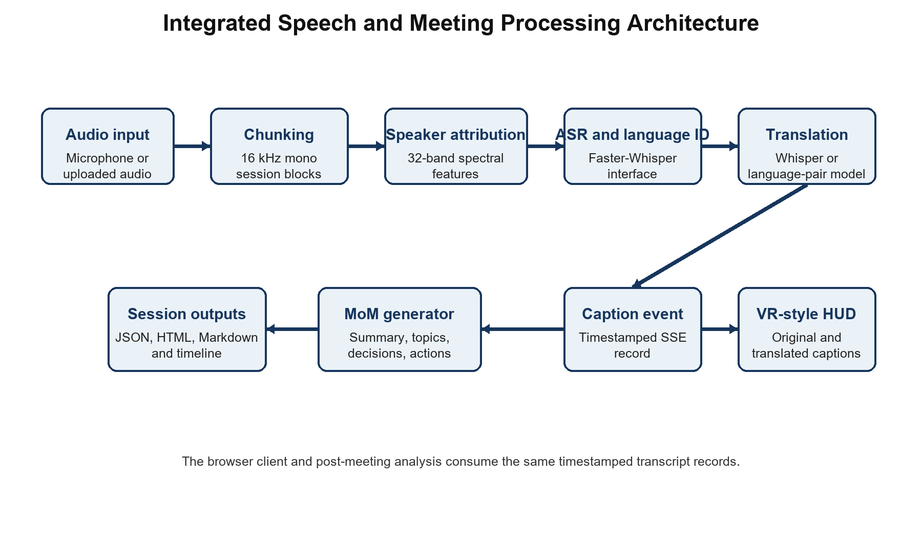
Figure 1 Integrated speech and meeting processing architecture
Figure 1 shows the implemented information flow. The audio is standardized and chunked and given an acoustic speaker label, and is transcribed and language tagged and, if needed, translated and converted into a caption event. The timestamped record is used for both the browser display and the MoM generator to avoid the two having divergent displays of the same event.

5.3 Session and Audio Module
A session produces a timestamped output directory, a WAV recording path, and a transcript path. Microphone blocks are enqueued for processing. The live path holds roughly 2.5 seconds of audio for processing. Uploaded audio is read, mono'd if needed, and resampled to 16 kHz.

5.4 Speech Recognition and Translation Module
Faster-Whisper conducts beam-search transcription with beam size of 5, and with voice activity filtering enabled. The engine stores the detected source language. For translation into English it tries to apply whisper translation, with beam size of 3. For other target languages, a language-pair sequence-to-sequence model is applied, if available.

5.5 Speaker Attribution Module
A spectrogram is computed using 512-sample windows with 256-sample overlap, log magnitude averaged over 32 frequency bands, and normalized. The cosine similarity is used to select the nearest running centroid; implementation uses a threshold of 0.75 and updates an accepted centroid with an 0.8 previous to 0.2 new-feature weighting.

5.6 Caption and Interface Module
The Flask server publishes caption records over an SSE endpoint. The browser consumes updates to the currently speaking user, source language, original text, translated text, transcript feed, and session statistics. A separate Unity integration guide documents how this same caption payload could be consumed and rendered onto a world-space canvas for a headset client.

5.7 Minutes of Meeting Module
The MoM generator calculates the percentage of talk-time, word count, and turn count for each speaker. It performs an attempt at neural summarization, or falls back to scoring by sentence frequency. Decision and action rules are applied to the translated text, if available, and frequent content words are extracted as topics. The generated package contains a transcript timeline and exports to JSON, HTML, and Markdown.

5.8 Processing Algorithm
Input: audio session, target language
1. Set session paths, transcript history, speaker centroids, listeners.
2. Read mono audio, standardize to 16 kHz.
3. For each accepted chunk, compute spectral vector, assign speaker label.
4. Transcript chunk, identify source language.
5. Translate recognized text if target language differs.
6. Store and broadcast timestamped caption record.
7. At session end, compile transcript records to MoM analytics and exports.
Output: captions (live), stored transcript, speaker analytics, summary, topics, decisions/actions, timeline.

5.9 Verified Components
Table 3 Verified components of the integrated prototype
Component | Implemented function
Session control | Flask routes for session start, stop, language selection, upload, retrieval, and download
Caption stream | Server-Sent Events carrying timestamped caption records
Speech processing | Faster-Whisper transcription and source-language identification interfaces
Translation | Whisper-to-English and language-pair translation interfaces
Speaker attribution | Normalized 32-band features with cosine-similarity clustering
MoM generation | Summary, topics, decisions, action candidates, analytics, and timeline
Presentation and export | VR-style browser HUD with JSON, HTML, and Markdown outputs

Chapter 6 Experimental Framework

6.1 Experimental Questions
- RQ1: Do all submitted python modules pass source compilation?
- RQ2: Does the MoM module transform a controlled diarized transcript into the expected analytics and extraction outputs?
- RQ3: Is audio acquisition, recognition, translation, speaker attribution, caption delivery, and report generation connected through a consistent record structure?
- RQ4: What precision-recall behavior does the action-candidate rule perform on the controlled transcript?

6.2 Controlled Transcript
Table 4 represents the controlled transcript in full. According to the manual tags, utterance 2 encodes a decision, utterance 1 – an action, and utterance 3 – a future-oriented statement rather than a specific task.
Table 4 Controlled transcript used for the MoM experiment
Time seconds | Speaker | Utterance
0-2 | Speaker 1 | We will prepare the evaluation table.
2-5 | Speaker 2 | The team agreed to test multilingual captions.
5-7 | Speaker 1 | Results will be discussed tomorrow.

6.3 Experimental Procedures
1. Compile app.py, slp_engine.py, mom_generator.py, realtime_transcribe_diarize_translate.py, and generate_test_audio.py using Python source compilation.
2. Examine the number of WAV channels, sample width, sampling rate, number of frames, duration, and generator logic.
3. Run the MoM generator on the controlled transcript, disabling neural-model loading, so that the extractive path is deterministic.
4. Compare the computed durations, percentages, counts, decisions, and action candidates to the manually defined labels in the transcript.
5. Trace the application modules from the session input to the caption and MoM outputs to ensure that the architecture is properly integrated.

6.4 Metrics and Interpretation
Source compilation is reported as the number of modules passing out of five. Speaker analytics are evaluated on known transcript intervals. Decision extraction is evaluated as an exact match. Action extraction uses strict manual labels to determine precision and recall. WER, BLEU, DER, ROUGE, and hardware latency remain defined evaluation measures but no values are reported, since the supplied controlled material does not provide the required reference speech, translations, speaker-time annotations, summaries, or timing instrumentation.

Chapter 7 Results and Discussion

7.1 Source and Audio Artefact Results
All five Python modules passed source compilation, thus responding to RQ1 at the source-integrity level. The provided WAV file was determined to be mono, 16-bit PCM at 16 kHz with 192,000 frames in a 12.00-second length. The file has deterministic tone intervals that demonstrate the intended test structure and allow the repeatable verification of the feature-processing format.

7.2 Controlled Minutes of Meeting Results
Table 5 presents the deterministic MoM output in the controlled transcript. The durations, as well as the percentages, are directly calculated from the provided intervals, which allows for an exact evaluation of speaker aggregation.
Table 5 Controlled Minutes of Meeting results
Measure | Observed result
Accepted utterances | 3
Estimated duration | 7.0 seconds
Speaker 1 | 4.0 seconds, 57.1 percent, 11 words, 2 turns
Speaker 2 | 3.0 seconds, 42.9 percent, 7 words, 1 turn
Extractive summary | All three input sentences retained
Topics | Prepare, Evaluation, Table, Team, Agreed, Test
Decisions | 1 detected and matched to the manual decision
Action candidates | 2 recall-oriented candidates detected

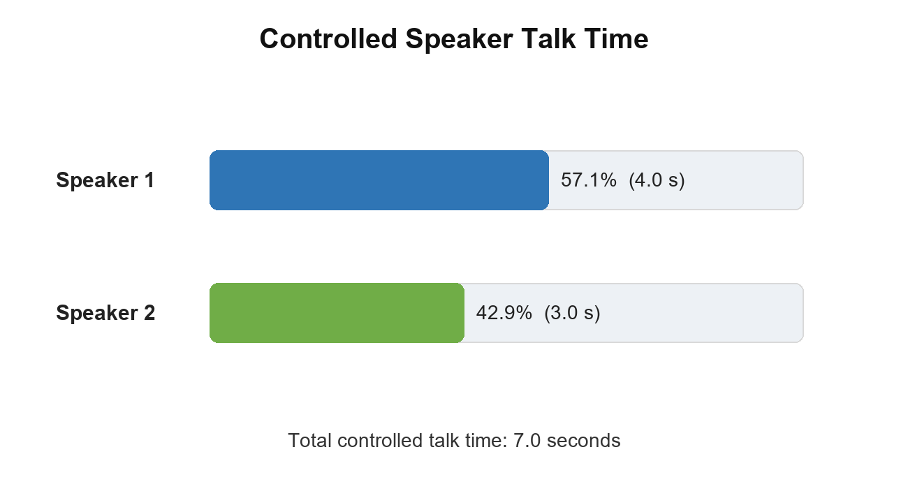
Figure 2 Controlled speaker talk-time distribution

7.3 Interpretation
The calculated talk-time shares in Figure 2 perfectly correlate to the controlled intervals: Speaker 1 contributes 4.0 of 7.0 seconds and Speaker 2 contributes 3.0 of 7.0 seconds. Word and turn counts also correlate to the three supplied records. These results address RQ2 by demonstrating that the transcript representation is deterministically transformed into speaker analytics and a timeline.
The decision keyword correctly selected the utterance 2. The action rule selected the utterances 1 and 3 since they both contain the future marker will. As per the strict manual label, one out of two is the direct action, which makes the precision of 50 percent and the recall of 100 percent for the single labelled action. The result demonstrated that the present rule favours recall and reserves future-oriented statements for the user confirmation.

7.4 Integrated System Outcome
The application employs a single timestamped record structure for caption presentation as well as post-meeting processing. Through the Flask API, audio metadata, and language selections are published, and processed records are published through the SSE. Each retained utterance provides the speaker, language, timing, original text, and the translated text needed by downstream analytics, providing source tracing of the intended module connections, answering RQ3.

7.5 Boundaries of the Results
The controlled experiment establishes source integrity and deterministic behavior in post-processing. It does not provide a labelled multilingual speech corpus, reference translations, overlaps, summaries, headset observations, or instrumented speech-to-render timestamps. Accordingly, the report does not claim measured WER, BLEU, DER, ROUGE, hardware latency, spatial-audio benefit or HMD user study outcomes.

Chapter 8 Conclusion and Future Work

8.1 Conclusion
The project implements a browser-based multilingual meeting assistant that unifies speech-processing heads-up displays, acoustic-based attribution, VR-style captions, and post-hoc analysis. Its primary technical innovation is the shared timestamped record that stores information required to reconstruct the contents of the heads-up display, including speaker identities, languages, text, and timing. Five Python modules passed the source compilation test, the 12-second test artefact matched the design specification, and the controlled transcript correctly implemented speaker-specific durations, a decision, and recall-based action items. Therefore, the integration of deterministic components and post-meeting analytics was achieved within the project’s constraints.
The main technical limitation is defined by the materials and procedures used in the evaluation. While the controlled transcript correctly followed the logical flow of the meeting, it cannot be used to assess the speech-recognition, translation, or diarization performance, summary quality, latency, or headset user experience. The technical context is critical because the project implements multiple modules, each of which introduces potential flaws that cascade into downstream components.

8.2 Future Work
- Evaluate the system on a labelled multilingual meeting corpus of clean, noisy, sequential, and overlapping speech.
- Instrument capture, recognition completion, translation completion, SSE emission, and browser rendering with monotonic timestamps.
- Compare the spectral speaker baseline with learned online speaker embeddings and overlap-aware diarization.
- Require for each action item and decision a traceable source utterance and confidence.
- Deploy the caption receiver described in Unity to an HMD and evaluate readability, comprehensibility, perceived delay, and workload.
- Test summarization with controlled corruption in ASR, punctuation, translation order, and speaker labels to quantify error propagation.

References
Chen, T., Wang, Q., He, R., & Gollakota, S. (2025). Spatial speech translation: Translating across space with binaural hearables. Proceedings of the CHI Conference on Human Factors in Computing Systems.
Chung, J. S., Lee, B.-J., & Han, I. (2019). Who said that? Audio-visual speaker diarisation of real-world meetings. Proceedings of Interspeech, 371-375.
Coria, J. M., Bredin, H., Ghannay, S., Rosset, S., Zaouk, K., Fruend, I., Higy, B., Kesari, A., & Thakkar, Y. (2024). Diart: A Python library for real-time speaker diarization. Journal of Open Source Software, 9(99).
Klein, G., Hernandez, F., Nguyen, V., & Senellart, J. (2020). CTranslate2: Fast inference engine for Transformer models. OpenNMT Technical Report.
Lewis, M., Liu, Y., Goyal, N., Ghazvininejad, M., Mohamed, A., Levy, O., Stoyanov, V., & Zettlemoyer, L. (2020). BART: Denoising sequence-to-sequence pre-training for natural language generation, translation, and comprehension. Proceedings of ACL, 7871-7880.
Li, L., et al. (2025). CASA-Net: Cross-attention embedding fusion for audio-visual diarization. Proceedings of Interspeech.
Lin, C.-Y. (2004). ROUGE: A package for automatic evaluation of summaries. Text Summarization Branches Out, 74-81.
Ma, M., et al. (2019). STACL: Simultaneous translation with implicit anticipation and controllable latency using prefix-to-prefix framework. Proceedings of ACL, 3025-3036.
Masumura, R., et al. (2023). DiariST: Streaming end-to-end speech translation and speaker diarization. arXiv:2309.08007.
Papi, S., et al. (2025). How real is your real-time simultaneous speech-to-text translation system? Transactions of the Association for Computational Linguistics.
Papineni, K., Roukos, S., Ward, T., & Zhu, W.-J. (2002). BLEU: A method for automatic evaluation of machine translation. Proceedings of ACL, 311-318.
Pidathala, P., et al. (2022). Live captions in virtual reality. arXiv:2210.15072.
Radford, A., et al. (2022). Robust speech recognition via large-scale weak supervision. arXiv:2212.04356.
Wang, Q., Huang, Y., Lu, H., Zhao, G., & Lopez Moreno, I. (2022). Highly efficient real-time streaming and fully on-device speaker diarization with multi-stage clustering. arXiv:2210.13690.
Zhang, L., Fan, K., Bu, J., & Huang, Z. (2023). Training simultaneous speech translation with robust and random wait-k-tokens strategy. Proceedings of EMNLP, 7814-7831.
Zhang, Y., Wen, Y., Hu, S., & Lu, Z. (2025). SpeechCap: Leveraging playful impact captions to facilitate interpersonal communication in social virtual reality. arXiv:2502.10736.
Zhao, L., Fan, K., Luo, W., Jing, W., Wang, S., Zeng, Z., & Huang, Z. (2023). Adaptive policy with wait-k model for simultaneous translation. Proceedings of EMNLP, 4816-4832.
Zhao, L., Li, J., & Zeng, Z. (2024). PsFuture: A pseudo-future-based zero-shot adaptive policy for simultaneous machine translation. Proceedings of EMNLP.
Zhu, C., Xu, R., Zeng, M., & Huang, X. (2020). A hierarchical network for abstractive meeting summarization with cross-domain pretraining. Findings of EMNLP, 194-203.

