Functional Design
Display screen start with this.

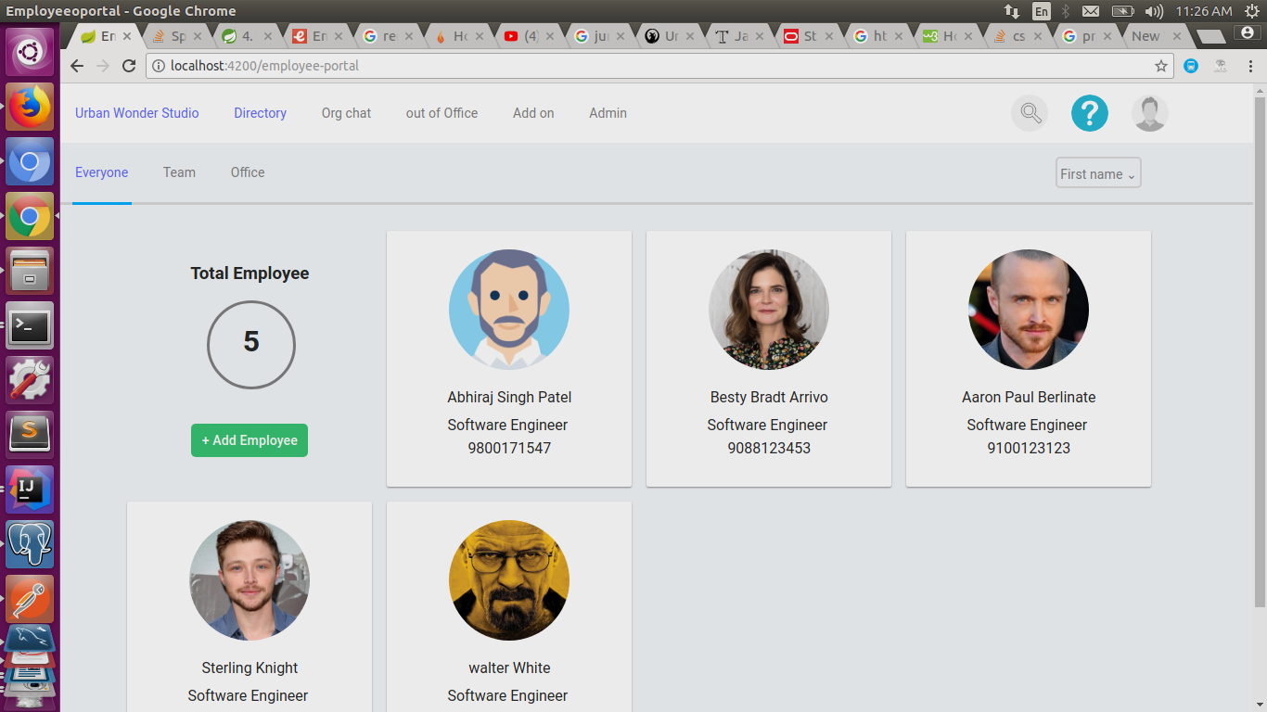
After clicking on add employee page the form input look like this, where * mark are mandatory and
auto validation is there for required feild.

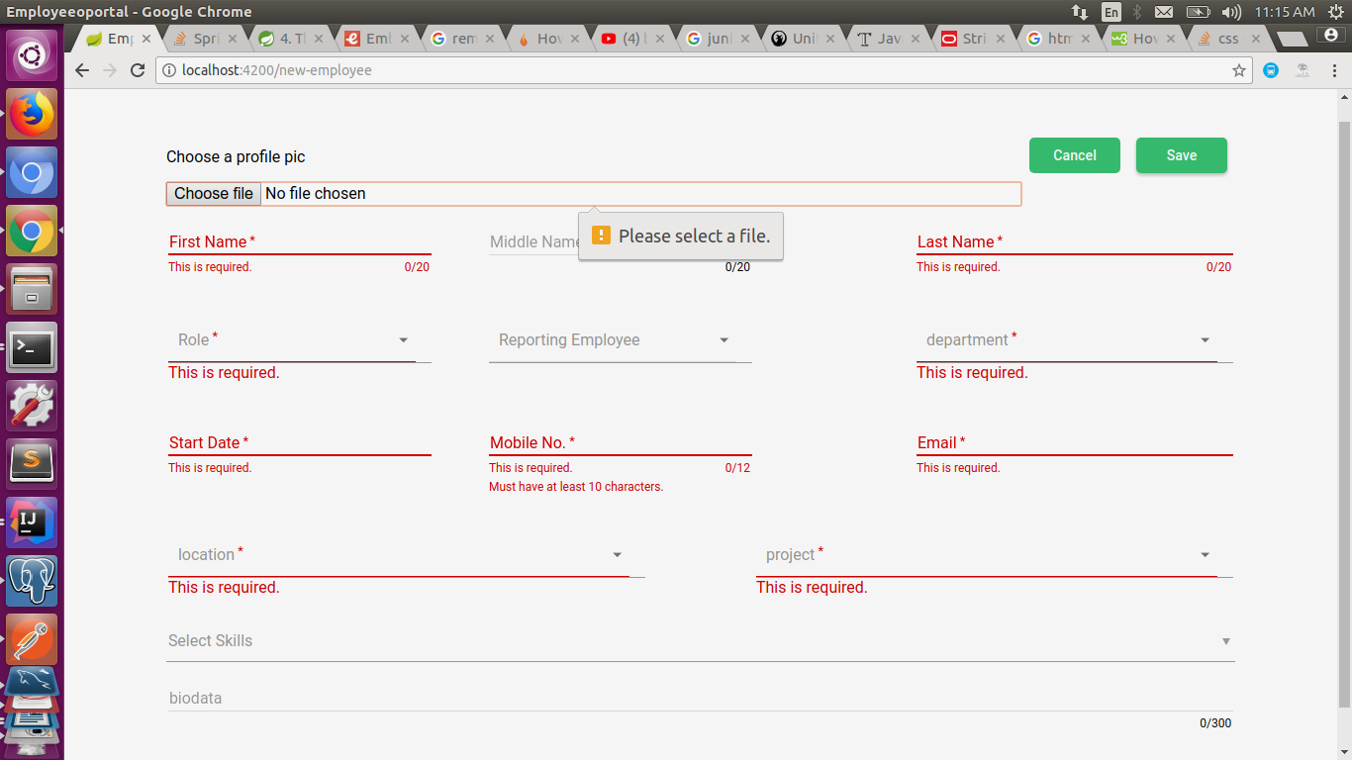

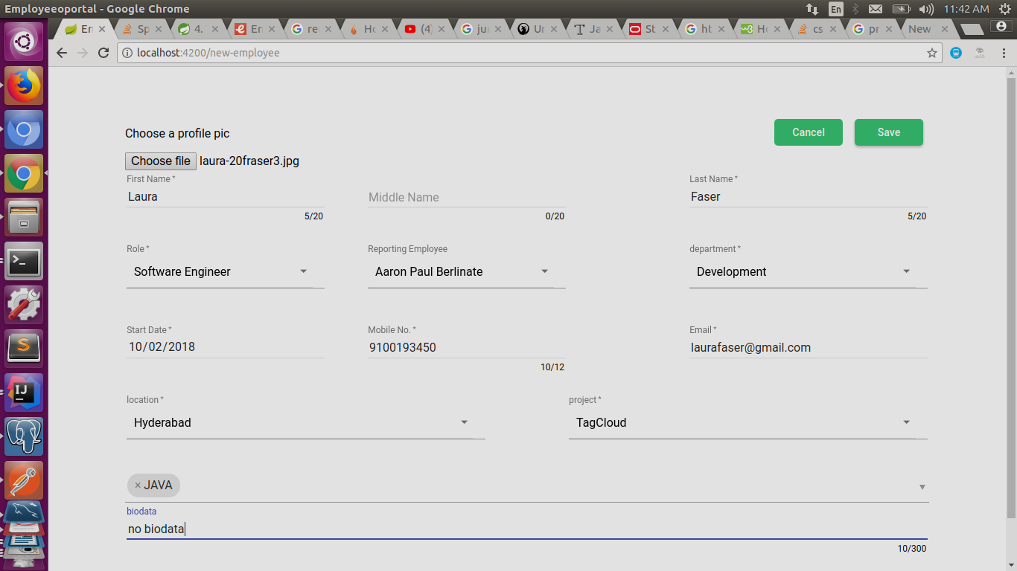
when all feild are full.

Design of table .
All relationship are defiend asmentioned.

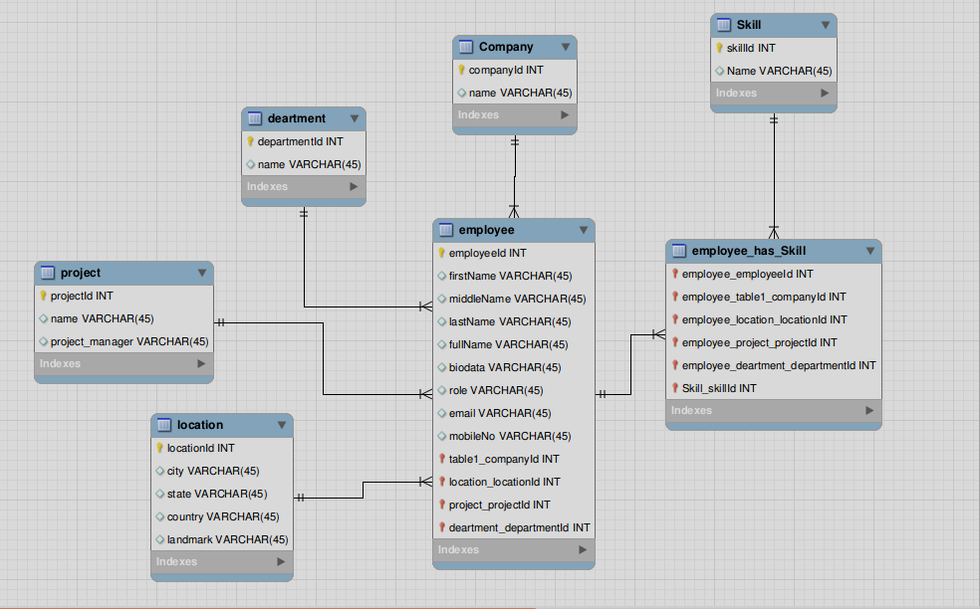
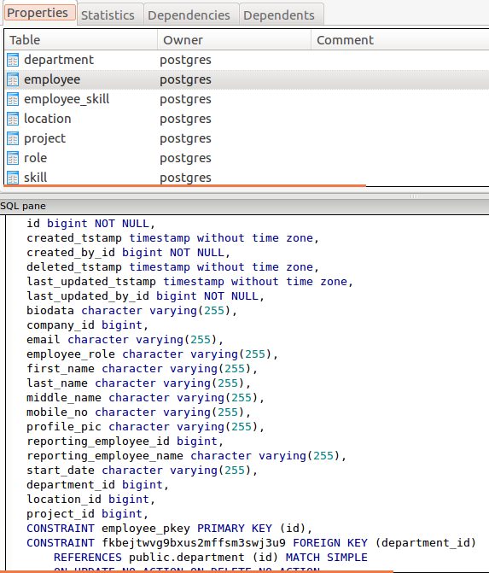
Code design

Rest Api in controller -> mapper(map to object and object to map conversion) -> services and then
return responce

one Entity is shown for Example.

