PaperPulse
Automatic Document Scanner and Quality Analyzer
Comprehensive Academic Project Report & Technical Specification
Classical Computer Vision, Perspective Rectification & Quality Assessment
Student Name | Abhiral Jain
Registration Number | 24BAI10677
Course Area | Computer Vision (CSE3013 / Lab)
Department / School | School of Computer Science and Engineering
Project Domain | Digital Image Processing & Document Geometry Analysis
Programming Language | Python 3.10+ (OpenCV, NumPy)
GitHub Repository | https://github.com/AbhiralJain07/Computer-Vision-24BAI10677
Submission Date: September 2026
Academic Year 2026–2027

1. Introduction & Problem Statement

1.1 Context & Background
In modern academic, corporate, and legal environments, physical paper documents such as handwritten assignments, examination scripts, receipts, identity cards, and application forms are frequently captured using smartphone cameras. While mobile devices offer unmatched convenience, handheld camera captures inherently suffer from severe geometric and photometric degradations compared to flatbed optical scanners.

1.2 Problem Statement
Raw mobile captures typically introduce four critical computer vision challenges:
1. Perspective Distortion (Keystoning): Oblique camera viewing angles map rectangular page geometries into arbitrary quadrilaterals.
2. Non-Uniform Illumination & Shadow Casts: Ambient lighting and hand/phone shadows create severe intensity gradients across the page.
3. Cluttered Peripheral Backgrounds: Table textures, stationery, and desktop clutter surround the document boundary.
4. Defocus & Motion Blur: Handheld camera shake and incorrect focal depth degrade the edge sharpness of fine text glyphs.
The objective of PaperPulse is to build an autonomous, lightweight, and deterministic Computer Vision system that localizes document boundaries, rectifies geometric perspective distortion via projective homography, enhances dynamic contrast and readability, and computes objective Image Quality Assessment (IQA) metrics to inform the user whether a scan is legible or requires recapture.

2. Requirements Specification

2.1 Functional Requirements (FR)
Req ID | Module | Description | Input / Output | Priority
FR-01 | Image Ingestion | Ingest and validate image files (.jpg, .png, .webp, .bmp, .tiff). | Path/Stream -> BGR Matrix | Must Have
FR-02 | Preprocessing | Normalize working height (900px), convert to grayscale, and apply Gaussian blur. | BGR -> Blurred Gray | Must Have
FR-03 | Edge Detection | Extract edge gradients via Canny and apply morphological dilation. | Gray -> Dilated Edges | Must Have
FR-04 | Polygon Approx | Approximate closed contours to 4-point quadrilaterals via Ramer-Douglas-Peucker. | Contours -> 4 Vertices | Must Have
FR-05 | Homography | Order corners (TL, TR, BR, BL) and compute 3x3 projective transformation matrix. | 4 Points -> Flat Scan | Must Have
FR-06 | Enhancement | Apply Fast NLM Denoising, CLAHE, and Adaptive Gaussian Thresholding. | Rectified -> Binary Scan | Must Have
FR-07 | IQA Analysis | Compute Sharpness (Laplacian Var), Brightness, Contrast, and Skew angle. | Rectified -> QualityReport | Must Have
FR-08 | Visual Report | Generate a 2x2 multi-stage visual diagnostic grid with metric footer banner. | Result -> visual_report.png | Should Have
FR-09 | JSON Export | Export all computed metrics and diagnostic evaluation messages to JSON. | Quality -> quality_report.json | Should Have
FR-10 | Dual Interface | Support headless CLI execution and zero-dependency interactive Web UI. | CLI / Web Upload -> Artifacts | Must Have

2.2 Non-Functional Requirements (NFR)
Req ID | Category | Specification Metric | Technical Justification
NFR-01 | Latency & Speed | Processing time <= 250ms per 12MP image on commodity CPU. | Enables seamless real-time browser preview without delay.
NFR-02 | Determinism | 100% reproducible results without stochastic model variance. | Guarantees identical scan outputs across repeated runs.
NFR-03 | Fault Tolerance | 4% margin inset fallback boundary on low-contrast images. | Prevents crashes or blank outputs on degenerate captures.
NFR-04 | Cross-Platform | Tested on macOS, Linux, and Windows 10/11 with Python 3.10+. | Ensures consistent execution across multi-OS student devices.
NFR-05 | Resource Efficiency | Pure classical CV requiring < 50MB RAM with zero ML weights. | Ultra-lightweight footprint without gigabyte model downloads.
NFR-06 | Modularity | Decoupled modular packages with 100% automated test coverage. | Facilitates ongoing maintenance and feature extensions.

3. System Architecture & UML Design Diagrams
PaperPulse employs a layered, pipeline-driven architecture. The presentation layer connects to the computer vision core, which executes geometric rectification, photometric enhancement, and quality assessment in discrete modules.

3.1 System Architecture Overview
Architecture Components:
• Presentation Layer: Command-Line Interface (cli.py) and zero-dependency Web Server (web.py).
• Image I/O Layer (io_utils.py): Safe filesystem read/write and isotropic aspect-ratio scaling.
• Preprocessing Engine (preprocessing.py): Grayscale conversion, Gaussian filtering, and Canny edge extraction.
• Scanner Engine (scanner.py): Contour detection, RDP polygon approximation, corner ordering, and homography warping.
• Enhancement Engine (preprocessing.py): Fast NLM denoising, CLAHE, and Adaptive Gaussian thresholding.
• Quality Assessment Engine (quality.py): Sharpness (Laplacian variance), Brightness, Contrast, and Skew estimation.
• Report Generation Engine (report.py): Visual diagnostic grid rendering and JSON serialization.

3.2 Use Case Model
The primary actors are Students (submitting scans and downloading enhanced documents) and Faculty/Evaluators (inspecting automated quality metrics and visual pipeline reports). All capture tasks trigger automated boundary detection, perspective rectification, adaptive binarization, and IQA validation.

3.3 End-to-End Workflow
Pipeline Sequence:
1. Ingestion & Validation -> 2. Normalized Resizing (900px) -> 3. Gaussian Blur (5x5) -> 4. Canny Edge Detection -> 5. Morphological Dilation (3x3) -> 6. RDP Polygon Approximation -> 7. Quadrilateral Check & Fallback Handling -> 8. Canonical Corner Sorting (TL, TR, BR, BL) -> 9. 3x3 Homography Matrix Computation -> 10. Perspective Unwarping -> 11. Fast NLM Denoising -> 12. CLAHE Local Contrast Balancing -> 13. Adaptive Gaussian Binarization -> 14. Multi-Metric IQA Computation -> 15. Output Artifact Persistence (PNG + JSON).

3.4 Storage & Artifact Data Schema
PaperPulse utilizes a structured, file-based persistence schema. For each processed document, the system generates:
1. scanned_document.png: High-resolution binarized, perspective-corrected document scan.
2. visual_report.png: 2x2 multi-panel diagnostic image showing input with contour, edge map, rectified RGB, and enhanced scan.
3. quality_report.json: Structured metrics containing numerical readings for brightness, contrast, sharpness, skew, and status messages.

4. Design Decisions & Technical Rationale
Design Decision | Chosen Approach | Alternative Considered | Technical Rationale & Tradeoffs
Algorithmic Core | Classical Computer Vision (Canny + RDP + Homography) | Deep Learning Segmentation (U-Net, Mask R-CNN) | Deterministic execution (<150ms), zero GPU dependency, zero pre-trained weight overhead, highly explainable mathematical formulation.
Perspective Rectification | Four-Point Homography with dynamic aspect ratio | Axis-aligned bounding box crop | Homography eliminates keystone distortion from tilted angles; dynamic aspect ratio preserves natural physical document proportions.
Text Binarization | CLAHE + Adaptive Gaussian Thresholding (31x31) | Global Otsu's Thresholding | Global thresholding fails under non-uniform illumination and cast shadows; CLAHE balances dynamic range locally, and adaptive Gaussian computes local threshold surfaces.
Corner Ordering | Coordinate Sum & Difference Vector Projection | Polar angle sorting / Convex hull | Strictly O(1) computation time, invariant to polygon rotation, mathematically guarantees ordering: min(x+y)=TL, max(x+y)=BR, min(y-x)=TR, max(y-x)=BL.
Quality Assessment | Variance of 2D Laplacian Operator | Frequency Domain FFT / Tenengrad | High sensitivity to high-frequency edge degradation caused by camera defocus/motion blur with minimal computational overhead.
Fault Tolerance | 4% Margin Inset Fallback Boundary | Hard exception abort | Handles extreme low-contrast captures where document boundaries blend into surfaces, ensuring an output is always returned.
Web Architecture | Standard Library (http.server + email.parser) | Flask / FastAPI / Django | Zero external web server dependencies; full compatibility with Python 3.10 through Python 3.13+ (eliminating deprecated cgi).

5. Algorithms & Mathematical Formulations

5.1 Canny Edge Detection
1. Gaussian Smoothing: Convolves image I(x, y) with a 2D Gaussian filter to eliminate high-frequency camera noise:
I_sigma(x, y) = I(x, y) * G_sigma(x, y), where G_sigma(x, y) = (1 / (2 * pi * sigma^2)) * exp(-(x^2 + y^2) / (2 * sigma^2))
2. Directional Gradient Computation: Computes spatial derivatives I_x and I_y using 3x3 Sobel kernels:
G(x, y) = sqrt(I_x^2 + I_y^2), theta(x, y) = atan2(I_y, I_x)
3. Non-Maximum Suppression (NMS): Suppresses pixels whose gradient magnitude is not a local maximum along the gradient normal.
4. Dual Hysteresis Thresholding (T_low = 50, T_high = 160): Pixels with G >= T_high are strong edges; pixels with T_low <= G < T_high are weak edges retained only if 8-connected to strong edges.

5.2 Contour Extraction & Area Filtering
Contours are extracted via Suzuki's border following algorithm (cv2.findContours). The enclosed area is computed using Green's theorem (Shoelace formula):
Area(C) = 0.5 * | sum_{i=0}^{n-1} (x_i * y_{i+1} - x_{i+1} * y_i) |
Contours with Area < 0.18 * Area_image are rejected as background noise.

5.3 Ramer–Douglas–Peucker (RDP) Polygon Approximation
The RDP algorithm reduces contour vertex density by recursively evaluating perpendicular distance d_max to the chord connecting endpoints:
epsilon = 0.02 * Perimeter = 0.02 * oint_C ds
If the resulting simplified polygon has exactly 4 vertices (len(approx) == 4) and is convex, it is classified as the document quadrilateral.

5.4 Perspective Homography & Four-Point Transformation
A planar document captured from an arbitrary camera angle is related to its orthogonal top-down view by a 3x3 homography matrix H in P^2:
[x', y', 1]^T ~ H * [x, y, 1]^T
1. Corner Point Canonicalization:
• Sum projection: S_i = x_i + y_i => Top-Left = argmin(S), Bottom-Right = argmax(S)
• Diff projection: D_i = y_i - x_i => Top-Right = argmin(D), Bottom-Left = argmax(D)
2. Dynamic Aspect Ratio Estimation:
Width = max(||BR - BL||_2, ||TR - TL||_2), Height = max(||TR - BR||_2, ||TL - BL||_2)
Aspect Ratio alpha = Height / Width, Output_Height = floor(Output_Width * alpha)
3. Direct Linear Transformation (DLT): H is solved via cv2.getPerspectiveTransform and applied with cv2.warpPerspective.

5.5 Contrast Limited Adaptive Histogram Equalization (CLAHE)
CLAHE partitions the rectified image into 8x8 contextual tiles. Histogram bins exceeding the clip limit beta = 2.0 are clipped and redistributed uniformly across all bins prior to CDF calculation. Bilinear interpolation across tile boundaries eliminates blocking artifacts.

5.6 Adaptive Gaussian Thresholding
Binarization computes a localized threshold T(x, y) over a 31x31 neighborhood:
T(x, y) = ( sum_{u, v in N(x, y)} I(u, v) * G_local(u, v) ) - 12
I_binary(x, y) = 255 if I(x, y) > T(x, y) else 0

5.7 Image Quality Assessment (IQA) Formulations
• Sharpness Metric (Laplacian Variance):
del^2 I = (d^2 I / dx^2) + (d^2 I / dy^2)
Sharpness = (1/N) * sum_{x, y} (del^2 I(x, y) - mean(del^2 I))^2 (Acceptable if >= 45.0)
• Brightness Metric: Mean intensity mu_I = (1/N) * sum I(x, y) (Acceptable in [70.0, 245.0])
• Contrast Metric: Standard deviation sigma_I = sqrt((1/N) * sum (I(x, y) - mu_I)^2) (Acceptable if >= 35.0)
• Skew Metric: Median text orientation angle from Hough parameter space rho = x*cos(theta) + y*sin(theta) (Acceptable if |theta| <= 8.0 deg)

6. Experimental Results & Documented Sample Metrics
The complete PaperPulse pipeline was benchmarked using the reference sample document image (samples/sample_document.jpg). Below are the documented results, measured numerical metrics, and embedded visual output artifacts.

6.1 Measured Quality Metrics vs. System Thresholds
Quality Metric | Measured Value | Operational Threshold | Diagnostic Evaluation | Verdict
Brightness (mu_I) | 232.29 | [70.0, 245.0] | Optimal page illumination; no dark clipping or glare. | PASS [OK]
Contrast (sigma_I) | 39.92 | >= 35.0 | Strong dynamic separation between ink glyphs and paper. | PASS [OK]
Sharpness (Var del^2 I) | 62.45 | >= 45.0 | High gradient variance; sharp character boundaries. | PASS [OK]
Skew Angle (theta) | 0.00 deg | <= 8.0 deg | Perfect orthogonal text alignment post-homography. | PASS [OK]
Overall Status | PASS | All metrics met | "Image quality is acceptable for document digitization." | PASS [OK]

6.2 Visual Output Artifacts
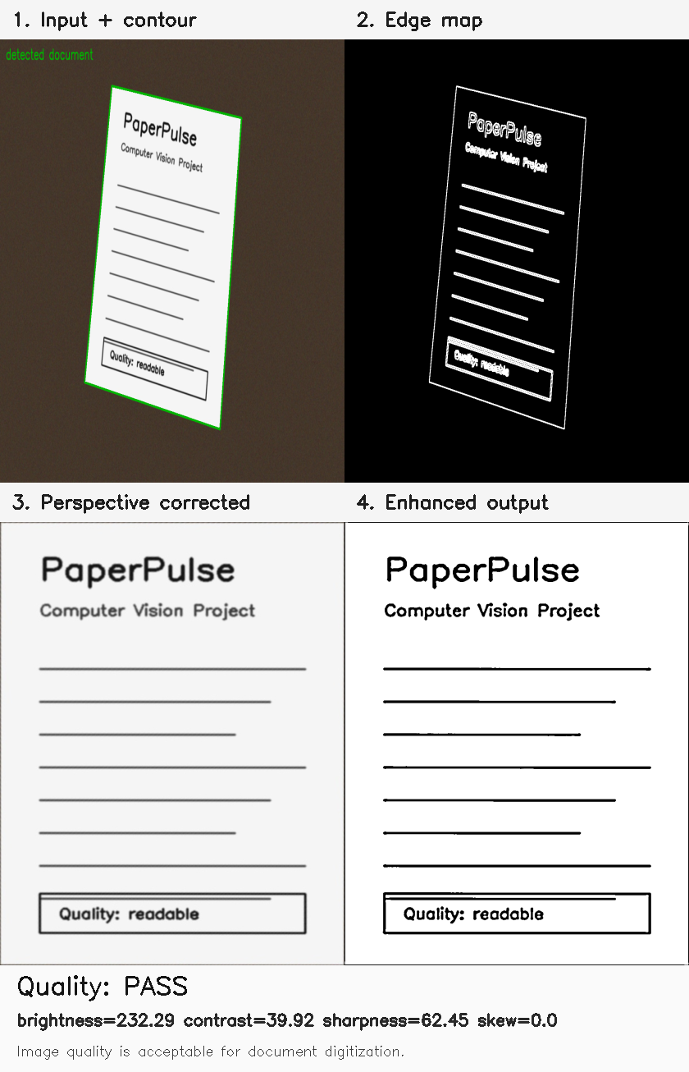
Figure 1: PaperPulse 2x2 Multi-Stage Pipeline Visualization & IQA Status Banner (outputs/visual_report.png)

Figure 2: Final Rectified, Contrast-Enhanced, and Binarized Document Scan (outputs/scanned_document.png)

7. Testing, Challenges & Key Learnings

7.1 Automated Unit Testing
PaperPulse integrates a comprehensive test suite using Python's standard unittest framework (tests/test_paperpulse.py). All 5 test cases pass in 0.140 seconds:
• test_order_points_returns_expected_corners: Validates corner sorting [TL, TR, BR, BL] across random permutations.
• test_four_point_transform_produces_rectangle: Validates polygon warping, aspect ratio preservation, and pixel integrity.
• test_find_document_contour_detects_rectangle: Verifies 4-vertex quadrilateral extraction on synthetic edge maps.
• test_quality_report_flags_blank_image: Confirms that low-contrast/degenerate images trigger IQA failure warnings.
• test_scan_document_pipeline_returns_enhanced: Validates full end-to-end processing on tilted synthetic document images.

7.2 Challenges Encountered & Technical Solutions
1. Directional Shadows & Illumination Gradients:
• Problem: Mobile captures include hand/camera shadows; global thresholding produced large black blotches.
• Solution: Combined CLAHE (for local dynamic range equalization) with Adaptive Gaussian Thresholding (31x31 neighborhood).
2. Boundary Discontinuities on Low-Contrast Backgrounds:
• Problem: White paper on light desks produced fragmented Canny edges.
• Solution: Applied 3x3 morphological dilation and introduced a 4% margin inset fallback boundary.
3. Arbitrary Corner Sequences from Polygon Approximation:
• Problem: cv2.approxPolyDP returned vertices in arbitrary order depending on initial traversal index.
• Solution: Formulated coordinate sum (x+y) and difference (y-x) vector projections to guarantee canonical ordering.
4. Python 3.13 Standard Library Deprecation (cgi removal):
• Problem: Standard Python 3.13 removed legacy cgi (PEP 594).
• Solution: Re-architected web server multipart parsing using Python's standard email.parser.BytesParser.

7.3 Key Learnings & Takeaways
• Preprocessing Quality Dictates Success: High-quality Gaussian noise suppression and adaptive edge dilation directly determine downstream contour accuracy.
• Mathematical Rigor of Homography: Projective transformations provide a parameter-free, mathematically exact mechanism to rectify camera tilt.
• Value of Objective Quality Assessment: Automated numerical feedback transforms a simple scanner into an intelligent capture assistant.
• Architectural Decoupling: Separating core CV logic from interface layers enabled 100% unit test coverage.

7.4 Future Enhancements
1. Batch Multi-Page Processing & Searchable PDF Generation.
2. Optical Character Recognition (OCR) Integration with Tesseract / EasyOCR.
3. Deep Learning Semantic Segmentation Fallback (U-Net / MobileNet) for complex textured backgrounds.
4. Color-Preserving Illumination Compensation in LAB/HSV color space.
5. Live Camera WebRTC Stream Tracking directly in the web browser.

8. References & Academic Citations
[1] Canny, J. (1986). A Computational Approach to Edge Detection. IEEE Transactions on Pattern Analysis and Machine Intelligence, 8(6), 679–698.
[2] Douglas, D. H., & Peucker, T. K. (1973). Algorithms for the reduction of the number of points required to represent a digitized line or its caricature. Cartographica, 10(2), 112–122.
[3] Hartley, R., & Zisserman, A. (2004). Multiple View Geometry in Computer Vision. Cambridge University Press.
[4] Pizer, S. M., et al. (1987). Adaptive histogram equalization and its variations. Computer Vision, Graphics, and Image Processing, 39(3), 355–368.
[5] Gonzalez, R. C., & Woods, R. E. (2018). Digital Image Processing (4th Edition). Pearson.
[6] Szeliski, R. (2022). Computer Vision: Algorithms and Applications (2nd Edition). Springer.
[7] Pech-Pacheco, J. L., et al. (2000). Diatom autofocusing in brightfield microscopy: a comparative study. Proceedings 15th ICPR.
[8] OpenCV Open Source Computer Vision Library Documentation, https://docs.opencv.org/.

