#1.Provide the list of markets in which customer "Atliq Exclusive" operates its business in the APAC region.

select distinct(market)

from dim_customer

where customer = "Atliq Exclusive" and region = "APAC";

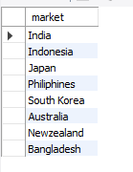

#2. What is the percentage of unique product increase in 2021 vs. 2020?

The final output contains these fields, unique_products_2020 unique_products_2021 percentage_chg

with unique_products_2021 as (

select count(distinct(product_code)) as unique_products_2021

from fact_sales_monthly where fiscal_year = 2021),

unique_products_2020 as(

select count(distinct(product_code)) as unique_products_2020

from fact_sales_monthly where fiscal_year = 2020)

select

*,((unique_products_2021 -unique_products_2020)/unique_products_2020)*100 as percentage_chg

from unique_products_2021,unique_products_2020

;

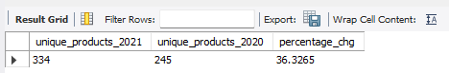

#3. Provide a report with all the unique product counts for each segment and sort them in descending order of product counts.

The final output contains 2 fields,segment product_count

select

segment,

count(distinct(product)) as product_count

from dim_product

group by segment

order by product_count;

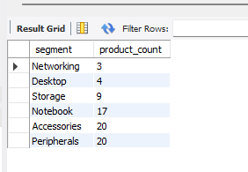

4. Follow-up: Which segment had the most increase in unique products in 2021 vs 2020?

The final output contains these fields, segment product_count_2020 product_count_2021 difference

with product_count_2021 as (

select

p.segment,

count(distinct(product)) as product_count_2021

from dim_product p

join fact_sales_monthly s

on p.product_code=s.product_code

where s.fiscal_year = 2021

group by segment

order by product_count_2021),

product_count_2020 as (

select

p.segment,

count(distinct(product)) as product_count_2020

from dim_product p

join fact_sales_monthly s

on p.product_code=s.product_code

where s.fiscal_year = 2020

group by segment

order by product_count_2020)

select

p21.segment,

p21.product_count_2021,

p20.product_count_2020,

(p21.product_count_2021-p20.product_count_2020) as difference

from product_count_2021 p21

join product_count_2020 p20

on p21.segment=p20.segment;

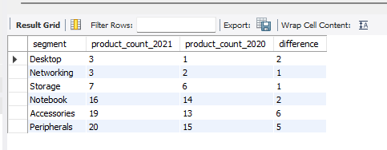

5. Get the products that have the highest and lowest manufacturing costs.

The final output should contain these fields, product_code product manufacturing_cost

Sol:

with max_cost as (

select

product_code,

max(manufacturing_cost) as manufacturing_cost

from fact_manufacturing_cost),

min_cost as (

select

product_code,

min(manufacturing_cost) as manufacturing_cost

from fact_manufacturing_cost)

select * from max_cost

union

select * from min_cost;

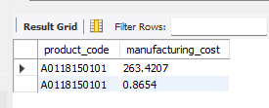

6. Generate a report which contains the top 5 customers who received an average high pre_invoice_discount_pct for the fiscal year 2021 and in the Indian market. The final output contains these fields, customer_code customer average_discount_percentage

Sol:

select

pi.customer_code,

c.customer,

avg(pi.pre_invoice_discount_pct) as average_discount_percentage

from fact_pre_invoice_deductions pi

join dim_customer c

on pi.customer_code = c.customer_code

where

pi.fiscal_year = 2021

and c.market = "India"

group by pi.customer_code,c.customer_code

order by average_discount_percentage desc

limit 5;

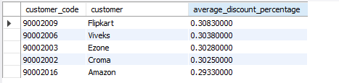

7. Get the complete report of the Gross sales amount for the customer “Atliq Exclusive” for each month . This analysis helps to get an idea of low and high-performing months and take strategic decisions.The final report contains these columns: Month Year Gross sales Amount

select

month(date_add(`date` , interval 4 month)) as month,

fiscal_year,

sum(gross_sales) as gross_sales

from gross_sales

where customer = "Atliq Exclusive"

group by fiscal_year,month;

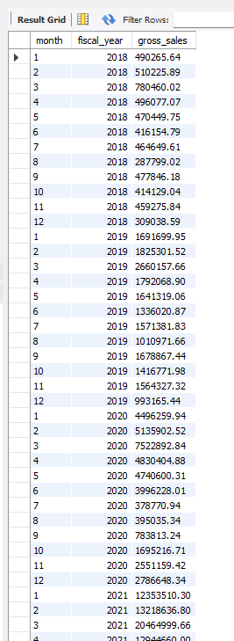

9. Which channel helped to bring more gross sales in the fiscal year 2021 and the percentage of contribution? The final output contains these fields, channel gross_sales_mln percentage

Sol:

with gs as(

select

c.channel,

round(sum(s.sold_quantity*g.gross_price)/1000000,2) as gross_sales_mln

from dim_customer c

join fact_sales_monthly s using(customer_code)

join fact_gross_price g using(product_code)

where s.fiscal_year = 2021

group by c.channel)

select

channel,

gross_sales_mln,

round((gross_sales_mln/(select sum(gross_sales_mln) from gs))*100,2) as percentage

from gs

order by gross_sales_mln desc;

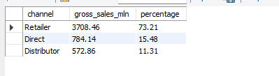

10.Get the Top 3 products in each division that have a high total_sold_quantity in the fiscal_year 2021?

The final output contains these fields, division product_code product total_sold_quantity rank_order

select * from dim_product;

with sd as(

select

p.division,

p.product_code,

p.product,

format(sum(sold_quantity),0)as total_sold_quantity,

dense_rank() over(partition by division order by sum(sold_quantity) desc) as rank_order

from dim_product p

join fact_sales_monthly s

using (product_code)

where fiscal_year = 2021

group by p.product_code)

select

*

from sd

where rank_order <= 3 ;

