RV College of Engineering®, Bengaluru – 59
Department of Information Science and Engineering
DATABASE MANAGEMENT SYSTEMS (CD252IA)
Software Requirement Specification
TITLE: VeriSphere: An AI-Assisted Academic Profile and Skill Verification Platform with a Normalized PostgreSQL Core and a MongoDB Evidence Store
TEAM | 1RV24IS006 | Abhijay M S
TEAM | 1RV24IS007 | Abhiram K
- Hardware Requirement Specification
Component | Minimum (demo and testing) | Recommended (development)
Processor | Intel Core i5 10th gen or Ryzen 5 3600 (4 cores) | Intel Core i7 12th gen or Ryzen 7 5800 (8 cores)
RAM | 8 GB DDR4 | 16 GB (Node, both databases and Chromium run together)
Storage | 256 GB SSD, 20 GB free | 512 GB NVMe SSD, 50 GB free
Graphics, display | Integrated GPU, 1366 x 768 | Integrated GPU (LLM runs on Groq cloud), 1920 x 1080
Network | Broadband, 10 Mbps | Broadband, 25 Mbps or more (Groq, GitHub, cloud DB)
Database host | Local install or free cloud tiers | Self hosted: 2 vCPU, 4 GB RAM, 50 GB SSD
- Software Requirement Specification
Operating system: Windows 10 or 11 (64 bit), Ubuntu 22.04 or macOS 12 and above.
Runtime and language: Node.js 18 or above, pnpm 8 or above (monorepo workspaces), TypeScript 5, Express 4.
Relational database: PostgreSQL 15 or above (Supabase hosted), accessed through Prisma ORM 5 with pooled and direct connection URLs.
NoSQL database (proposed): MongoDB 7 (Atlas or local Docker) with the MongoDB Node driver.
Libraries and services: pdf-parse for resume text, Handlebars and Puppeteer (Chromium) for the PDF report, Groq API (llama-3.3-70b-versatile) for semantic matching, GitHub REST API token, helmet, cors and morgan for API hardening.
Tools: VS Code, Git, Prisma Studio, pgAdmin, MongoDB Compass, and Chrome or Edge as the browser.
- Functional Requirements
FR1. Register a candidate and accept a resume PDF, certificate files and a GitHub URL.
FR2. Create a verification job and track its status as QUEUED, ANALYZING, COMPLETED or FAILED.
FR3. Parse the resume and store education, certificates and skills as relational records.
FR4. Run forensic checks on certificates (metadata rules, issuer and institution email domain, accreditation).
FR5. Analyse the GitHub profile (repositories, languages, commits) and detect technologies.
FR6. Use the language model to match claims with evidence and list contradictions.
FR7. Compute a trust score from 0 to 100 and store risk indicators with type and severity.
FR8. Generate an audit report that can be viewed online and exported as PDF.
FR9. Store raw evidence in MongoDB and findings in PostgreSQL, saving the report in one transaction.
FR10. Provide recruiter login with ADMIN, RECRUITER and VIEWER roles and log every action in AUDIT_LOG.
FR11. List and search jobs by status or candidate, show a dashboard view and verify report integrity with a hash chain (proposed).
- Non-Functional Requirements
NFR1. Performance: asynchronous pipeline, a job finishes in about a minute, indexed reads under 500 ms.
NFR2. Reliability: ACID transactions protect report saving, and a MongoDB outage does not stop verification.
NFR3. Security: hashed passwords, role based access, secrets in environment variables, TLS, helmet and CORS.
NFR4. Privacy: candidate personal data is accessible only to authorised roles and every access is audited.
NFR5. Scalability: pooled connections, indexes on status and candidate, stateless API instances.
NFR6. Usability and explainability: every score is shown with its risk indicators, contradictions and evidence.
NFR7. Maintainability and portability: typed TypeScript monorepo, versioned SQL scripts, runs on Windows, Linux and macOS.
RV College of Engineering®, Bengaluru – 59
Department of Information Science and Engineering
DATABASE MANAGEMENT SYSTEMS (CD252IA)
TITLE: VeriSphere: An AI-Assisted Academic Profile and Skill Verification Platform with a Normalized PostgreSQL Core and a MongoDB Evidence Store
TEAM | 1RV24IS006 | Abhijay M S
TEAM | 1RV24IS007 | Abhiram K

Entity Relationship Diagram and Schema
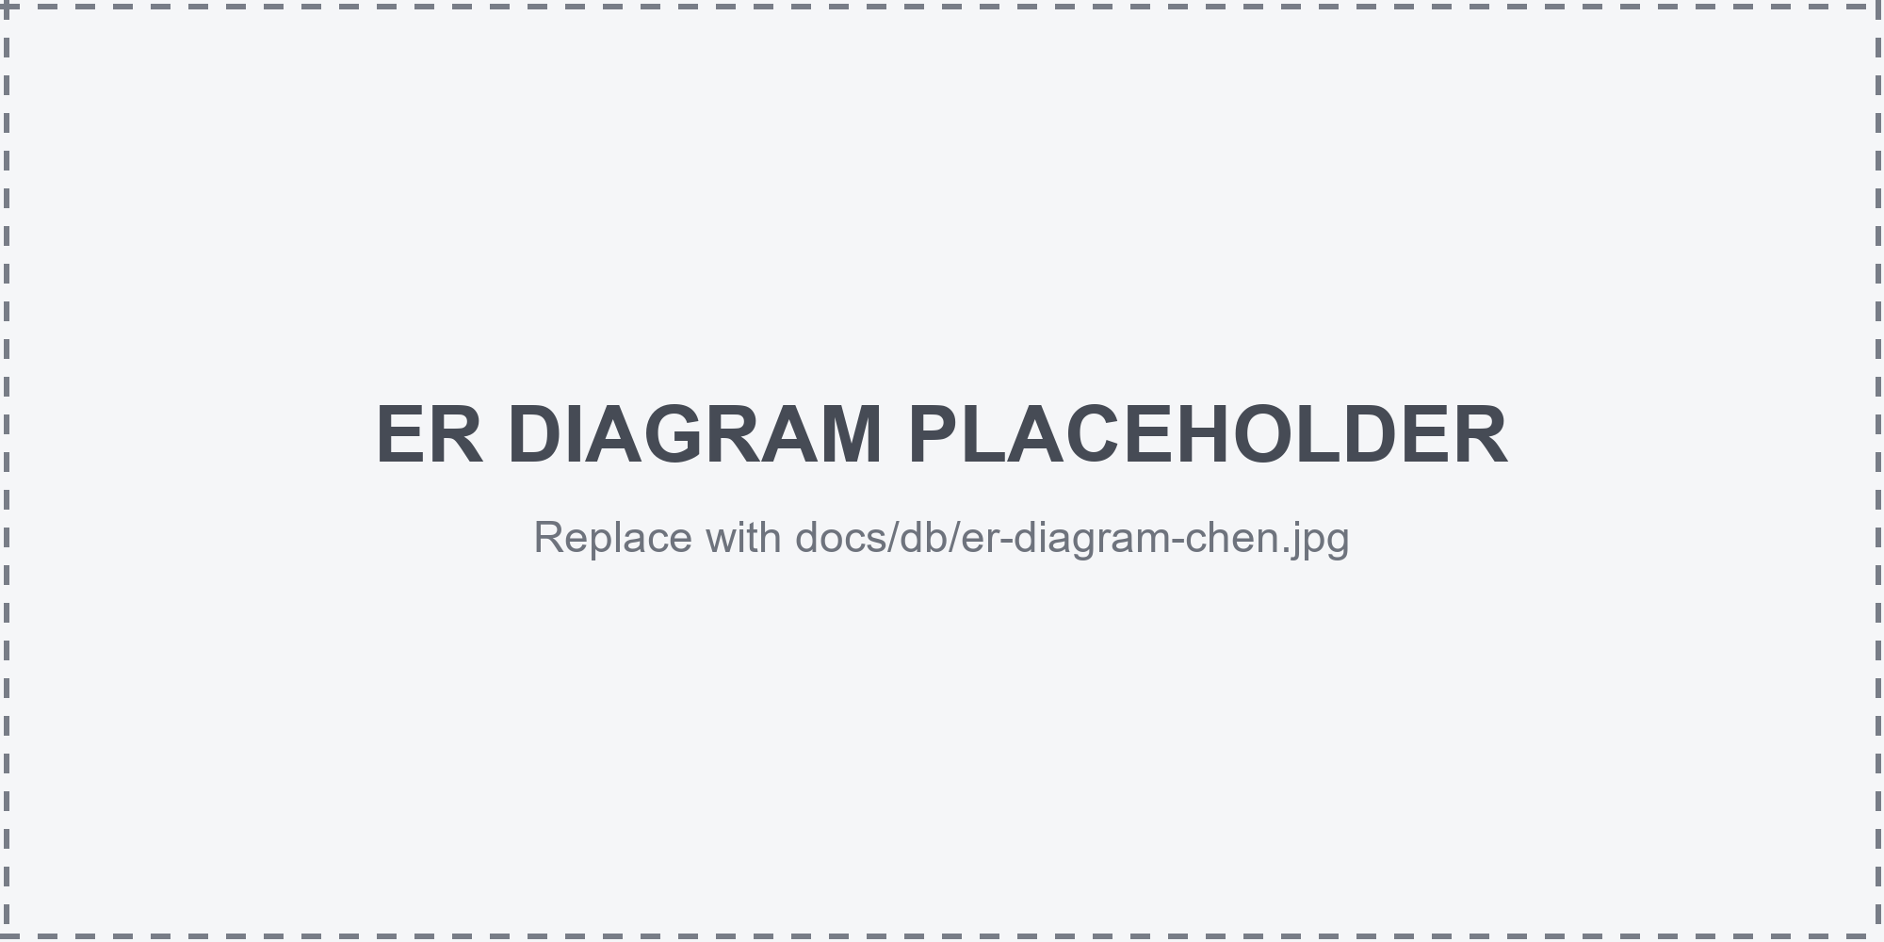
Figure 1: Entity Relationship Diagram of VeriSphere (PostgreSQL entities with the MongoDB evidence store)
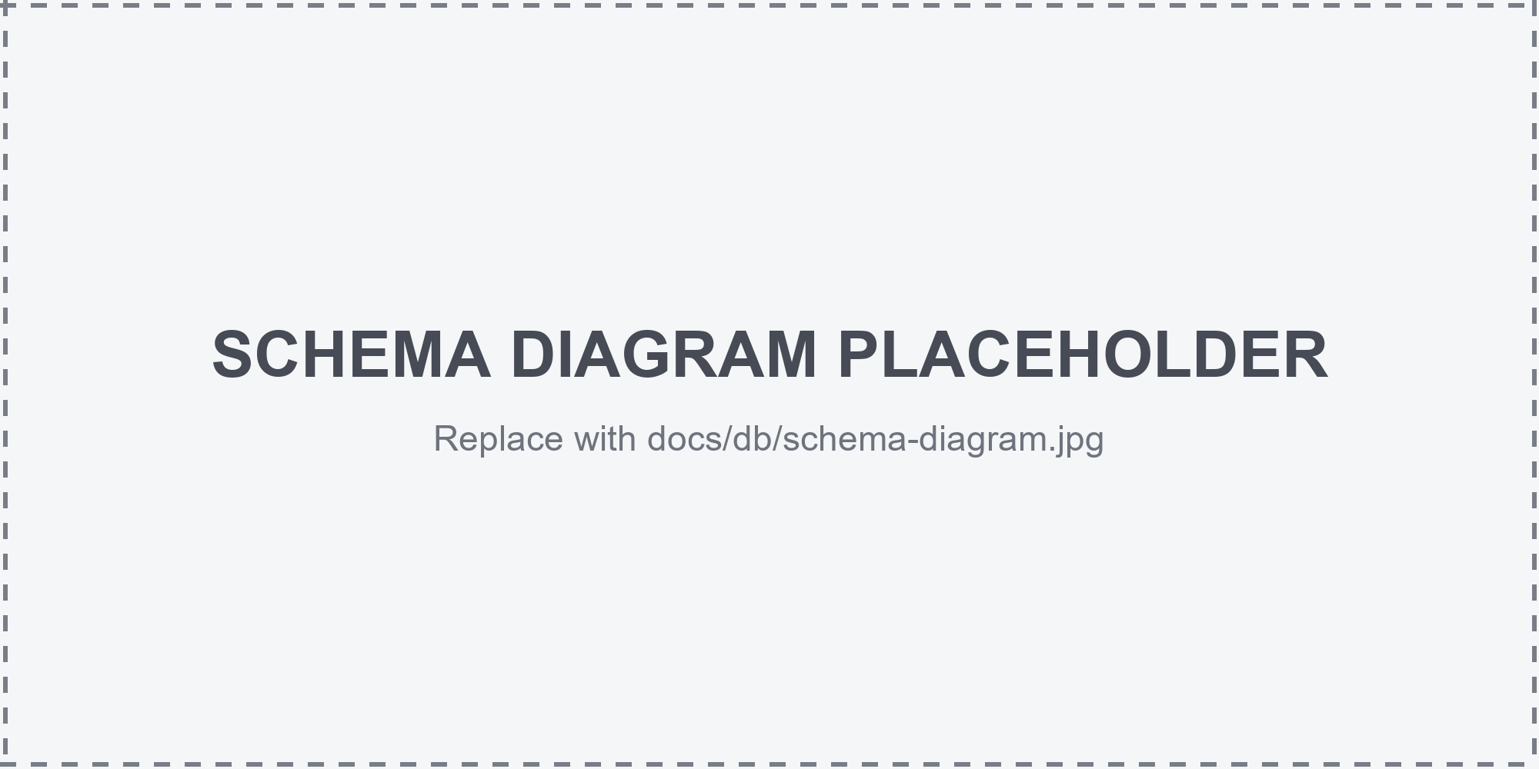
Figure 2: Relational schema diagram of VeriSphere (primary keys underlined)

