Last updated: 20 Nov 2020
By: Palak Dave
For ‘new’ annotation:
- Open the tool by double clicking on Count_Annotation_Tool.exe
- Click on ‘Open Case’ button on the tool.
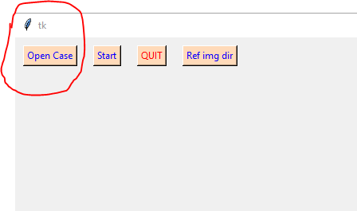

- Select a mouse folder. for example, select ‘PI3-19’ folder and click on ‘Select Folder’.
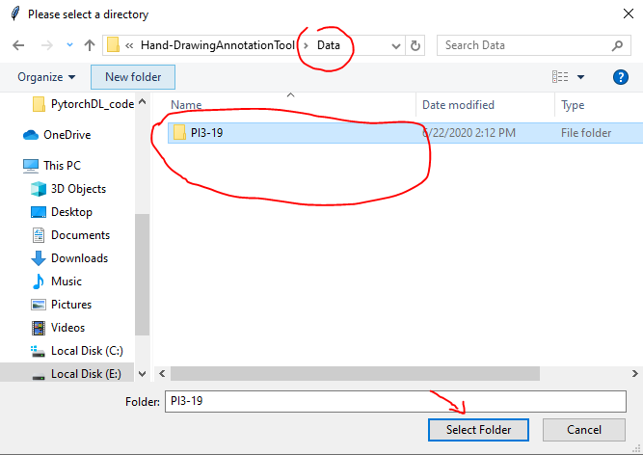

- Click on ‘Ref img dir’ on the tool. This is previous annotation that can be loosely used as a guide.
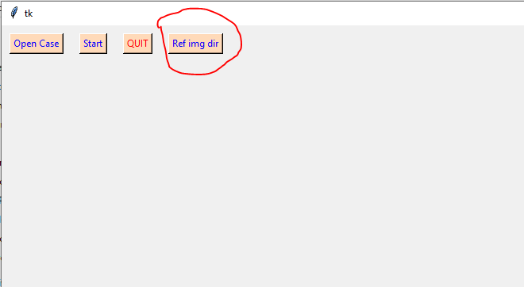

- Select ‘annotation’ folder inside case folder. (../PI3-19/annotation) And click on ‘Select Folder’.
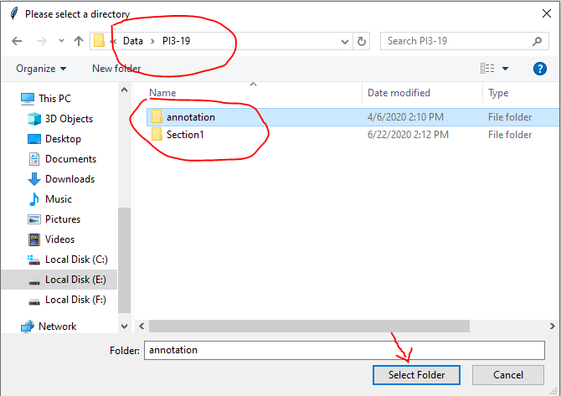

- Click ‘Start’ on the annotation tool. This should open two images. One on the tool and one separate window with name ‘Ref Annotation’.
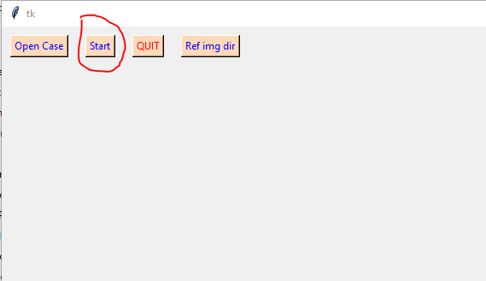
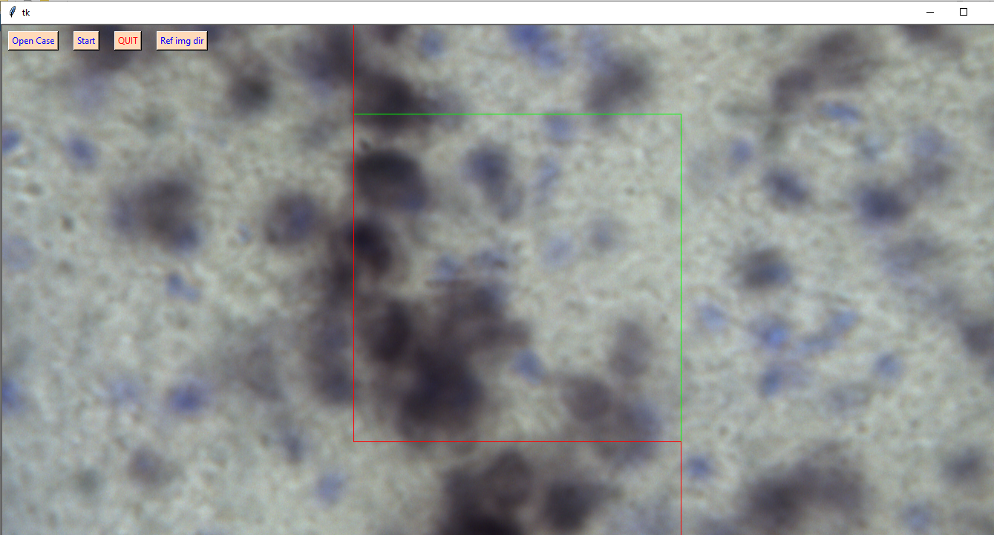

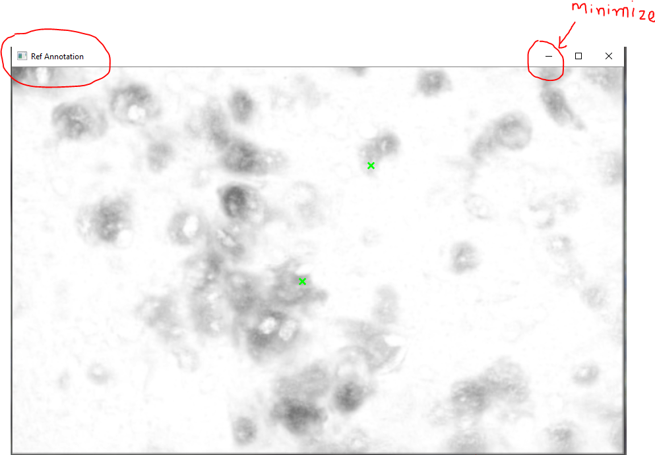

- You may minimize the ‘Ref Annotation’ image as shown in the previous image.
- Press ‘s’ key on the keyboard to skip a stack if image or stain quality is not adequate.
- Start annotating (using mouse and up-down arrow keys). Try to identify best focus for each cell before annotating (don’t fall for the temptation to annotate a cell just when it is visible).
- Press ‘BackSpace’ to remove last annotated cell.
- Once all the cells are annotated, open the minimized ‘Ref Annotation’ image and compare your annotation with it. Each green cross mark in the ‘Ref Annotation’ should be annotated in your annotation.
  - There might be some cells missed or wrongly annotated in the ‘Ref Annotation’. Try to fix that in the new annotation.
- Once all the above points are done, press ‘Enter key’ to move to the next stack.
- Close the tool to stop annotating
- To restart annotating, repeat steps 1 through 12. The tool would automatically pick-up from where you left previously.

Keys Guide:
- Up and down arrow keys: navigate within a stack.
- Enter: To go to next stack
- BackSpace: To remove last annotated cell (the green cross mark becomes black when removed.) Any number of cells in the current stack can be removed by removing one cell at a time with BackSpace.
- ‘s’: To skip a stack if stain or image quality is not adequate.

For ‘update’ annotation:
- Open the tool by double clicking on Update_Count_Annotation_Tool.exe
- Click on ‘Open Case’ button on the tool.

- Select a mouse folder. for example, select ‘PI3-19’ folder and click on ‘Select Folder’.

- Click on ‘Ref img dir’ on the tool. This is the folder with algorithm predictions. The cells marked with red contour are not present in the annotation currently. Update those to the annotation if that is a cell.

- Select ‘model_pred’ folder inside case folder. (../PI3-19/’model_pred’) And click on ‘Select Folder’.
- This will open two windows like ‘new’ mode. The main window will show already annotated cells.
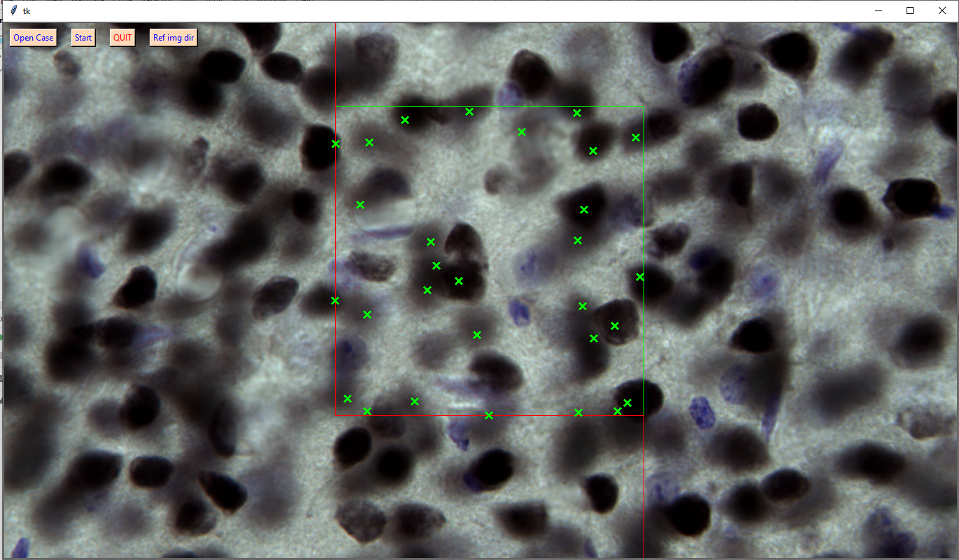
‘Ref Annotation’ window shows predictions from an algorithm. The red contours are potentially missed cells in the current annotation. Check if the cells corresponding to the red contour are neurons and annotated if they are.
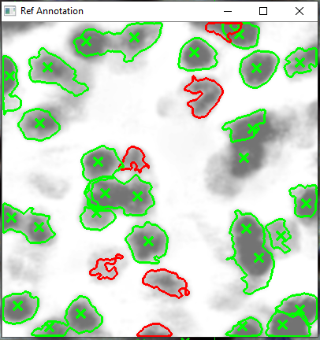

- Continue annotation in the same way as ‘new’ annotation. All the feature of ‘new’ annotation (skip, backspace, up-down arrow) are available.
- The updated annotation is overwritten in case_dir/count_annotation folder.

