Last updated: 20 Nov 2020

By: Palak Dave

1. Open the tool by double click on Mask_Annotation_Tool.exe
2. Click on ‘Open Case’ button on the tool.

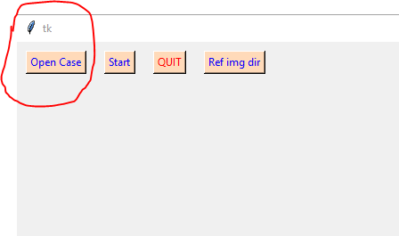

1. Select case (animal) folder. (e.g. ../Data/PI3-19) And click on ‘Select Folder’.

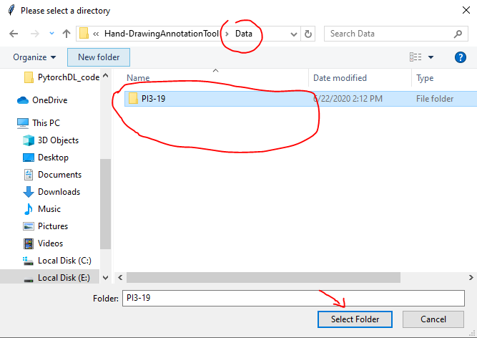

1. Click on ‘Ref img dir’ on the tool. Here, you can choose a previously done count annotation to be displayed for reference.

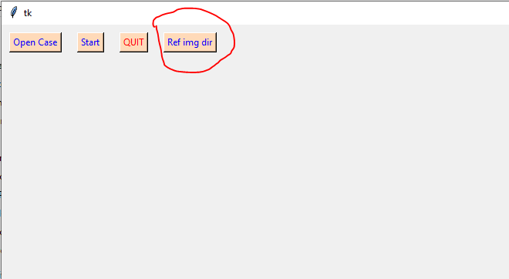

1. Select ‘count_annotation’ folder inside case folder. (..Data/PI3-19/count_annotation) And click on ‘Select Folder’.

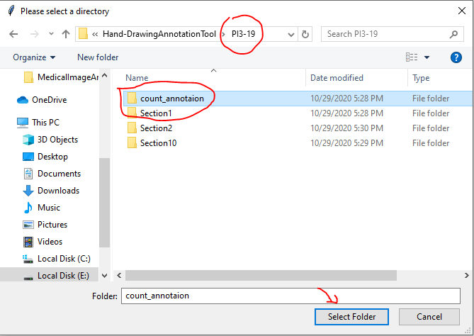

1. Click ‘Start’ on the annotation tool. This should open two images. One on the tool and one separate window with name ‘Ref Annotation’.

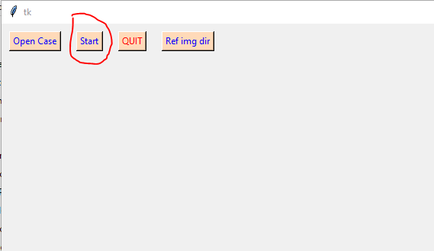

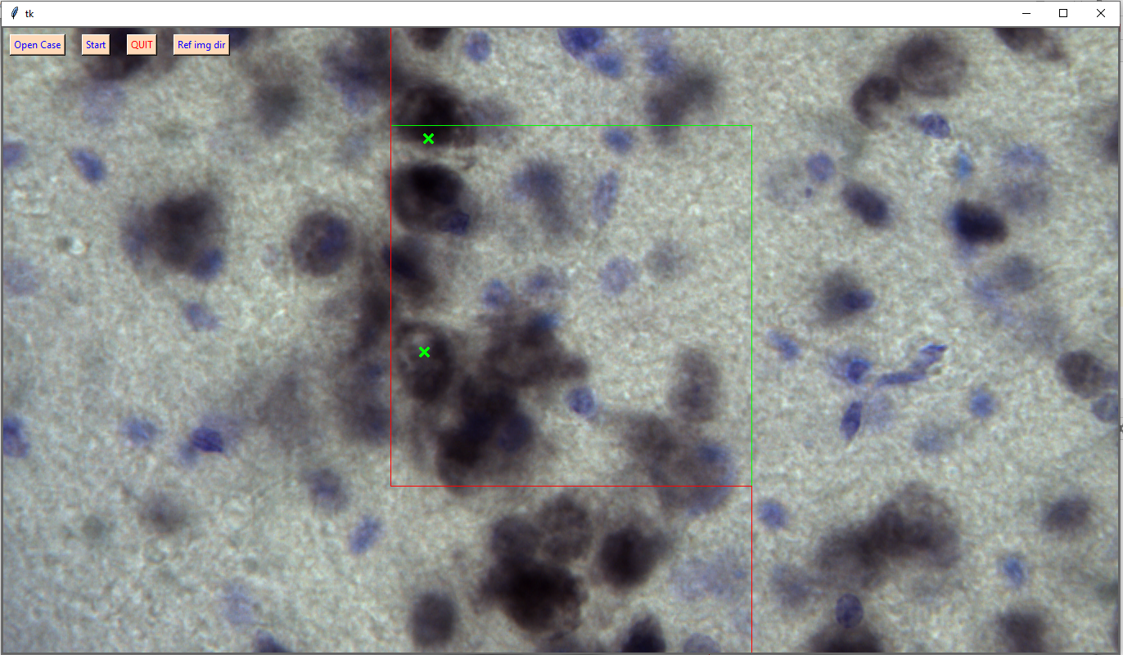

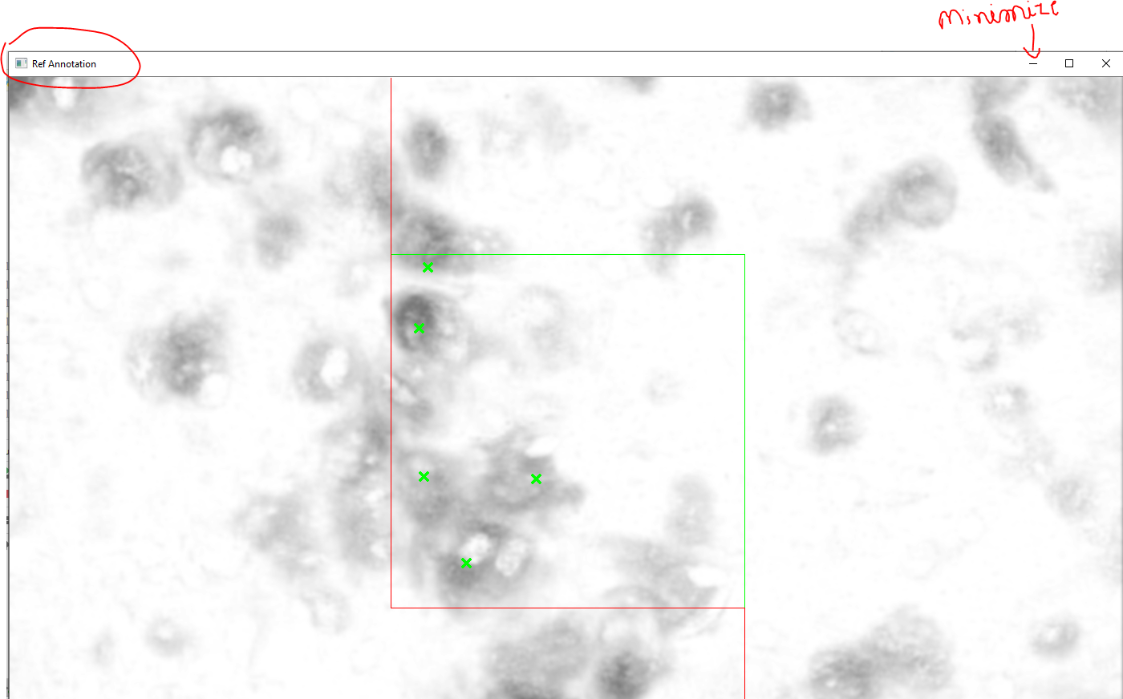

1. All the annotations on the current stack are displayed on EDF image in the ‘Ref Annotation’ image and annotations on corresponding slices are shown in the main window. Optionally, one can minimize the ‘Ref Annotation’ image as shown in the previous image.
2. Start annotating (drawing around boundaries using mouse and navigating by up-down arrow keys). Please check that each cell is annotated on best focus slice in the reference annotation. If not, the user should identify and draw boundaries in the best focus slice.
3. If a mistake is made during boundary drawing, it can be undone by ‘BackSpace’ key. Upto all the steps on the current stack can be undone. (The boundary of the deleted cell becomes red.)
4. Once all the cells are annotated, open the minimized ‘Ref Annotation’ image and compare your annotation with it. Each green cross marked cell in the ‘Ref Annotation’ should have boundary drawn around it in the main window.
5. Once all the above points are done, press ‘Enter key’ to move to the next stack.
6. If there are different number of cells drawn than that in the ‘Ref Annotation’, it will show you a warning message and ask if you want to still move to the next stack. Press ‘yes’ or ‘no’ as appropriate.

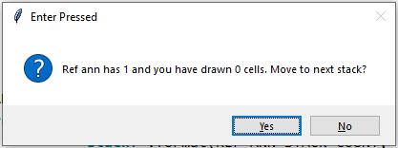

1. Close the tool to stop annotating.
2. The mask annotation is stored in the same directory under which there is case directory. Mask annotation is saved in ‘case_annotated’ dir (e.g. PI3-19_annotated).

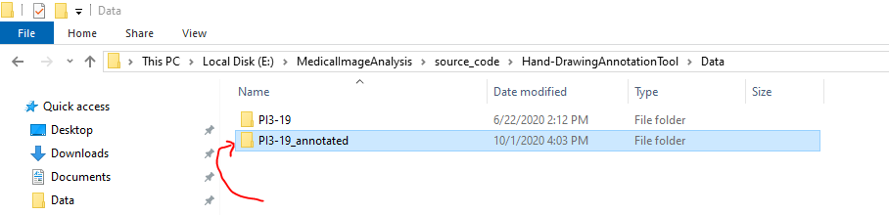

1. To restart annotating, repeat steps 1 through 12. The tool would automatically pick-up from where you left previously.

**Keys Guide:**

* **Up and down arrow keys:** navigate within a stack.
* **Enter:** To go to next stack
* **BackSpace:** To remove last annotated cell (the green cross mark becomes black when removed.) Any number of cells in the current stack can be removed by removing one cell at a time with BackSpace.