Music Recommendation System Using BigData

Now-a-days entertainment industry is growing in full-fledged with enormous number of songs and movies introduce every year. Storing and processing such enormous data with traditional systems may consume lots of time so we are using distributed Hadoop storage and processing where all songs and meta data will be stored in Hadoop and user just has to enter keywords of liking or desired songs and then Hadoop will execute content based recommendation algorithm to fetch all similar songs and then display to user. User can click on desired song to play and anytime can stop that song and go for new recommendation.

To implement this project we need to install and saved all songs in Hadoop and so we downloaded some songs from internet which showing in below screen

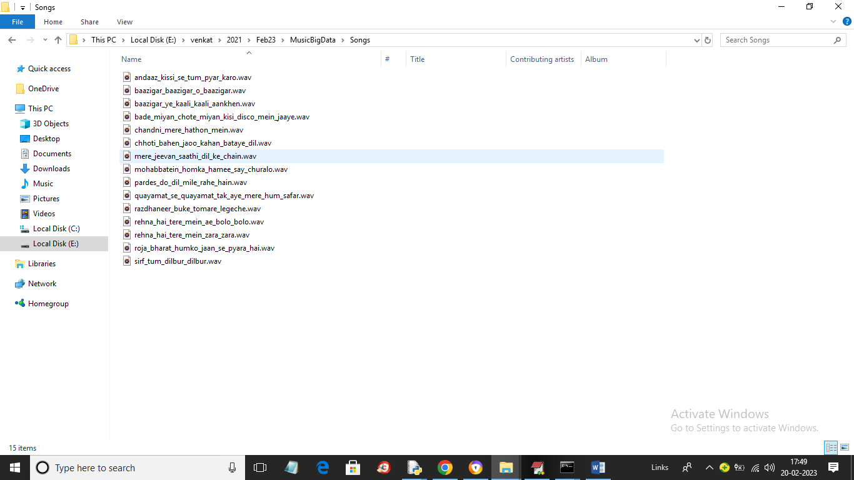

Some songs are showing in above screen but you can add few more song and now we need to store all this songs in Hadoop by following below steps

1. install java 1.8 in your System C directory under Java folder
2. set JAVA_HOME in system variable as C:/Java
3. set java path up to C:/Java/bin
4. install python 3.7.0 and then install all packages from requirements.txt file
5. now put Hadoop folder in your C directory and set Hadoop home in system variable
6. HADOOP_HOME = C:/hadoop
7. set Hadoop path in system variable as “path = C:/hadoop/bin”
8. now open command prompt and execute below commands
9. set command prompt location to cd C:/hadoop/bin and enter command as “hdfs namenode –format” and press enter key
10. now change command prompt location to C:/hadoop/sbin and then execute command as ‘start-dfs’ to start Hadoop servers and get below screens

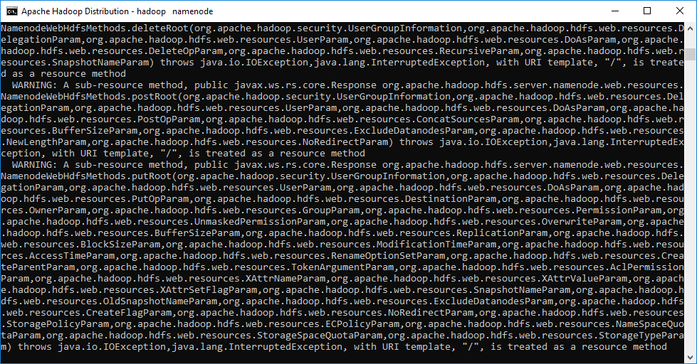

In above screen Hadoop server started and now open browser and enter URLS as ‘http://localhost:9870’ and press enter key to get Hadoop page like below screen

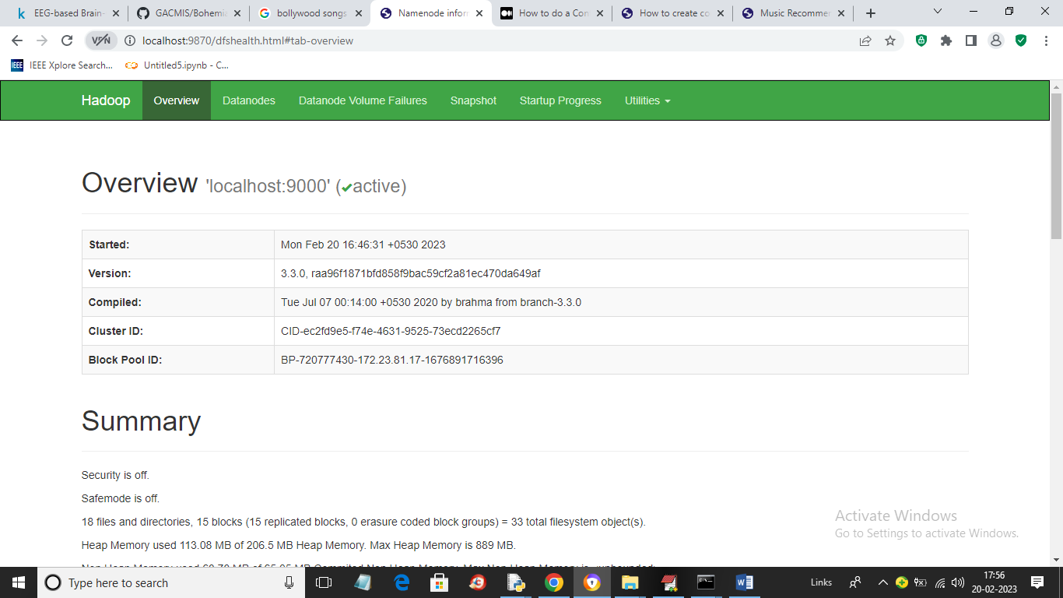

Now we can upload all songs to Hadoop by opening another command prompt and set location to your code folder and then type below commands

hdfs dfs -mkdir -p /Songs

Above command will create Songs folder in Hadoop

Now execute below command

hdfs dfs -put Songs hdfs://localhost:9000/Songs

Above command will upload all songs to Hadoop Songs folder and we can see in Hadoop screens by clicking on ‘Utilities’ link

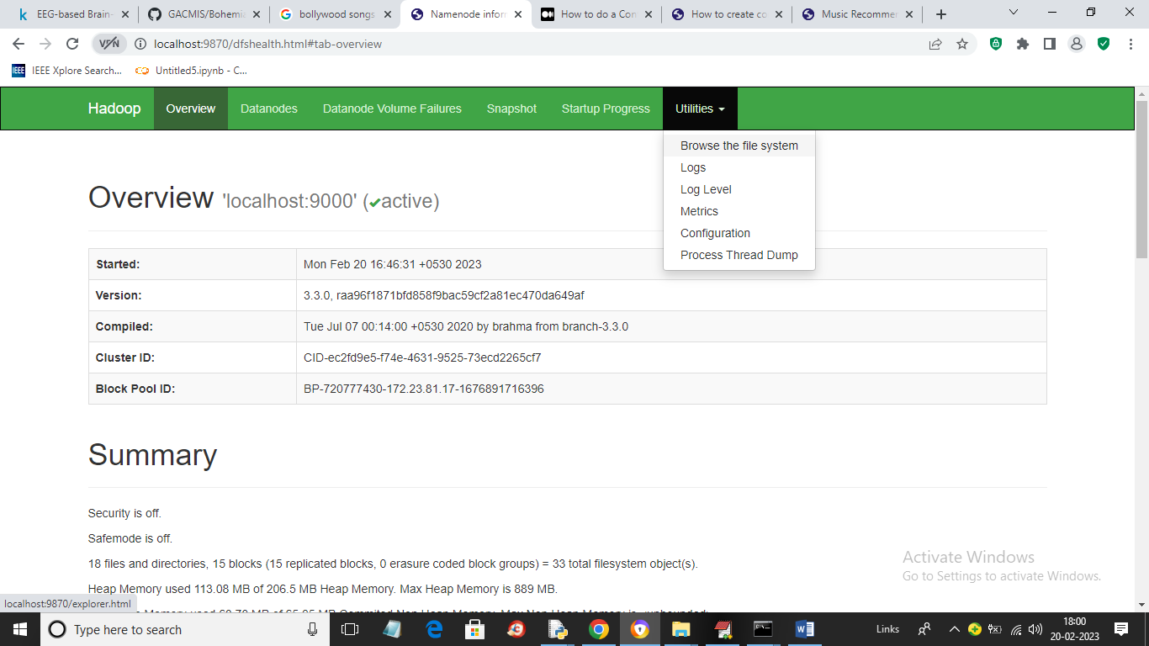

In above screen from ‘Utilities’ link just click on ‘Browse the File System’ link to get below page

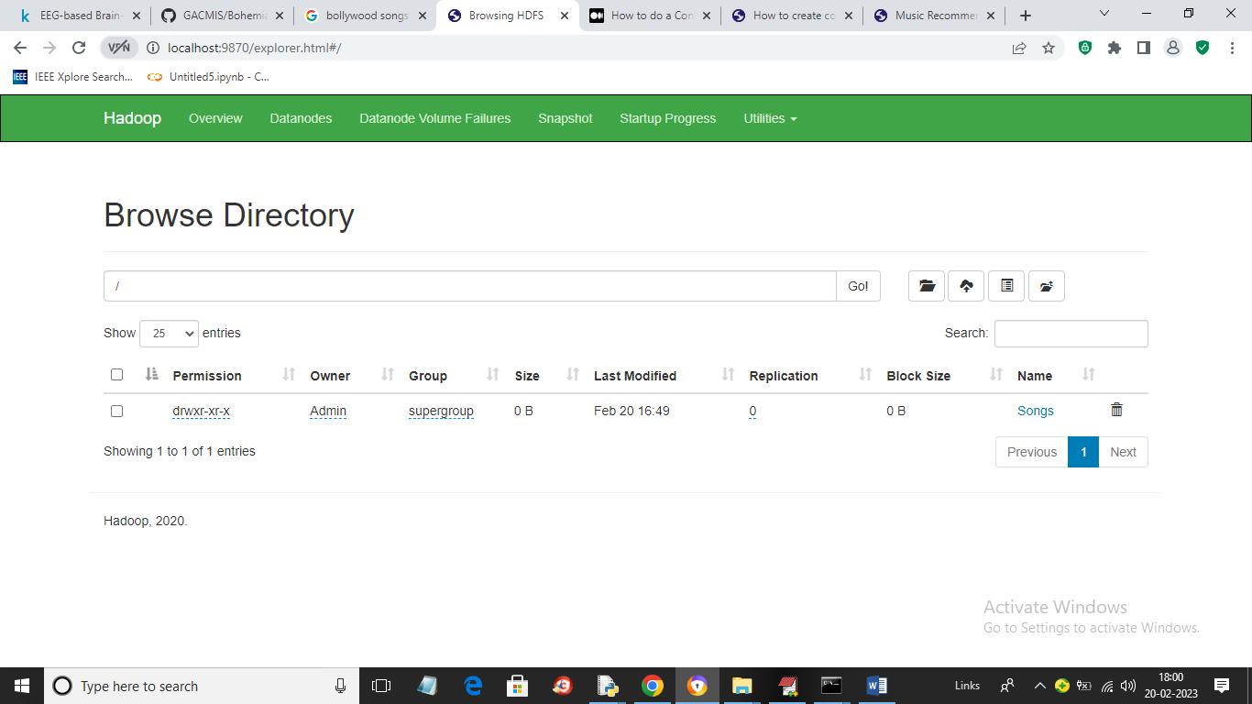

In above screen just click on ‘Songs’ link from right side to get below screen

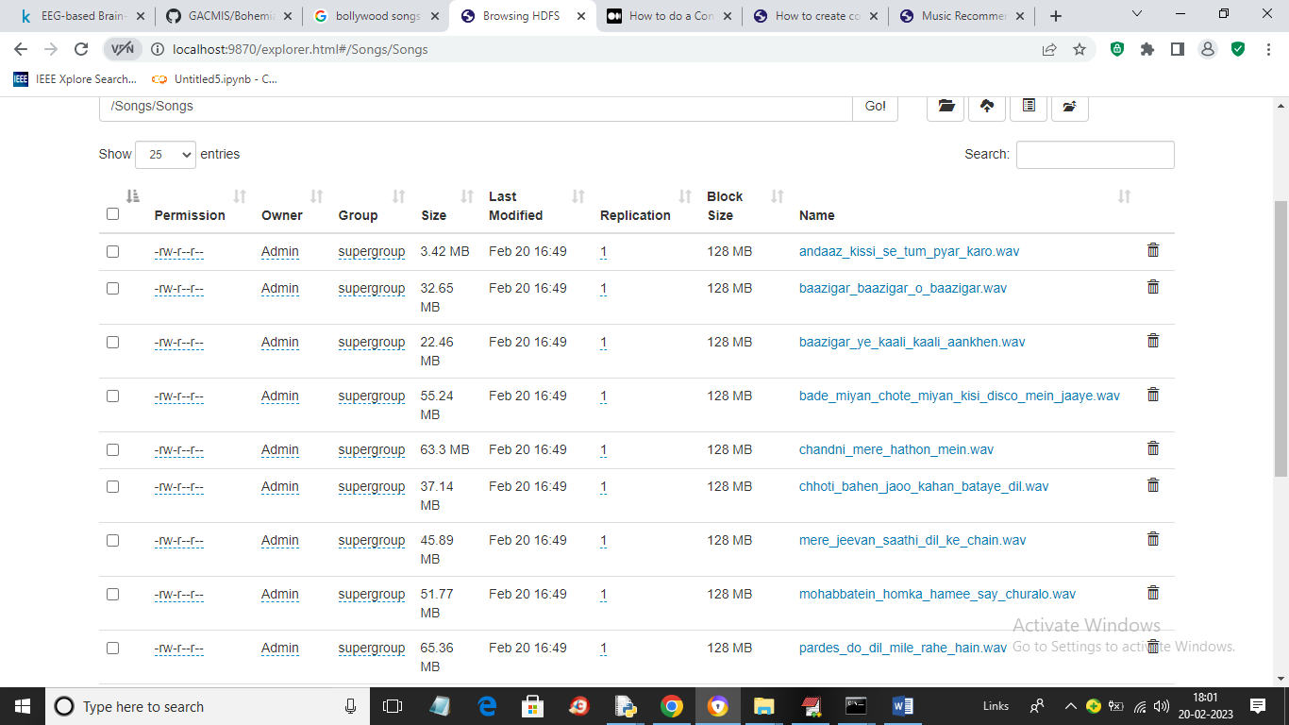

In above screen we can see all Songs are uploaded to Hadoop and now we can run application by double click on ‘run.bat’ file to start Python server and get below page

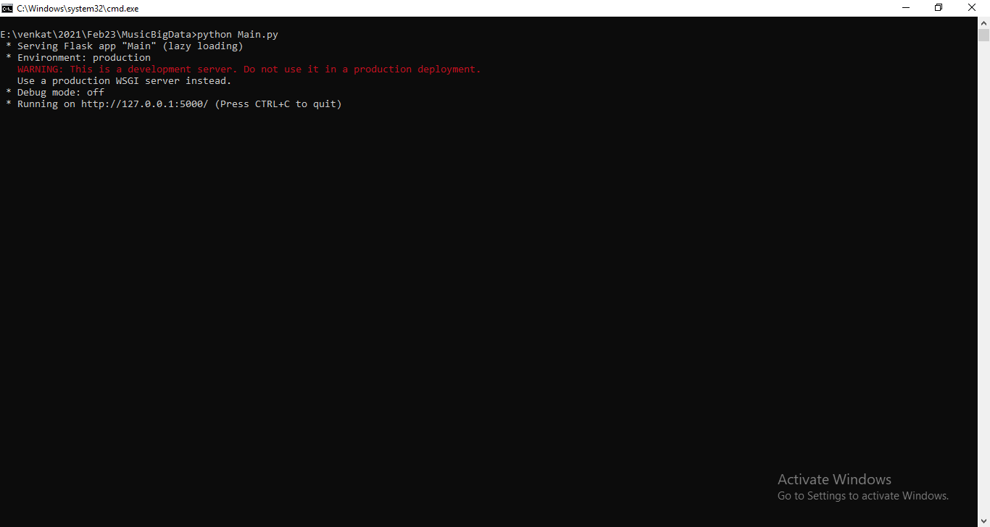

In above screen python server started and now open browser and enter URL as ‘http://127.0.0.1:5000/index’ and press enter key to get below page



In above screen user can click on ‘Music Recommendation’ link to get below page

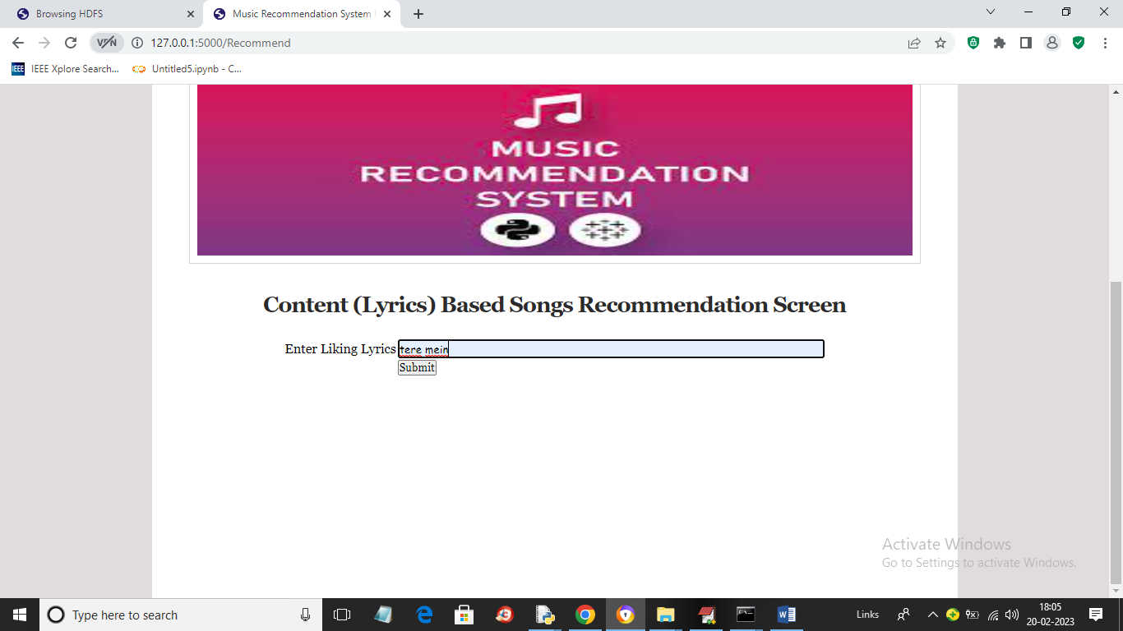

In above screen user will enter some liking lyrics and then press button to get below recommendation

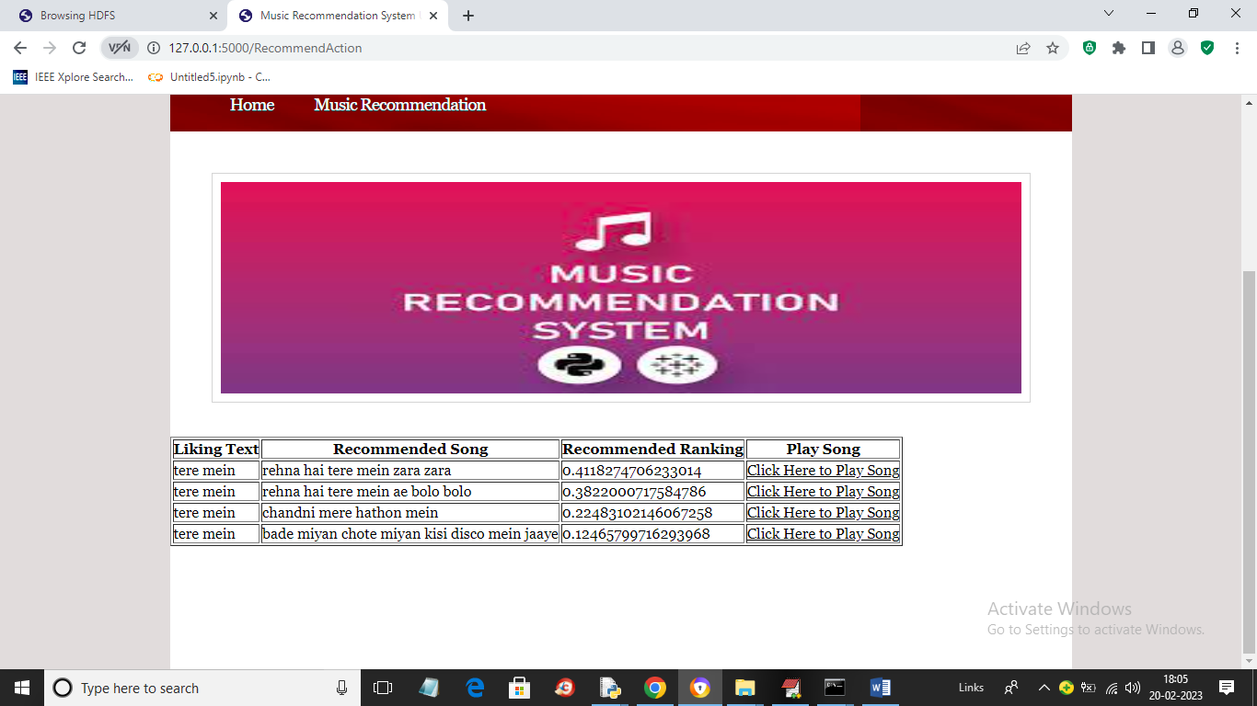

In above screen user can get lyrics content based songs recommendation list with ranking score and can click on ‘Click Here to Play Song’ link to start play desired song

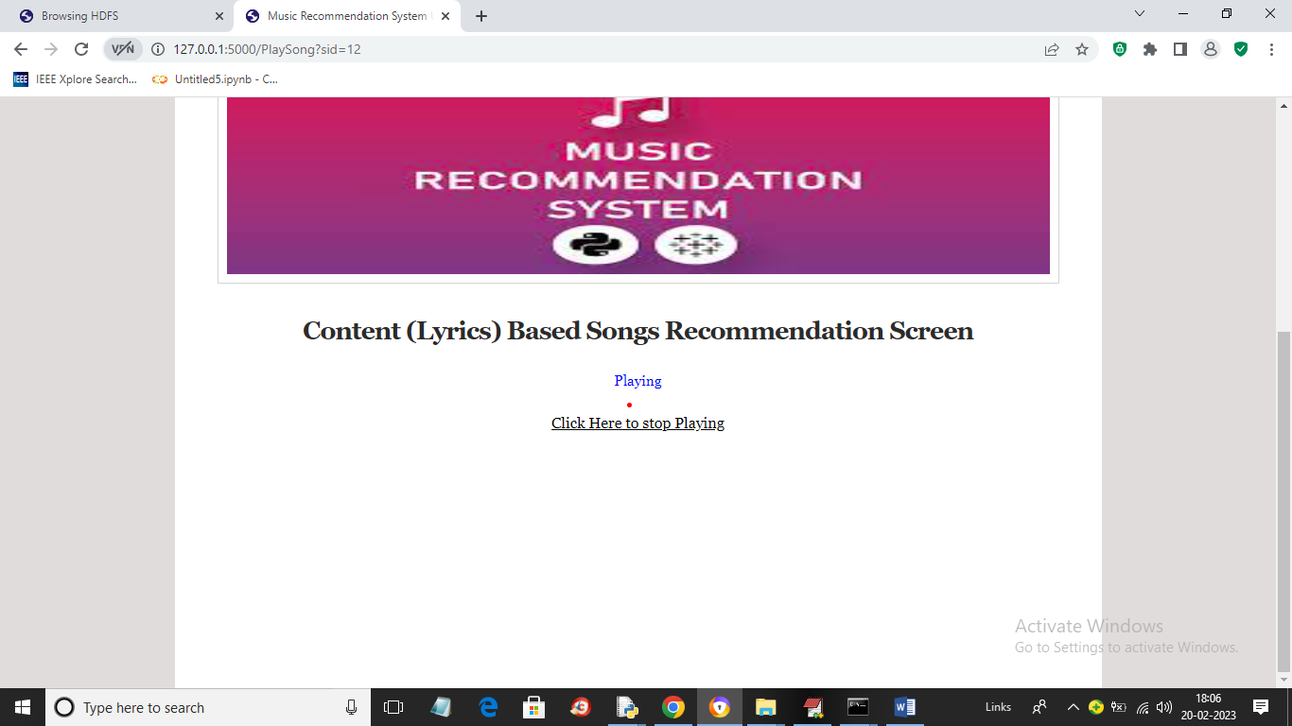

In above screen you can here song start playing and anytime you can click on ‘Click Here to Stop Playing’ to go for new recommendation.



In above screen song stop playing and user can go for new recommendation. Similarly you can get recommendation, play and stop song