In this project as per your request we have added LSTM, SVM and Gradient Boosting Algorithms and below is the output of each algorithm and this is a forecast based algorithms so we can calculate Mean Square Error (MSE). MSE refers to difference between predicted price and original test price so the lower the MSE the better is the predictions.

To run project double click on ‘run.bat’ file to get below screen

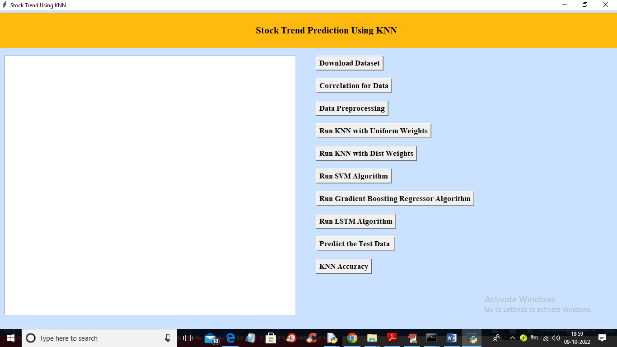

In above screen run all algorithms one by one to get below output

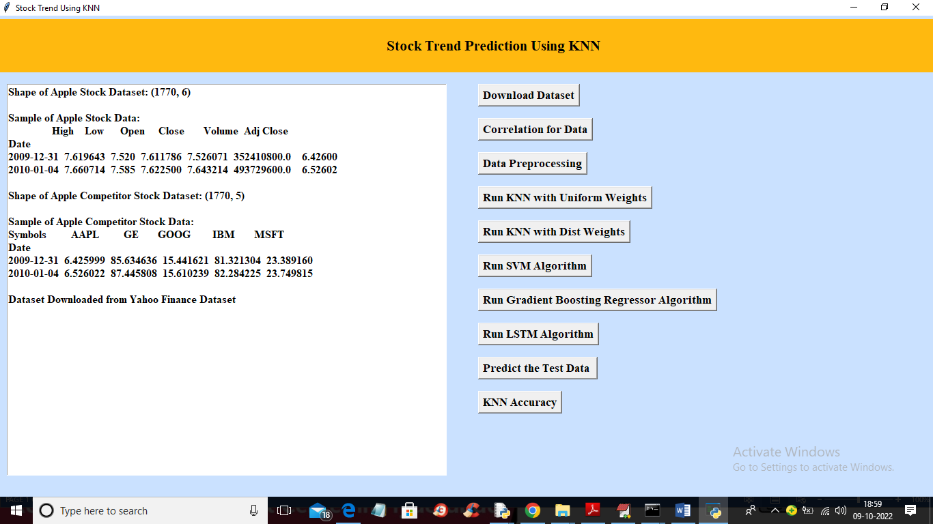

In above screen dataset loaded and now run up to KNN parts

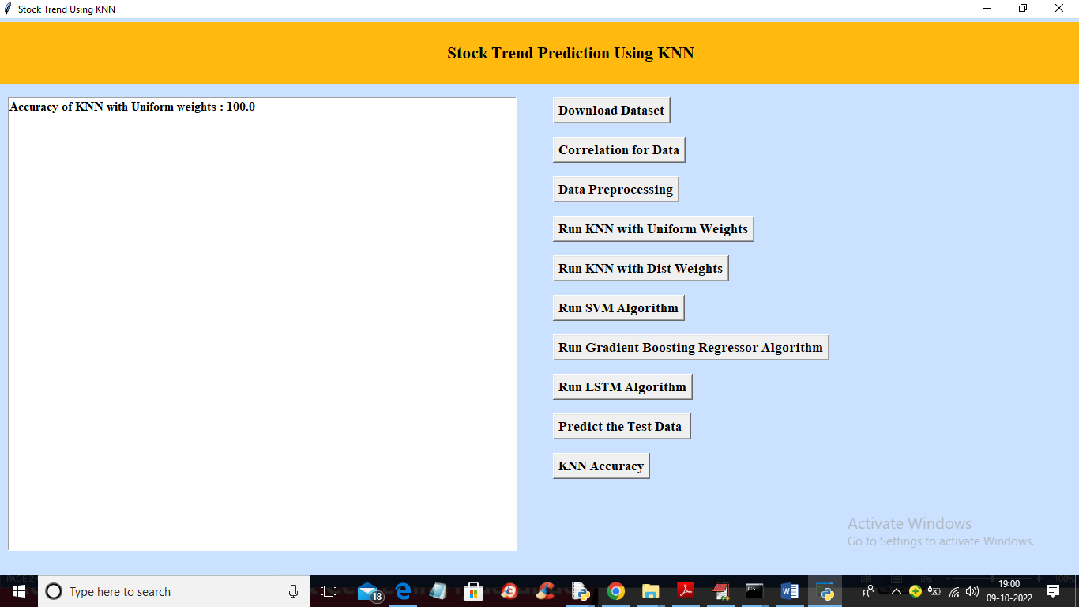

In above screen with KNN Uniform weights we are getting 100% accuracy and now click on ‘Run SVM Algorithm’ button to get below output

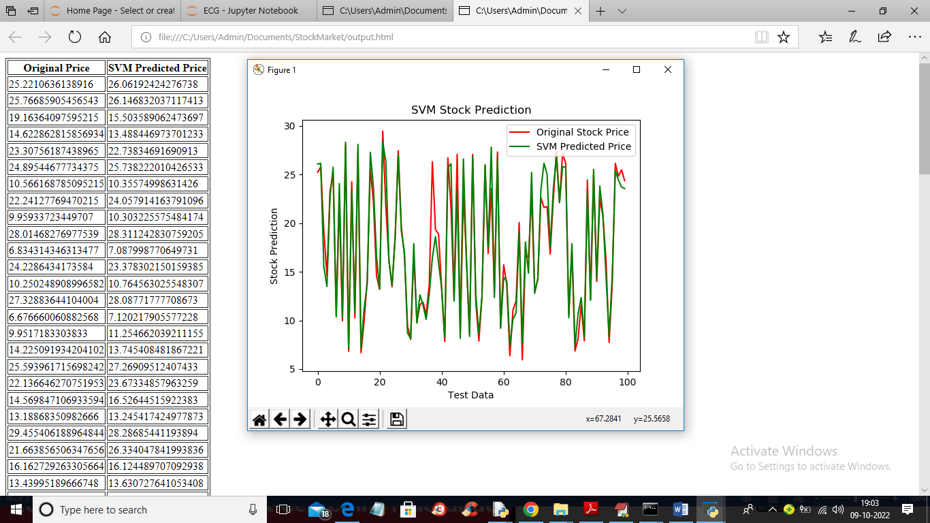

In above screen we are showing original stock price and then predicted SVM price and we can see there is close difference between original test price and predicted price. In above graph we are showing prediction for next 100 days where green red line represents original test price and green line represents SVM predicted price and both lines are closely colliding and below is the SVM MSE rate.

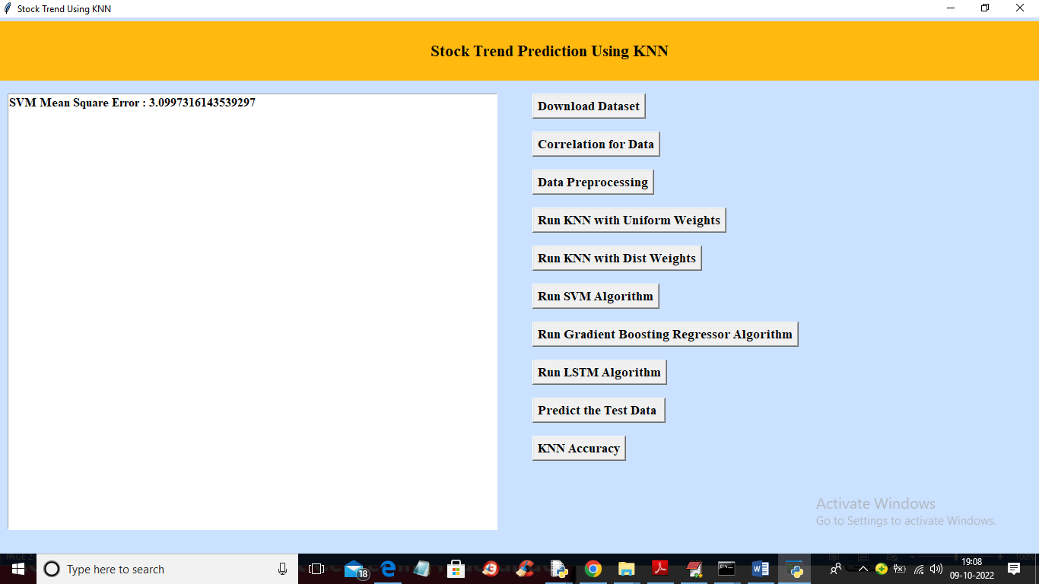

In above screen with SVM we got only 3% difference between original and predicted prices. Now click on ‘Run Gradient Boosting Regressor Algorithm’ button to get below output

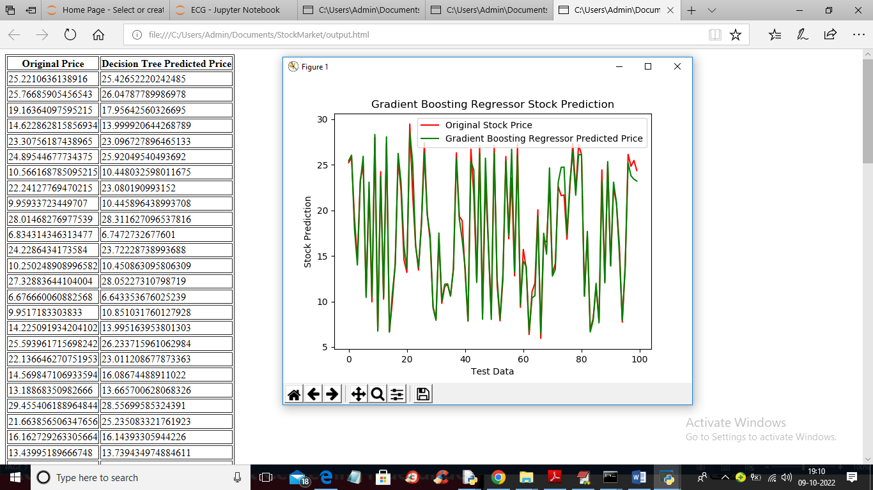

In above screen we can see prediction of gradient boosting algorithm and this algorithm green line is fully colliding with red line so its predicted prices are accurate and now click on ‘Run LSTM Algorithm’ button to get below output

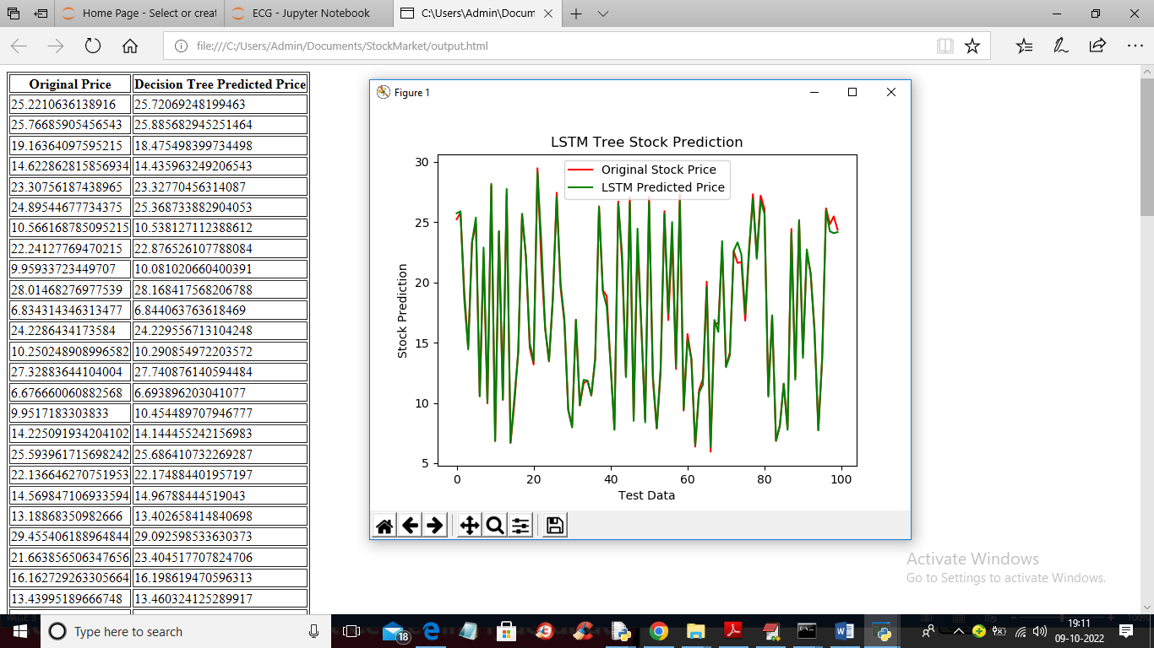

In above screen we can see prediction of LSTM which is very much close and accurate to original prices and you can see both green and red lines are fully overlapping with minor difference and below is the MSE rate of all 3 algorithms

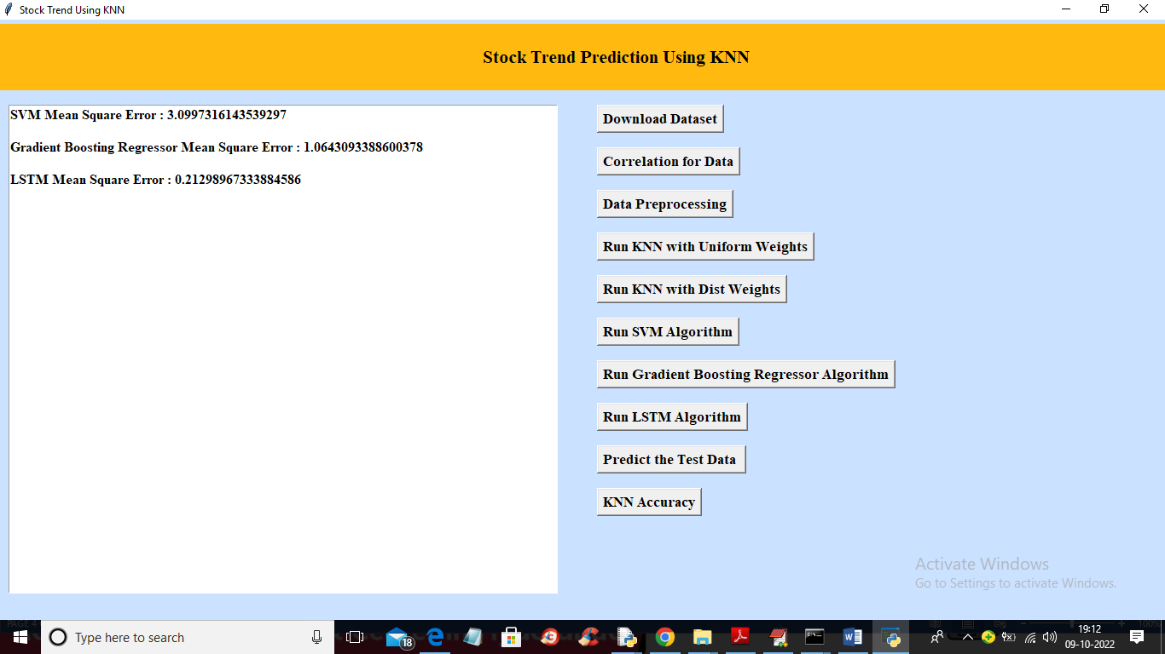

In above screen with SVM we got high MSE error rate as 3% and with gradient boosting we got MSE error as 1.06% and with LSTM we got less MSE error rate as 0.21 which is lesser than all other algorithms. So from above algorithms we can say LSTM is accurate