**Aero Watch: Beyond Surveillance-Active Crowd Safety Solutions**

* **Problem Statement:**

Crowd stampedes are a serious problem at events, festivals, and emergencies where large groups gather. These sudden surges can cause injuries and even deaths when people react to unexpected triggers like barriers or loud noises, creating chaos. Crowded spaces, like events and festivals, are especially risky because of high numbers of people, unclear communication, and uncertain emergencies. Trampling, crushing, and suffocation are common, leading to injuries and emotional distress. Traditional crowd management struggles to handle these fast-changing situations, worsened by the lack of real-time monitoring. To tackle this issue, in the hackathon we want to leverage the use of drones, image and edge processing. The aim is to develop new ways to monitor crowds and spot stampede risks early, making crowded places safer. We will be working on strategies using these technologies to improve safety during large gatherings.

* **Validation of Severity of The Problem:**

Given the frequent occurrence of serious incidents at densely populated gatherings, there's an urgent need for intelligent solutions to regulate crowd flow. In countries like India, where large religious gatherings are common, reports highlight the challenges and accidents associated with heavy crowds. Traditional crowd management methods often fail to effectively monitor and respond to dynamic crowd behavior. Key issues include surveillance gaps, where current approaches struggle to cover expansive areas with dense crowds, resulting in blind spots and delayed responses. Additionally, reactive measures in conventional crowd management lack the capability to proactively predict and prevent incidents.

* **Deadliest Stampedes in India (based on research and news reports):**

**Rajahmundry stampede, July 2015**

* This stampede happed on the opening day of Pushkaralu festival on banks of Godavari River in Rajahmundry when the pilgrims rushed into the Puskhar ghat to take a holy dip. This resulted in death of 27 people.

**Sabarimala stampede, January 2011**

* The worst recorded accident happened at Sabarimala in Kerala on 14 January 2011, Makara Jyothi Day when a stampede triggered by toppling over of a jeep took as many as 106 lives.
* **Existing Solutions:**

1. Combination of physical infrastructure, crowd management strategies, and technology.
2. Physical measures: Designing venues with sufficient exits and barriers.
3. Crowd management: Involves trained personnel and technology like surveillance cameras and sensors.

* **Drawbacks:**
* Human limitations.
* Delays in response time.
* Challenges in real-time crowd density estimation.
* **Our Solution**
* Integrated Drone System:
* Utilizes swarm techniques with 2 to 3 drones flying simultaneously.
* Autonomous path planning, Return to Launch (RTL), and predefined flight missions for efficient crowd monitoring.
* Jetson Nano Integration:
* Jetson Nano onboard each drone for real-time video capture and processing.
* Integrated with high-resolution cameras for accurate image acquisition.
* Employs machine learning models and algorithms for crowd density estimation.
* Real-time Crowd Density Monitoring:
* Drone captures live footage and processes it using Jetson Nano.
* ML models analyze crowd dynamics and estimate density in real time.
* Alert System:
* Ground Control Station receives real-time data from drones.
* Alerts triggered when crowd density exceeds predefined thresholds.

Usefulness and Unique Features:

* Proactive stampede prevention through early detection.
* Swift response with immediate alerts to potential danger zones.
* Comprehensive coverage with multiple drones and autonomous navigation.

In conclusion, the utilization of drones empowered by Jetson Nano technology presents a proactive and effective approach to address the persistent challenge of crowd stampedes in densely populated gatherings. By harnessing swarm techniques and advanced image processing algorithms, this innovative solution enables real-time monitoring and early detection of crowd density fluctuations. With its ability to provide comprehensive coverage and prompt alerts, it offers a promising means to enhance crowd safety and prevent stampedes before they escalate. Through collaborative efforts and technological innovation, we can work towards creating safer environments for large gatherings, ensuring the protection and well-being of individuals attending events and festivals.

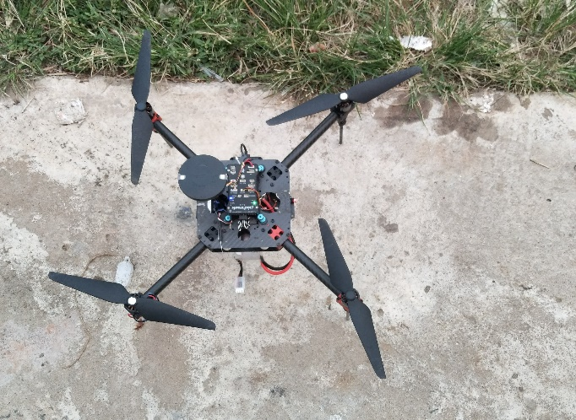

. Jetson nano

Drone