PRODUCT ARCHITECTURE & WORKFLOW SPECIFICATION
SOCIAL ORBIT

Influencer Intelligence · Consumer Intelligence · Campaign Intelligence
Prepared for Leadership Review
August 2026

Contents
Executive Summary 3
1. Platform Overview 4
2. Data Foundation 5
3. Client Access & Plans 7
4. Client Workflow A -Influencer Intelligence 9
5. Influencer Report 11
6. AI Influencer Analysis 12
7. Save Influencer & Export 13
8. Client Workflow B -Campaign Management 14
9. Talent Rate vs. Client Rate 15
10. Campaign Hashtag Tracking 16
11. Campaign Performance 17
12. Consumer Intelligence 18
13. The Three Intelligence Engines 19
14. Complete Platform Workflow 20
15. The Core Product Loop 21

Executive Summary
The platform is built around three intelligence engines -Influencer Intelligence, Consumer Intelligence, and Campaign Intelligence -that share a common data foundation and a single AI analysis layer. Data is collected from Instagram and YouTube, either through authenticated OAuth connections for influencers who choose to verify their account, or through public data collection for profiles that have not yet connected. All data is normalized into a central database before any analysis takes place.
Two client-facing workflows sit on top of this foundation. Influencer Intelligence lets a client search for a creator and receive an evidence-based report covering account health, audience quality, and content performance. Campaign Management lets a client run an influencer campaign end-to-end -from selecting talent and negotiating rates, through hashtag-based content tracking, to a final ROI report.
A consistent architectural principle governs the use of AI throughout: OpenAI analyzes and enriches data the platform has already and legitimately collected. It is not a source of private social data, and it is not presented as having direct knowledge of information -such as an influencer's private asking rate -that has not actually been provided to the system.
Taken together, the three engines and two workflows form a closed intelligence loop: Consumer Intelligence identifies who the audience is, Influencer Intelligence identifies who can reach that audience authentically, Campaign Management runs the engagement, Campaign Intelligence measures how each influencer performed, and the resulting ROI data feeds back in to improve the next round of recommendations.

1. Platform Overview
At the highest level, the platform organizes everything it does into three intelligence products, each answering a distinct business question for the client.

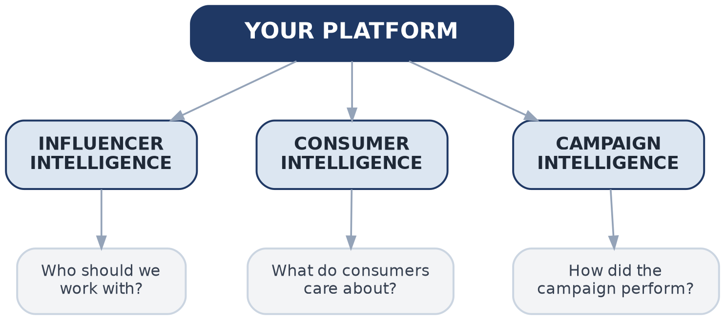
Figure 1.1 -The three intelligence pillars of the platform

2. Data Foundation
The platform starts with data acquisition from the supported social platforms -Instagram and YouTube -through their respective APIs. Collected data is ingested and normalized into a single structured format before it reaches the influencer database.
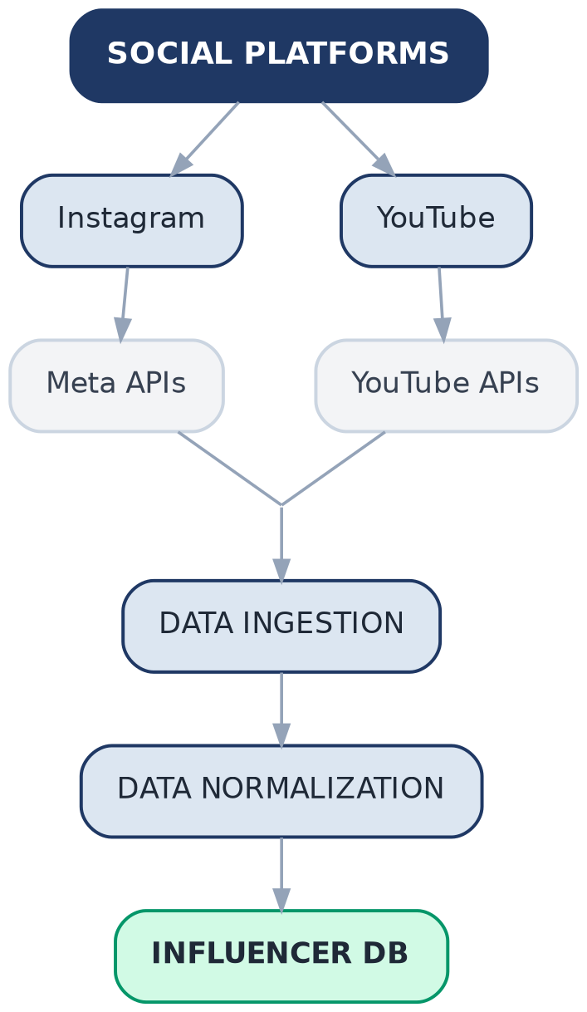
Figure 2.1 -Data ingestion pipeline

Influencer Authentication (OAuth)
For influencers who choose to connect and verify their account, the platform uses OAuth to establish a verified relationship with the influencer's social account. A verified or connected status is only assigned once the relevant social account has been successfully authenticated and the platform is able to confirm the account relationship -the platform does not assign this status based on public data collection alone.
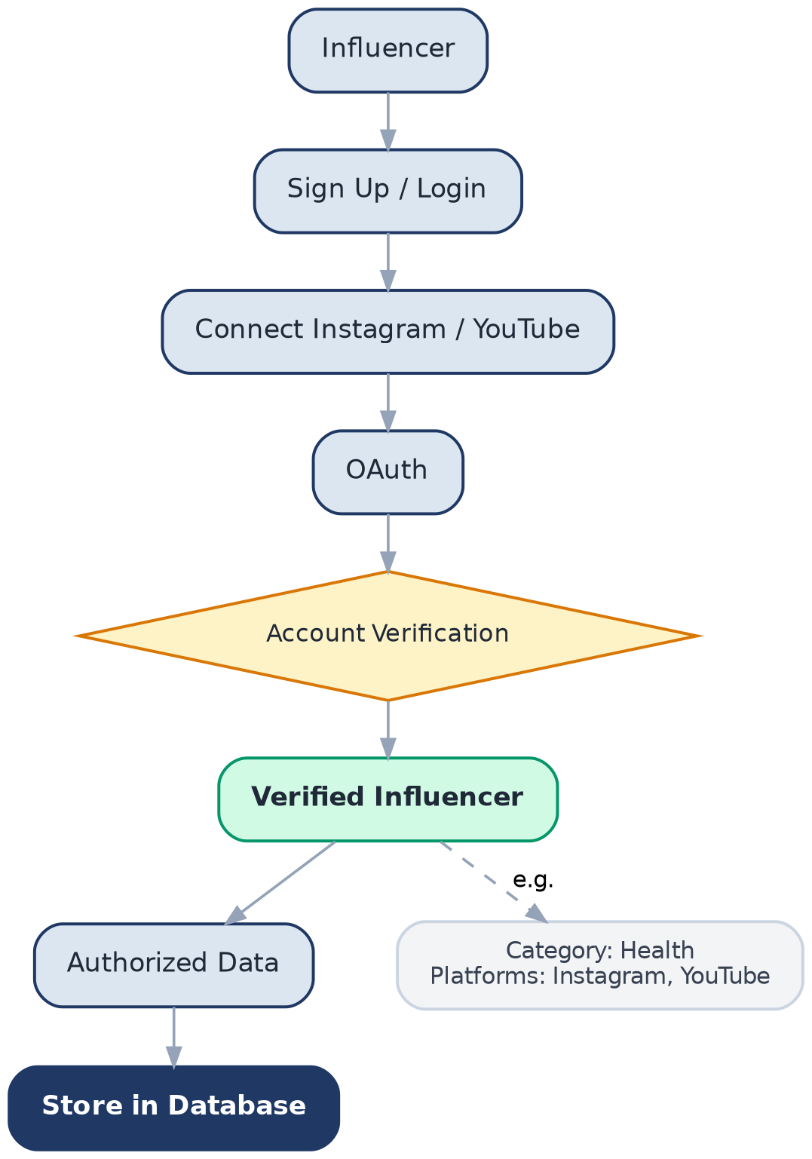
Figure 2.2 -Influencer authentication and verification flow

3. Client Access & Plans
A client must register and log in before accessing either intelligence product. Once authenticated, the client dashboard is the entry point to both the Influencer Intelligence workflow and the Campaign Management workflow.

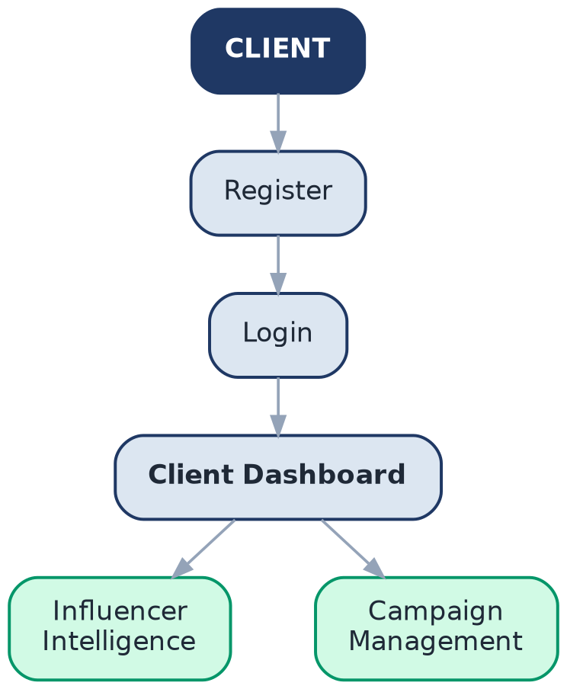
Figure 3.1 -Client registration and dashboard access

Free Plan Search Limit
The five-search restriction applies to the Influencer Intelligence search workflow. Free-plan clients receive five searches per month; the sixth search prompts an upgrade.
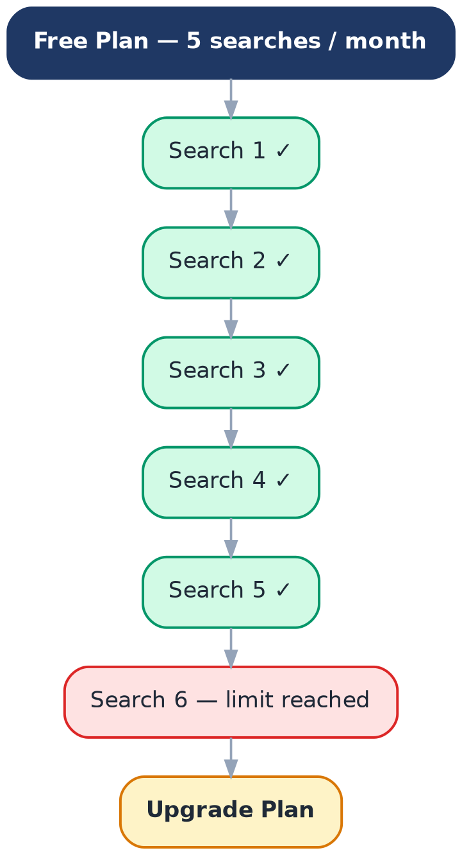
Figure 3.2 -Free plan search allowance and upgrade trigger

4. Client Workflow A -Influencer Intelligence
This is the platform's first major product.
Business question: “Should I work with this influencer?”
When a client searches for an influencer, the platform first checks whether that influencer already exists in the database. If so, the client is shown the existing profile. If not, the platform runs public data collection, normalizes the data, and passes it through the analytics engine and AI analysis to build a new profile before generating the report.
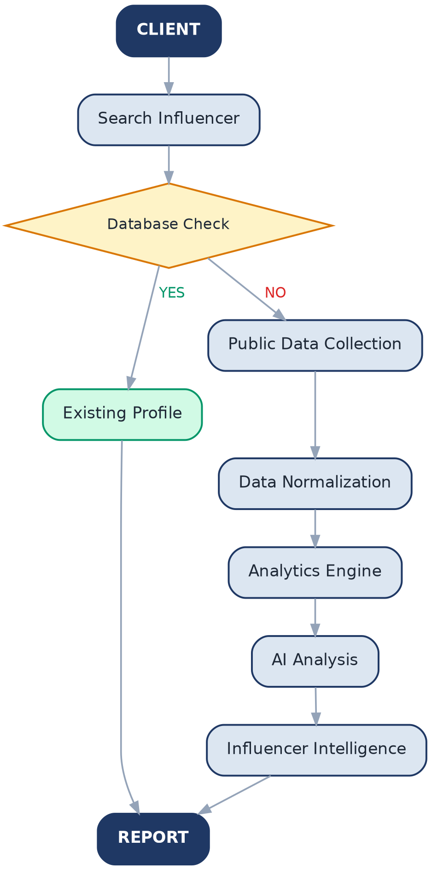
Figure 4.1 -Influencer Intelligence search-to-report flow

Data & AI Architecture Principle
The intended architecture routes public data through the analytics engine first, with OpenAI used to analyze and enrich data the platform has already collected -never as a direct pipeline from OpenAI to a source platform such as Instagram.
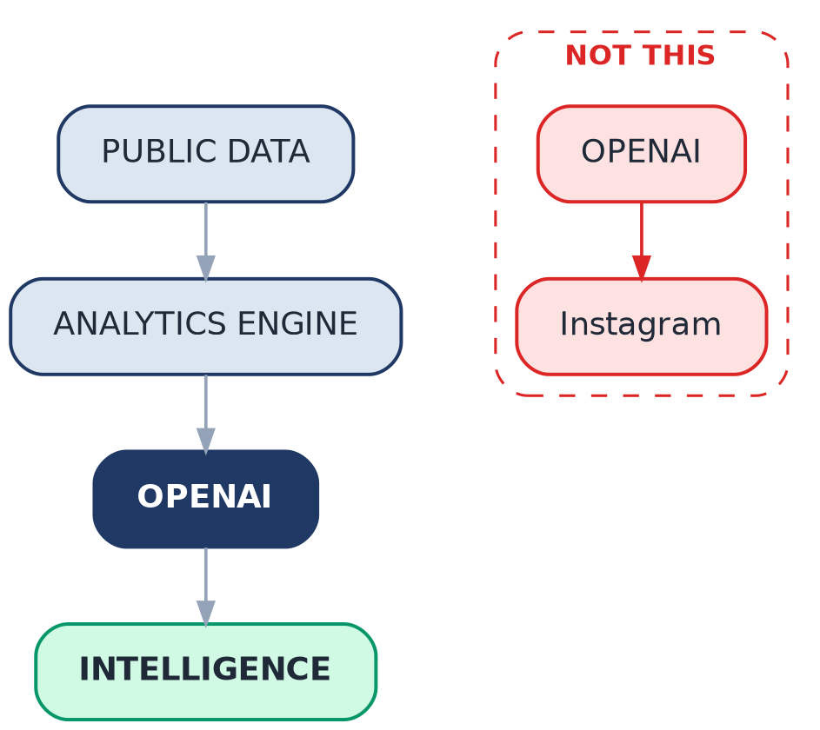
Figure 4.2 -Correct vs. incorrect data flow through the AI layer

5. Influencer Report
Every report the client receives is organized into three major sections, covering the account itself, its audience, and its content performance.

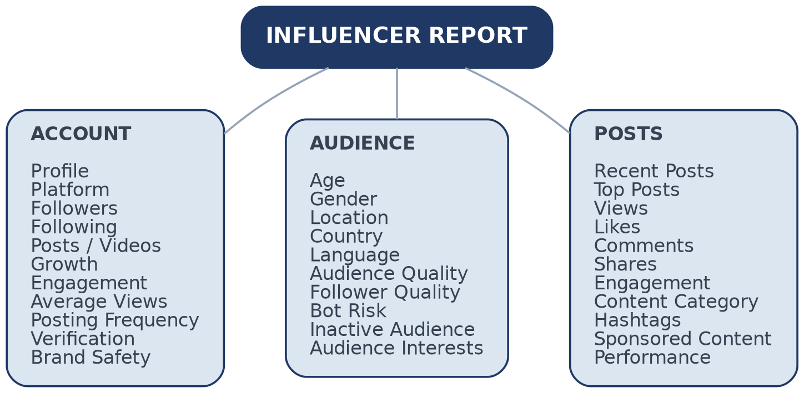
Figure 5.1 -Influencer report structure

6. AI Influencer Analysis
For a creator whose profile needs to be generated or enriched, the AI analysis layer evaluates a defined set of quality and risk dimensions:
- Bot Risk
- Inactive Audience
- Engagement Quality
- Growth Pattern
- Audience Quality
- Brand Safety
- Content Relevance
- Potential Campaign Fit
Output is evidence-based and confidence-aware, for example:
Metric | Result
Health Score | 88 / 100
Audience Quality | 91 / 100
Engagement Quality | 86 / 100
Growth Quality | 83 / 100
Brand Safety | Low Risk
Bot Risk | Low
Campaign Fit | 92 / 100
The exact scoring formulas are implemented in backend code; the AI layer's role is to explain the results and identify patterns within them, not to compute the underlying score in an opaque way.

7. Save Influencer & Export
After viewing a report, the client can save the influencer to a personal library. Saved profiles do not need to be regenerated on a later visit -once a profile has been produced, the platform stores that intelligence for reuse.
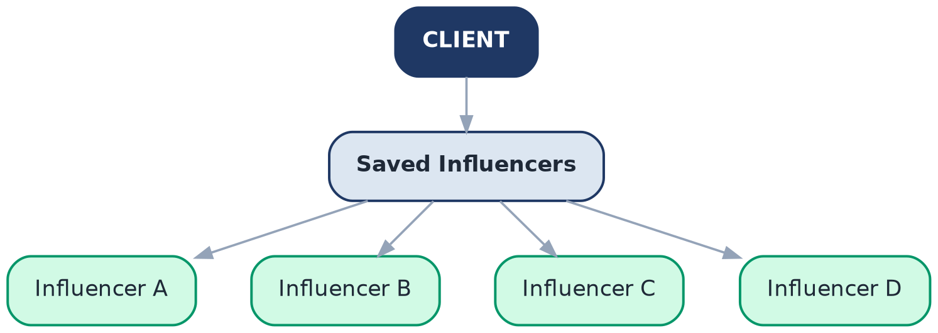
Figure 7.1 -Client's saved influencer library

Export
The client can export an influencer profile in the following formats:
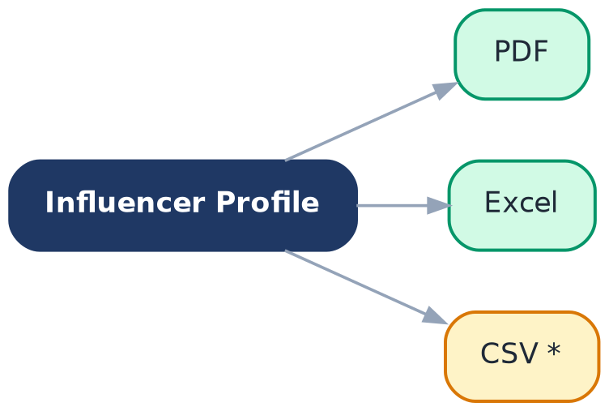
Figure 7.2 -Export formats

8. Client Workflow B -Campaign Management
This is the platform's second major product, beginning when a client wants to run a campaign.
Business question: “I want to run a campaign.”
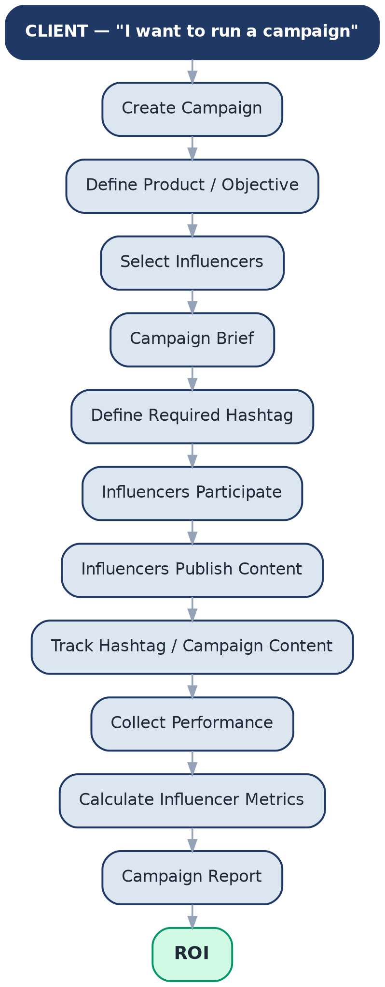
Figure 8.1 -Campaign Management, end to end

9. Talent Rate vs. Client Rate
During campaign planning, the platform compares the influencer's stated rate against the client's proposed rate and returns an AI-assisted recommendation for negotiation.
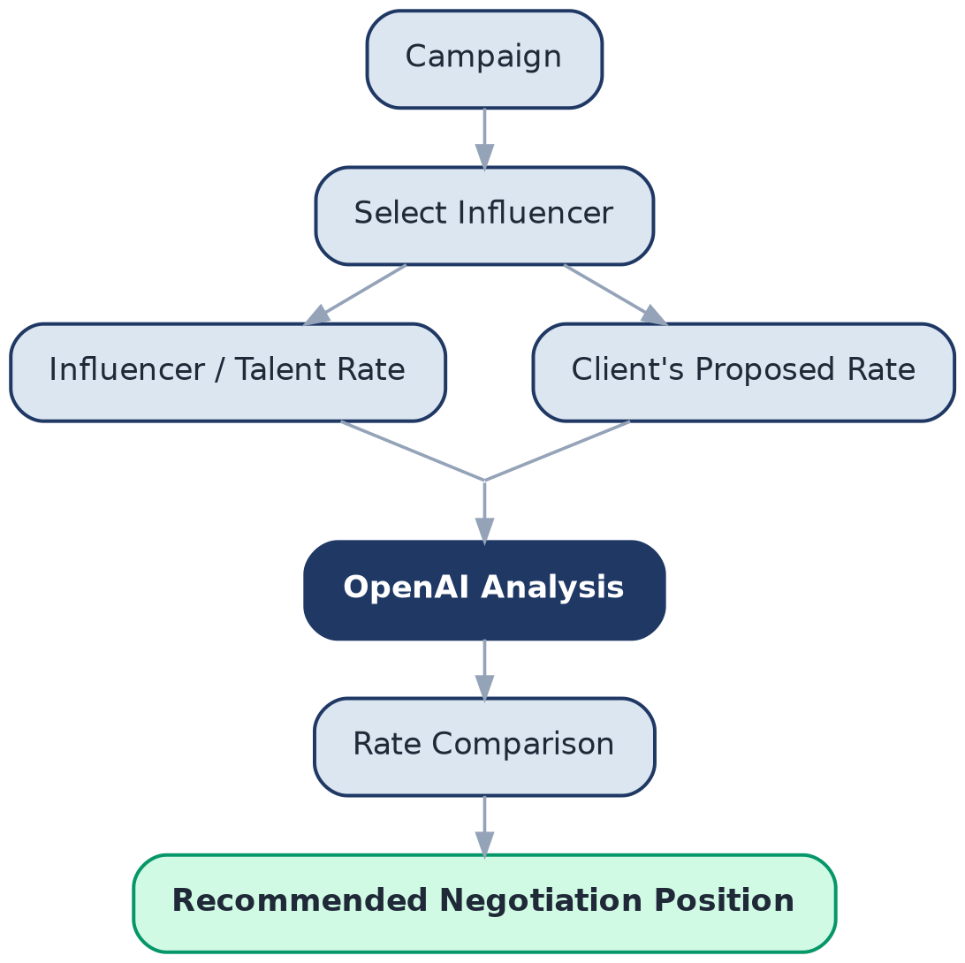
Figure 9.1 -Rate comparison and negotiation workflow
Field | Value
Influencer Rate | ₹1,50,000
Client Rate | ₹1,00,000
Difference | ₹50,000
Market Positioning | High
Creator Value | Strong
Engagement | Above average
Audience Quality | Strong
Recommended Range | ₹1,10,000 – ₹1,30,000

10. Campaign Hashtag Tracking
Every campaign requires a specific tracking hashtag -for example, a "Health Product Launch" campaign might require #MyBrandHealth2026. Influencer posts are then scanned for that hashtag to build the campaign's performance dataset.
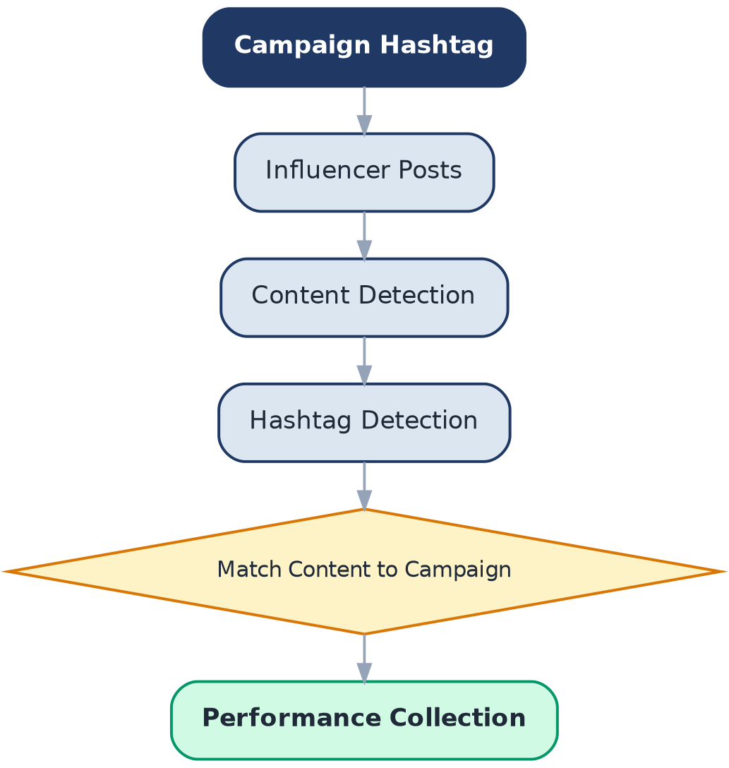
Figure 10.1 -Hashtag-based content detection and matching

11. Campaign Performance
Every participating influencer receives a campaign-specific performance score, separate from their general Influencer Intelligence score. This distinction lets the client answer: how did this influencer actually perform for our campaign?

Example -Influencer A
General Intelligence | Score | Campaign Performance | Value
Health Score | 91 | Reach | 420K
Audience Quality | 94 | Views | 390K
Campaign Fit | 92 | Likes | 32K
 |  | Comments | 2.8K
 |  | Shares | 5.1K
 |  | Engagement | 10.2%
 |  | Hashtag Posts | 3
 |  | Campaign Score | 94

12. Consumer Intelligence
The third major intelligence product answers a broader question about the market itself.
Business question: “Who are the consumers, what are they interested in, what are they saying, and which entities or influencers are relevant?”
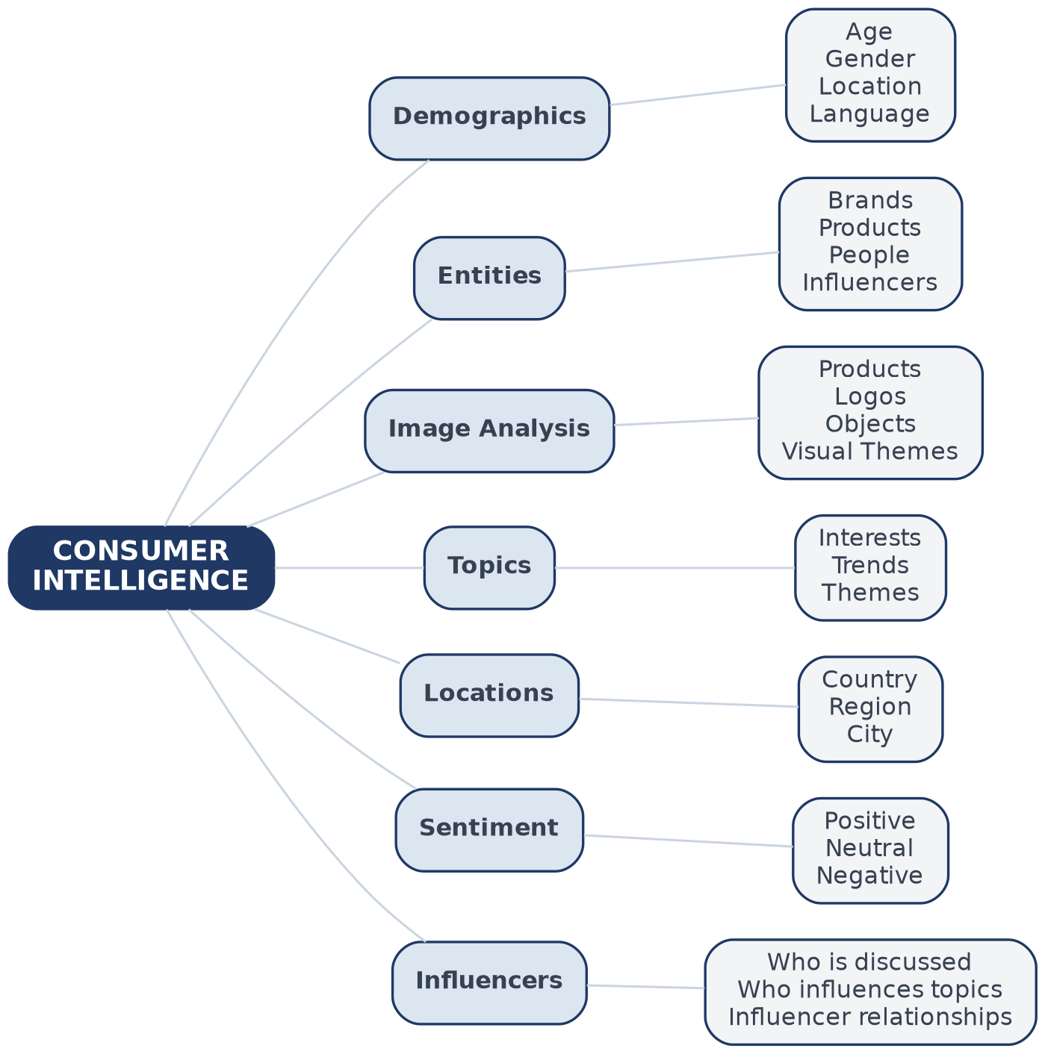
Figure 12.1 -Consumer Intelligence coverage
The phrase "across broad datasets" is central to this product: Consumer Intelligence is intended to operate across aggregated content and data sources, rather than being restricted to a single influencer profile.

13. The Three Intelligence Engines
With Consumer Intelligence added alongside Influencer and Content Intelligence, the platform's architecture becomes fully symmetric: three data domains, three intelligence engines, feeding one shared AI engine that powers discovery, campaigns, and insights.
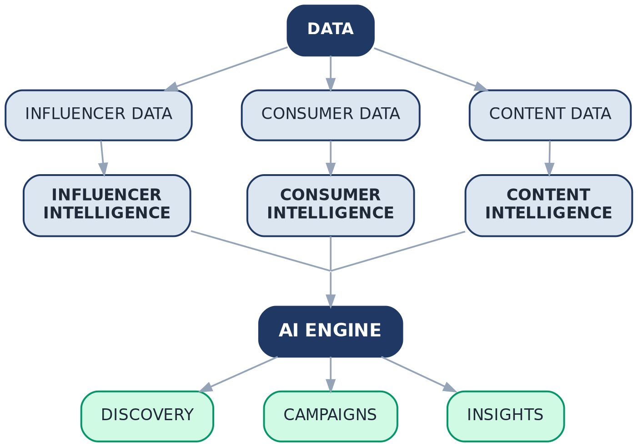
Figure 13.1 -Three data domains converging on one AI engine

14. Complete Platform Workflow
The diagram below is the platform's master workflow -from raw data source through the AI engine, down both client-facing workflows, to business insights and future recommendations.
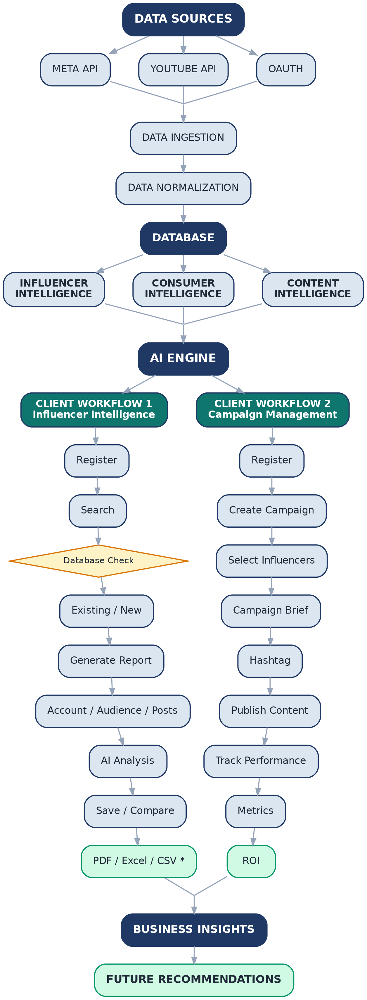
Figure 14.1 -Complete platform workflow

15. The Core Product Loop
Ultimately, every part of the platform feeds a single closed loop. This is what distinguishes the product from a simple influencer database: Consumer Intelligence identifies the audience, Influencer Intelligence identifies who can reach it, Campaign Management runs the engagement, Campaign Intelligence measures the result, ROI quantifies what the brand actually received, and that outcome becomes the learning input for the next recommendation.

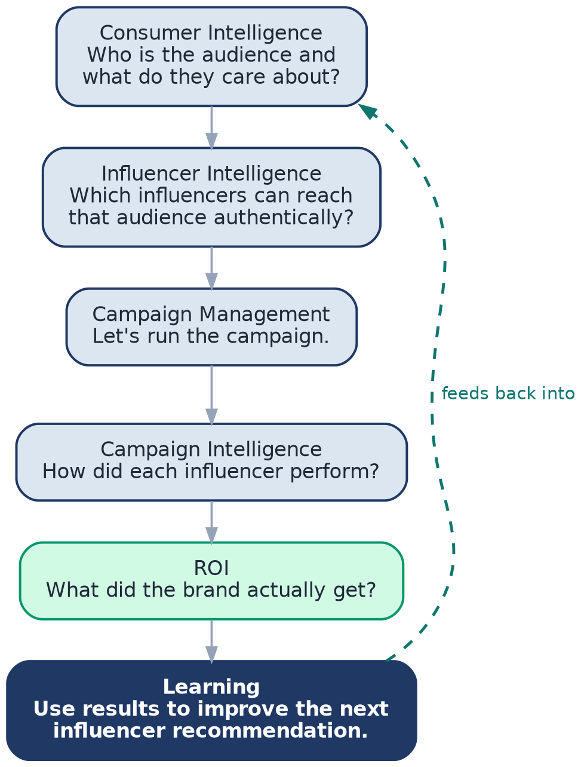
Figure 15.1 -Consumer → Influencer → Campaign → Performance → ROI → Learning

