CSE3002 – Internet and web Programming

Lab – 11

Pinni Venkata Abhiram

20BAI1132

Question – 1

Write a minimal web application to display the capital names of the user input state. Design an appropriate GUI for the same. Assume that the state and capital names are stored in associative array. Pass the name of the capital from form to server code

(i) using form element – names – synchronous

(ii) using ajax – asynchronous –(a) Get method with hard coded value as well as user input value

(b) POST method with hard coded value as well as user input value

Code

Form action method

<!DOCTYPE html>

<html>

    <head>

    <meta charset= "UTF-8">

    </head>

    <body>

    <form action = "x1.php" method = "GET">

         Enter name of the state : <input type = "text" name = "fname">

         <input type = "submit">

    </form>

    </body>

</html>

<?php

    $input = $_GET["fname"];

    $states = array("Telangana" => "Hyderabad" , "Maharashtra" => "Mumbai" , "Tamil Nadu" => "Chennai");

    foreach($states as $x => $x_val){

        if ($x == $input){

            echo "Capital = " . $x_val;

        }

    }

?>

GET Method

<!DOCTYPE html>

<html>

    <head>

        <meta charset="UTF-8">

        <script>

            function xhttpstuff()

            {

                var x = new XMLHttpRequest();

                x.onreadystatechange = function() {

                    if (this.readyState == 4 && this.status == 200) {

                        document.getElementById('demo').innerHTML = this.responseText;

                    }

                }

                var y = document.getElementById('name1').value;

                x.open("GET","states.php?f1="+y,true);

                x.send();

            }

        </script>

    </head>

    <body>

        <form name="form1" method="get">

            Enter name of the state : <input type = "text" id = "name1" name = "fname">

            <input type = "button" value="OK" onclick = "xhttpstuff()">

        </form>

        <div id = "demo"></div>

    </body>

</html>

POST Method

<!DOCTYPE html>

<html>

    <head>

        <meta charset="UTF-8">

        <script>

            function xhttpstuff()

            {

                var x = new XMLHttpRequest();

                x.onreadystatechange = function() {

                    if (this.readyState == 4 && this.status == 200) {

                        document.getElementById('demo').innerHTML = this.responseText;

                    }

                }

                var y = document.getElementById('name1').value;

                x.open("POST", "postinp.php", true);

                x.setRequestHeader('Content-type', 'application/x-www-form-urlencoded');

                x.send("f1="+y);

            }

        </script>

    </head>

    <body>

        <form name="form1" method="get">

            Enter name of the state : <input type = "text" id = "name1" name = "fname">

            <input type = "button" value="OK" onclick = "xhttpstuff()">

        </form>

        <div id = "demo"></div>

    </body>

</html>

PHP Code

<?php

    $input = $_GET["fname"];

    $states = array("Telangana" => "Hyderabad" , "Maharashtra" => "Mumbai" , "Tamil Nadu" => "Chennai");

    foreach($states as $x => $x_val){

        if ($x == $input){

            echo "Capital = " . $x_val;

        }

    }

?>

Output  
POST Method

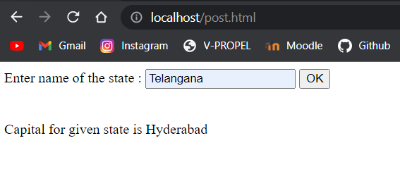

Form action

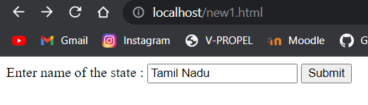

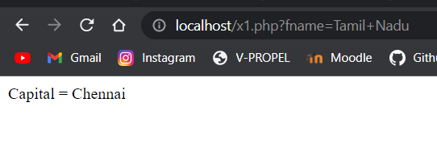

GET Method

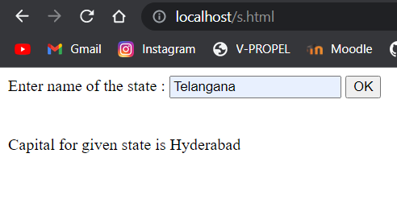

Question – 2

Design a user interface with required code using html and php to add the new state name and its capital from form input to the php array (provided if the array does not have the user input state and capital names already).

Code

HTML Code

<!DOCTYPE html>

<html>

    <head>

    <meta charset= "UTF-8">

    </head>

    <body>

    <form name = "form1" method = "GET">

        Enter name of the state : <input type = "text" id = "fname1" name = "name1"> <br>

        Enter name of the capital : <input type = "text" id = "fname2" name = "name2">

        <input type = "button" value="OK" onclick = "function1()">

        <div id="demo1"></div>

        <script src="new.js"></script>

    </form>

    </body>

</html>

JS Code

function function1() {

    var xhttp = new XMLHttpRequest();

    var input1 = document.getElementById("fname1").value

    var input2 = document.getElementById("fname2").value

    xhttp.onreadystatechange = function() {

        if (this.readyState == 4 && this.status == 200) {

            document.getElementById("demo1").innerHTML = this.responseText;

        }

    }

    xhttp.open("GET", "x2.php?fname1="+input1+"&fname2="+input2, true);

    xhttp.send();

}

PHP Code

<?php

    $input = $_GET["fname1"];

    $input2 = $_GET["fname2"];

    $states = array("Telangana" => "Hyderabad" , "Maharashtra" => "Mumbai" , "Tamil Nadu" => "Chennai");

    if (array_key_exists($input, $states)) {

        echo "Capital of given state is " . $states[$input];

    }

    if (!array_key_exists($input, $states)) {

        $states += [$input => $input2];

        echo "Array has been updated";

        print_r($states);

    }

?>

Output

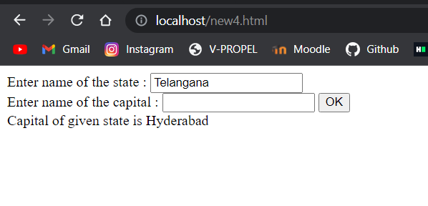

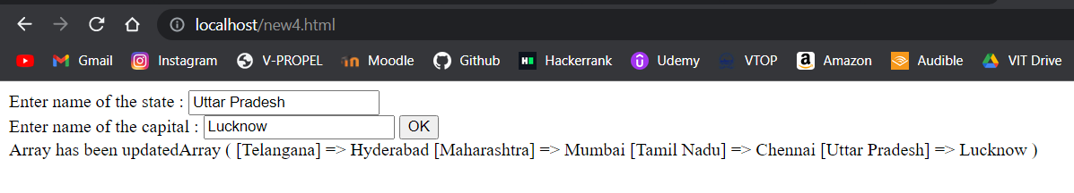

Thank you ma’am

Pinni Venkata Abhiram

20BAI1132