**BATCH NO: A16**

**INTERFACING TEMPERATURE AND HUMIDITY SENSOR**

**COMPONENTS USED:**

**1.Breadboard**

**2.Arduino uno**

**3.Jumper wires (type: male to female, male to male)**

**4.Temperature sensor (LM35)**

**5.Humidity sensor (DHT11)**

**6.OLED display**

**WORKING:**

Humidity is the measure of water vapour present in the air. The level of humidity in air affects various physical, chemical and biological processes. In industrial applications, humidity can affect the business cost of the products, health and safety of the employees. So, in semiconductor industries and control system industries measurement of humidity is very important. Humidity measurement determines the amount of moisture present in the gas that can be a mixture of water vapour, nitrogen, argon or pure gas etc… Humidity sensors are of two types based on their measurement units. They are a relative humidity sensor and Absolute humidity sensor. DHT11 is a digital temperature and humidity sensor.

Working Principle of DHT11 Sensor

DHT11 sensor consists of a capacitive humidity sensing element and a thermistor for sensing temperature. The humidity sensing capacitor has two electrodes with a moisture holding substrate as a dielectric between them. Change in the capacitance value occurs with the change in humidity levels. The IC measure, process this changed resistance values and change them into digital form.

For measuring temperature this sensor uses a Negative Temperature coefficient thermistor, which causes a decrease in its resistance value with increase in temperature. To get larger resistance value even for the smallest change in temperature, this sensor is usually made up of semiconductor ceramics or polymers.

The temperature range of DHT11 is from 0 to 50 degree Celsius with a 2-degree accuracy. Humidity range of this sensor is from 20 to 80% with 5% accuracy. The sampling rate of this sensor is 1Hz.i.e. it gives one reading for every second. DHT11 is small in size with operating voltage from 3 to 5 volts. The maximum current used while measuring is 2.5mA.

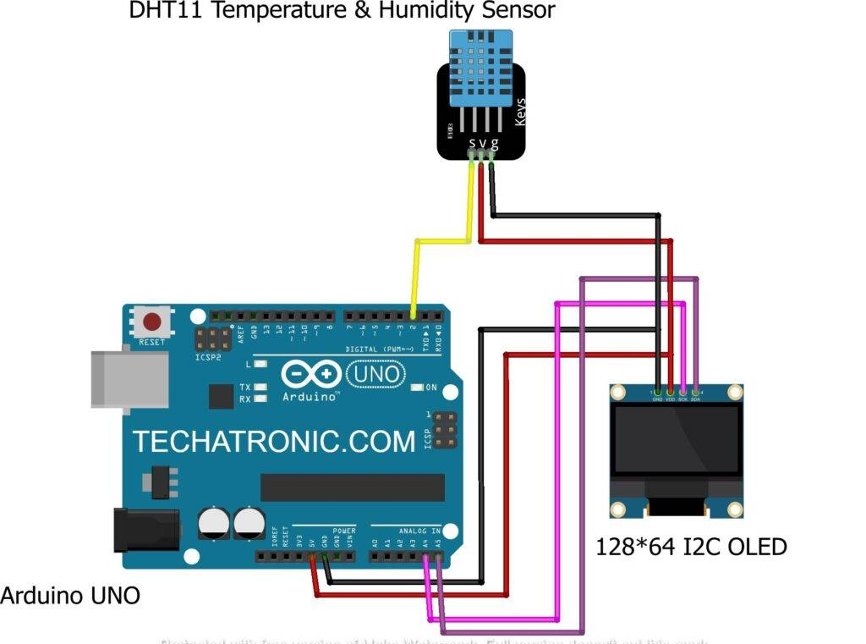

**Applications:**

* Industrial HVAC/R
* Thermostats/humidistats
* Respiratory therapy
* White goods
* Micro environments/data centres
* Automative climate control and de-fogging
* Asset and good tracking

**Roll numbers**

**21B81A0456(G. Rajya Lakshmi Devi)**

**21B81A0457(G. Kavya Sri Naga Durga)**

**21B81A0458(G. Mallika)**

**21B81A0460(J. Rashmika)**