RETAIL CUSTOMER RETENTION ANALYTICS — IKEA

Prepared By: Abhiram Rajesh
Date: June 2026
Project Video Presentation: Click Here to Watch the Video Presentation

Section 1: Executive Summary & Recommendations

1.1 Introduction & Project Context
In the modern omni-channel retail ecosystem, customer acquisition costs (CAC) continue to escalate due to market fragmentation and heightened digital competition. For a global retail leader like IKEA, sustaining long-term margin growth depends heavily on optimizing Customer Lifetime Value (CLV) and minimizing customer churn.
This project establishes an enterprise-grade analytics infrastructure using Power BI to evaluate, profile, and mitigate customer attrition. By integrating disparate behavioral, demographic, and promotional datasets, this dashboard serves as a strategic framework to diagnose structural friction points in the post-purchase lifecycle, isolate high-risk customer segments, and transition from reactive operational planning to proactive, predictive customer retention.
1.2 Comprehensive Problem Statement
IKEA's transactional data reveals a critical structural vulnerability: an inefficient customer lifecycle funnel characterized by high initial acquisition but sub-optimal post-purchase retention. While top-of-funnel marketing campaigns successfully draw new customers into the brand ecosystem, a substantial portion of these buyers fail to transition into repeat shoppers. This leak in the customer retention funnel indicates that a high volume of accounts lapse into long-term dormancy after their initial transaction.
This churn represents a significant loss of unrealized revenue and puts unsustainable pressure on marketing acquisition budgets to continuously replace departing customers. The primary business challenges addressed by this analytical model include:
- Programmatic Engagement Friction: Identifying why a significant portion of customers remain trapped in entry-tier loyalty brackets without redeeming accumulated points.
- Operational & Spatial Discrepancies: Isolating performance gaps across geographical territories and determining why newer retail store formats exhibit higher initial attrition rates compared to heritage brick-and-mortar locations.
- Lack of Micro-Targeting Capability: Resolving the historical inability to identify and profile high-risk cohorts based on their financial and behavioral attributes, which previously prevented the execution of automated, high-margin win-back campaigns.

- 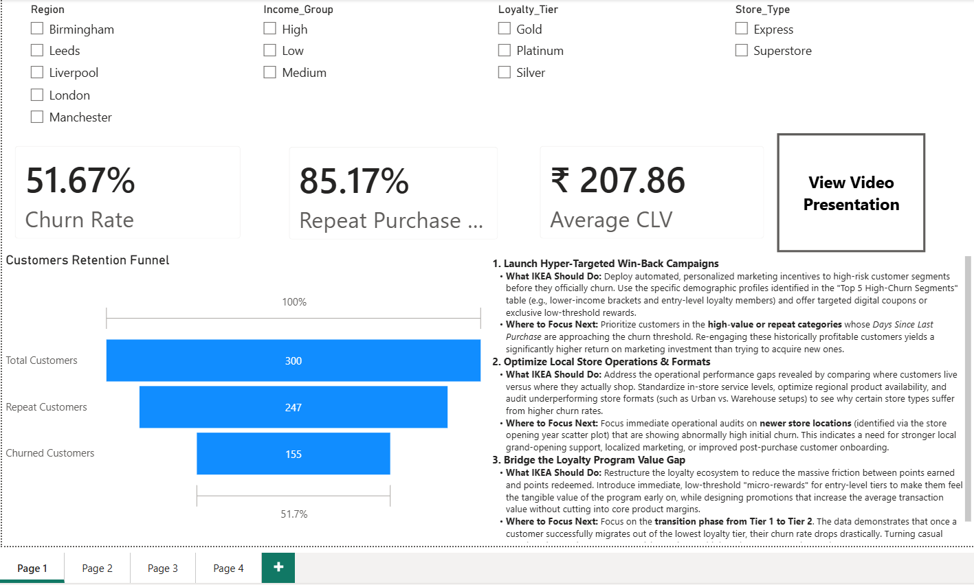
1.3 Top 3 Strategic Recommendations for Executive Leadership
- 1. Launch Hyper-Targeted Win-Back Campaigns
  - Actionable Strategy: Deploy automated, personalized marketing incentives to high-risk customer segments before they officially churn. Use the specific demographic profiles identified in the Top 5 High-Churn Segments table (e.g., lower-income brackets and entry-level loyalty members) and offer targeted digital coupons or exclusive low-threshold rewards.
  - Where to Focus Next: Prioritize customers in the high-value or repeat categories whose Days Since Last Purchase are approaching the churn threshold. Re-engaging these historically profitable customers yields a significantly higher return on marketing investment than trying to acquire new ones.
- 2. Optimize Local Store Operations & Formats
  - What IKEA Should Do: Address the operational performance gaps revealed by comparing where customers live versus where they actually shop. Standardize in-store service levels, optimize regional product availability, and audit underperforming store formats (such as Urban vs. Warehouse setups) to see why certain store types suffer from higher churn rates.
  - Where to Focus Next: Focus immediate operational audits on newer store locations (identified via the store opening year scatter plot) that are showing abnormally high initial churn. This indicates a need for stronger local grand-opening support, localized marketing, or improved post-purchase customer onboarding.
- 3. Bridge the Loyalty Program Value Gap
  - What IKEA Should Do: Restructure the loyalty ecosystem to reduce the massive friction between points earned and points redeemed. Introduce immediate, low-threshold "micro-rewards" for entry-level tiers to make them feel the tangible value of the program early on, while designing promotions that increase the average transaction value without cutting into core product margins.
  - Where to Focus Next: Focus on the transition phase from Tier 1 to Tier 2. The data demonstrates that once a customer successfully migrates out of the lowest loyalty tier, their churn rate drops drastically. Turning casual members into active program participants is your highest-leverage retention tool.

SECTION 2: TECHNICAL METHODOLOGY & CALCULATIONS

2.1 Analytics Framework & CRISP-DM Alignment
This project was executed in strict accordance with the CRISP-DM (Cross-Industry Standard Process for Data Mining) framework, ensuring a methodical progression from raw data collection to commercial deployment:
- Business Understanding: Framed the analytics goal around reducing churn, protecting retail margins, and optimizing operational allocation.
- Data Understanding: Documented and evaluated incoming customer profiles, transaction frequencies, regional store designations, and loyalty engagement tables.
- Data Preparation: Executed end-to-end Extract, Transform, Load (ETL) pipelines within Power Query. This involved removing duplicate accounts, standardizing regional date formats, addressing missing demographic variables, and structuring clean relational schemas.
- Modeling & DAX Engineering: Established a high-performance star schema model within Power BI, building dedicated dimensional tables around a central transactional fact table. Advanced Data Analysis Expressions (DAX) were authored to calculate complex retention behavior.
- Evaluation: Validated calculated outputs against historical financial baselines to ensure absolute precision across all dashboards.
- Deployment: Delivered an interactive, dashboard-driven visualization environment tailored for director-level strategic review.
2.2 Advanced DAX Calculations & Core Metrics Formulation
To ensure analytical accuracy, core retention and financial metrics were engineered using robust DAX logic. The primary formulas are defined below:
- Churn Rate:

- Repeat Purchase Rate: 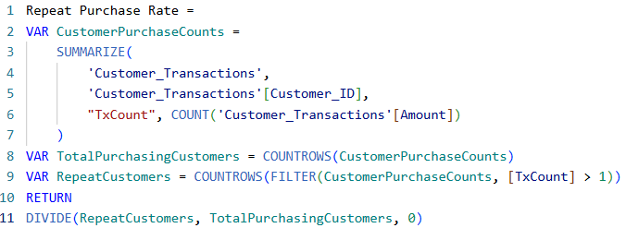

- Average Customer Lifetime Value (CLV):

Where CLV is computed as a calculated column: 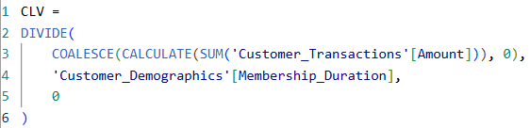

- Average Purchase Frequency:
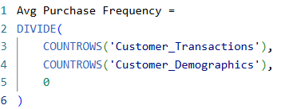

SECTION 3: FINAL DASHBOARD SHOWROOM

3.1 Page 1: Overview KPIs
  - Visual Component Inventory & Configuration:
    - KPI Cards (x3): Individual cards displaying Churn Rate, Repeat Purchase Rate, and Average CLV.
    - Funnel Chart: Displays the brand's retention lifecycle stages mapped to the Y-axis using the explicit metrics: Total Customers -> Repeat Customers -> Churned Customers.
    - Slicers (x4): Dedicated drop-down filtering controls for Region, Income_Group, Loyalty_Tier, and Store_Type.
    - Text Box: Embedded executive report text box detailing the Top 3 Strategic Recommendations.
    - Action Button: Native navigation button providing a clean interface flow to subsequent pages.
  - Interactive Flow Exploration:
    - When an executive interacts with the Region or Store_Type slicers, the core KPI cards instantly recalibrate. Simultaneously, the Customer Retention Funnel dynamically recalculates its ratios, pinpointing exactly which geographic areas experience the highest drop-off between a customer's first and second purchase.
3.2 Page 2: Loyalty & Promotion Impact
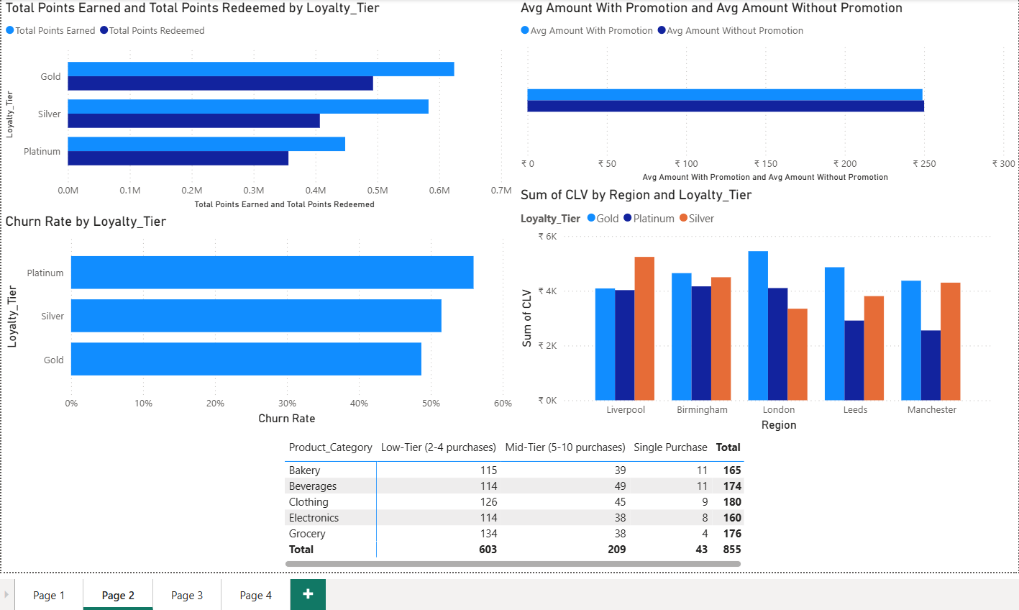
  - Visual Component Inventory & Configuration:
    - Matrix (Pivot Table): Breaks down product trends by mapping Product_Category to Rows, Customer_Loyalty_Tier to Columns, and tracking transaction volume via Min(Transaction_ID) to highlight items most frequently purchased by highly retained segments.
    - Clustered Bar Chart (Points Flow): Tracks Loyalty_Tier on the axis against both Total Points Earned and Total Points Redeemed in the values area.
    - Clustered Bar Chart (Promotion Spends): Compares financial behaviors using Avg Amount With Promotion and Avg Amount Without Promotion.
    - Clustered Bar Chart (Tier Attrition): Plots Loyalty_Tier on the axis against the calculated Churn Rate.
    - Clustered Column Chart (Value Distribution): Charts Region on the category axis and Sum(CLV) on the value axis, segmented out by Loyalty_Tier as the series legend.
    - Slicers (x4): Interactive canvas filters for Store_Type, Loyalty_Tier, Income_Group, and Region.
  - Interactive Flow Exploration:
    - Clicking on any underperforming tier within the Loyalty Tier Attrition Chart automatically filters the Product Category Matrix. This interaction highlights exactly which product categories are failing to engage entry-tier loyalty members, allowing category managers to adjust their inventory strategies.
3.3 Page 3: Store and Region Insights
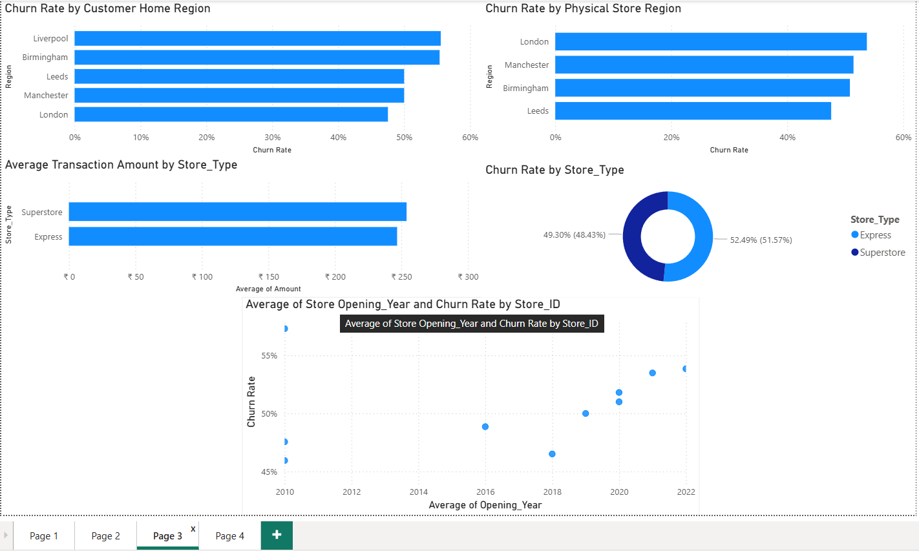
  - Visual Component Inventory & Configuration:
    - Clustered Bar Chart (Format Spending): Tracks Store_Type on the category axis against Avg(Amount) spent per invoice.
    - Clustered Bar Chart (Regional Loss): Breaks down geographic performance by showing Store_Locations.Region against Churn Rate.
    - Scatter Chart (Maturity vs. Retention): Evaluates store lifecycles by placing Opening_Year on the X-axis, Churn Rate on the Y-axis, and details down to individual Store_ID nodes to track operational maturity correlations.
    - Donut Chart (Format Attrition): Displays the distribution of Churn Rate across different physical Store_Type classifications.
    - Clustered Bar Chart (Demographic Attrition): Shows Customer_Demographics.Region plotted against Churn Rate.
    - Slicers (x4): Direct canvas filters for Store_Type, Region, Income_Group, and Loyalty_Tier.
  - Interactive Flow Exploration:
    - Selecting a newly opened store outlier on the Opening Year Scatter Chart instantly filters the adjacent charts. This highlights whether a store's high churn rate stems from its physical format (tracked via the Store Type Donut Chart) or localized regional challenges (tracked via the Regional Loss Bar Chart).

3.4 Page 4: Customer Segmentation
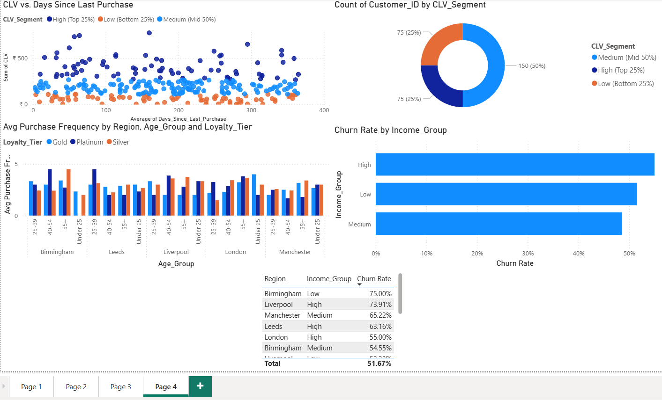
Visual Component Inventory & Configuration:
- Scatter Chart (Recency vs. Value Grid): Plots individual Customer_ID nodes across a behavioral matrix defined by Sum(Days_Since_Last_Purchase) on the X-axis and Sum(CLV) on the Y-axis, color-coded by CLV_Segment.
- Clustered Bar Chart (Income Attrition): Displays customer Income_Group categories against their respective Churn Rate.
- Table (High-Churn Target Segments): A structured data table displaying Region, Income_Group, and Churn Rate to identify vulnerable shopper segments.
- Donut Chart (Value Breakdown): Breaks down the customer base across various calculated CLV_Segment groups.
- Clustered Column Chart (Frequency Metrics): A deep-dive chart tracking Avg Purchase Frequency on the Y-axis against a dual-category axis of Region and Age_Group, broken down by Loyalty_Tier.
- Slicers (x4): Control filters for Store_Type, Loyalty_Tier, Income_Group, and Region.
Interactive Flow Exploration:
Selecting a high-risk segment row within the High-Churn Target Table updates the main Recency vs. Value Scatter Chart. This instantly isolates the corresponding customer nodes on the visual grid, allowing database marketing teams to export clean lists for targeted win-back campaigns.

