

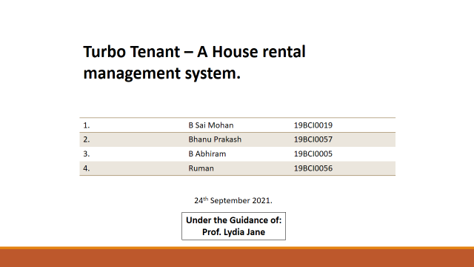

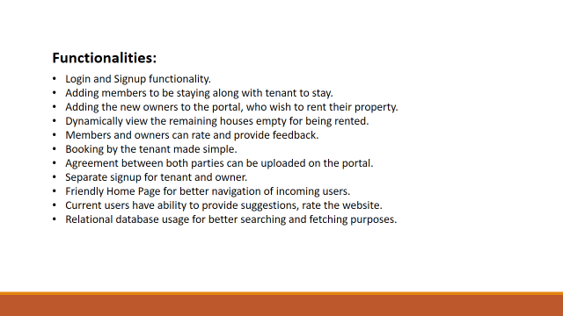

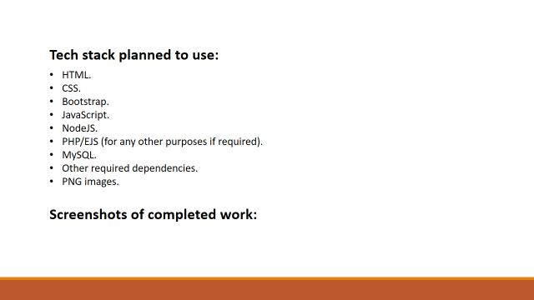

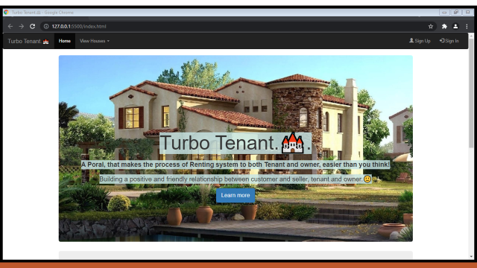

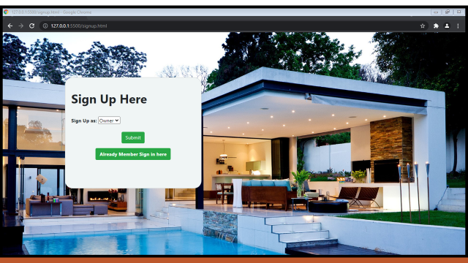

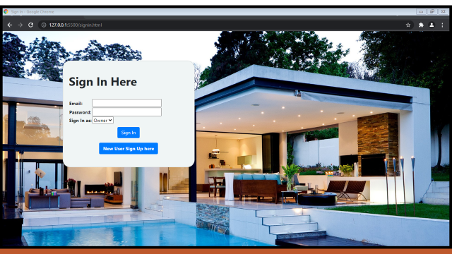

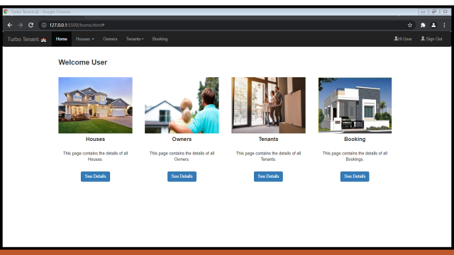

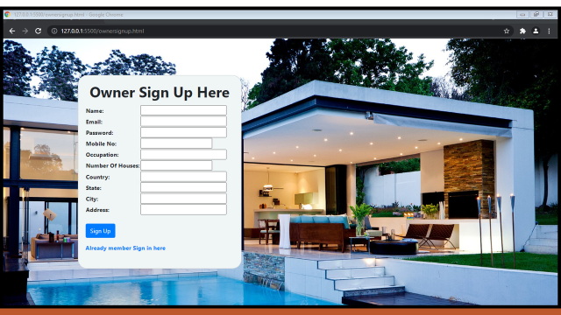

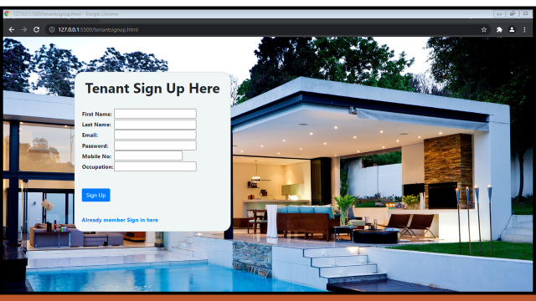

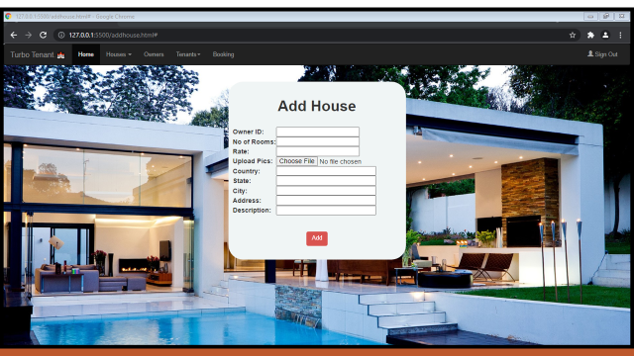

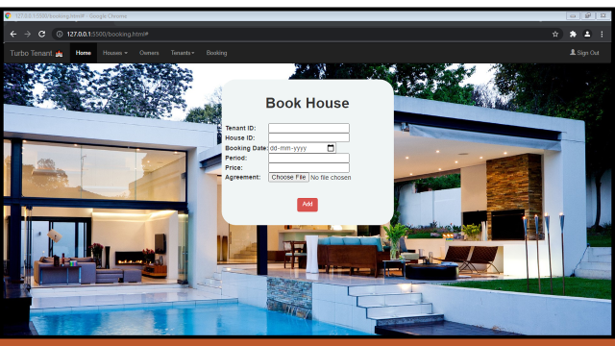

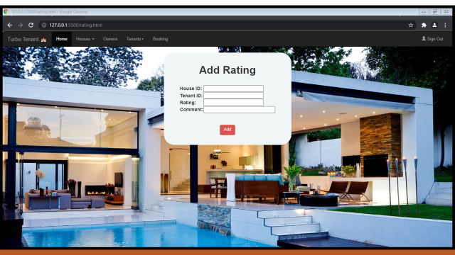

**Code:**

**home.html**

<!DOCTYPE html>

<html lang="en">

<head>

<title>Turbo Tenant.🏰</title>

<meta charset="utf-8" />

<meta name="viewport" content="width=device-width, initial-scale=1" />

<link rel="stylesheet" type="text/css" href="styles/home.css" />

<link

rel="stylesheet"

href="https://maxcdn.bootstrapcdn.com/bootstrap/3.4.0/css/bootstrap.min.css"

/>

<script src="https://ajax.googleapis.com/ajax/libs/jquery/3.4.1/jquery.min.js"></script>

<script src="https://maxcdn.bootstrapcdn.com/bootstrap/3.4.0/js/bootstrap.min.js"></script>

</head>

<body>

<nav class="navbar navbar-inverse">

<div class="container-fluid">

<div class="navbar-header">

<button

type="button"

class="navbar-toggle"

data-toggle="collapse"

data-target="#myNavbar"

>

<span class="icon-bar"></span>

<span class="icon-bar"></span>

<span class="icon-bar"></span>

</button>

<a class="navbar-brand" href="#">Turbo Tenant.🏰</a>

</div>

<div class="collapse navbar-collapse" id="myNavbar">

<ul class="nav navbar-nav">

<li class="active"><a href="#">Home</a></li>

<li class="dropdown">

<a class="dropdown-toggle" data-toggle="dropdown" href="#"

>Houses <span class="caret"></span

></a>

<ul class="dropdown-menu">

<li><a href="#">Houses</a></li>

<li><a href="#">Rating</a></li>

</ul>

</li>

<li><a href="#">Owners</a></li>

<li class="dropdown">

<a class="dropdown-toggle" data-toggle="dropdown" href="#"

>Tenants<span class="caret"></span

></a>

<ul class="dropdown-menu">

<li><a href="#">Tenants</a></li>

<li><a href="#">Members</a></li>

</ul>

</li>

<li><a href="#">Booking</a></li>

</ul>

<ul class="nav navbar-nav navbar-right">

<li>

<a href="#">

<!-- User has to be replaced by embedded javascript code to retrive the logged in username -->

<span class="glyphicon glyphicon-user"></span>Hi User

</a>

</li>

<li>

<a href="index.html"

><span class="glyphicon glyphicon-user"></span> Sign Out</a

>

</li>

</ul>

</div>

</div>

</nav>

<div class="container" style="margin-top: 5px">

<h3>

<!-- User has to be replaced by embedded javascript code to retrive the logged in username -->

<b>Welcome User</b><br /><br />

</h3>

<div class="row">

<div class="col-lg-3">

<div class="card colo-md-4" style="width: 250px">

<img

class="card-img-top"

src="img/h1.jpg"

alt="Card image"

width="250px;"

height="190px;"

/>

<div class="card-body">

<center>

<h4 class="card-title"><b>Houses</b></h4>

<br />

<p class="card-text">

This page contains the details of all Houses.

</p>

<br />

<a href="#" class="btn btn-primary">See Details</a>

</center>

<br />

</div>

</div>

<br />

</div>

<div class="col-lg-3">

<div class="card colo-md-4" style="width: 250px">

<img

class="card-img-top"

src="img/h2.jpg"

alt="Card image"

width="250px;"

height="190px;"

/>

<div class="card-body">

<center>

<h4 class="card-title"><b>Owners</b></h4>

<br />

<p class="card-text">

This page contains the details of all Owners.

</p>

<br />

<a href="#" class="btn btn-primary">See Details</a>

</center>

<br />

</div>

</div>

<br />

</div>

<div class="col-lg-3">

<div class="card colo-md-4" style="width: 250px">

<img

class="card-img-top"

src="img/h3.jpg"

alt="Card image"

width="250px;"

height="190px;"

/>

<div class="card-body">

<center>

<h4 class="card-title"><b>Tenants</b></h4>

<br />

<p class="card-text">

This page contains the details of all Tenants.

</p>

<br />

<a href="#" class="btn btn-primary">See Details</a>

</center>

<br />

</div>

</div>

<br />

</div>

<div class="col-lg-3">

<div class="card colo-md-4" style="width: 250px">

<img

class="card-img-top"

src="img/h4.jpg"

alt="Card image"

width="250px;"

height="190px;"

/>

<div class="card-body">

<center>

<h4 class="card-title"><b>Booking</b></h4>

<br />

<p class="card-text">

This page contains the details of all Bookings.

</p>

<br />

<a href="#" class="btn btn-primary">See Details</a>

</center>

<br />

</div>

</div>

<br />

</div>

</div>

</div>

</body>

</html>

**addhouse.html**

<html>

<head>

<link rel="stylesheet" type="text/css" href="styles/signup.css" />

<link

rel="stylesheet"

href="https://maxcdn.bootstrapcdn.com/bootstrap/3.4.0/css/bootstrap.min.css"

/>

<script src="https://ajax.googleapis.com/ajax/libs/jquery/3.4.1/jquery.min.js"></script>

<script src="https://maxcdn.bootstrapcdn.com/bootstrap/3.4.0/js/bootstrap.min.js"></script>

</head>

<body>

<nav class="navbar navbar-inverse">

<div class="container-fluid">

<div class="navbar-header">

<button

type="button"

class="navbar-toggle"

data-toggle="collapse"

data-target="#myNavbar"

>

<span class="icon-bar"></span>

<span class="icon-bar"></span>

<span class="icon-bar"></span>

</button>

<a class="navbar-brand" href="#">Turbo Tenant.🏰</a>

</div>

<div class="collapse navbar-collapse" id="myNavbar">

<ul class="nav navbar-nav">

<li class="active"><a href="home.php">Home</a></li>

<li class="dropdown">

<a class="dropdown-toggle" data-toggle="dropdown" href="#"

>Houses <span class="caret"></span

></a>

<ul class="dropdown-menu">

<li><a href="houses.php">Houses</a></li>

<li><a href="rating.php">Rating</a></li>

</ul>

</li>

<li><a href="owner.php">Owners</a></li>

<li class="dropdown">

<a class="dropdown-toggle" data-toggle="dropdown" href="#"

>Tenants<span class="caret"></span

></a>

<ul class="dropdown-menu">

<li><a href="tenant.php">Tenants</a></li>

<li><a href="members.php">Members</a></li>

</ul>

</li>

<li><a href="booking.php">Booking</a></li>

</ul>

<ul class="nav navbar-nav navbar-right">

<li>

<a href="index.html"

><span class="glyphicon glyphicon-user"></span> Sign Out</a

>

</li>

</ul>

</div>

</div>

</nav>

<center>

<br />

<div

class="card"

style="width: 43rem; border-radius: 35px; background-color: #f0f5f5"

>

<br />

<div class="card-body">

<h1 class="card-title" style="text-align: center">

<b>Add House</b>

</h1>

<br />

<form

name="Form2"

action="addhouse.php"

method="get"

enctype="multipart/form-data"

>

<table>

<tr>

<td><b>Owner ID: </b></td>

<td><input type="number" name="o" value="" size="25" /></td>

</tr>

<tr>

<td><b>No of Rooms: </b></td>

<td><input type="number" name="n" value="" size="25" /></td>

</tr>

<tr>

<td><b>Rate: </b></td>

<td><input type="number" name="ra" value="" size="35" /></td>

</tr>

<tr>

<td><b>Upload Pics: </b></td>

<td>

<input

type="file"

name="u"

value=""

size="25"

accept="image/*"

/>

</td>

</tr>

<tr>

<td><b>Country: </b></td>

<td><input type="textbox" name="c" value="" size="25" /></td>

</tr>

<tr>

<td><b>State: </b></td>

<td><input type="textbox" name="s" value="" size="25" /></td>

</tr>

<tr>

<td><b>City: </b></td>

<td><input type="textbox" name="city" value="" size="25" /></td>

</tr>

<tr>

<td><b>Address: </b></td>

<td><input type="textbox" name="a" value="" size="25" /></td>

</tr>

<tr>

<td><b>Description: </b></td>

<td><input type="textbox" name="de" value="" size="25" /></td>

</tr>

</table>

<br /><br />

<input

type="submit"

value="Add"

class="btn btn-danger"

name="submit"

/>

</form>

<br />

</div>

</div>

</center>

</body>

</html>

**booking.html**

<html>

  <head>

    <link rel="stylesheet" type="text/css" href="styles/signup.css" />

    <link

      rel="stylesheet"

      href="https://maxcdn.bootstrapcdn.com/bootstrap/3.4.0/css/bootstrap.min.css"

    />

    <script src="https://ajax.googleapis.com/ajax/libs/jquery/3.4.1/jquery.min.js"></script>

    <script src="https://maxcdn.bootstrapcdn.com/bootstrap/3.4.0/js/bootstrap.min.js"></script>

  </head>

  <body>

    <nav class="navbar navbar-inverse">

      <div class="container-fluid">

        <div class="navbar-header">

          <button

            type="button"

            class="navbar-toggle"

            data-toggle="collapse"

            data-target="#myNavbar"

          >

            <span class="icon-bar"></span>

            <span class="icon-bar"></span>

            <span class="icon-bar"></span>

          </button>

          <a class="navbar-brand" href="#">Turbo Tenant.🏰</a>

        </div>

        <div class="collapse navbar-collapse" id="myNavbar">

          <ul class="nav navbar-nav">

            <li class="active"><a href="home.php">Home</a></li>

            <li class="dropdown">

              <a class="dropdown-toggle" data-toggle="dropdown" href="#"

                >Houses <span class="caret"></span

              ></a>

              <ul class="dropdown-menu">

                <li><a href="houses.php">Houses</a></li>

                <li><a href="rating.php">Rating</a></li>

              </ul>

            </li>

            <li><a href="owner.php">Owners</a></li>

            <li class="dropdown">

              <a class="dropdown-toggle" data-toggle="dropdown" href="#"

                >Tenants<span class="caret"></span

              ></a>

              <ul class="dropdown-menu">

                <li><a href="tenant.php">Tenants</a></li>

                <li><a href="members.php">Members</a></li>

              </ul>

            </li>

            <li><a href="booking.php">Booking</a></li>

          </ul>

          <ul class="nav navbar-nav navbar-right">

            <li>

              <a href="index.html"

                ><span class="glyphicon glyphicon-user"></span> Sign Out</a

              >

            </li>

          </ul>

        </div>

      </div>

    </nav>

    <center>

      <br />

      <div

        class="card"

        style="width: 43rem; border-radius: 35px; background-color: #f0f5f5"

      >

        <br />

        <div class="card-body">

          <h1 class="card-title" style="text-align: center">

            <b>Book House</b>

          </h1>

          <br />

          <form

            name="Form2"

            action="dobooking.php"

            method="get"

            enctype="multipart/form-data"

          >

            <table>

              <tr>

                <td><b>Tenant ID: </b></td>

                <td><input type="number" name="t" value="" size="25" /></td>

              </tr>

              <tr>

                <td><b>House ID: </b></td>

                <td><input type="number" name="h" value="" size="25" /></td>

              </tr>

              <tr>

                <td><b>Booking Date: </b></td>

                <td><input type="date" name="b" value="" size="25" /></td>

              </tr>

              <tr>

                <td><b>Period: </b></td>

                <td><input type="number" name="p" value="" size="25" /></td>

              </tr>

              <tr>

                <td><b>Price: </b></td>

                <td><input type="number" name="pr" value="" size="25" /></td>

              </tr>

              <tr>

                <td><b>Agreement: </b></td>

                <td><input type="file" name="a" value="" size="25" /></td>

              </tr>

            </table>

            <br /><br />

            <input

              type="submit"

              value="Add"

              class="btn btn-danger"

              name="submit"

            />

          </form>

          <br />

        </div>

      </div>

    </center>

  </body>

</html>

**Similarly, all others.**

