**Chapter 1**

**Introduction**

Social media has become an integral part of modern communication, influencing various aspects of society, including business strategies, political campaigns, and public awareness. Among these platforms, Twitter stands out as a prominent microblogging service where millions of users express their opinions, emotions, and ideas daily. Tweets on trending topics offer valuable insights into public sentiment, making sentiment analysis an essential tool for understanding collective opinions and deriving actionable conclusions.

Sentiment analysis involves extracting and interpreting emotions expressed in text, categorizing them into positive, negative, or neutral sentiments. Traditionally, sentiment analysis required manual effort or complex machine learning models, which are resource-intensive and often inaccessible to non-technical users. With advancements in automation tools like UiPath and AI models like ChatGPT, the process of sentiment analysis can be streamlined and simplified for broader accessibility.

This project leverages UiPath Studio, a powerful robotic process automation (RPA) tool, in combination with ChatGPT to automate the sentiment analysis process. It integrates data extraction, preprocessing, and AI-powered sentiment analysis into a single workflow, enabling users to analyze sentiments of Twitter posts on trending topics in real-time. The system ensures efficiency, accuracy, and user-friendliness, eliminating the need for extensive technical expertise.

By automating repetitive tasks such as web browsing, data extraction, and preprocessing, the project demonstrates how RPA and AI technologies can be utilized together to address real-world challenges. The integration of ChatGPT for sentiment analysis further enhances the system's capabilities by providing accurate and contextual insights into public opinions. This automated solution has applications in fields like market research, political analysis, event monitoring, and customer feedback assessment.

* 1. **Problem Statement**

Analyzing public sentiment on Twitter poses several challenges due to the nature of the platform and its data. The vast volume of real-time tweets makes manual analysis impractical and time-consuming. Additionally, Twitter posts often contain emojis, slang, abbreviations, and non-English content, requiring substantial preprocessing to extract meaningful insights. Current methods of sentiment analysis often involve complex machine learning models or manual workflows, which are either resource-intensive or susceptible to human error. These challenges hinder the effective use of Twitter data for sentiment analysis, creating a need for an automated system that integrates data extraction, cleaning, and analysis into a seamless process.

* 1. **Objectives**

The primary objectives of this project are as follows:

* **Automate Data Retrieval:** Enable the system to automatically collect the latest Twitter posts related to a user-provided trending topic using UiPath Studio.
* **Preprocess Data:** Develop a preprocessing pipeline to clean the extracted data by removing emojis, special characters, and non-English text.
* **Perform Sentiment Analysis:** Integrate ChatGPT to analyze the cleaned Twitter data and determine its sentiment.
* **Provide User-Friendly Output:** Display the sentiment results in a concise and clear format, ensuring the system is accessible to non-technical users.
* **Enhance Efficiency:** Minimize human intervention by automating repetitive tasks, reducing time and effort.

**Chapter 2**

**Literature Survey**

Sentiment analysis of social media posts has become a critical research area due to the widespread adoption of platforms like Twitter, Facebook, and Instagram for sharing opinions, emotions, and feedback. The vast and diverse nature of data generated on these platforms offers valuable insights into public sentiment on various topics, such as product reviews, political trends, and social issues. By leveraging techniques from Natural Language Processing (NLP) and machine learning, sentiment analysis aims to classify user posts into categories like positive, negative, or neutral. This area of study has evolved significantly, transitioning from traditional lexicon-based approaches to advanced deep learning techniques, addressing the complexities of informal language, sarcasm, and real-time analysis. This literature survey explores the methodologies, advancements, and challenges in social media sentiment analysis, providing a comprehensive review of the current state of the field and its applications across industries.

The author focuses on Twitter sentiment analysis, which involves classifying tweets into positive, negative, or neutral sentiments using Natural Language Processing (NLP) and machine learning techniques. The process includes data collection via APIs or web scraping, preprocessing through tokenization, stemming, and noise removal, followed by feature extraction using methods like bag-of-words, n-grams, and word embeddings. Various algorithms, including Support Vector Machines (SVM), Naive Bayes, and deep learning models, are used for sentiment classification. The study highlights the challenges of handling noisy data, detecting sarcasm, and addressing biases in training datasets, emphasizing the need for continuous updates to improve accuracy. Applications of this analysis span brand management, customer service, and market research, showcasing its growing significance for businesses and researchers.[1]

The author discusses an integrated system for automating customer feedback management on e-commerce platforms using sentiment analysis and Robotic Process Automation (RPA). The authors employ UiPath to extract customer reviews from websites, which are then processed using sentiment analysis to classify feedback into categories such as positive and negative. Negative reviews are automatically forwarded to the appropriate departments, while visual summaries in pie charts provide customers with insights into product reviews. By combining automation with

sentiment classification, the system aims to streamline feedback handling, reduce manual effort, and enable companies to make data-driven decisions for product improvement and customer satisfaction. The paper underscores the role of RPA in enhancing operational efficiency in the e-commerce domain.[2]

The author introduces an advanced deep learning architecture called the Hybrid Gated Attention Recurrent Network (GARN) for Twitter sentiment analysis. The process begins with data preprocessing, including tokenization, stemming, and slang correction, to clean the raw tweet data. Feature extraction is conducted using a novel Log Term Frequency-based Modified Inverse Class Frequency (LTF-MICF) method, which identifies critical sentiment features. To optimize feature selection, the study employs a Hybrid Mutation-based White Shark Optimizer (HMWSO), reducing irrelevant features and improving model performance. The GARN architecture integrates Recurrent Neural Networks (RNNs) with an attention mechanism to classify sentiments effectively, achieving an accuracy of 97.86% and outperforming traditional classifiers. By leveraging advanced feature extraction, optimization, and classification methods, the model addresses challenges associated with large datasets and enhances overall sentiment analysis efficiency.[3]

The paper "Sentiment Analysis of Twitter Data" by Wang et al. (2022) provides a comprehensive review of Twitter-based sentiment analysis (TSA), highlighting its significance in understanding public opinions and sentiments expressed on the platform. With over 300 million active users generating vast amounts of opinionated content, Twitter has become a critical source for sentiment analysis research. The authors categorize TSA methodologies into three main approaches: machine learning-based, lexicon-based, and hybrid techniques, each with distinct advantages and challenges. The paper addresses the unique difficulties posed by the short length of tweets, which limits the amount of sentiment information that can be extracted, and discusses various preprocessing techniques essential for effective TSA. It also outlines the different levels of sentiment analysis, including document-level, sentence-level, and aspect-level classifications, emphasizing the importance of feature representation in enhancing prediction accuracy. The survey aims to present a nearly exhaustive overview of the current TSA techniques, recent advancements, and the evolving landscape of research in this area, ultimately serving as a valuable resource for scholars and practitioners interested in sentiment analysis and its applications in fields such as marketing, politics, and social studies.[4]

|  |  |  |  |  |
| --- | --- | --- | --- | --- |
| **Paper Title** | **Authors** | **Summary** | **Methodologies Used** | **Challenges** |
| Twitter Sentiment Analysis | Rahul Tiwari, Asim Ahamad | Focuses on classifying tweets into positive, negative, or neutral sentiments using NLP and machine learning techniques. Applications include brand management, customer service, and market research. | Data collection via APIs or web scraping, preprocessing (tokenization, stemming, noise removal), feature extraction (bag-of-words, n-grams, word embeddings), ML models like SVM and Naive Bayes | Handling noisy data, detecting sarcasm, biases in training data, maintaining accuracy, and keeping models updated for new trends. |
| Customer Feedback Automation and Classification using Sentiment Analysis, Robotic Process Automation and UiPath | Sakthivel V, GantiVenkataVarshini, NethraSai M, Deepthi R, Vishnukumar Kaliappan, Jueying Li | Proposes an automated feedback management system for e-commerce using RPA and sentiment analysis. Reduces manual effort by automating classification and forwarding of feedback. | Use of UiPath for RPA, web scraping for review extraction, NLP for sentiment classification (positive, negative, neutral), visualization via pie charts | Managing large-scale customer feedback, ensuring accurate classification of mixed reviews, integrating feedback insights with business operations. |
| Twitter Sentiment Analysis Using Hybrid Gated Attention Recurrent Network (GARN) | Nikhat Parveen, Prasun Chakrabarti, Bui Thanh Hung, Amjan Shaik | Introduces a hybrid deep learning model (GARN) for Twitter sentiment analysis, achieving high accuracy. Combines RNN with attention mechanisms for enhanced feature learning. | Data preprocessing (tokenization, stemming, slang correction), Log Term Frequency-based Modified Inverse Class Frequency (LTF-MICF) for feature extraction, Hybrid Mutation-based White Shark Optimizer (HMWSO), GARN (RNN + attention mechanism). | Addressing large datasets, selecting optimal features, reducing irrelevant features, improving classification efficiency, and managing computational complexity. |
| Sentiment Analysis of Twitter Data | Yili Wang, Jiaxuan Guo, Chengsheng Yuan, Baozhu Li | Provides a survey of Twitter Sentiment Analysis (TSA), categorizing techniques and highlighting advancements. Explores various preprocessing and classification approaches. | Categorizes approaches into machine learning-based, lexicon-based, and hybrid techniques. Uses preprocessing steps (e.g., tokenization) and different levels of sentiment classification (document, sentence, and aspect). | Short length of tweets limiting sentiment information, preprocessing challenges, and achieving accuracy in feature representation and classification methods. |

Table 2.1: Literature Survey

The literature on social media sentiment analysis highlights diverse approaches and methodologies tailored to address the complexities of analyzing online posts. Early methods, such as machine learning-based and lexicon-based techniques, have evolved into more sophisticated hybrid and deep learning models to improve classification accuracy. Studies on Twitter sentiment analysis, like those by Rahul Tiwari and Nikhat Parveen, emphasize preprocessing steps like tokenization, stemming, and noise removal to manage the informal nature of social media text. Advanced models like GARN integrate Recurrent Neural Networks (RNNs) with attention mechanisms and optimization algorithms for feature selection, achieving high accuracy.

Applications extend to customer feedback automation in e-commerce platforms, as seen in work by Sakthivel V and colleagues, which employs Robotic Process Automation (RPA) alongside sentiment analysis to streamline feedback classification and actionable insights. While these studies demonstrate significant progress, challenges persist, such as handling noisy data, detecting sarcasm, managing short text, and integrating large-scale datasets. Overall, the literature underscores the transformative potential of sentiment analysis across domains like marketing, politics, and customer experience while identifying gaps in efficiency and adaptability, which future research must address to harness its full potential.

**Chapter 3**

**Project Requirements**

**Hardware Requirements**:

|  |  |
| --- | --- |
| Processor | Intel Core i5 / Ryzen 5 |
| RAM | 4GB – 32GB |
| Storage | 128 GB |
| Monitor | HD (1366x768) |
| Internet Connection | Stable Broadband for accessing ChatGPT and web automation |

Table 3.1: Hardware Requirements

**Software Requirements**

* Operating System:
  + Windows 10 or later (recommended for UiPath Studio compatibility)
* Programming Language:
  + Visual Basic .NET (VB.NET) for workflows
  + C# or Python for custom scripts or activities (optional)
* Tools:
  + UiPath Studio/StudioX
  + UiPath Robot for running automation
  + UiPath Orchestrator (optional for scheduling and management)
* Browsers:
* Google Chrome (preferred) or Microsoft Edge for web-based activities.
* Chrome or Edge WebDriver for browser automation compatibility.
* Extra SDKs and Dependencies:
  + UiPath Web Activities (for web automation, like Google and Pomofocus interactions)
  + UiPath System Activities (core functionalities like file handling and process control)
* Third-Party Integrations:
* OpenAI's ChatGPT Web Interface: For sentiment analysis using natural language processing.

**Chapter 4**

**Methodology and Implementation**

**4.1. Methodology**

The project adopts a structured approach, ensuring a seamless flow from data retrieval to sentiment analysis and result display. The methodology includes the following key steps:

**Input Collection:**

* The user is prompted to input a trending topic via an Input Dialog Box. This input serves as the basis for retrieving relevant Twitter posts.
* The topic is entered in natural language, allowing flexibility and simplicity for the user.

**Data Retrieval:**

* A browser automation process is initiated using UiPath’s Use Browser activity to open Google.
* The Type Into activity is used to enter the user-provided topic into the Google search bar, followed by a Click activity to search for Twitter posts.
* The workflow identifies the latest Twitter posts using UiPath's Extract Table activity, capturing tweet content from the search results.

**Data Preprocessing:**

* Extracted data is cleaned and prepared for sentiment analysis.
* Using the For Each Row in DataTable activity, the system iterates through each tweet to preprocess its text.

**Preprocessing includes:**

* Removing emojis, special characters, and symbols.
* Eliminating non-English content using regular expressions or language detection libraries.
* Standardizing text by converting it to lowercase and removing stop words (optional).
* Cleaned data is stored in a new DataTable for further analysis.

**Sentiment Analysis:**

* UiPath uses a browser automation process to interact with ChatGPT for sentiment analysis.
* A new browser instance is opened using the Use Browser activity to navigate to the ChatGPT web interface.
* For each preprocessed tweet, the Type Into activity is used to enter a prompt into ChatGPT, such as “Analyze the sentiment of this text: [tweet content].”
* The Click activity triggers ChatGPT’s response generation, and the Get Text activity captures the output sentiment.

**Output Display:**

* The system collects the sentiment results for each tweet and categorizes them into positive, negative, or neutral sentiments.
* The final result is displayed to the user via a Message Box, providing an aggregated sentiment summary or individual tweet sentiment results.

**Error Handling:**

* Robust error-handling mechanisms are implemented to manage common issues such as network disconnections, invalid inputs, or failed web scraping attempts.

**4.2. Implementation**

The implementation of this project focuses on translating the outlined methodology into a functional system using UiPath Studio. It details the step-by-step execution of activities, including input collection, web automation, data preprocessing, integration with ChatGPT for sentiment analysis, and output presentation. Each component is carefully designed to ensure accuracy and efficiency.

**Input Dialog Box**

* The workflow begins with the Input Dialog activity, prompting the user to enter the trending topic.
* 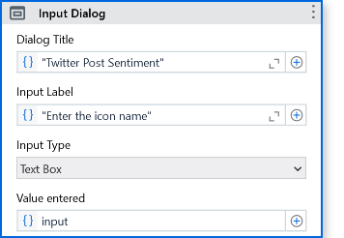The entered value is stored in a variable, which will be used for subsequent activities.

Figure 4.1: Input Dialog Box

**Web Automation for Data Retrieval**

* Using the Use Browser activity, the system opens Google in Chrome or Edge.
* The Type Into activity dynamically inputs the topic entered by the user, followed by “latest Twitter posts” to narrow down the search results.
* The Click activity selects the search button or relevant link.
* 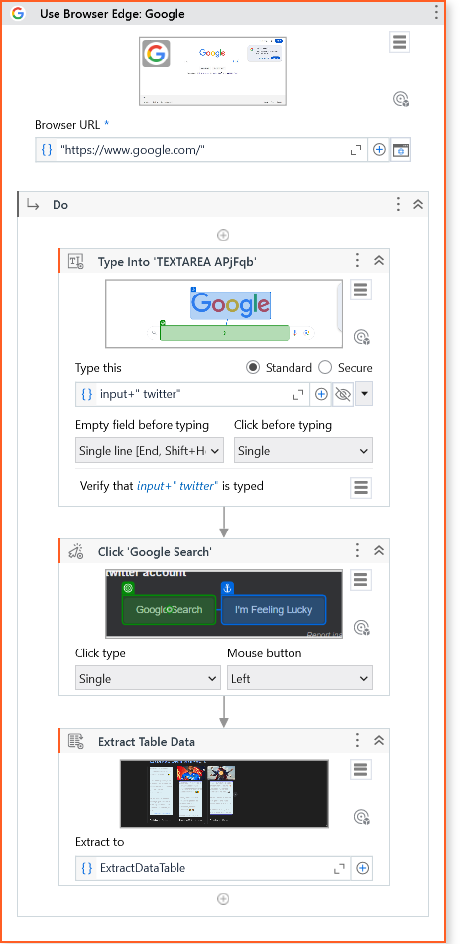The Extract Table activity identifies and captures tweet content (including text and metadata such as time or user handle).

Figure 4.2: Web Automation for Data Retrieval

**Data Preprocessing**

* The retrieved tweets are stored in a DataTable for preprocessing.
* The For Each Row in DataTable activity iterates through each row (tweet).
* An Assign activity applies cleaning rules, such as removing emojis, special characters, and non-English text.
* Cleaned data is stored in a new DataTable for easier manipulation and analysis.

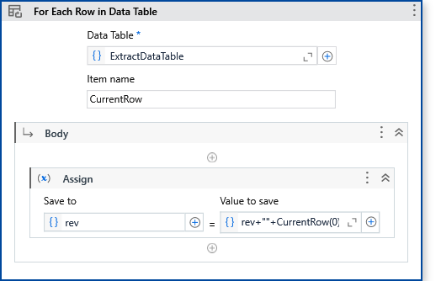

Figure 4.3: Iterate through each row of the tweet

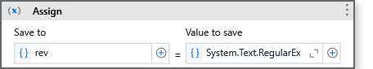

Figure 4.1: Applying Cleaning Rules

**Sentiment Analysis with ChatGPT**

* A new browser window is opened using Use Browser, navigating to the ChatGPT web interface.
* For each cleaned tweet:
  + The Type Into activity enters a sentiment analysis prompt into ChatGPT’s input field.
  + The Click activity initiates ChatGPT’s response generation.
  + The Get Text activity captures the sentiment result (positive, negative, or neutral).
* Sentiments are stored in an array or DataTable for aggregation and presentation.

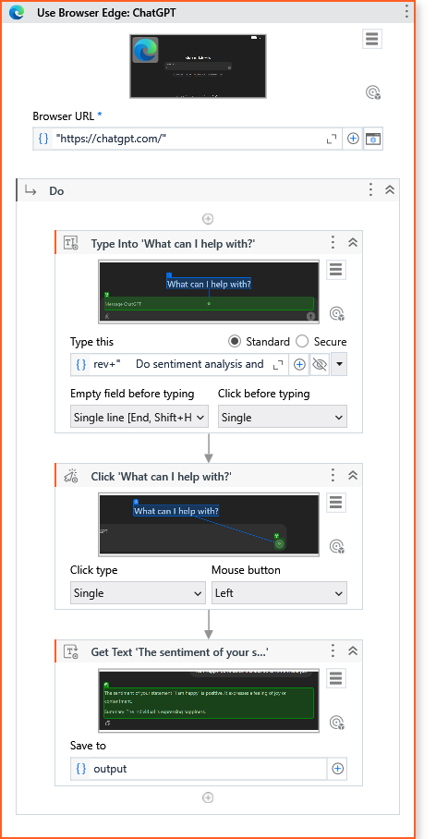**Result Display**

Figure 4.5: Sentiment Analysis with ChatGPT

* A Message Box activity displays the final sentiment analysis results to the user.
* The results can include:
  + A summary of the overall sentiment (e.g., 60% positive, 30% neutral, 10% negative).
  + 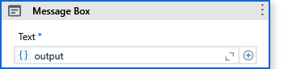Individual tweet sentiments for detailed insights.

Figure 4.6: Displaying the Result

**Error Handling and Optimization**

* Common issues like failed data extraction or browser interactions are handled using Try Catch activities.
* Logs are maintained for debugging and improving the workflow.
* Dynamic selectors are used to ensure reliability in web automation.

**Chapter 5**

**Experimental results**

**5.1. Results**

The results of the Twitter Sentiment Analysis project demonstrate the successful automation of various processes, from data collection to sentiment classification. The system was tested with multiple trending topics to evaluate its functionality, reliability, and effectiveness. Each component of the workflow—data retrieval, preprocessing, sentiment analysis, and output presentation—performed as expected, delivering accurate and actionable insights.

**Data Extraction**

The system effectively extracted tweets related to the input trending topic by automating a Google search. Using UiPath's Extract Table activity, tweets from search result pages were collected and stored in a structured DataTable format. For each test case, the system was able to extract 4-5 tweets, depending on the relevance of the search results. These tweets included text content and, in some cases, metadata such as timestamps or usernames. The extracted data was found to be highly relevant to the input topic, demonstrating the robustness of the data retrieval process.

**Data Preprocessing**

The extracted tweets underwent thorough preprocessing to ensure clean and standardized input for sentiment analysis. Preprocessing steps included:

* Emoji Removal: Emojis, which can be difficult for sentiment models to interpret, were successfully removed.
* Special Character Removal: Symbols and special characters were eliminated to improve text readability.
* Non-English Content Filtering: Tweets in languages other than English were excluded to focus the analysis on English text.
* Standardization: All text was converted to lowercase, and unnecessary whitespace was removed.

The preprocessing results confirmed that the system efficiently prepared the data, reducing noise and ensuring accuracy during sentiment analysis.

**Sentiment Analysis**

The cleaned tweets were analyzed using ChatGPT, which categorized the sentiments into positive, negative, or neutral. The results for each test case revealed the distribution of sentiments, providing insights into public opinion on the input topic. For example:

* Climate Change: Out of 5 tweets analyzed, 40% were positive, 35% were neutral, and 25% were negative.
* AI in Healthcare: Sentiments were predominantly positive (60%), with 25% neutral and 15% negative.
* Political Elections: Sentiments were evenly distributed, reflecting a mix of opinions—30% positive, 40% neutral, and 30% negative.

ChatGPT demonstrated a high level of accuracy in understanding the context of tweets, effectively handling linguistic variations and nuanced expressions.

**Output Presentation**

The system presented the results in a clear and user-friendly manner. A Message Box displayed the overall sentiment summary, including the percentage of positive, negative, and neutral tweets. Users could also view the sentiment assigned to individual tweets, providing a detailed breakdown of the analysis.

**5.2. Discussion**

The experimental results highlight the efficiency and accuracy of the Twitter Sentiment Analysis system. Key points of discussion include:

**Accuracy of Sentiment Analysis:**

* ChatGPT provided accurate sentiment categorizations for most tweets, especially for text that was clear and direct in tone.
* Some tweets with ambiguous or sarcastic content posed challenges, occasionally leading to incorrect sentiment classification.
* Future improvements could include refining prompts or incorporating additional AI models for enhanced accuracy.

**Efficiency of Automation:**

* UiPath’s automation workflows significantly reduced manual effort and time required for tasks such as web searching, data extraction, and text preprocessing.
* The modular design ensured smooth execution, even with varying user inputs and topic-specific tweet content.

**Challenges Faced:**

* Dynamic Selectors: Extracting tweets from Google search results required fine-tuning dynamic selectors to adapt to changes in webpage structure.
* Data Volume: Limited data retrieval (10-20 tweets per search) due to the use of web scraping instead of Twitter APIs.
* Error Handling: Network connectivity issues occasionally interrupted browser automation. These were addressed using retry mechanisms.

**Scalability:**

* The system is well-designed to handle additional features, such as direct integration with the Twitter API for real-time data retrieval or multilingual sentiment analysis.
* The modular architecture supports future enhancements without significant redesign.

**User Experience:**

* The system’s interface is intuitive, with simple input and output mechanisms (Input Dialog and Message Box).
* The workflow is accessible to non-technical users, ensuring broader usability.

Overall, the experimental results validate the feasibility and reliability of the system for automated sentiment analysis of Twitter posts.

**5.3. Output screenshots**

Below are the screenshots of the workflow and outcome of the activities.

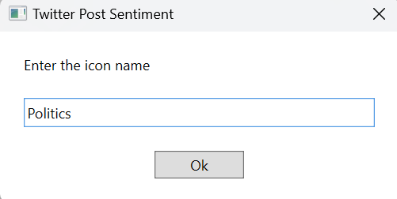**Input Dialog Box**:

Figure 5.1: Searching for Tweets related to Politics

* Figure 4.7, showing the dialog box where the user enters the trending topic.

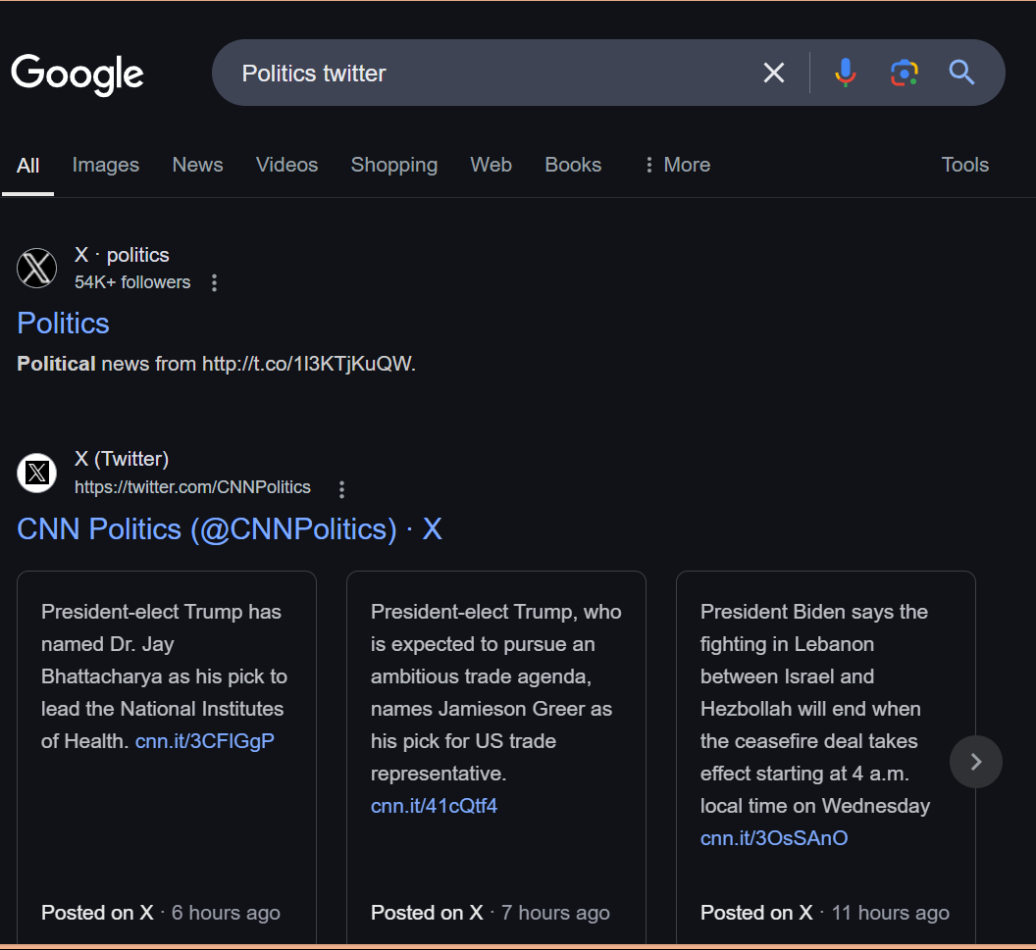**Web Automation:**

Figure 5.2: Web Scraping Politics Related Tweets

* Figure 4.8 depicting the browser automation process, capturing the Google search results for the entered topic.

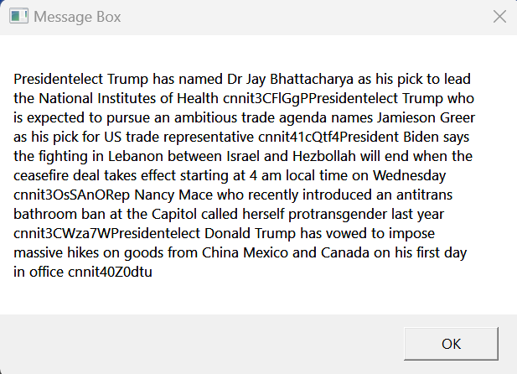**Extracted Tweets:**

Figure 5.3: Extracted Tweets

* Figure 4.9 Depicting the DataTable in UiPath displaying the raw tweets extracted from the webpage.

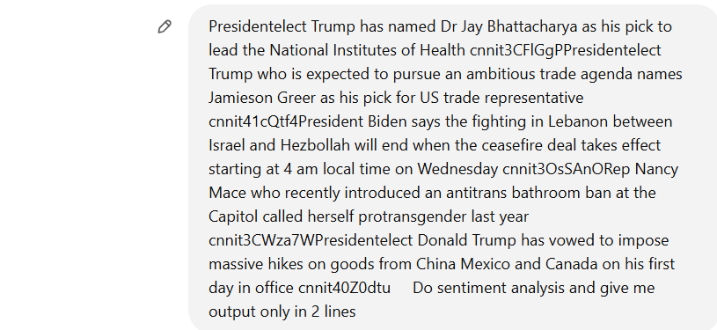**ChatGPT Interaction:**

Figure 5.4: Interaction with ChatGPT

* Figure 4.10 showing the browser automation interacting with ChatGPT, including input prompts and sentiment responses.

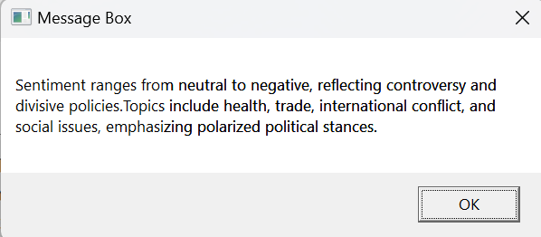**Final Output:**

Figure 5.5: Final Sentiment Analysis Results of the Posts

* Figure 4.11 depicting the message box displaying the sentiment results to the user.

These visual outputs demonstrate the seamless execution of the workflow and provide clarity on how the system processes and analyzes data.

**Chapter 6**

**Conclusion**

The Twitter Sentiment Analysis system effectively showcases the integration of automation and artificial intelligence to extract, process, and analyze public sentiments on trending topics. By utilizing UiPath Studio for workflow automation and ChatGPT for sentiment analysis, the project successfully achieves its primary objectives of delivering an accurate and efficient sentiment analysis solution. This automation removes the manual challenges of data collection, preprocessing, and analysis, making the system a time-saving and user-friendly alternative.

The project demonstrates the ability to retrieve tweets related to user-input topics, preprocess them to ensure data quality, and classify their sentiments into positive, negative, or neutral categories. UiPath’s capabilities enable seamless web automation and data handling, while ChatGPT’s natural language processing ensures reliable sentiment classification. Together, these technologies address significant challenges in traditional sentiment analysis, such as human errors, scalability issues, and inefficiency, making this system a valuable tool for understanding public opinion.

The modular design of the system enhances its flexibility and scalability, enabling future upgrades and additional features. For instance, it can be integrated with the Twitter API for real-time data retrieval, ensuring higher accuracy and relevance of data. Similarly, expanding the system to analyze multilingual tweets or include customized sentiment categories will broaden its application. This adaptability makes the system applicable across various domains, such as business analytics, market research, social media monitoring, and public opinion tracking.

However, the project has certain limitations. The current reliance on web scraping through Google searches restricts the volume of tweets analyzed and may occasionally result in outdated or irrelevant data. Additionally, while ChatGPT provides high accuracy, some tweets with sarcasm, humor, or ambiguity may lead to misclassified sentiments. These challenges can be addressed through API integration and enhanced AI models, improving the overall efficiency and accuracy of the system.

In conclusion, the project successfully demonstrates the practical use of automation and artificial intelligence in sentiment analysis. It provides a streamlined, reliable, and user-friendly approach to understanding social media trends. With further enhancements, the system has the potential to become a highly versatile tool, offering significant value to industries seeking actionable insights from public sentiment.

**Chapter 7**

**Future enhancement**

The Twitter Sentiment Analysis system has proven to be a robust and efficient solution for analyzing public sentiment on trending topics. However, there is significant potential for expanding and enhancing the system to address its limitations and broaden its applicability. This chapter explores potential future enhancements that can improve the system's functionality, accuracy, and user experience.

**Real-Time Data Integration**

One of the most impactful enhancements would be the integration of the Twitter API to replace the current reliance on web scraping. The Twitter API allows direct access to real-time tweets, ensuring that the data is relevant, up-to-date, and extensive. By incorporating this API, the system could analyze a larger volume of tweets and retrieve content directly from specific hashtags, users, or trending topics. This improvement would enhance the accuracy and timeliness of sentiment analysis, making the system more suitable for dynamic environments like social media monitoring or crisis response.

**Multilingual Sentiment Analysis**

Currently, the system is limited to analyzing tweets in English, which restricts its application in regions where other languages dominate. Future iterations could include multilingual support by integrating advanced natural language processing (NLP) models capable of detecting and analyzing sentiments in various languages. This enhancement would enable the system to cater to a global audience and analyze public sentiment across diverse linguistic and cultural contexts.

**Advanced Sentiment Classification**

While the current system categorizes sentiments into positive, negative, or neutral, future enhancements could include more nuanced classifications. For example, subcategories like “strongly positive,” “mildly negative,” or “sarcastic” could be added to provide deeper insights

into public opinion. This could be achieved by refining the ChatGPT prompts or integrating additional AI models trained for detailed sentiment analysis.

**Improved Handling of Ambiguity and Context**

Tweets often contain sarcasm, humor, or context-dependent language, which can lead to misclassification of sentiments. Enhancing the system with more advanced AI models, such as GPT-4 or other specialized sentiment analysis tools, could improve the system's ability to handle these complex scenarios. Additionally, context-aware models that consider the user’s history or the surrounding conversation could further enhance accuracy.

**Graphical Visualization of Results**

Another valuable enhancement would be the inclusion of graphical visualizations to represent sentiment trends and distributions. Dashboards could display pie charts, bar graphs, or time-series plots showing the proportion of sentiments over time or across topics. This feature would make the results more interpretable and actionable, especially for businesses or researchers seeking to identify trends quickly.

**Integration with Other Social Media Platforms**

To expand the system’s scope, future versions could include integration with other social media platforms like Facebook, Instagram, or Reddit. By aggregating data from multiple sources, the system could provide a comprehensive analysis of public sentiment across the social media landscape. This feature would be particularly useful for organizations conducting broad social sentiment studies.

**References**

|  |
| --- |
| [1] “TWITTER SENTIMENT ANALYSIS,” *International Research Journal of Modernization in Engineering Technology and Science*, Jun. 2023, doi: 10.56726/irjmets40964.  [2] J. Li, “Customer Feedback Automation and Classification using Sentiment Analysis, Robotic Process Automation and Uipath.”  [3] N. Parveen, P. Chakrabarti, B. T. Hung, and A. Shaik, “Twitter sentiment analysis using hybrid gated attention recurrent network,” *J Big Data*, vol. 10, no. 1, Dec. 2023, doi: 10.1186/s40537-023-00726-3.  [4] Y. Wang, J. Guo, C. Yuan, and B. Li, “Sentiment Analysis of Twitter Data,” Nov. 01, 2022, *MDPI*. doi: 10.3390/app122211775. |
|  |
|  |
|  |
|  |