Puppet Installation in Linux
sudo rpm -ivh http://yum.puppetlabs.com/puppetlabs-release-el-7.noarch.rpm

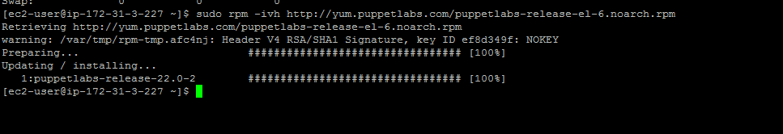
sudo yum install puppet-server
If you are getting following error:
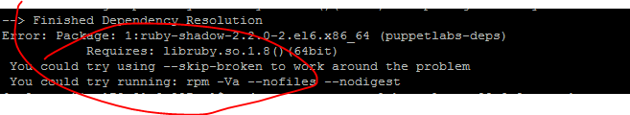
Try following steps:
sudo rpm -ev puppetlabs-release-22.0-2.noarch
sudo rpm -ivh http://yum.puppetlabs.com/puppetlabs-release-el-7.noarch.rpm
sudo yum clean all
sudo yum install puppet-server

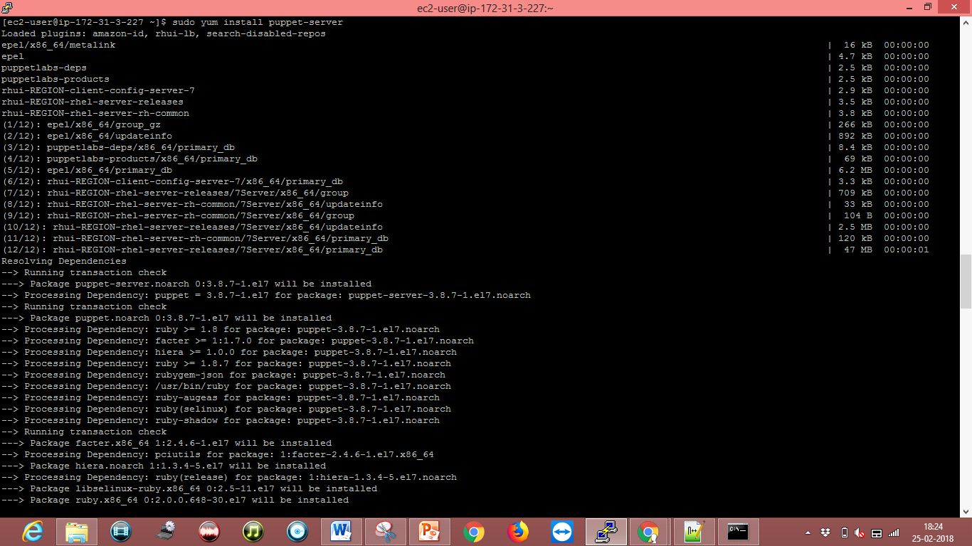

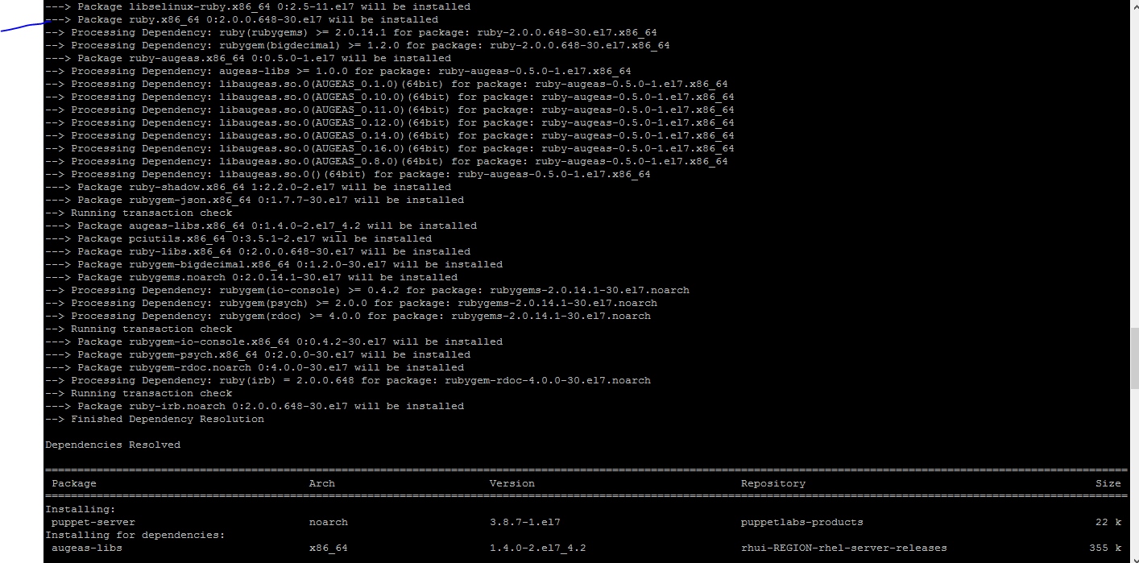

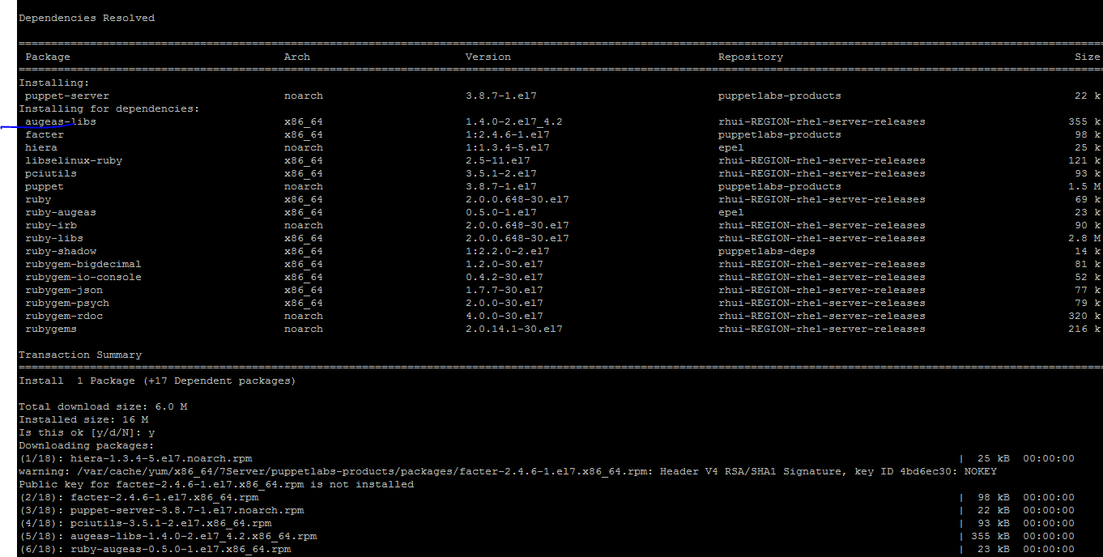
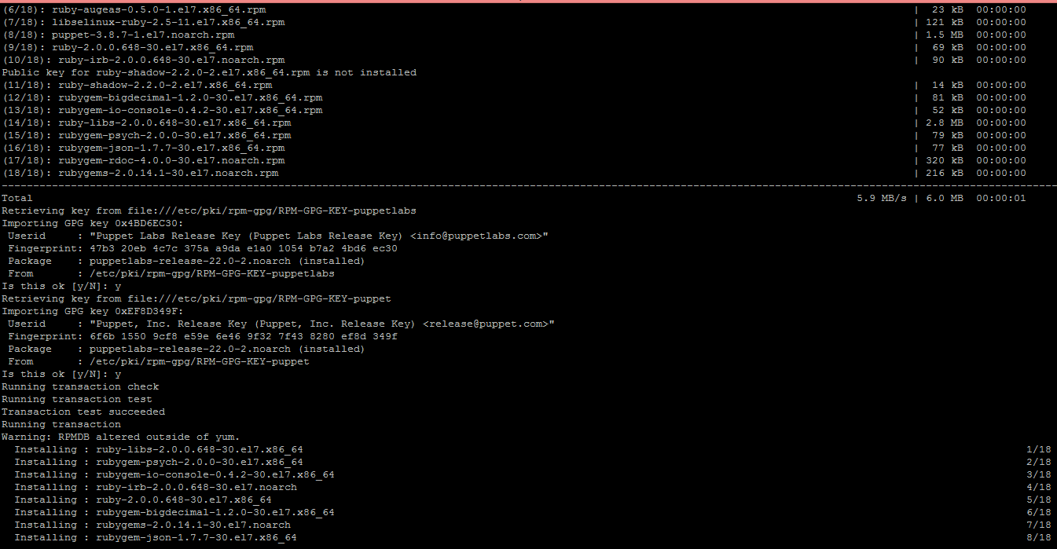

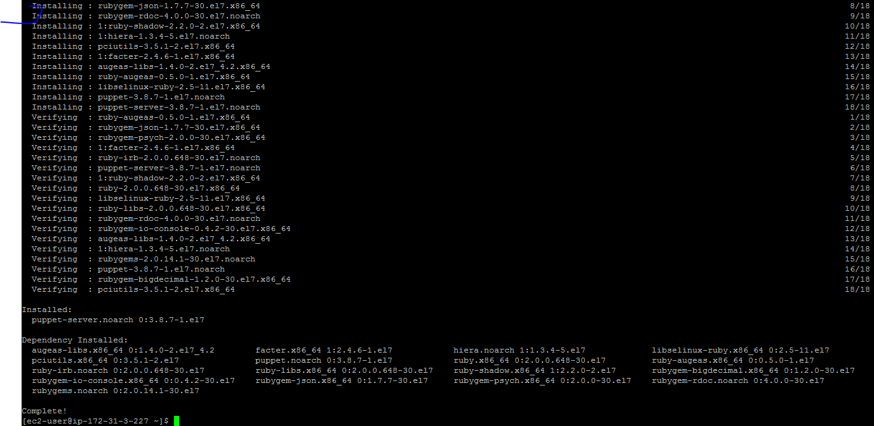

[ec2-user@ip-172-31-3-227 ~]$ more /etc/puppet/puppet.conf
[main]
# The Puppet log directory.
# The default value is '$vardir/log'.
logdir = /var/log/puppet

# Where Puppet PID files are kept.
# The default value is '$vardir/run'.
rundir = /var/run/puppet

# Where SSL certificates are kept.
# The default value is '$confdir/ssl'.
ssldir = $vardir/ssl

[agent]
# The file in which puppetd stores a list of the classes
# associated with the retrieved configuratiion. Can be loaded in
# the separate ``puppet`` executable using the ``--loadclasses``
# option.
# The default value is '$confdir/classes.txt'.
classfile = $vardir/classes.txt

# Where puppetd caches the local configuration. An
# extension indicating the cache format is added automatically.
# The default value is '$confdir/localconfig'.
localconfig = $vardir/localconfig
[ec2-user@ip-172-31-3-227 ~]$
Use sudo vi
Edit /etc/puppet/puppet.conf and add
dns_alt_names = puppet,ec2-34-208-146-39.us-west-2.compute.amazonaws.com
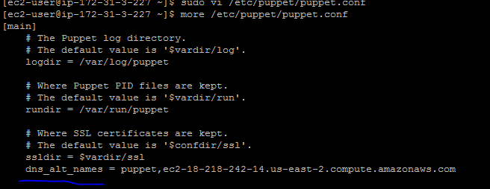

sudo service puppetmaster start

Puppet client configuration
sudo rpm -ivh http://yum.puppetlabs.com/puppetlabs-release-el-7.noarch.rpm

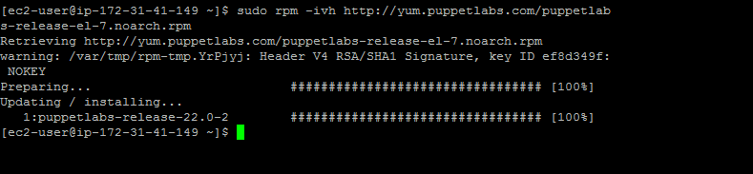

sudo yum install puppet
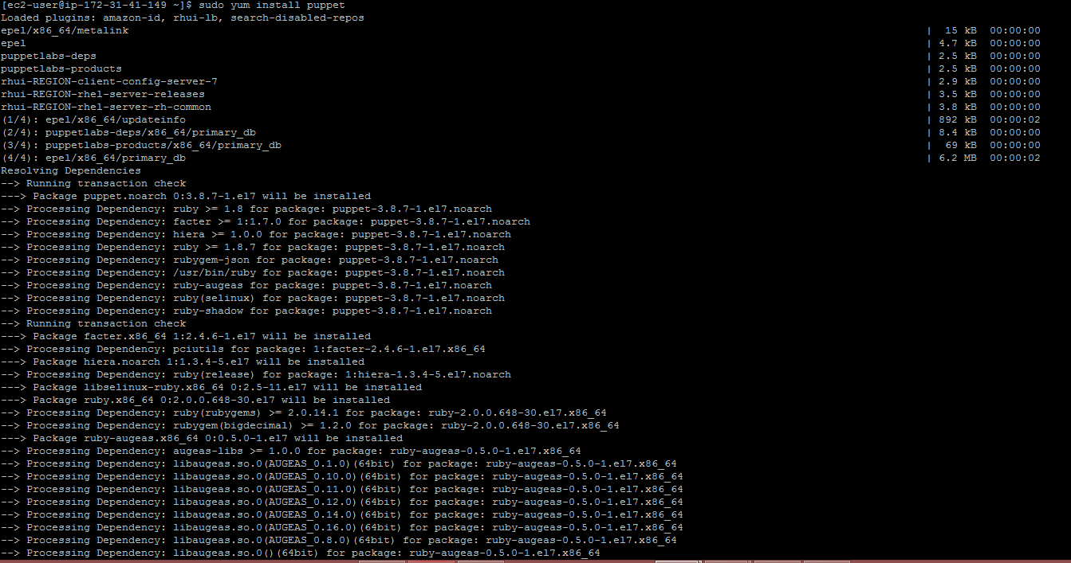
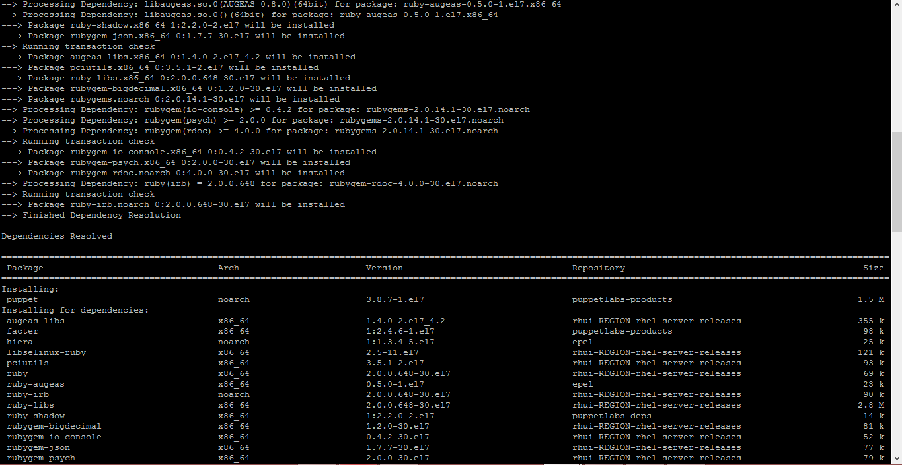
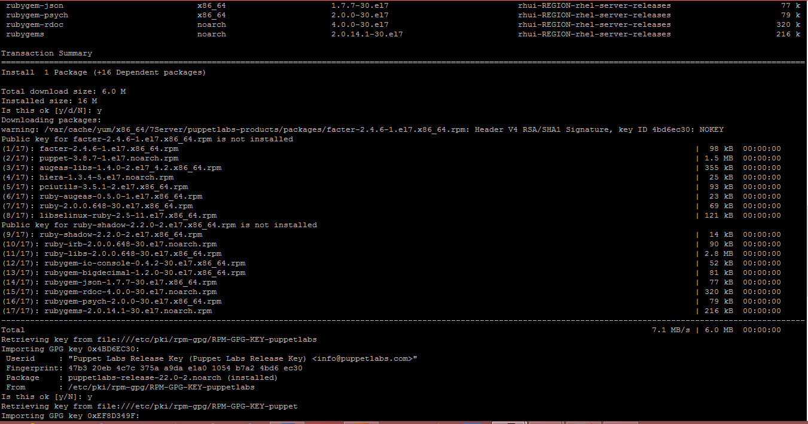
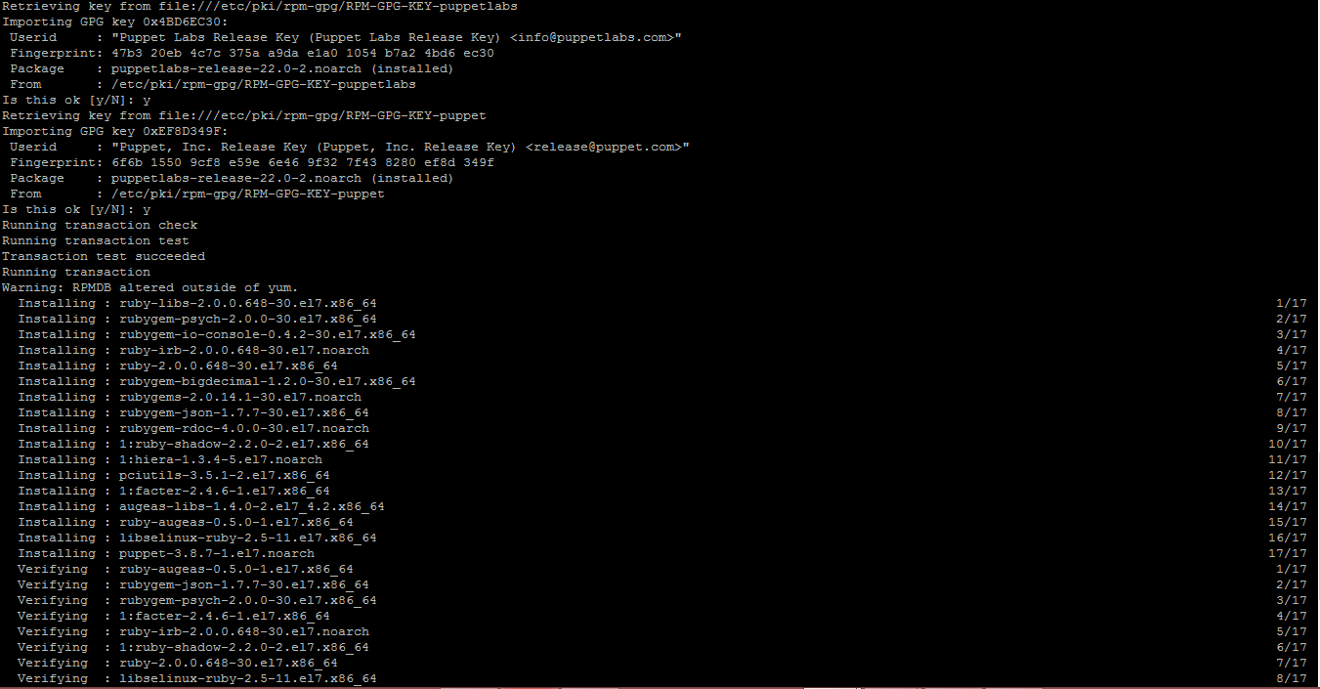
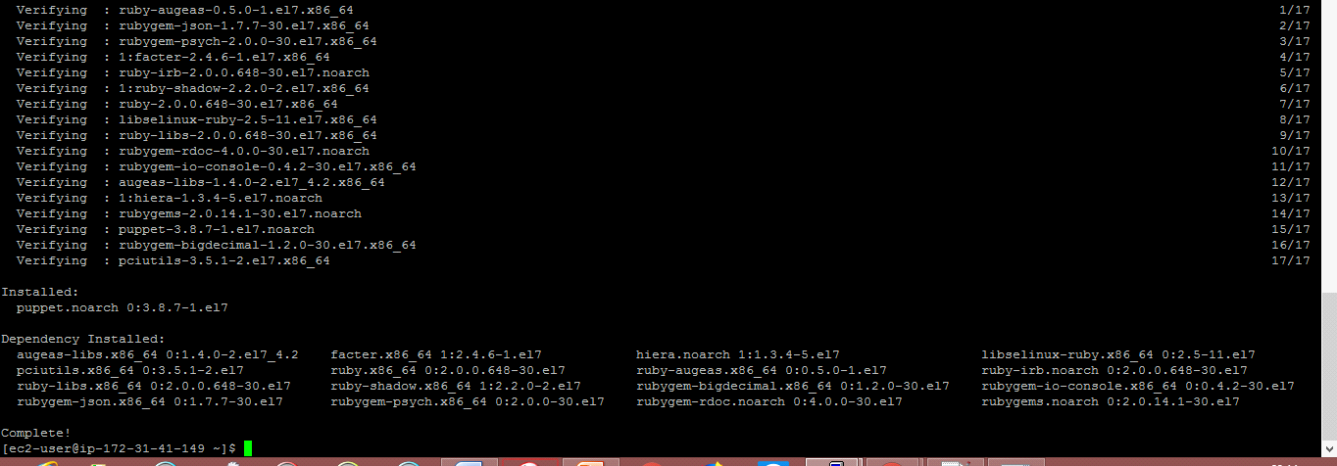

#Open the conf file and add the puppet server hostname
************************************************************
[ec2-user@ip-172-31-41-149 ~]$ sudo vi /etc/puppet/puppet.conf
[main]
# The Puppet log directory.
# The default value is '$vardir/log'.
logdir = /var/log/puppet

# Where Puppet PID files are kept.
# The default value is '$vardir/run'.
rundir = /var/run/puppet

# Where SSL certificates are kept.
# The default value is '$confdir/ssl'.
ssldir = $vardir/ssl

vi /etc/puppet/puppet.conf
# The puppetmaster server
server=ec2-34-208-146-39.us-west-2.compute.amazonaws.com

sudo service puppet start
Puppet uses SSL to communicate with it’s clients, when you start puppet on a client, it will automatically connect to the puppet server in it’s conf file and request for it’s certificate to be signed.

On the puppet server run
sudo puppet cert list
[ec2-user@ip-172-31-16-247 ~]$ sudo puppet cert list
"ip-172-31-20-244.us-west-2.compute.internal" (SHA256) FE:02:04:E6:4B:CA:3C:E3:E4:F5:64:86:3C:02:F4:D3:C2:1E:E1:77:53:EB:70:11:24:EC:1F:A0:6C:E6:0A:B3
[ec2-user@ip-172-31-16-247 ~]$
&
sudo puppet cert sign ip-172-31-20-244.us-west-2.compute.internal

Now our client server “ip-172-31-41-149.us-east-2.compute.internal” is authorized to fetch and apply configurations from the puppet server.

Puppet server: ec2-18-218-242-14.us-east-2.compute.amazonaws.com
Puppet client:ip-172-31-41-149.us-east-2.compute.internal
Example: Installing apache web server with puppet
Although puppet server configuration is stored in “/etc/puppet/puppet.conf”, client configurations are stored in files called manifests.
[user@puppet ~]# sudo vi /etc/puppet/manifests/site.pp

node 'ip-172-31-20-244.us-west-2.compute.internal' {

package { 'httpd' :
ensure => installed,
}
}

On client machine
sudo puppet agent –test
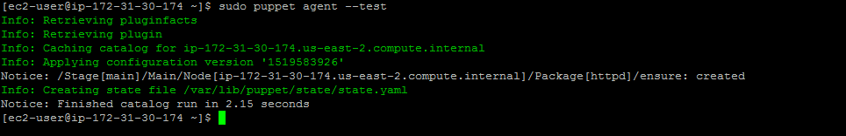
sudo apachectl start

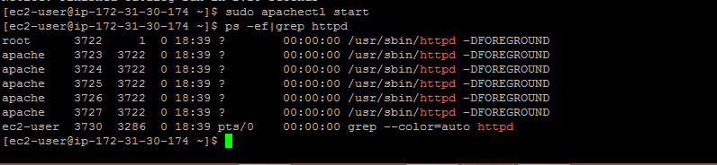

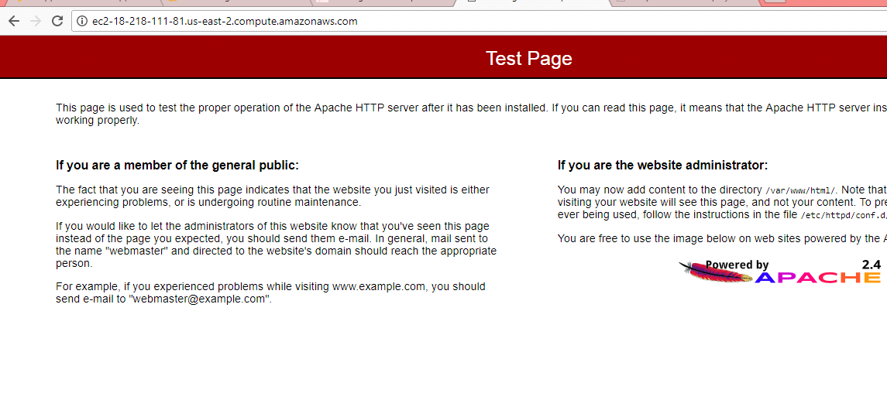
http://ec2-52-43-121-175.us-west-2.compute.amazonaws.com/

