Installation setup:
We will have two guest OS on our host OS. For that we are going to use Virtual box and Vagrant.

Download virtual box manager:
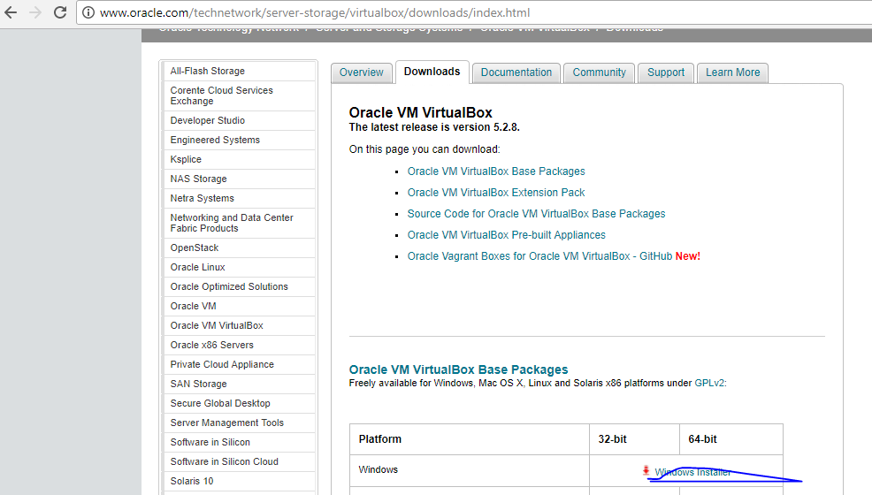
Download vagrant
https://www.vagrantup.com/downloads.html

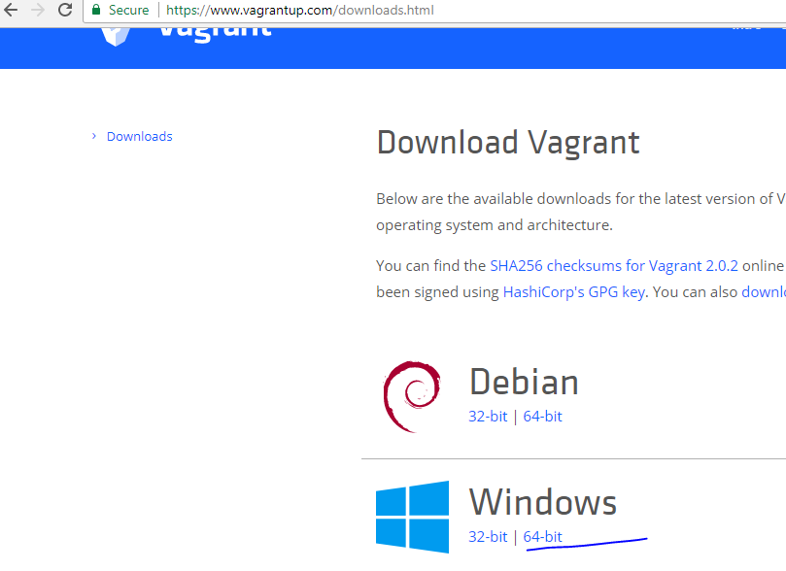

Vagrant –version
E:
mkdir myvgrant
cd myvgrant
vagrant init
vagrantfile
# -*- mode: ruby -*-
# vi: set ft=ruby :

# All Vagrant configuration is done below. The "2" in Vagrant.configure
# configures the configuration version (we support older styles for
# backwards compatibility). Please don't change it unless you know what
# you're doing.
Vagrant.configure("2") do |config|

config.vm.box = "base"
config.vm.provider "virtualbox" do |v|
v.memory = 2048
v.cpus = 1
end
config.vm.define "puppetmaster" do |pm|
config.vm.box = "centos/7"
pm.vm.network "private_network", ip: "192.168.33.10"
pm.vm.hostname = "puppetmaster"
end
config.vm.define "puppetagent" do |pa|
config.vm.box = "centos/7"
pa.vm.network "private_network", ip: "192.168.33.11"
pa.vm.hostname = "puppetagent"
end

end

vagrant status
vagrant up

try login using putty
see:
putty gen to generate the private keys for aws.
Try login
User vagrant
Sudo su – root

rpm -ihv http://yum.puppetlabs.com/puppet5/el/7/x86_64/puppet5-release-5.0.0-1.el7.noarch.rpm
on both the nodes
yum -y install puppetserver
yum -y install puppet-agent

[root@puppetmaster etc]# puppet
-bash: puppet: command not found
[root@puppetmaster etc]# pwd
/etc
[root@puppetmaster etc]#

Add puppet to path
vi /etc/profile.d/puppet-agent.sh
[root@puppetmaster etc]# more /etc/profile.d/puppet-agent.sh
# Add /opt/puppetlabs/bin to the path for sh compatible users

if ! echo $PATH | grep -q /opt/puppetlabs/bin ; then
export PATH=$PATH:/opt/puppetlabs/bin
export PATH=$PATH:/opt/puppetlabs/puppet/bin
fi
[root@puppetmaster etc]#

[root@puppetmaster ~]# puppet
See 'puppet help' for help on available puppet subcommands
[root@puppetmaster ~]#
[vagrant@puppetagent ~]$ sudo su - root
Last login: Sun Mar 4 06:26:01 UTC 2018 on pts/0
[root@puppetagent ~]# puppet
See 'puppet help' for help on available puppet subcommands
[root@puppetagent ~]#

puppet –version

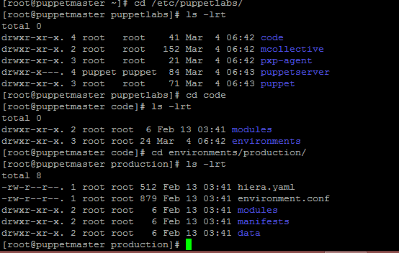

Global puppet configuration:

/etc/puppetlabs/puppet
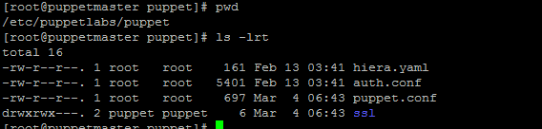

/etc/puppetlabs/puppetserver
[root@puppetmaster puppetserver]# ls -lrt
total 8
-rw-r--r--. 1 root root 939 Feb 9 20:22 request-logging.xml
-rw-r--r--. 1 root root 2635 Feb 9 20:22 logback.xml
drwxrwxr-x. 2 root root 132 Mar 4 06:43 conf.d
drwxrwxr-x. 2 root root 20 Mar 4 06:43 services.d
[root@puppetmaster puppetserver]#

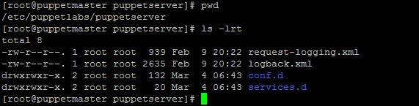

Parameter file for puppet service:
[root@puppetmaster puppetserver]# cat /etc/sysconfig/puppet
# You may specify parameters to the puppet client here
#PUPPET_EXTRA_OPTS=--waitforcert=500
[root@puppetmaster puppetserver]#

Parameter file for puppet server:
cat /etc/sysconfig/puppetserver
root@puppetmaster puppetserver]# cd /opt/puppetlabs/
[root@puppetmaster puppetlabs]# ls -lrt
total 0
drwxr-xr-x. 3 root root 21 Mar 4 06:42 facter
drwxr-xr-x. 3 root root 21 Mar 4 06:42 mcollective
drwxr-xr-x. 9 root root 110 Mar 4 06:42 puppet
drwxr-xr-x. 5 root root 53 Mar 4 06:42 pxp-agent
drwxr-xr-x. 5 root root 41 Mar 4 06:43 server
drwxr-xr-x. 2 root root 78 Mar 4 06:43 bin
[root@puppetmaster puppetlabs]#

Modify Puppet Server Memory parameters from 2g to 1g
vi /etc/sysconfig/puppetserver
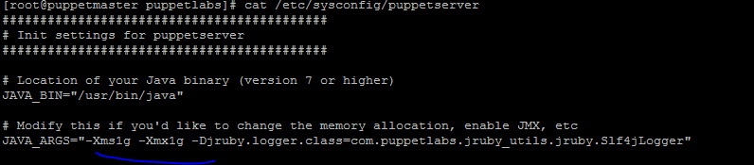

Start puppet server service:
systemctl start puppetserver

ps –ef|grep puppetserver

netstat –nlp
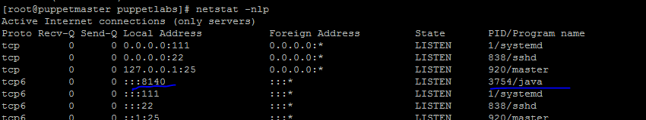

oot@puppetmaster production]# pwd
/etc/puppetlabs/code/environments/production
[root@puppetmaster production]#
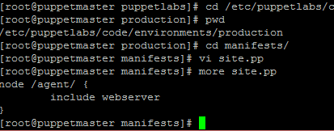

[root@puppetmaster manifests]# cd ..
[root@puppetmaster production]# cd modules/
[root@puppetmaster modules]# mkdir -p webserver/manifests
[root@puppetmaster modules]#

Puppet Agent Configuration:

[root@puppetagent ~]# more /etc/hosts

127.0.0.1 puppetagent puppetagent
127.0.0.1 localhost localhost.localdomain localhost4 localhost4.localdomain4
::1 localhost localhost.localdomain localhost6 localhost6.localdomain6
192.168.33.10 puppetmaster.local
[root@puppetagent ~]#

Run following on agent
puppet agent --test --server puppetmaster.local

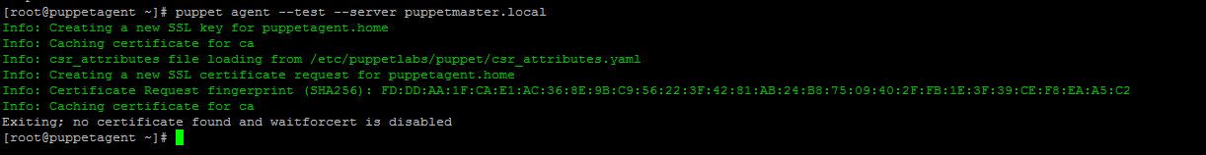

Signing request is sent to puppet master.

Login into puppet master machine
[root@puppetmaster modules]# puppet cert list
"puppetagent.home" (SHA256) FD:DD:AA:1F:CA:E1:AC:36:8E:9B:C9:56:22:3F:42:81:AB:24:B8:75:09:40:2F:FB:1E:3F:39:CE:F8:EA:A5:C2
[root@puppetmaster modules]#

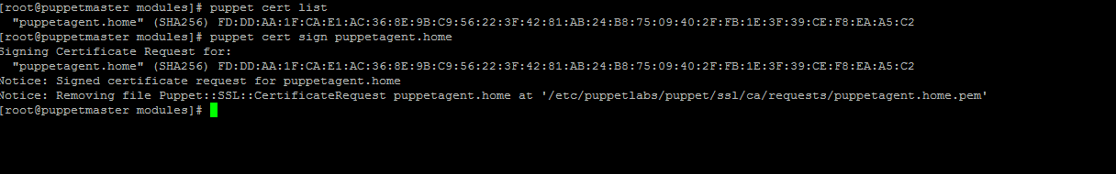

Go to agent and run the webserver catalogue
puppet agent --test --server puppetmaster.local
