Puppet Server:
Install Puppet Repository:
rpm -Uvh https://yum.puppetlabs.com/puppet5/puppet5-release-el-7.noarch.rpm
yum install -y puppetserver
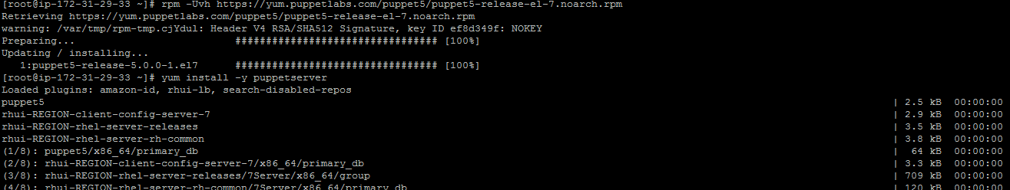
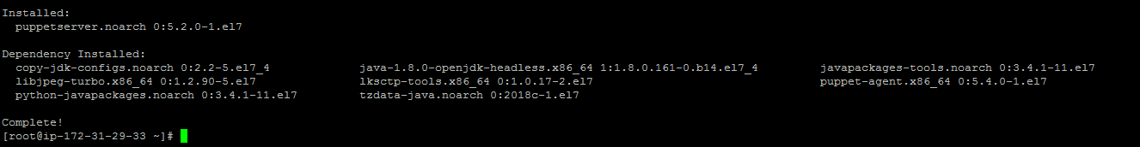
Change memory Parameter:
/etc/sysconfig/puppetserver
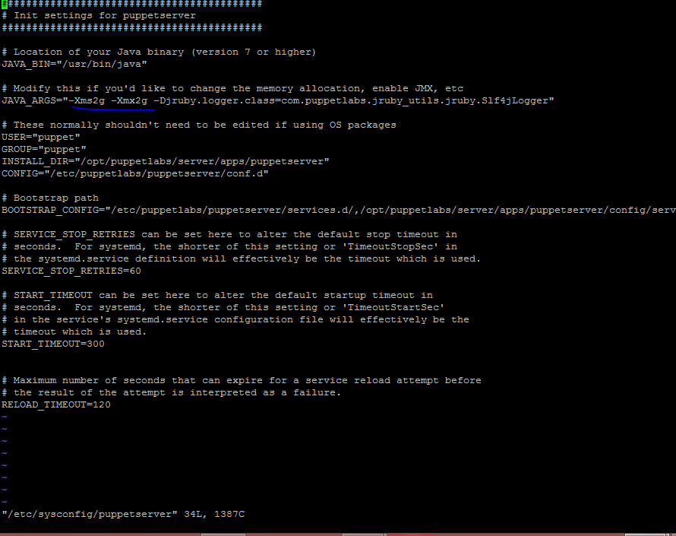
JAVA_ARGS="-Xms512m -Xmx512m"
# Modify this if you'd like to change the memory allocation, enable JMX, etc
JAVA_ARGS="-Xms512m -Xmx512m -Djruby.logger.class=com.puppetlabs.jruby_utils.jruby.Slf4jLogger"
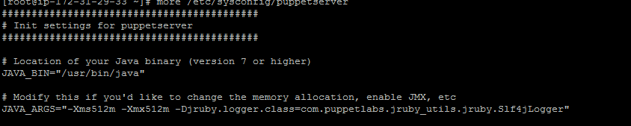

Puppet Configuration file
/etc/puppetlabs/puppet/puppet.conf
systemctl start puppetserver

Puppet Agent Installation
Install Puppet Repository:
rpm -Uvh https://yum.puppetlabs.com/puppet5/puppet5-release-el-7.noarch.rpm
yum install -y puppet-agent
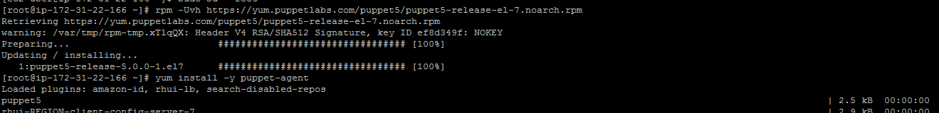

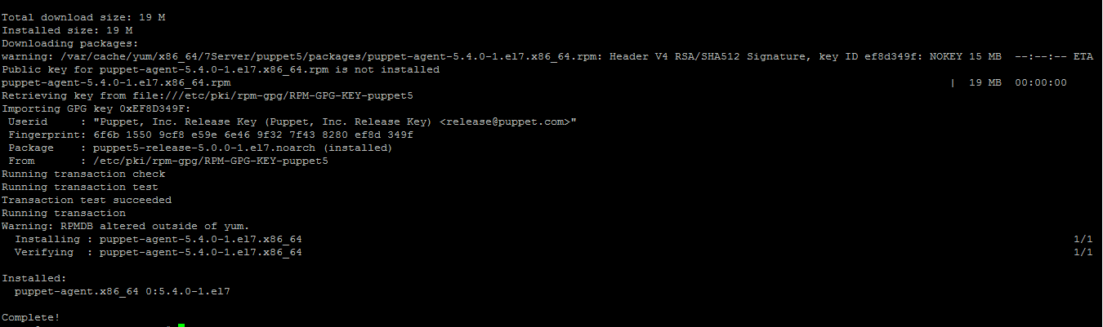
vi /etc/puppetlabs/puppet/puppet.conf
/etc/puppetlabs/puppet/puppet.conf

[main]
certname = ip-172-31-22-166.us-east-2.compute.internal
server = ec2-13-59-81-42.us-east-2.compute.amazonaws.com
environment = production
runinterval = 1h
systemctl start puppet ---------- Start puppet agent

tail -200f /var/log/messages
Feb 28 20:27:15 localhost systemd: Starting Cleanup of Temporary Directories...
Feb 28 20:27:15 localhost systemd: Started Cleanup of Temporary Directories.
Feb 28 20:28:39 localhost systemd: Started Puppet agent.
Feb 28 20:28:39 localhost systemd: Starting Puppet agent...
Feb 28 20:30:23 localhost systemd: Reloading.
Feb 28 20:30:23 localhost systemd: Reloading.
Feb 28 20:30:43 localhost puppet-agent[1377]: Did not receive certificate

Come back to Puppet server:
/opt/puppetlabs/bin/puppet cert list

[root@ip-172-31-29-33 ~]# /opt/puppetlabs/bin/puppet cert list
"ip-172-31-22-166.us-east-2.compute.internal" (SHA256) AB:73:A2:70:7B:A9:7C:66:C5:0E:82:E8:26:B5:7B:18:3A:1F:4E:4B:48:86:99:C6:5A:40:DC:4F:4B:80:00:E2
[root@ip-172-31-29-33 ~]#

Sign the certificate
[root@ip-172-31-29-33 ~]# /opt/puppetlabs/bin/puppet cert sign ip-172-31-22-166.us-east-2.compute.internal
Signing Certificate Request for:
"ip-172-31-22-166.us-east-2.compute.internal" (SHA256) AB:73:A2:70:7B:A9:7C:66:C5:0E:82:E8:26:B5:7B:18:3A:1F:4E:4B:48:86:99:C6:5A:40:DC:4F:4B:80:00:E2
Notice: Signed certificate request for ip-172-31-22-166.us-east-2.compute.internal
Notice: Removing file Puppet::SSL::CertificateRequest ip-172-31-22-166.us-east-2.compute.internal at '/etc/puppetlabs/puppet/ssl/ca/requests/ip-172-31-22-166.us-east-2.compute.internal.pem'
[root@ip-172-31-29-33 ~]#

[root@ip-172-31-22-166 ~]# /opt/puppetlabs/bin/puppet agent --test
Info: Caching certificate for ip-172-31-22-166.us-east-2.compute.internal
Error: Could not request certificate: SSL_connect returned=1 errno=0 state=error: certificate verify failed: [ok for /CN=ip-172-31-29-33.us-east-2.compute.internal]
Exiting; failed to retrieve certificate and waitforcert is disabled
[root@ip-172-31-22-166 ~]#

