**Ansible**

All the commands and screenshots are provided here

**mkdir -p ansible-project**

**163 cd ansible-project**

**164 nano ansible.cfg**

**165 nano inventory**

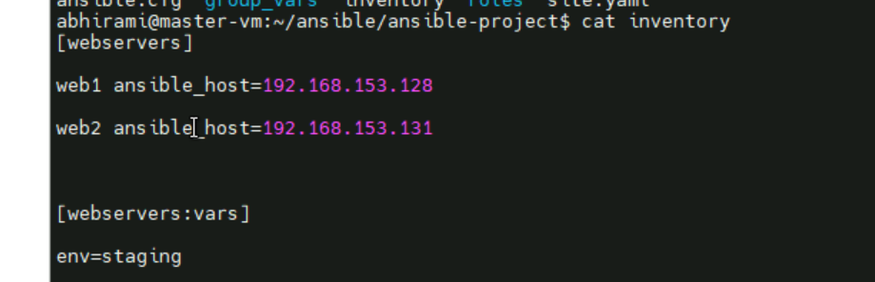

**166 cd roles**

**167 mkdir roles**

**168 cd roles**

**169 ansible-galaxy init webserver**



**170 mkdir webservers**

**171 mkdir tasks**

**172 nano main.yaml**

**173 cd ..**

**174 cd roles**

**175 nano main.yaml**

**176 ls**

**177 rm -rf main.yaml**

**178 rm -rf webservers**

**179 ls**

**180 cd webserver/**

**181 ls**

**182 cd tasks/**

**183 nano main.yaml**

**184 cd ..**

**185 ls**

**186 cd handlers/**

**187 nano main.yaml**

**188 cd ..**

**189 cd templates/**

**190 ls**

**191 nano index.html.j2**

**192 cd ..**

**193 nano site.yaml**

**194 ansible-playbook site.yml --tags "apache" --ask-vault-pass**

**195 ansible-playbook site.yaml --tags "apache" --ask-vault-pass**

**196 ansible-playbook site.yaml --tags "apache" -kK**

**197 nano site.yaml**

**198 cat site.yaml**

**199 nano site.yaml**

**200 ansible-playbook site.yaml --tags "apache" -kK**

**201 ls**

**202 l**

**203 nano ansible.cfg**

**204 ansible-playbook site.yaml --tags "apache" -kK**

**205 ls**

**206 ansible-playbook -i inventory site.yaml --tags "apache" -kK**

**207 cat inventory**

**208 ansible-playbook -i inventory site.yaml --tags "apache" -K**

**209 exit**

**210 ansible-playbook -i inventory site.yaml --tags "apache" -kK**

**211 cd ansible-project/**

**212 ansible-playbook -i inventory site.yaml --tags "apache" -kK**

**213 exit**

**214 cd ansible-project/**

**215 ansible-playbook -i inventory site.yaml --tags "apache" -kK**

**216 cd ..**

**217 cd ansible**

**218 ls**

**219 cat ansible.cfg**

**220 ls**

**221 pwd**

**222 cd ..**

**223 cd ansible-project/**

**224 ls**

**225 cd roles**

**226 ls**

**227 cd tasks**

**228 l**

**229 ls**

**230 cd ..**

**231 cd tasks**

**232 cd ..**

**233 ls**

**234 cd webserver/**

**235 ls**

**236 cd tasks/**

**237 ls**

**238 main.yml**

**239 cat main.yml**

**240 cat main.yaml**

**241 nano main.yaml**

**242 cd ..**

**243 ansible-playbook site.yaml --tags "apache" --ask-vault-pass**

**244 echo "abhi" > ~/.vault_pass.txt**

**245 chmod 600 ~/.vault_pass.txt**

**246 ansible-playbook site.yaml --tags "apache" --vault-password-file ~/.vault_pass.txt**

**247 ansible-playbook site.yaml --tags "apache"**

**248 ansible-playbook -i inventory site.yaml --tags "apache" -kK**

**249 exit**

**250 ansible-playbook -i inventory site.yaml --tags "apache" -kK**

**251 cd ansible-project/**

**252 ansible-playbook -i inventory site.yaml --tags "apache" -kK**

**253 ls**

**254 cat inventory**

**255 cd roles**

**256 ls**

**257 cd ..**

**258 cd ansible**

**259 ls**

**260 cd roles**

**261 ls**

**262 cd ..**

**263 mkdir roless**

**264 rm -rf roless**

**265 cd ..**

**266 cp ansible-project/ ./ansible**

**267 cp -r ansible-project/ ./ansible**

**268 cd ansible**

**269 cd ansible-project/**

**270 ansible-playbook -i inventory site.yaml --tags "apache" -kK**

**271 nano inventory**

**272 ansible-playbook -i inventory site.yaml --tags "apache" -kK**

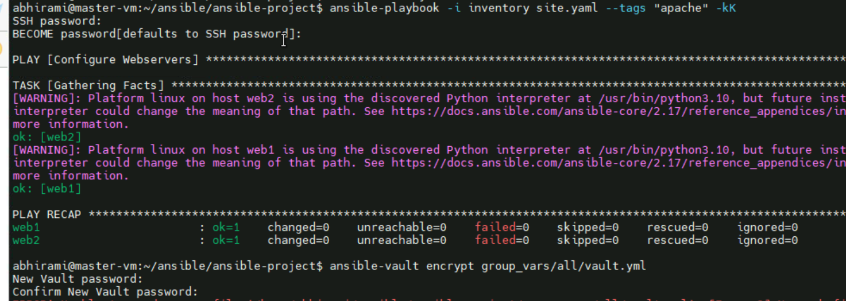

**273 ansible-vault encrypt group_vars/all/vault.yml**

**274 ls**

**275 mkdir group_vars/all/**

**276 mkdir group_vars**

**277 cd group_vars/**

**278 mkdir all**

**279 cd all**

**280 ls**

**281 nano vault.yaml**

**282 ansible-vault encrypt group_vars/all/vault.yml**

**283 cd ..**

**284 ansible-vault encrypt group_vars/all/vault.yml**

**285 ansible-vault encrypt group_vars/all/vault.yaml**



**286 history**

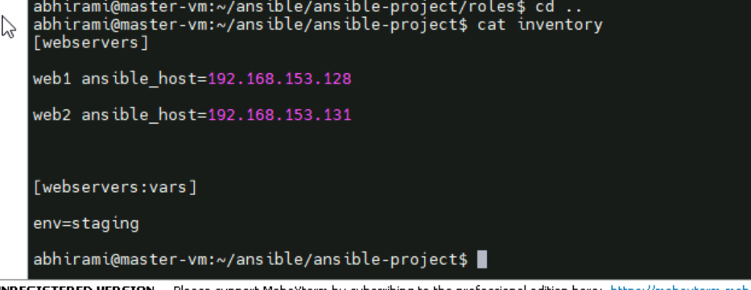

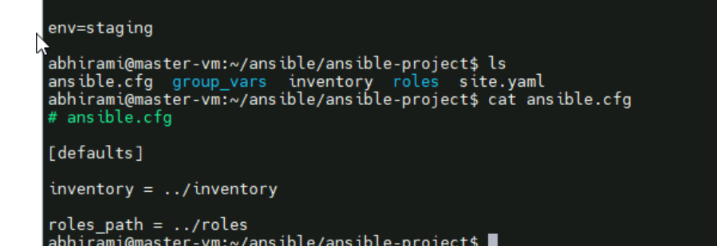

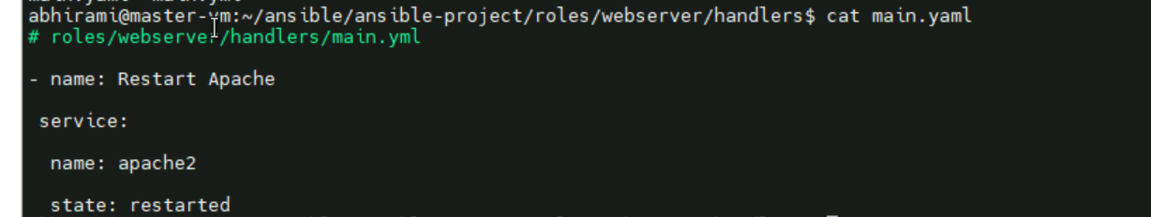

**Site.yaml file**



