Q1. Ansible

Creating the user:

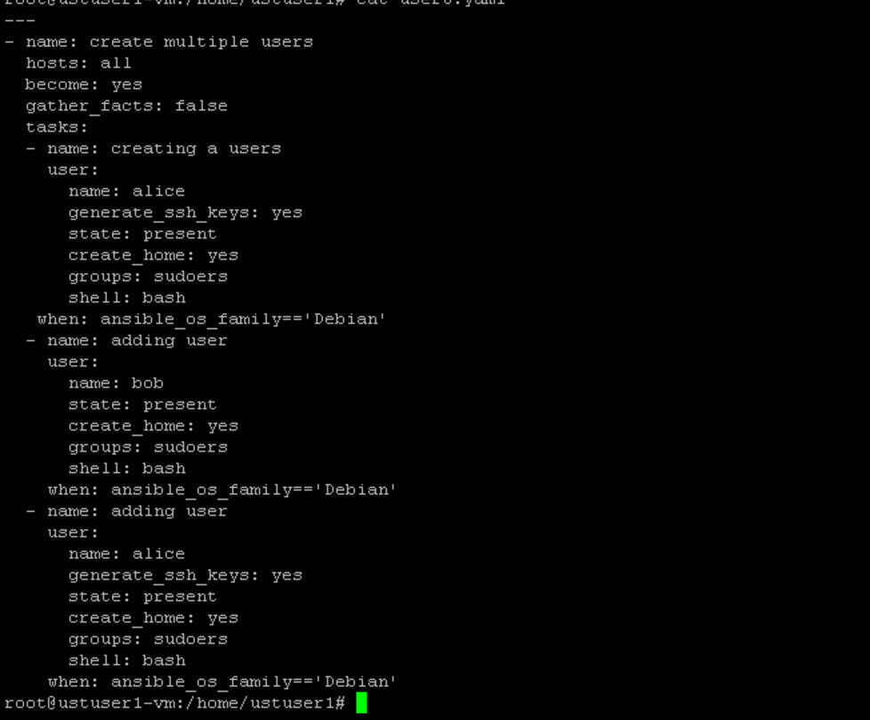

Output:

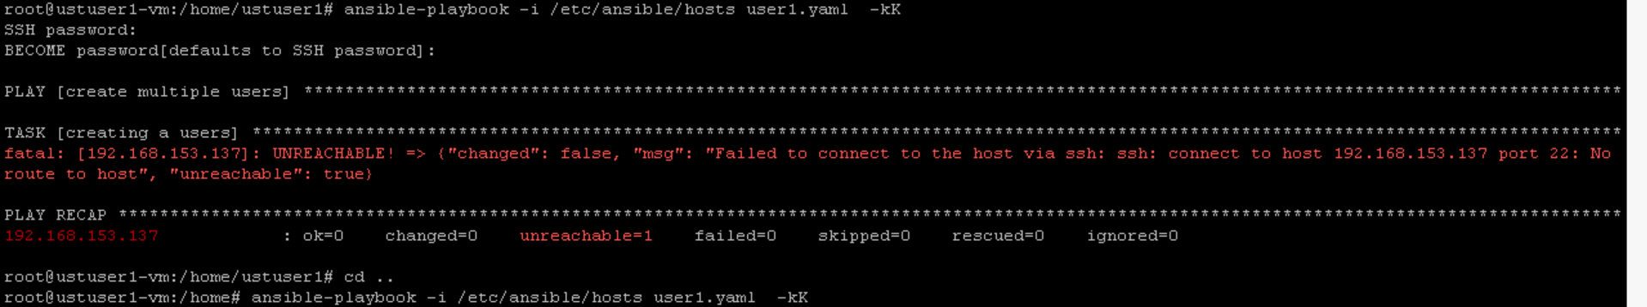

I have some configuration issues with my pc ..

I tried copying the ssh key also but it didn’t worked

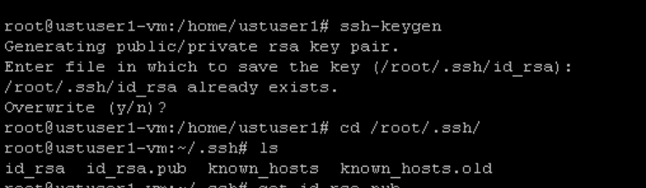

Still showing unreachable

I copied ssh to authorized keys also

My worker machine is not up so.. this error is coming