Q1.python scapy:

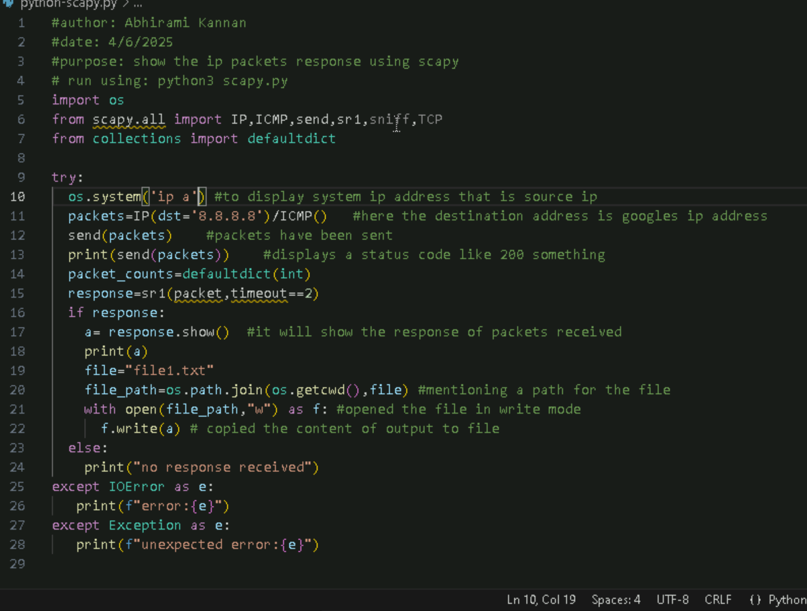

Couldn’t run this code its showing like :

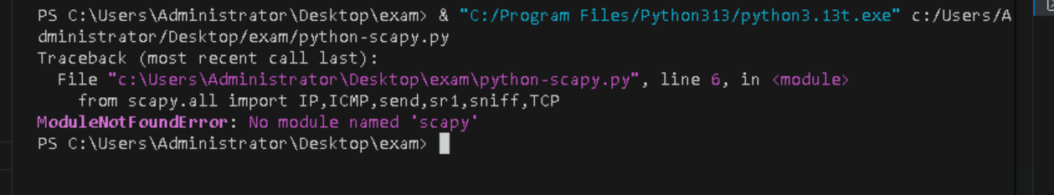

Documentation also was not available for scapy

* The actual working of this ip is here I used google address
* Soo it will show like a status code of 200 ‘s
* 200 means success
* And while we are receiving response we are using sr1 to get response
* So here we can see the packets that received
* But because of this no module named scapy I cant get to see the output.