Q2.Ansible

To create a role

ansible-galaxy init webserver

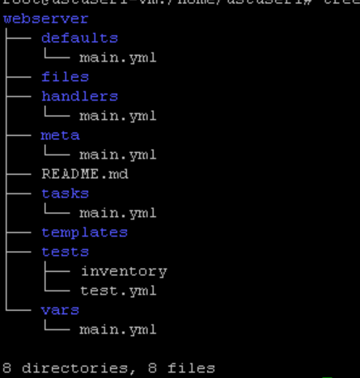

Tasks/main.yaml

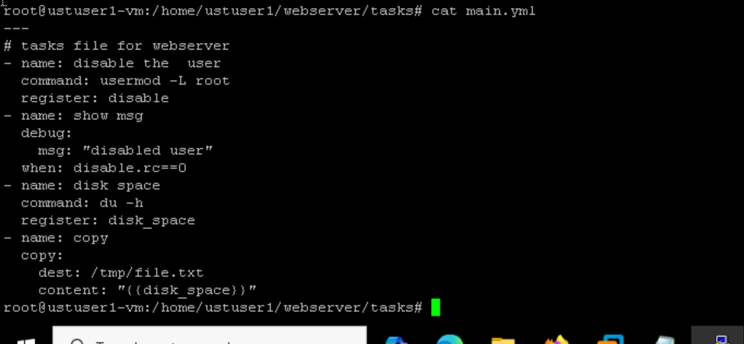

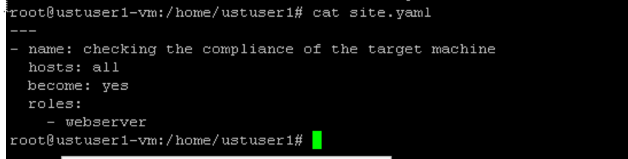

Ansible-playbook -i /etc/ansible/inventory site.yaml

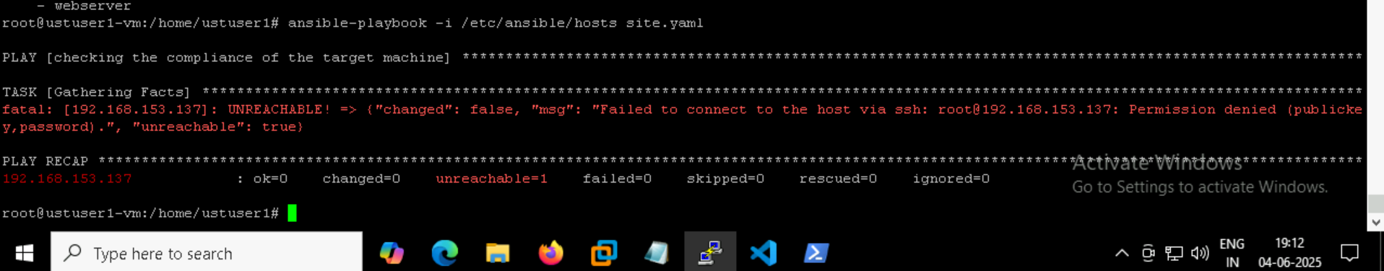

Im getting the permission denied issue because of some configuration issues im thinking

And I cant even run my playbook to see the errors and correct also