Q3. Python monitoring file changes

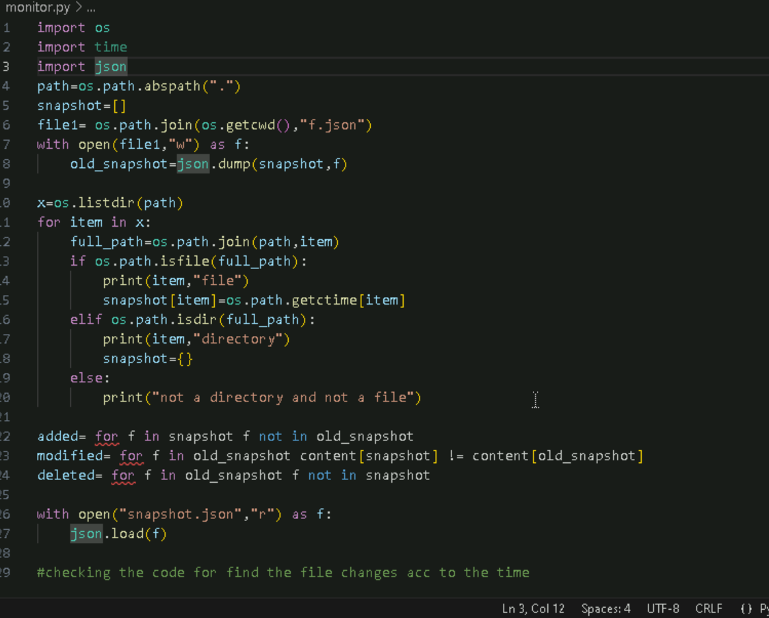

* I have written an another program to hash the file

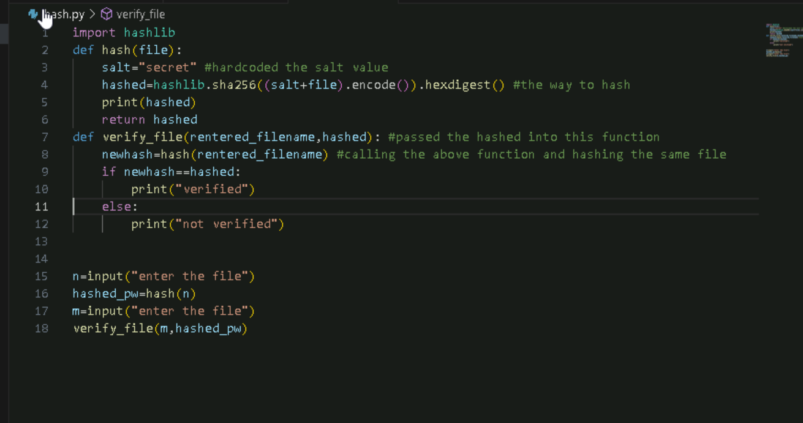

Output:

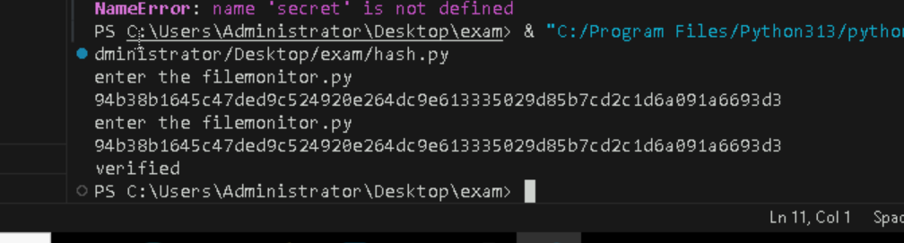

Also I added an alert to print if the file didn’t matches

Means if hashed value not matches

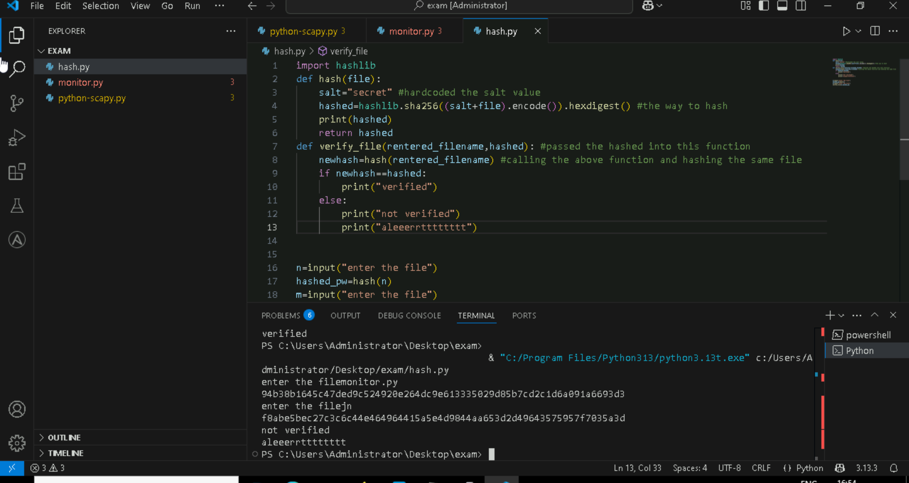

* Added error handling to this code

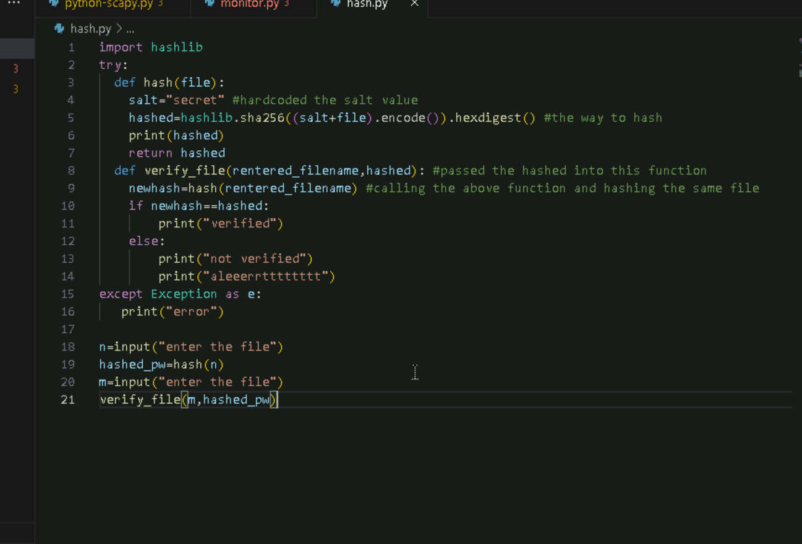

* Added a code to write on a disk file about the alert

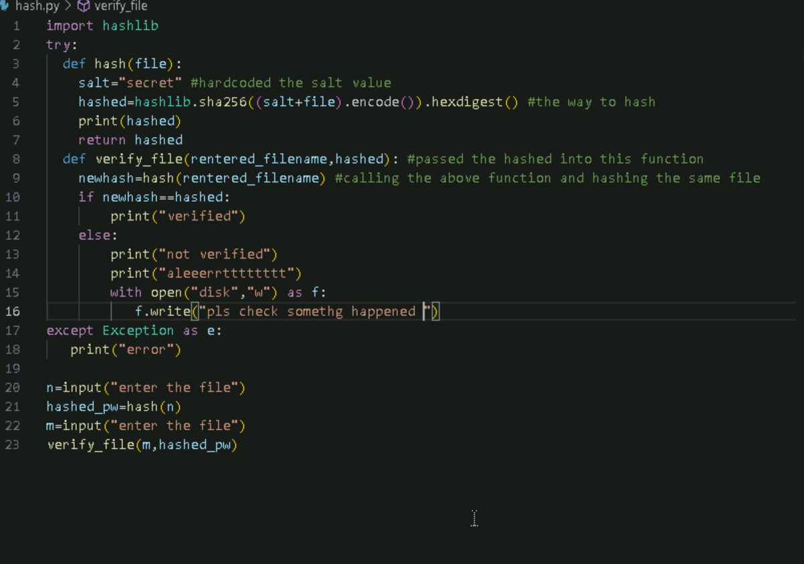

Output:

Here the file entered didn’t match and created a file by adding the contents

