**Shell-api**

* Created a shell script like curled the url
* And stored the output to a variable
* And printed that table
* Stored the contents of the table into a file

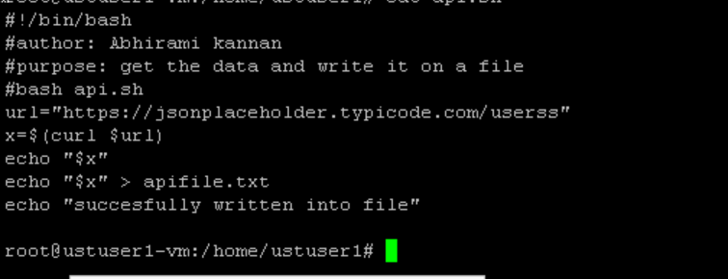

Output:

