**Devops exam**

**Repo url:** https://github.com/Abhiramikannan/spring-boot-hello-world.git

* **Created a Dockerfile**

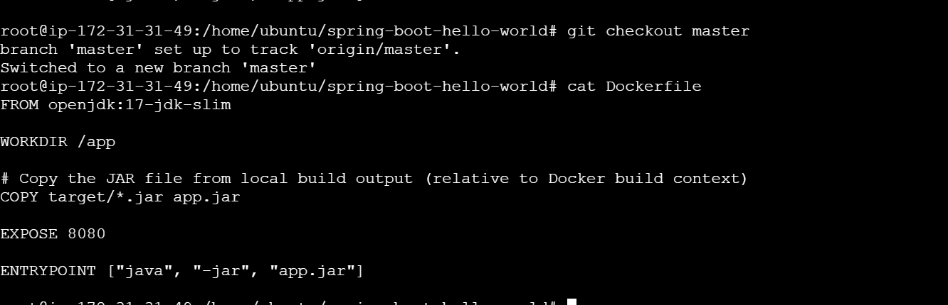

* **builded image**

docker build -t abhiramikannan/javaimage .

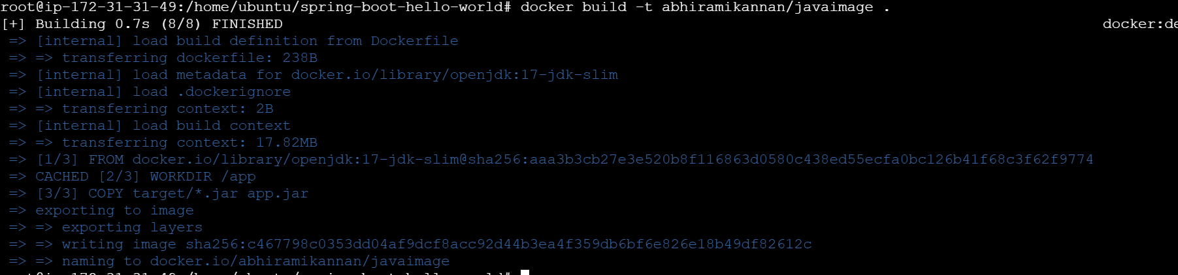



* **pushed into dockerhub**

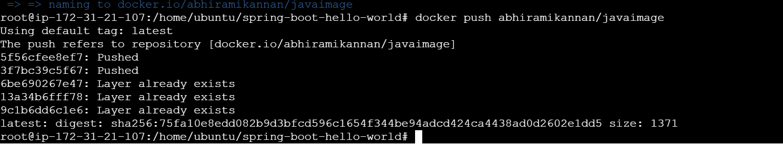



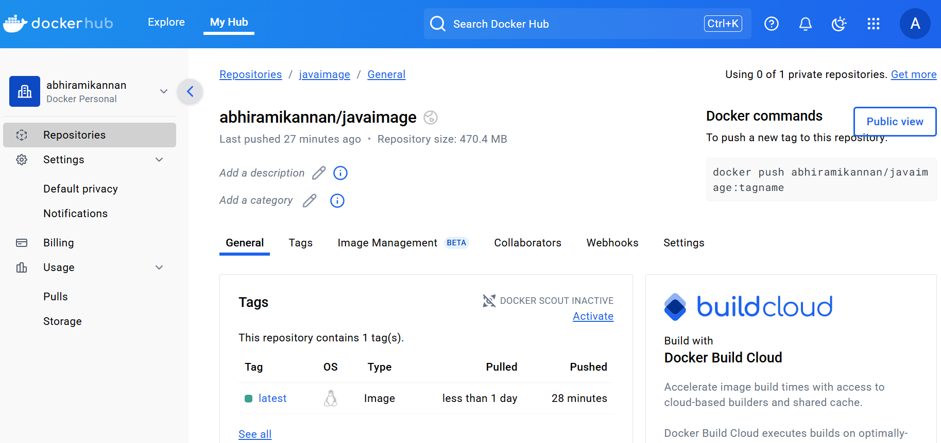

* **done webhook** in github by creating another instance because my instance terminated

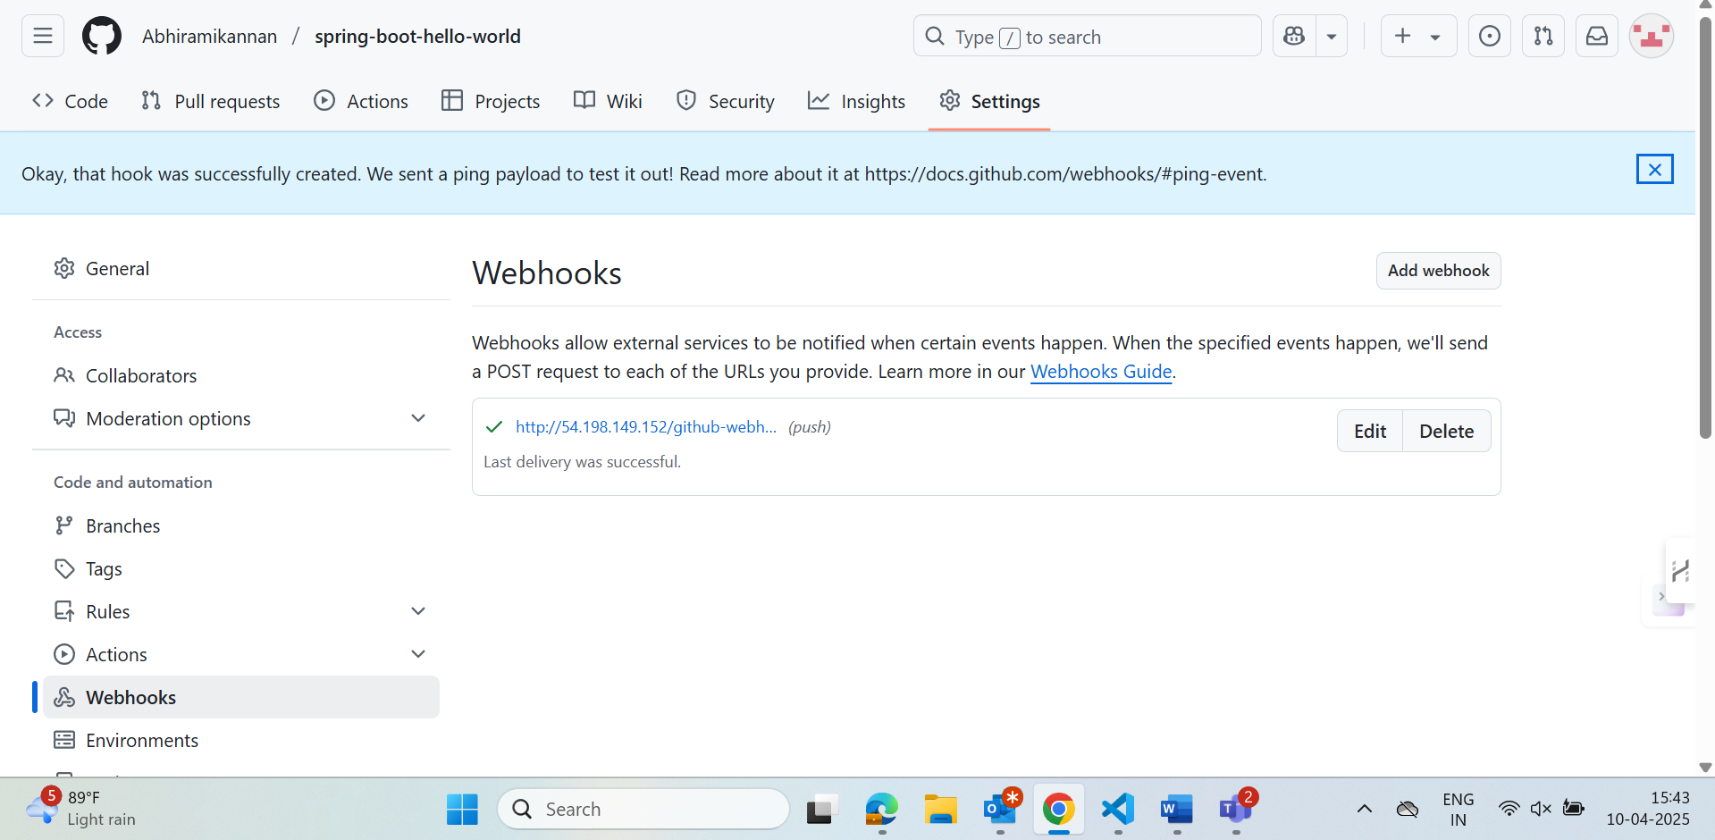

* **Jenkins multibranch-pipeline**

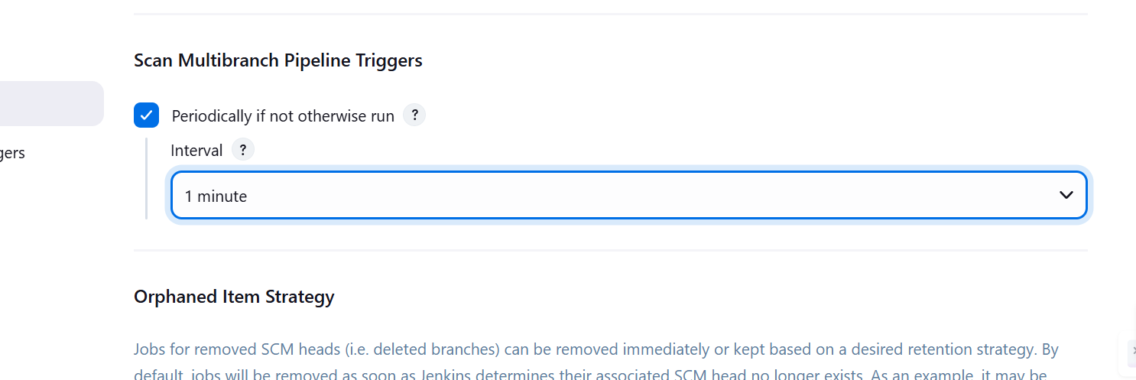

* **credentials added in Jenkins**

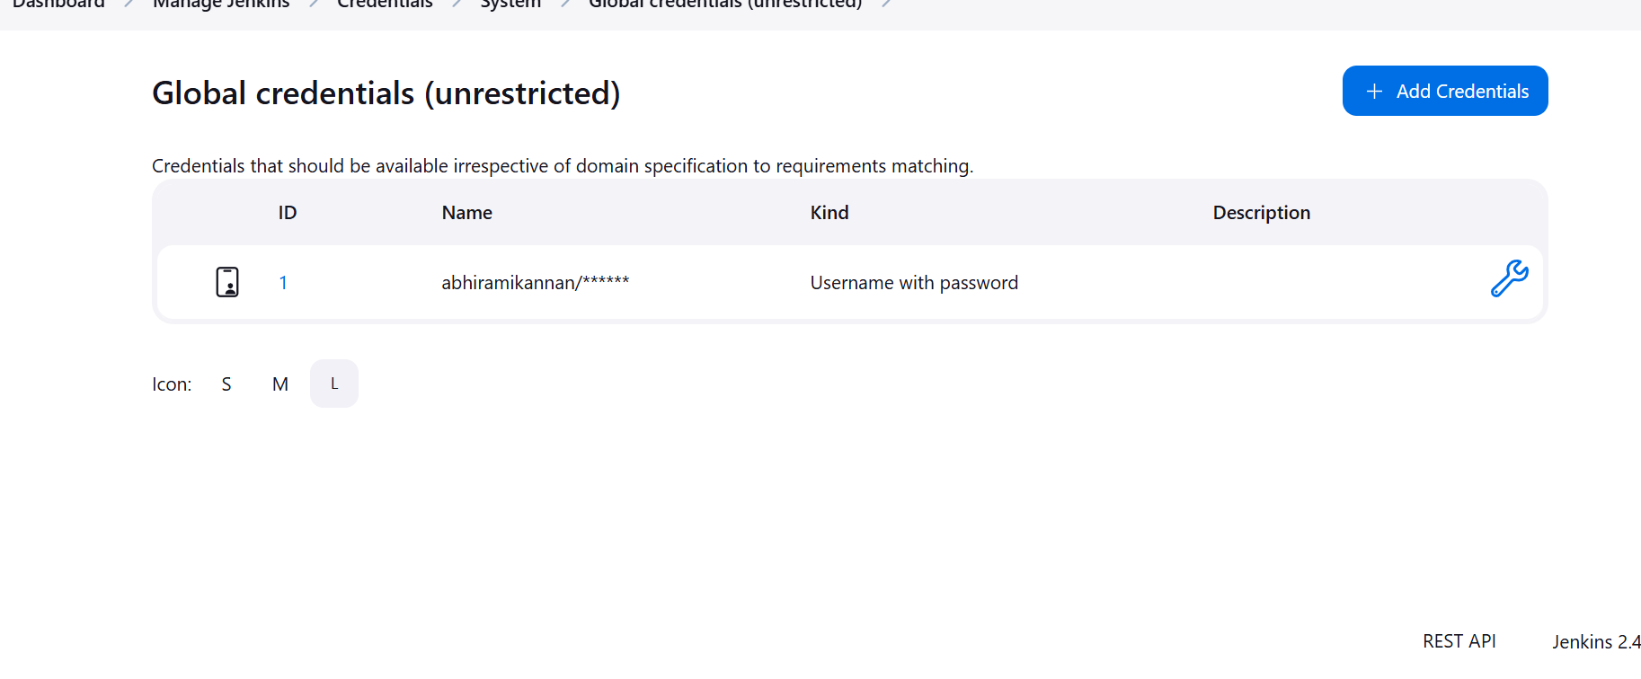

* **Created a multibranch pipeline**
* 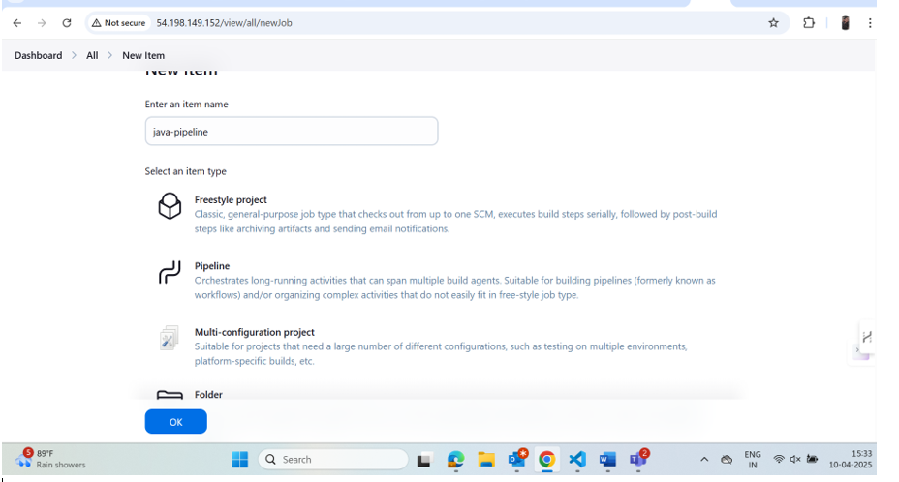
* 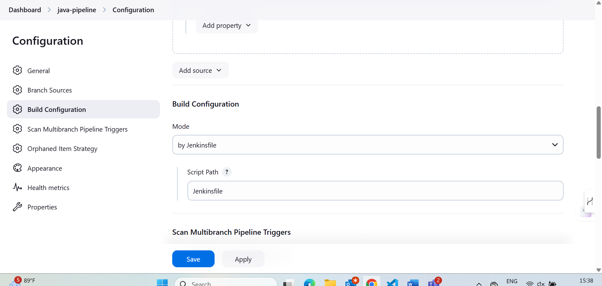

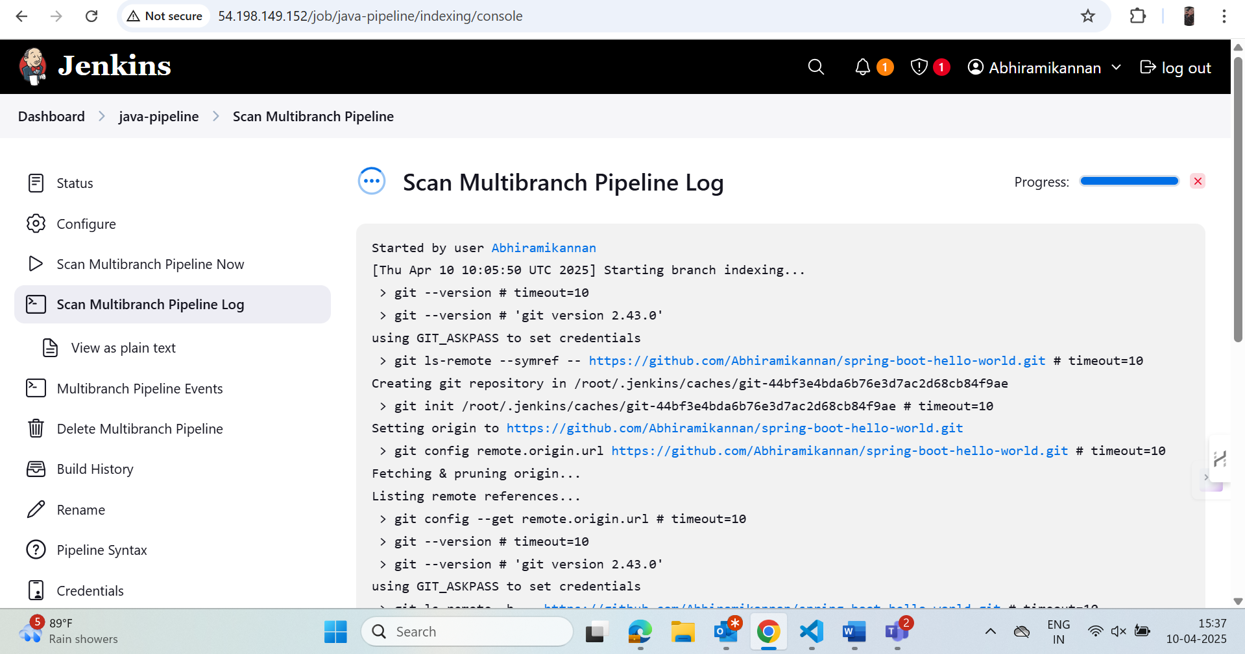

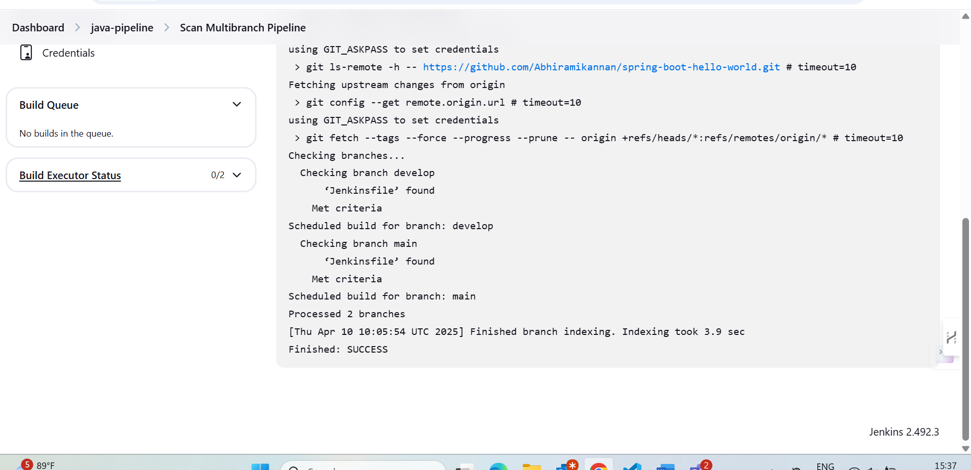

Installed maven

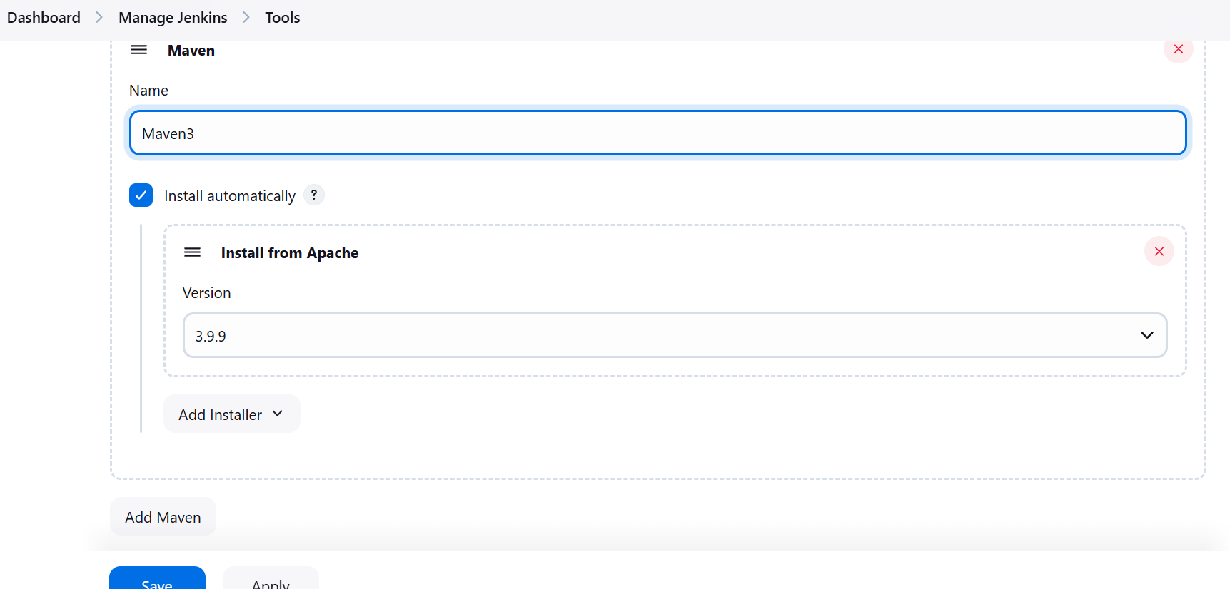

Result:

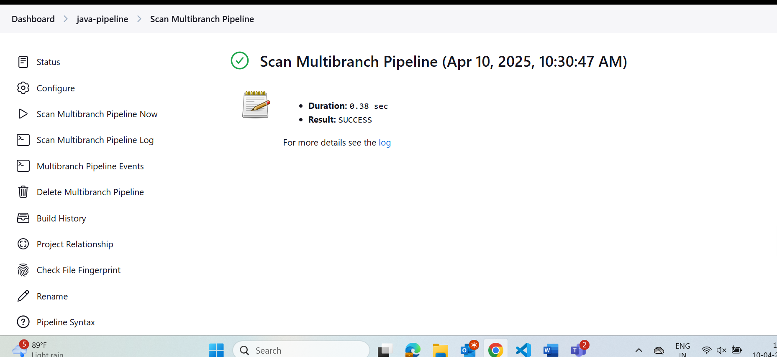

* **Jenkins part success**- tried by creating master branch and feature branch separately
  + - I created a new branches feature and master because of some configuration issues in Jenkins file.

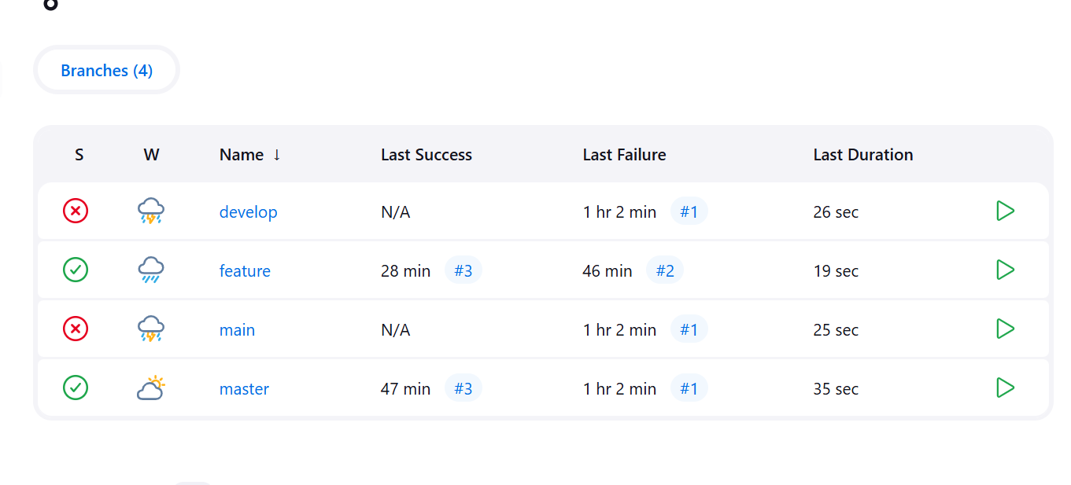

* Master:[https://github.com/Abhiramikannan/spring-boot-hello-world/tree/master#](https://github.com/Abhiramikannan/spring-boot-hello-world/tree/master)
* Feature: <https://github.com/Abhiramikannan/spring-boot-hello-world/tree/feature>

**Jenkinsfile in masterbranch:**

pipeline {

agent any

environment {

IMAGE_NAME = "abhiramikannan/javaimage"

TAG = "latest"

config_docker_credentials_id = "1"

}

stages {

stage('Git Cloning') {

steps {

git branch: 'main', url: 'https://github.com/Abhiramikannan/spring-boot-hello-world.git'

}

}

stage('Build JAR File') {

steps {

sh '''

mvn dependency:go-offline

mvn clean package -DskipTests

'''

}

}

stage('Copy JAR File to Docker Context') {

steps {

sh '''

rm -f app.jar

cp /root/.jenkins/workspace/multi-branch_master/target/*.jar app.jar

'''

}

}

stage('Login & Push Docker Image') {

steps {

withCredentials([usernamePassword(

credentialsId: "${config_docker_credentials_id}",

usernameVariable: 'DOCKER_USER',

passwordVariable: 'DOCKER_PASS'

)]) {

sh '''

echo $DOCKER_PASS | docker login -u $DOCKER_USER --password-stdin

docker build -t ${IMAGE_NAME}:${TAG} .

docker push ${IMAGE_NAME}:${TAG}

'''

}

}

}

stage('Deploy to Kubernetes') {

steps {

sh '''

kubectl delete deployment hello-world-deployment || true

kubectl apply -f deployment.yaml

kubectl apply -f service.yaml

'''

}

}

}

}

* 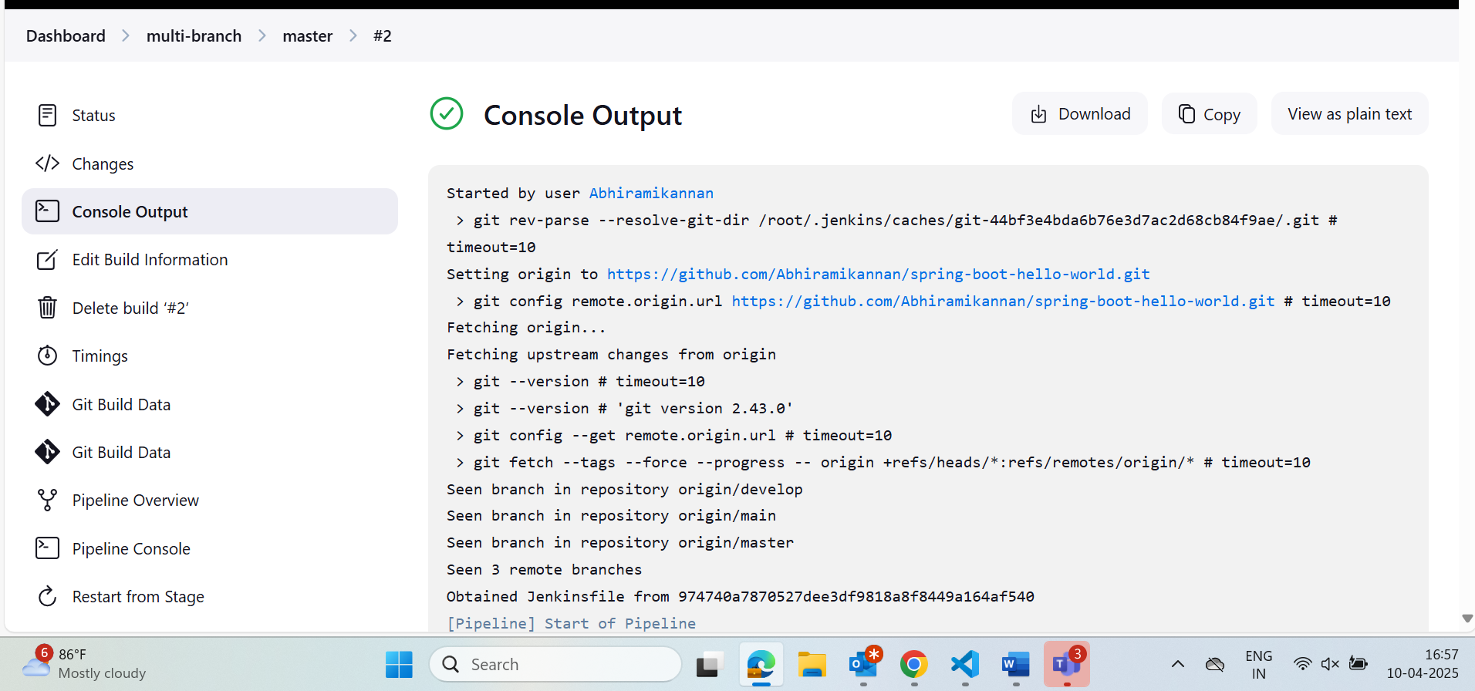
* **Jenkins in featurebranch**

**Jenkinsfile:**

pipeline {

agent any

stages {

stage('Git Cloning') {

steps {

// Clone code from the GitHub repository

git branch: 'feature', url: 'https://github.com/Abhiramikannan/spring-boot-hello-world.git'

}

}

stage('Build JAR File') {

steps {

// Download dependencies

sh 'mvn dependency:go-offline'

// Build the project, skipping tests

sh 'mvn clean package -DskipTests'

}

}

}

}

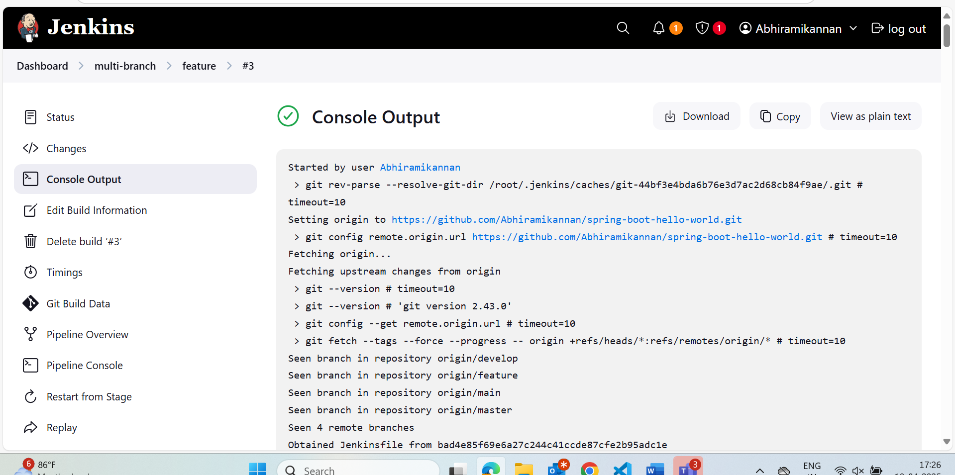

* **Multipipeline logs**
* 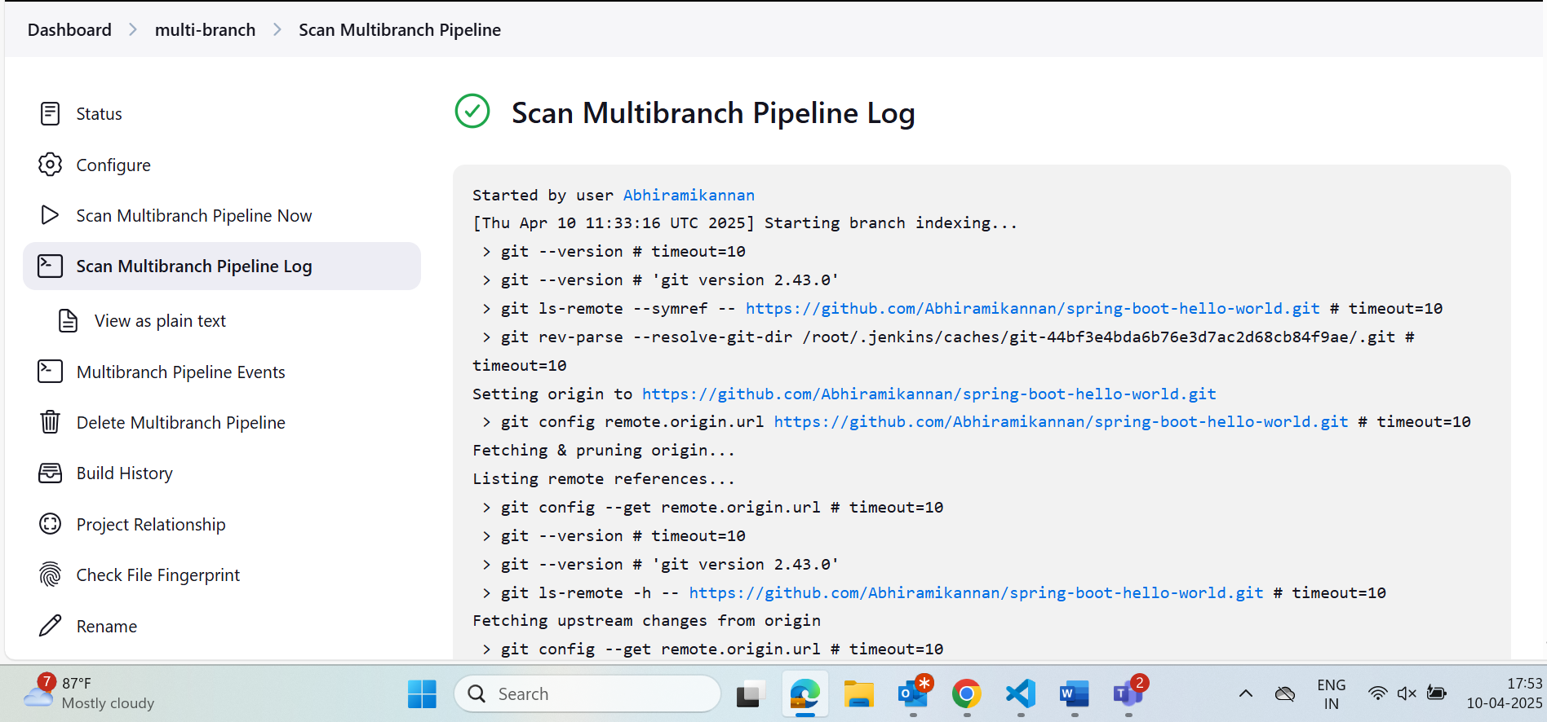
* **Kubernetes yaml files**

1. Deployment.yaml

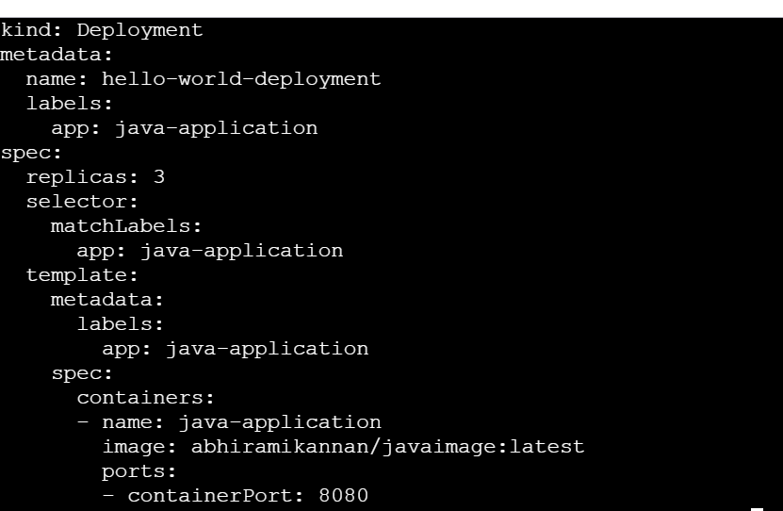

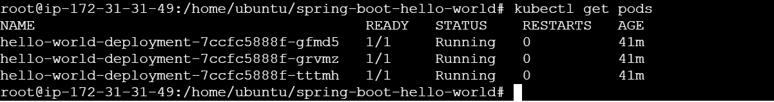

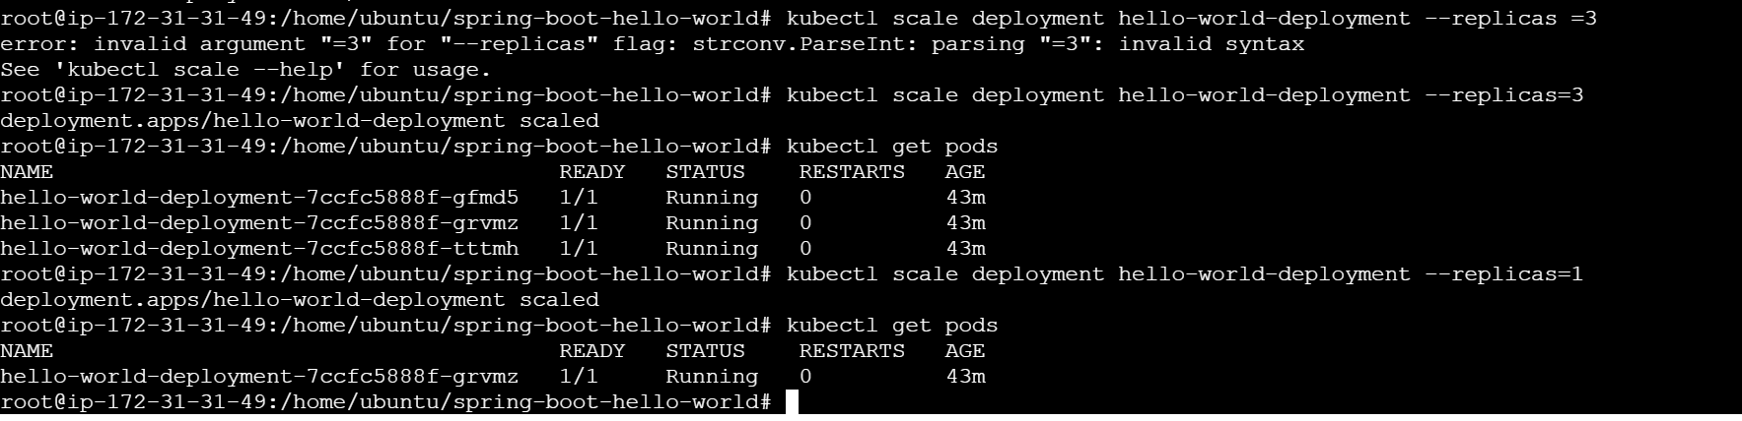

1. **Service.yaml** using nodeport

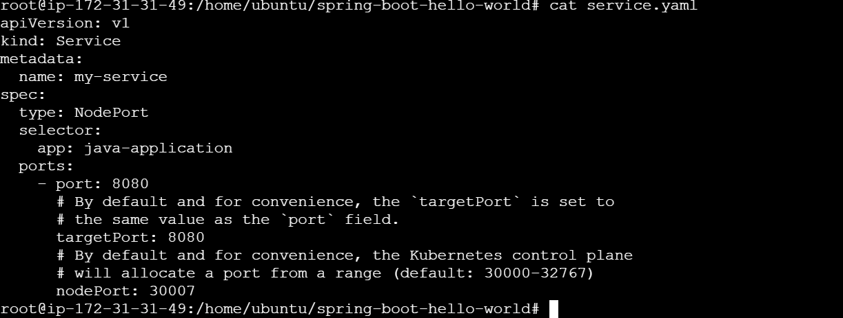

Node port access of app, exposed this using service

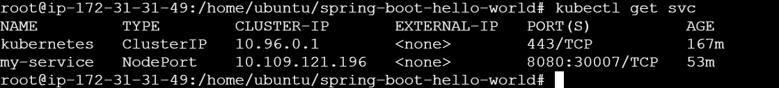

**Webooks:**

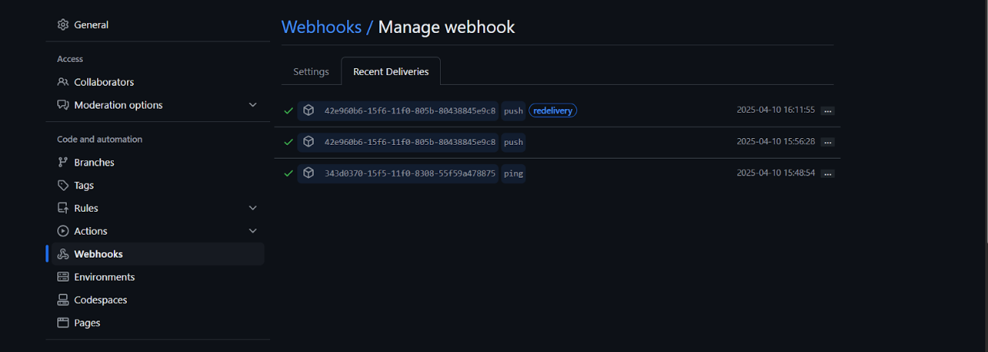

* **Multipipeline configurations:**

