Qn2 docker

* Docker version



* Pulling the ubuntu image

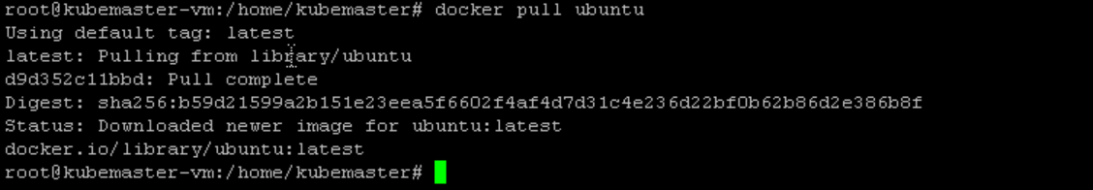

* Docker images : here the tag also included as latest

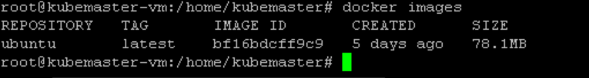

* Run the container using the ubuntu image

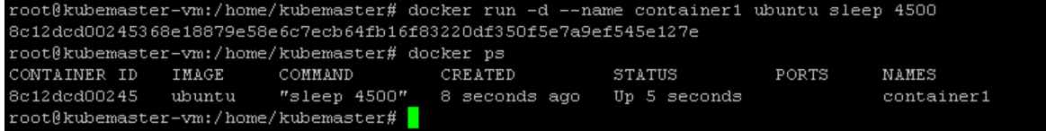

* Entered the container using docker command and looking the system resources
  + **top**

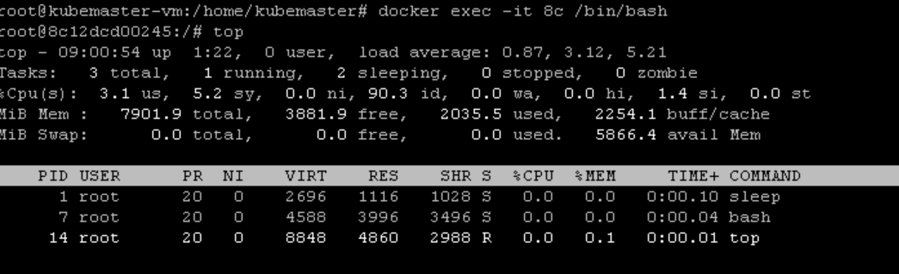

* + **uname -a** : to see the linux kernal feature
  + **uptime**



* + **lscpu**: cpu details

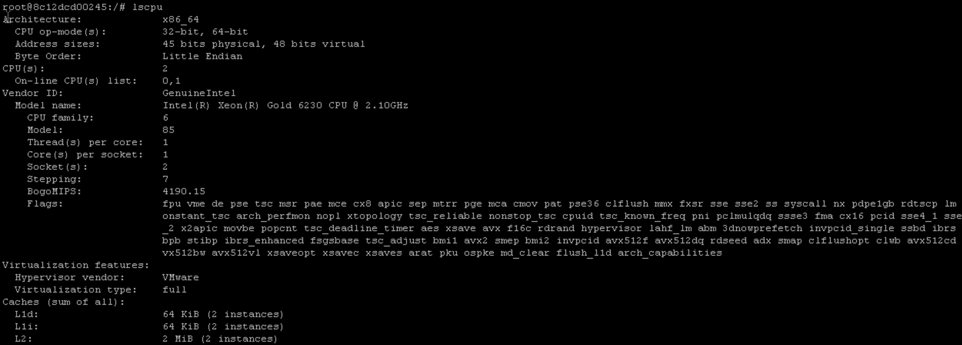

* + **ps -ef**

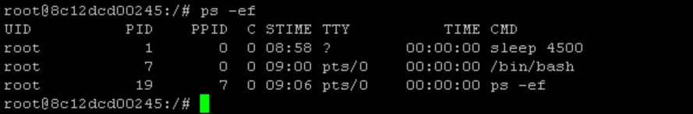

* + df

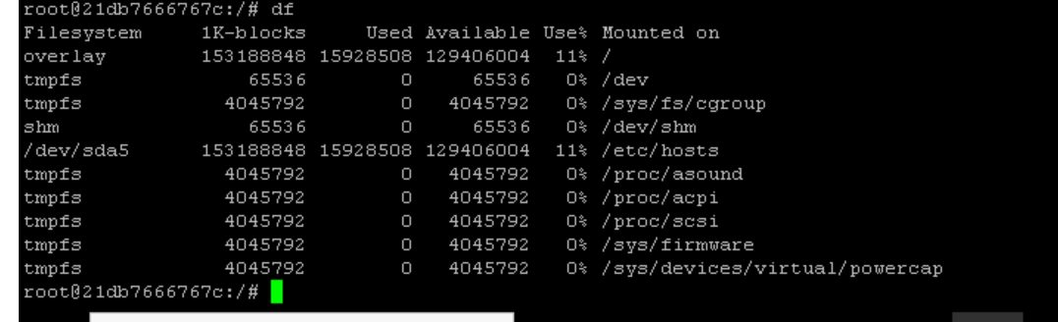

* + **du -h**

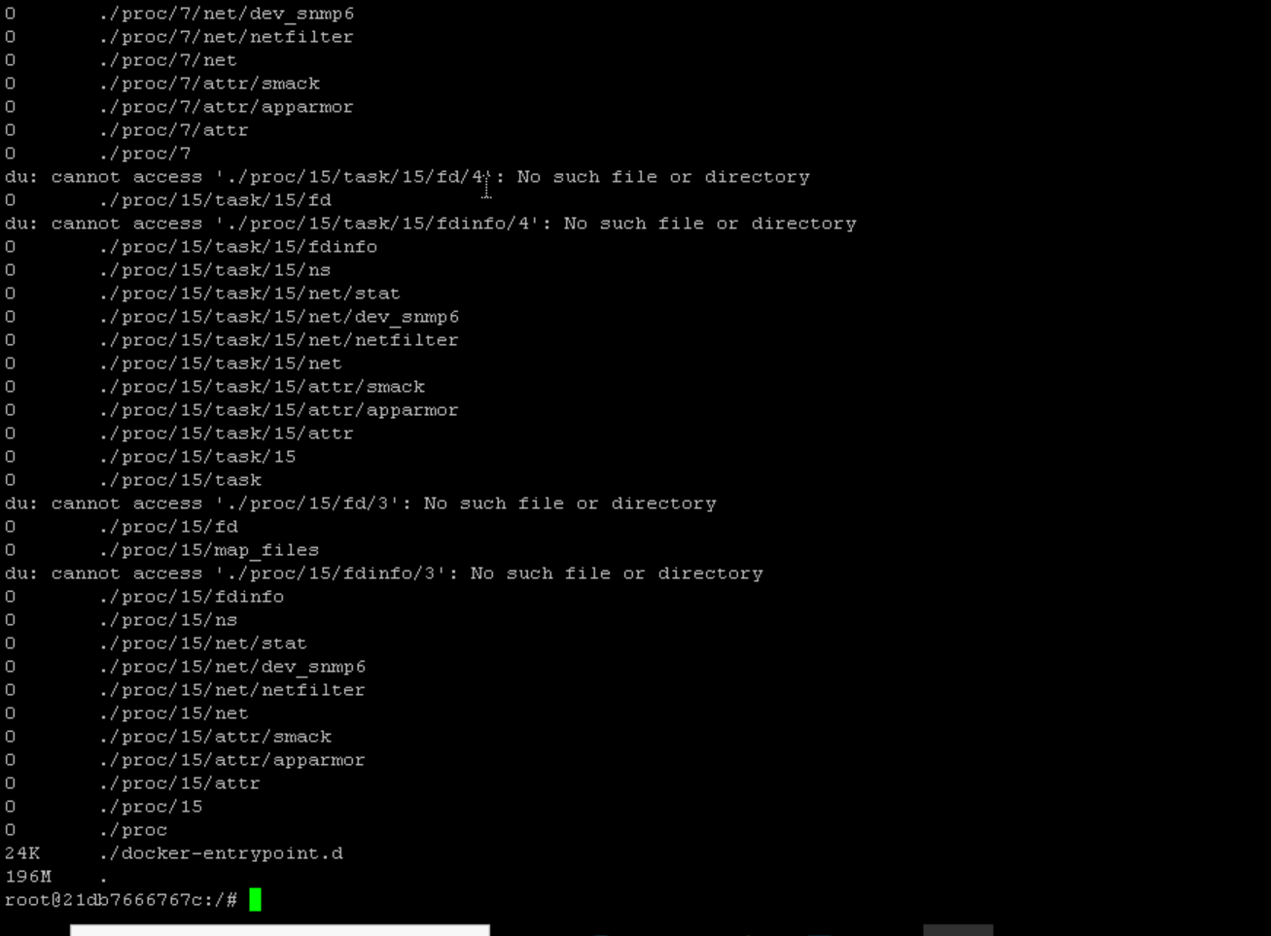

* + **free :** not working inside container
* exited from container and I can use a command **docker stats** also to see the container resources



* stopping and removing the container
  + stopping:
  + **docker stop 8c**
  + **docker rm 8c**

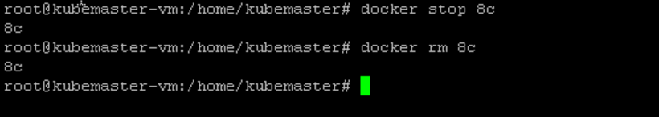

* so cleaned up the container by removing it
* also tried creating a container and applied a command

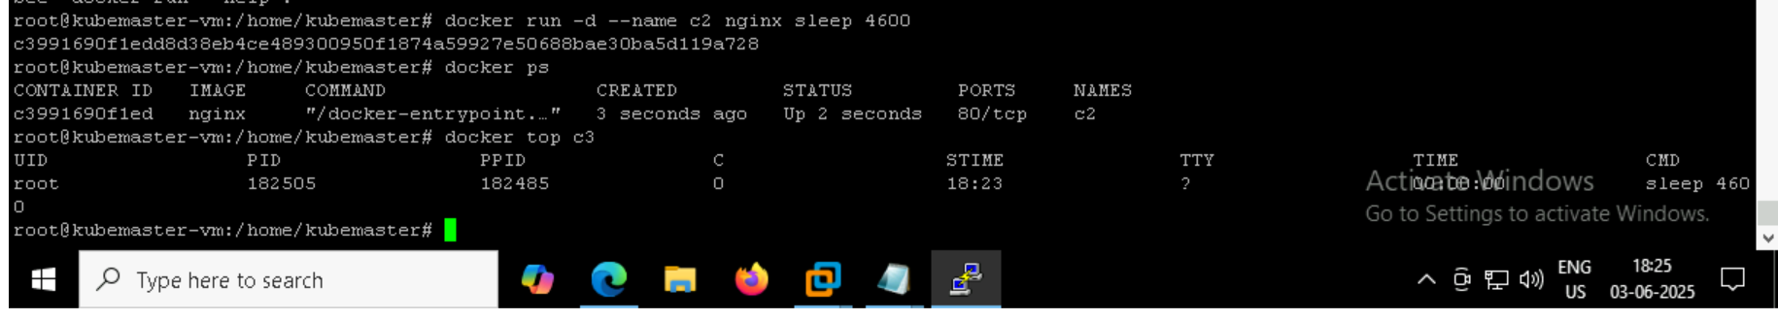

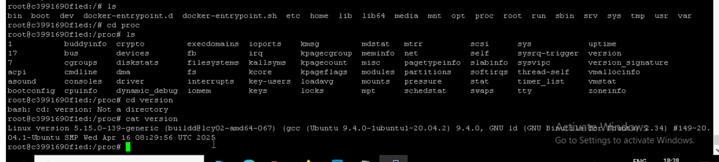

* to make the container empty:
  + rm -rf* : everything removed

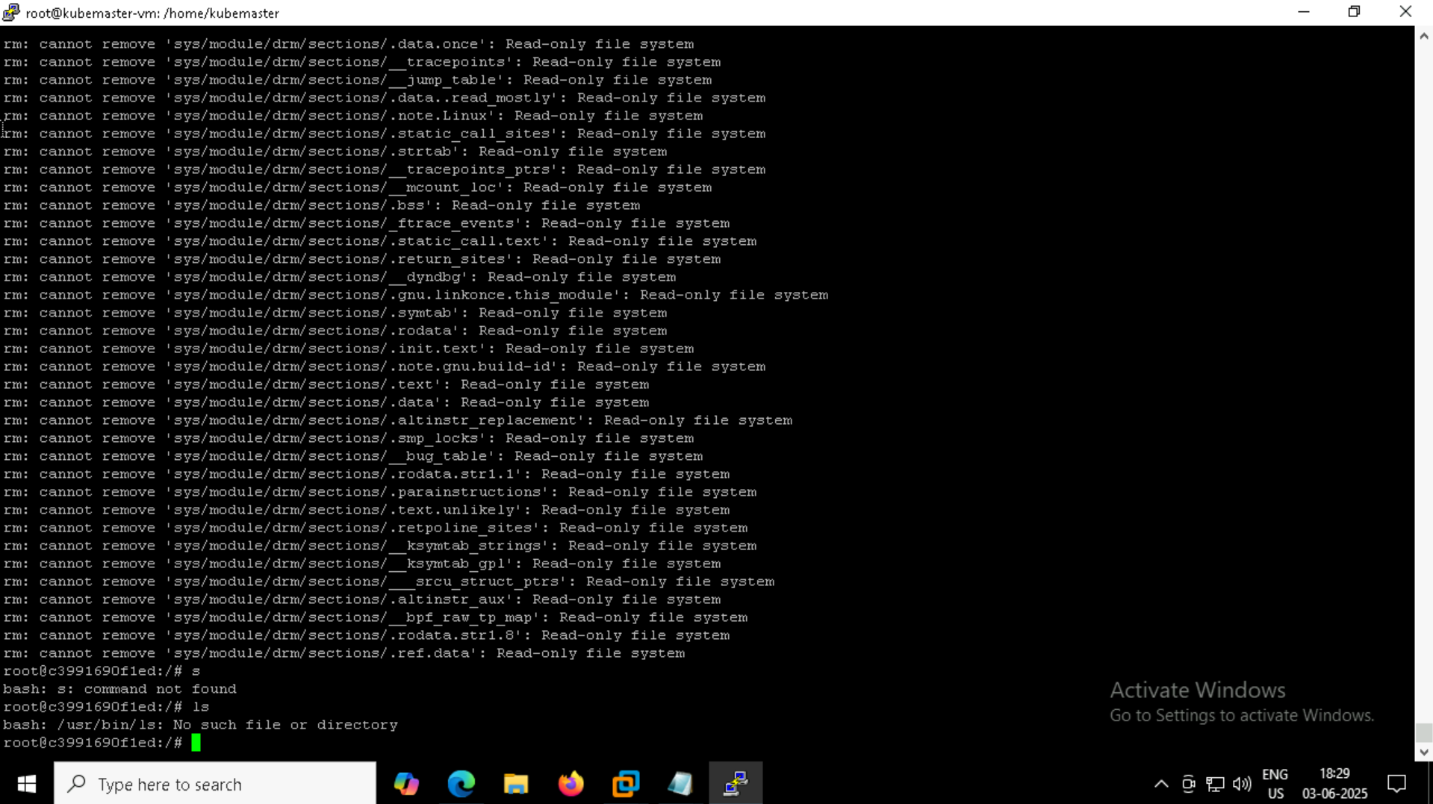

* stopped and deleted the container

